# Minutes – South East regional fostering leads meeting

Chair: Carol Cammiss DCS Wokingham

Meeting details: July 19 via MS Teams 10.30-12 noon   
Attendees: Kerry Bailey (Portsmouth); Jackie Clark (Portsmouth); Cathy Seiderer, (Brighton and Hove); Liz Shields (Buckinghamshire); Clark Mcauley, (Surrey), Helen Field, (Southampton); Gemma Pavey, (Brighton and Hove); Jackie Giles (Oxfordshire), Sally Harper (?), Seamus Jennings, (Brighter Futures/Reading); Jo Conlon (Slough/SCS), John Donnelly (Brighton and Hove); Keith Langley, (West Berkshire); Maria Cordrey, (Kent); Natalie Bugeja, (Afc/Windsor and Maidenhead); Sivay Heer (Milton Keynes); Martin Smith (Southampton), Sarah Smith (Hampshire); Lynne Tripp (supported by Rebecca Eligon, SESLIP

## Review notes from last time

The notes from the April meeting were agreed

## Item 1: Mystery Shopping

Feedback from Portsmouth on the key themes from the fourth wave of mystery shopping. The scenario used by Portsmouth focused on the transfer process. The foster carer in the mystery shopping exercise was positioned to be quite experienced and currently had one looked after child in place, but another bedroom available, and looking for a referral for more local support. Portsmouth picked this scenario as they were keen to understand how fostering services would talk about the transfer process in general, timescales etc.

The highest scoring was NFA – scored 9, local authorities came in 8-6s, a few fostering services didn’t respond. Lots of really good practice, very competent communication, good telephone manner. Reasons for high scores were enthusiastic and engaging person on the phone, clear pathways which were well explained, if people didn’t know answer they were prompt with getting back and really persevered, websites clear and informative, weren’t pushy, and gave time to think. Reasons for lower scores, only a basic understanding of transfer process, couldn’t give a confident explanation of pathways or timescales, sometimes felt like person answering the phone had a wider recruitment role and didn’t necessarily understand the transfer process.

Quite a lot of calls transferred to voice mail, but the person who called back didn’t always leave contact details. Some gave vague answers and others kept firing answers, and sometimes it was difficult for the mystery shopper to interject and ask a question. Only 2 fostering services asked the mystery shopper why they wanted to transfer, and none asked directly about their motivation or ethnicity. Key differences between IFAs and LAs were the same as having been recorded previously: non-profit making, support local. Good practice – one LA had a person with a photo and that felt more personal, other good practice was specific content on websites about transfer.

Many noted a 3-4 months process and the original form with the current fostering agency could be used. There were differences in whether the mystery shopper had to update references, some were unsure if you could care for child in place, the majority didn’t advise on when to advise the current IFA about the intention to leave. One LA mentioned children’s champions to work with birth children, but not many mentioned how they support birth families (i.e. children in the foster family). Only a few offer training in person, and only a couple talked about therapeutic training or support. Some said they would match financial package, and some didn’t know and some said would be discussed later. Most offered around 2 weeks’ leave, although there were some different amounts. One fostering service includes foster carer in initial visit.

**Action:** Can we look at all the feedback and themes together after the first year (i.e. waves 1-4), Rebecca to do this for January 2022 meeting

**Action:** Next waves are allocated as follows: Reading – October, Isle of Wight January, Southampton April

## Item 2: Benchmarking discussion:



Surrey had requested we share benchmarking data from 2020/21. Key points from the discussion are summarised below:

Kent with the higher conversion rate shared their practice approach: In Kent someone rings, we do the assessment then follow up, so feels like we do in a different order, Oxfordshire reflected that they do the other way. Bucks note that their process is a full enquiry, then initial visit – rule someone in or out at that stage before starting an application. Some noted that if you run stage 1 and 2 concurrently there is a risk you could end up with right to go to panel. Most LAs shared that they rule out prospective carers at telephone enquiry and don’t send applications prior to initial visits to reduce demand on the system and increase conversion levels.

Surrey has a specific worker that facilitates themed, monthly pre-approval support groups, not just skills to foster, not just someone tracking them, but a group of peers all going through the process together and they noted that has really helped with making people feel invested and stay on the journey, even if there are delays. The same person runs the post-approval group. Bucks has a quarterly recruitment newsletter as they were finding they lose people from enquiry to application. Surrey has also found that a word of mouth event hosted/led by foster carers have been very successful… They recruited 11 foster carers through a word of mouth event.

**Action:** CM to share topics from pre-approval support group.

**Action:** collect % in house and number per 100,000

## Practice sharing: Oxfordshire, step down from residential

Oxfordshire shared their stepdown project which began in March 2018 focusing on children in residential care to see if they could live with foster families. 55 children have been part of the project, 46 were progressed to the stepdown project. The project was not driven solely by financial savings, but to improve outcomes and place children closer to home. The majority were males aged 13+. After review 30 remained not suitable to stepdown so 25 progressed.

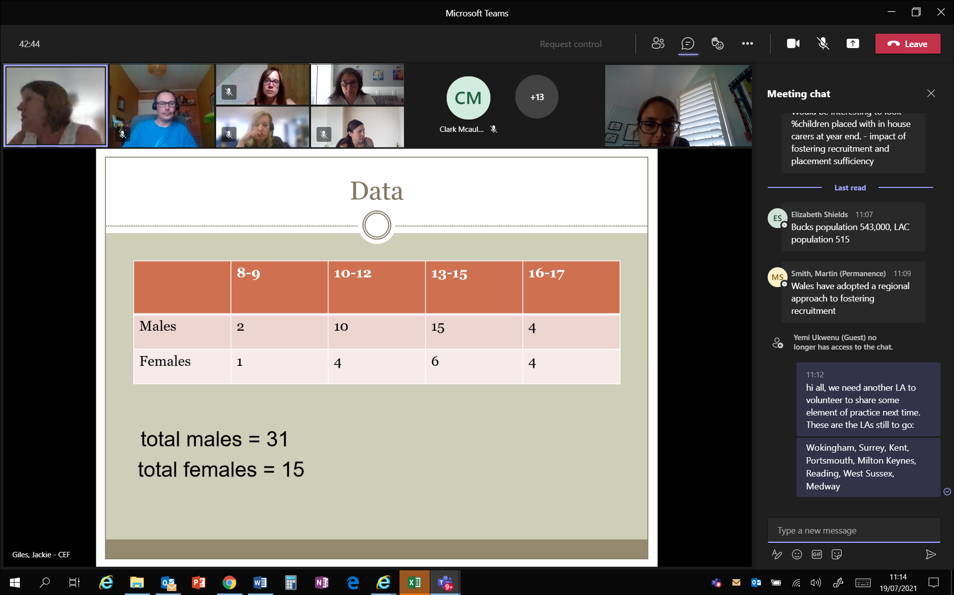

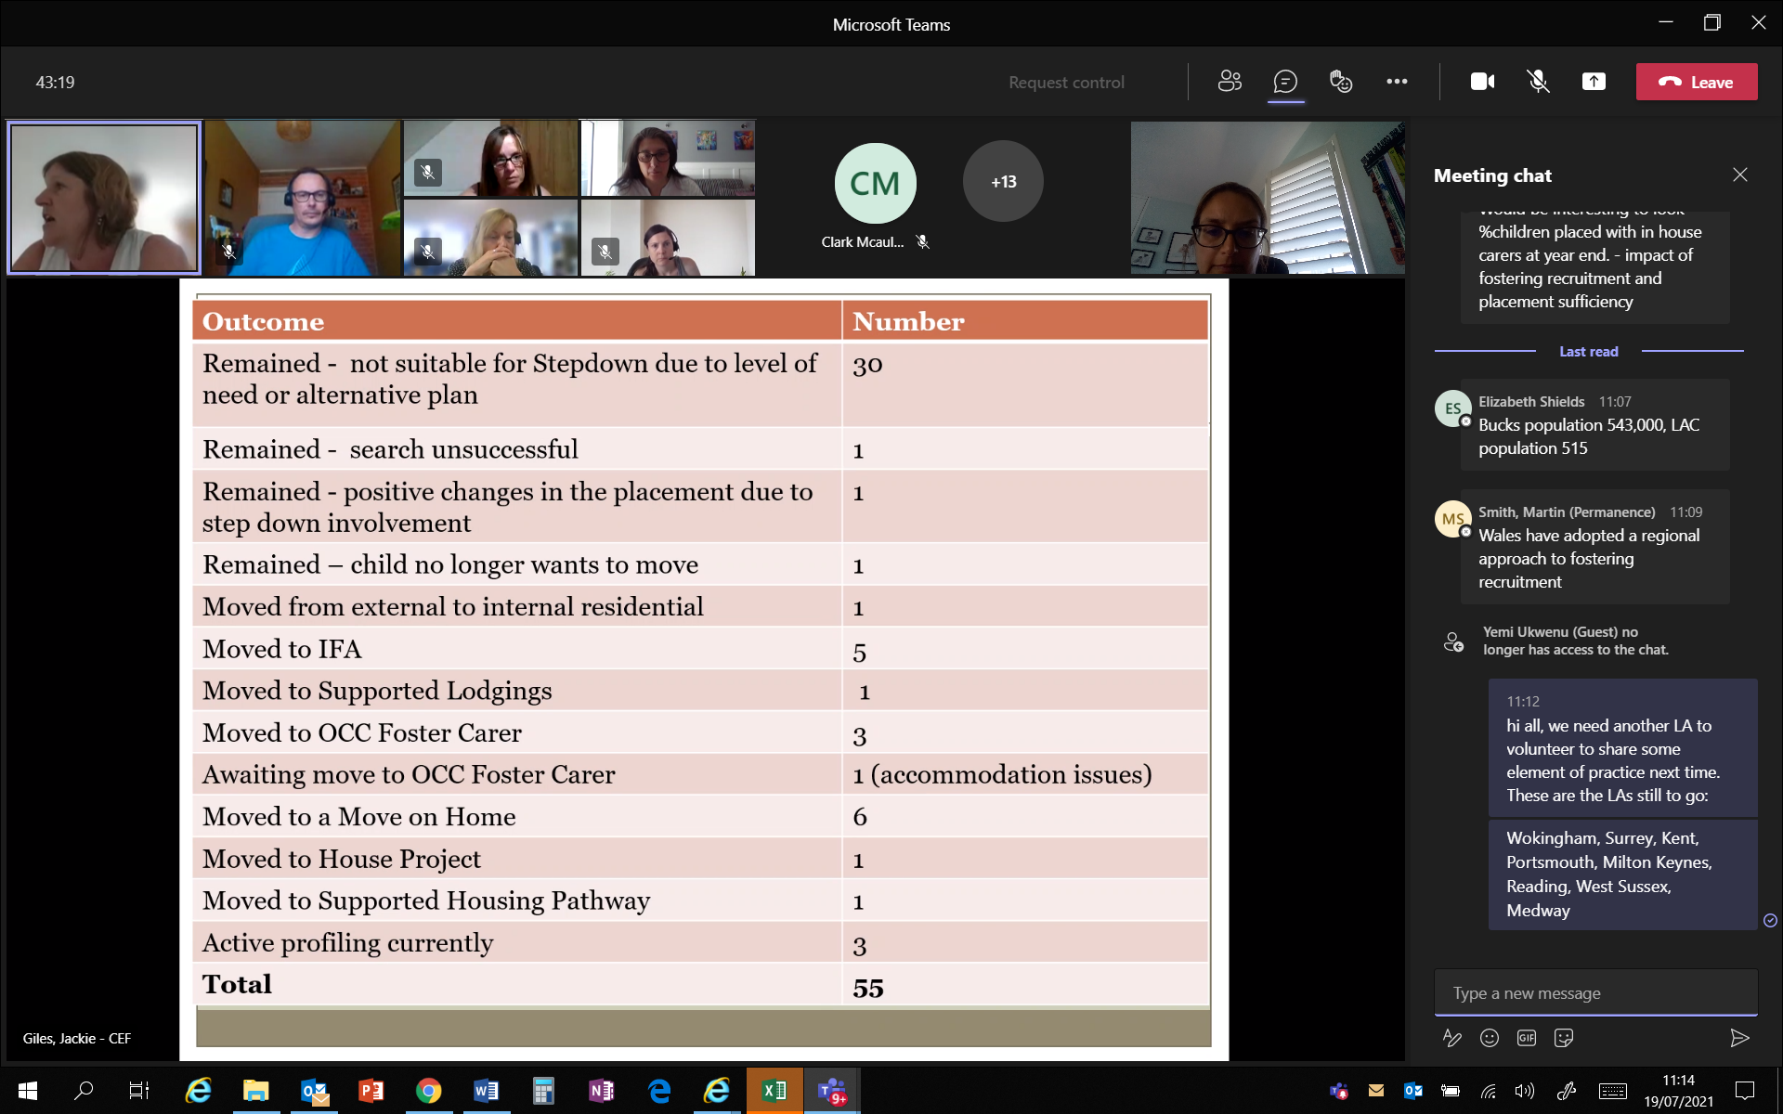

The project found it is possible to move children from residential to fostering with careful preparation. It also found that profiling events where children are presented to fostering agencies have been good at securing placements and raising Oxfordshire’s profile. The project also found it was harder to step down older children, and stepping down at key transition points (yr 5 and yr 10) were more successful. The project also highlighted the importance of stepping stone placements or move-on homes as a route to independence. The project found it takes on average of 6 months to find a stepdown placement. Although it was relatively small cohort of children, there has been a robust tracking process, including savings tracking and the project is estimated to save £3.5m alongside the improvement in outcomes for those young people.

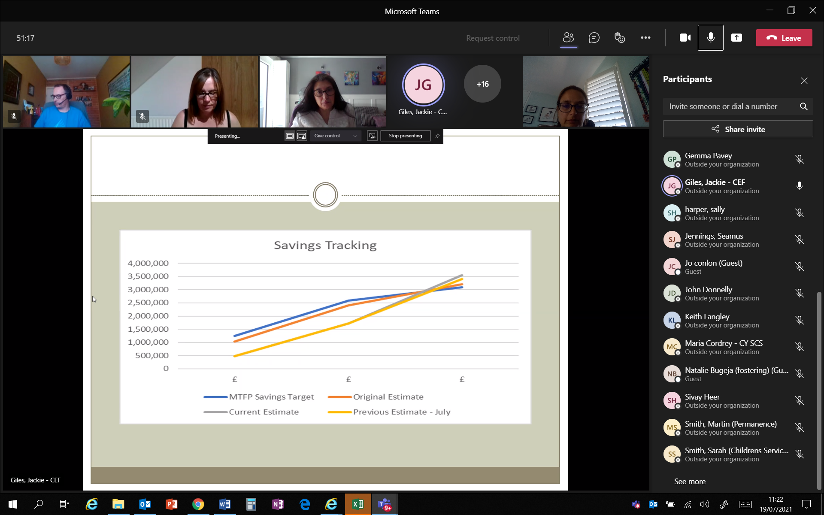

**Practice sharing:** next time: Portsmouth to share practice on Mockingbird. The following LAs are still to share practice: Wokingham, Surrey, Kent, Milton Keynes, Reading, West Sussex and Medway.

## Standing items:

No items for escalation to DCSs recorded

## Funding

Presentation from DfE identified the DfE funding pot which is currently available to all regions. The funding is to be split into 3 strands – core funding, in total £1m – which is around £110k per region; Priority areas – this used to be solely carried out by partners in practice – now any LA that is good or outstanding can apply. And the final area is innovation funding, which is about carrying on previously evaluated innovation funded projects (there are 98 projects).

**Action:** RE to set up meeting with subgroup of attendees to put together potential bids around therapy, regional website and Mockingbird.

Next meeting: November 5 2021 11-12.30

Meetings for 2022 still to be scheduled, but will carry on as virtual meetings.