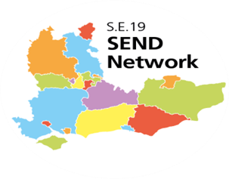

Strategic Co-Production for Commissioning Group
Terms of Reference

Frequency of meeting:
Three times a year

Purpose of meeting:
- To lead, champion and demonstrate Co-production at a regional and national level
- To share progress, good practice, challenges and solutions on how Co-production is working at a strategic and operational level in the S.E region
- To support the embedding of Co-production across service design, development and commissioning
- To encourage Commissioners and other key influencers to use Local Offer information and feedback when making commissioning decisions
- To develop a trusted network that can provide informal and formal peer support and challenge to increase confidence and expertise in co-production across SE19
- To support and influence the development of the Local Offer to contain all SEND provision in each local area

Membership:
- The meeting will be Chaired by a strategic lead from a Local Authority and the NNPCF SE Region Representative
- Up to three nominated representatives from each Local Area, to include commissioning, a parent carer and young people’s participation lead
- Other local area members as appropriate to the agenda

Reporting:
- Co-ordinating Local Area and S.E. NNPCF Steering Group Member to report back to and from the SE19 SEND Regional Steering Group
- Key outcomes from meetings to be fed into NNPCF Steering Group
- Minutes will be shared on the South East Sector Led Improvement (SESLIP) website

Ownership:
- The group to be co-ordinated by a Local Authority (currently West Sussex) in partnership with S.E. NNPCF Steering Group Member.
- Any SE19 area can nominate themselves to become the Chair/Co-ordinator on an annual basis

