Agenda – in house fostering

Meeting details: 10.30-12.30, Monday November 25, Beecham Room, Local Government Association, 18 Smith Square, London SW1P3HZ
Attendees: Pinaki Ghoshal (Brighton and Hove CHAIR), Amber James (Hampshire), Gill Burtwell (Portsmouth), Karen Devine (Brighton and Hove) Karl Davis (West Berkshire), Martin Smith (Southampton), Liz Shields (Buckinghamshire), Peter Hodges (Bracknell Forest), Seamus Jennings (Wokingham) Clark McAuley (Surrey), John Donnelly (Brighton and Hove) Adrian Sewell (East Sussex), Hilary Sparling (Medway), Gemma Pavey (Brighton and Hove) Rebecca Eligon (SESLIP)
Apologies: Karen Wright (Hampshire), Lynn Buckle (Hampshire), Steven Orchard (Surrey), Sivay Heer (Milton Keynes), Catherine Seiderer (Brighton and Hove), Teresa Lavelle-Hill (East Sussex), Saima Arif (Slough), James Ball (West Sussex), Jackie Giles (Oxfordshire), Daniel Ruaux (Oxfordshire), Karen Wright (Hampshire), Sarah Smith (Hampshire), Steffi Roth (Reading) Stephany Carolan (Hampshire), Kirsty Benson-Allison (Slough)

Item 1: feedback from DCS meeting
PG updated the group from the October DCS meeting and updated those who were not at the first meeting of the in-house fostering group in September. The DCSs endorsed the direction of travel suggested by the group. They were less convinced that sharing foster carers would yield significant change but are happy for the group to pursue this on a sub-regional/likely RAA footprint if there was appetite.

Item 2: Sharing practice.
Leads from Hampshire and East Sussex shared key aspects of their practice with the group. Summary notes are included below for those unable to attend the meeting. Brighton and hove (JD) and Hampshire (AB) will share practice from their respective authorities at the next meeting of the group in February. The group agreed it was useful to share practice and will make this a standing item on the agenda going forward. The notes below are not entirely verbatim but attempt to cover the key points raised.
East Sussex:
Training: East Sussex place 80% of children in foster care in house. We are suffering with a national shortage of foster carers, as is common with all the LAs, and those coming forward, are not who we have traditionally had. It has taken a long time to get to 80% in-house. Ten to fifteen years ago East Sussex was a hotbed of IFAs but now we haven’t got that many IFAs resident so they are not in our locality. Our foster carers say that IFAs are not as attractive as they have to go out for training. We know our local, high quality training offer is important.
Our lifeline for recruiting isn’t new foster carers, it is largely a transfer from IFAs. We also make the most of saying that we are all under one roof – if you are a foster carer for us you are working with child’s social worker, CIC CAMHS, Virtual school.
Foster care association: Another thing we are really proud of is our Foster carer’s association – it gives foster carers a voice, gives them a role. They were responsible for putting forward a business case to get a pay and allowances increase. They recently got a Queen’s award. We would say our Foster Carer’s Association is particularly successful and active because the chair and trustees are charismatic and energised and because they have a clear purpose, which is driven by them not us – their purpose as they see it is to work as a union of sorts for foster carers. We put funds in to support their administration, but they are there for foster carers and they have managed to secure other funding. Our foster carers know that the Foster Carers Association is listened to and they have the ear of members. The leaders in the Foster Care Association would definitely be up for mentoring, sharing advice with more fledgling and less developed foster care agencies. I am sure they would love to do that. Offer to the other SESLIP authorities: Contact Adrian Sewell to connect your foster care association with the East Sussex foster care association
Vinnie the recruitment van: East Sussex is a difficult place to recruit given the coast, and we have traditionally been less strong at recruiting further inland. We have had particular success with Vinnie the recruitment Van – a used a Library bus, with fostering on one side. Vinnie replaces information evenings which were starting to feel quite sad. We knew we weren’t competing on information evenings with IFAs who had fancy canapes and a glass of Chablis and only 1-2 people were turning up. We no longer have recruitment evenings, we now run Vinnie instead. Vinnie costs about £4k to run each year and was bought for £10k, we spent about £1,200 livery. In winter months Vinnie is out once a week and once a week we park it up as a sort of moving billboard.
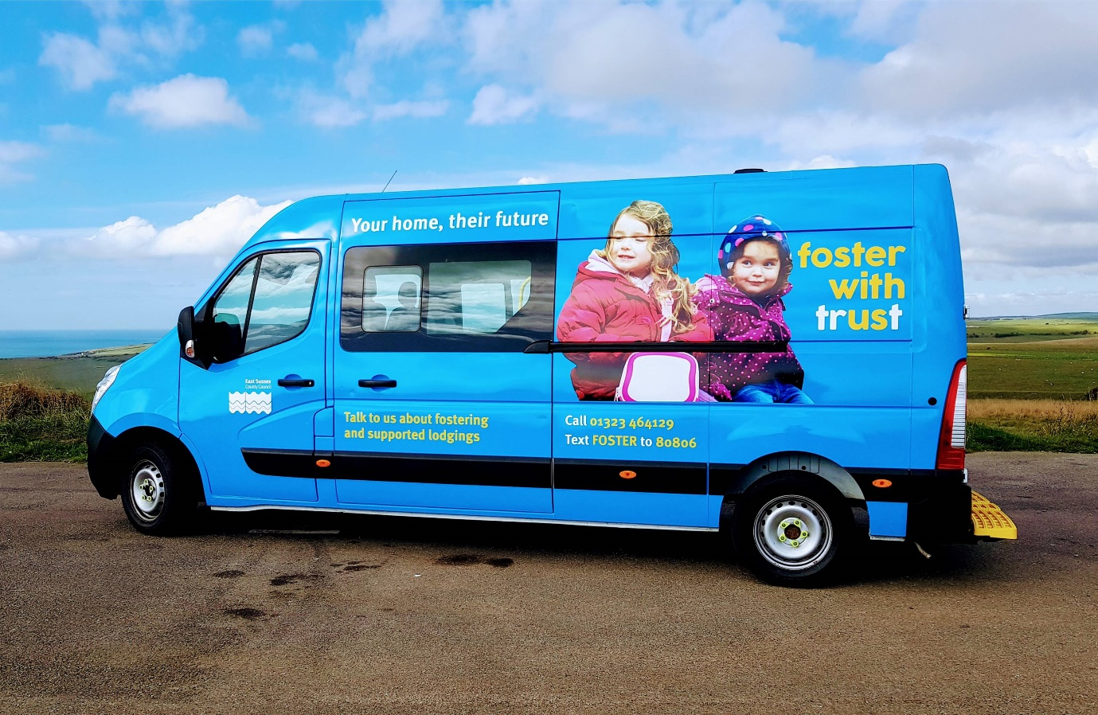
E-marketing: We have also made great strides in e-marketing, but it did take us a while to get our heads around –in some way initially we had all the gear but no idea, we recognised we didn’t have the people with the knowledge to get the right content in the right places. We employed some younger people who really got a handle on it. Initially we were on the wrong websites, our twitter wasn’t interesting, we weren’t being retweeted by the right individuals. Now 60-70% of our enquiries come from social media.
Bracknell Forest
Bracknell Forest is a small unitary we don’t have the capacity or the numbers to do some of the things a big county can do. I want to share our approach to preventing placement breakdown. We have a RAG rating approach to all our placements on the stability of the placement. The child’s social worker, and foster care social worker work together to complete a RAG rating. We then review on a monthly basis all that are RAG rated amber or red in terms of their placement stability. As a result of this we put in appropriate support. We have 140 looked after children. The nature of being a small unitary means we don’t have the depth of support, and so often we might need to spot purchase. We don’t have a CAMHS/LAC worker, we need to buy-in. We have also used the insight from those meetings to create a more tailored support offer for our foster carers on different themes like managing teenagers, working better with virtual school etc. Foster carers generally welcome the approach- they might have a number of children placed in their home but only one is red/amber. We bring the voice of the child into the process through our use of signs of safety in statutory visits.

Item 3: Mystery Shopping
RE introduced the North West approach to mystery shopping. The group felt they would like to do something which included both online and calls and also included IFAs. AJ from Hampshire updated the group that they have recently undertaken mystery shopping of 23 other LAs and IFAs using a fictitious set of circumstances. Their mystery shopping was undertaken by a Hampshire manager. The Hampshire mystery shopping was all undertaken by one person to provide consistency. The group agreed that consistency was important.
The main learning was the stronger performers were very good at immediately building a relationship, making the caller feel they could be a foster carer. The best performers upskilled callers during the call, and were genuine in being interested. AJ noted that LAs performed more strongly overall in the mystery shopping that IFAs.
Actions:
- Aspiration for a quarterly mystery shop which is rotated around the SESLIP authorities to undertake. This will ensure that knowledge around the methodology and insight is shared and there is consistency each quarter around the feedback.
- Suggest using Hampshire methodology as the basis for developing the approach for the SESLIP authorities. Needs to capture soft/feeling/investment in the person – can you request a call back in the evening or weekend? Needs to include both LAs and IFAs. Not clear whether should be one call/email to each LA or more each quarter.
- GB – Portsmouth, AJ - Hampshire, GP - Brighton, MS-Southampton, and a nomination from Surrey to work together to set up a process. First wave of mystery shopping to be conducted in January and reported back in February.

Item 4: Our unique selling points
The group identified a range of factors which they believe make the LA fostering offer unique from the IFA offer.
- Local authorities are relatively stable organisations, they will not be bought over by other agencies like IFAs might be
- Local authorities are not profit making like some IFAs are
- There is potentially easier access to other relevant services (e.g. youth services, virtual school, CAMHS – all under one roof)
- Training will be local (not somewhere far away at a national or regional centre)
- Foster carers are considered part of the whole team supporting the child (the child’s social worker, fostering social worker, foster carer), you won’t be coming in from a separate organisation to work with the LA.
- You are providing support in your own community – our carers, our children, giving something back to your own local community
- The LA is part of the place – i.e. some insight that people choose to be a foster carer in a particular location because they care about that place, even if they aren’t resident there, they might have lived there or had family, work, uni connections, support the football team.
- You can access the employee support that local authority employees receive (e.g. employee assistance helplines, counselling, etc)
- You are more likely to be asked to foster a child from a particular cohort that you express interest in
- You will have first access to the children who need a foster home – cutting out the middle-man (LAs only go to IFAs to place children that they can’t find an appropriate home for in-house)
- There is a good support offer (this isn’t nec different to an IFA, but LAs less good at explaining/selling this)
  - inspirational celebration events, picnics and BBQs, health and well being, mindfulness, yoga, massage and beauty, free leisure passes (looking after you so you can look after our children- you are not alone)
  - good peer to peer support (mockingbird schemes, connections to others in the same position as you, foster carer walks etc.)
  - training (recognising your skill as a professional foster carer – training around therapeutic foster care etc.)
  - out of hours support

Action: RE to appoint marketing agency to develop some core messages for the SESLIP authorities to use, using the content above as a basis.

Item 5: Formalised sharing agreement
Agreed to postpone taking this forward until maybe next year and to continue sharing foster carers on an ad hoc basis.

Item 6: Update from other regions
RE has contacted the other regions to see what they are pursuing relating to fostering on a regional basis. The North West are further ahead than us and have brought together some services on a regional basis (front door, marketing). Their reflection is that the key and most impactful thing they have done regionally is around sharing practice.
Bath and North East Somerset are leading the development of a market position statement for the South West. They are happy to share when they are little further in development.
Action: RE to invite the North West group to present at the next meeting
Action: RE to keep in touch with South West market position statement development
Action: RE invited to North East group who are just forming on Jan 22. RE to update group at next meeting

AOB
CM from Surrey asked how the different marketing functions are structured and funded in the South East
Action: RE to send out a few short questions which we can report back on at the next meeting

Proposed meetings
Group agreed to continue to meet at the LGA 3 times a year.
Action: RE to book rooms for 2020 and circulate for February, June and October.

