South East Region Adoption and Special Guardianship Leadership Board
NOTES: January 24 14.00-15.30
Invitees: Dr Mac Heath (CHAIR Milton Keynes), Lorna Hunt VICE CHAIR (Chair Adopt Thames Valley and PACT), Teresa Rogers (Adopt Thames Valley), Kevin Yong (CORUM and National ASGLB Sponsor), Sarah Skinner (Adoption PARTNERSHIP), Rebecca Eligon (SUPPORT Sector Led Improvement Programme), Alastair Lee (Data lead, East Sussex), Lucy Peake (Kinship), Rachel Reynolds (Adopt South), Hilary Sparling (Medway), Carole Atkin (for Sandra Bucks), Cathrine Clarke (Corum), Richard Morris (CAFCASS),
Apols: KY needs to leave early at 3pm, Michael Wilson (Adopt South East), Vanessa Glenn(ADM Adopt South), Raheela Khan (Slough), Sandra Carnell (Bucks), Hilary Loades (Brighter Futures/Reading), Alison Alexander (Cornerstone)

Item 1: Minutes and action log.
Minutes and action log agreed. Decision: Terms of reference agreed to adopted

Item 2: Feedback from national board
National board was held last week. KK tasked members of the national board to share and discuss the priority task and finish groups in our region including the top 100 children and adopters waiting, which we have on the agenda to look in particular at the decline in matching. Discussion at the national board was relatively anecdotal and high level so MH noted it will be good to discuss this in more detail today. At the national board there is a far better representation across all the regions than previously, and they have greater coherence to their partnerships than previously.
KK asked if he could attend a future meeting of ASGLB in the South East and MH said yes it would be appropriate. He is particularly focused on children waiting and disparity regarding foster carers adopting; the second priority national is around systems and processes and PLO variability. There is a separate meeting with judges which will take place on this. The third area of national priority is support plans (in their widest sense), both for adoption and special guardianship. Issues were raised about the stability and continuation of the ASF. MH noted that a fourth plinth is needed around strategic direction of travel. The preferred option was around family time/contact/post-placement/post-adoption contact and the sense still that closed contact arrangements are the prevalent form of contact. MH noted adopters and birth families all have a better understanding of what might be expected in terms of post-order contact.
Action: MH to invite KK to future ASGLB
At the national board there were also some high-level discussions about the repercussions of the Somerset judgement in relation to ADM decisions. MH then opened up for discussion/comment.
TR said that it is right that ‘contact’ as a word needs to change, relationships and family time are not just about direct contact. TR agreed it is an exciting area, but adopters need reassurance that it will be managed carefully, and sensitively. MH asked TR if she felt that things had improved. TR said we are good at talking about the change, but it had not yet been fully embedded. It is about identifying the situations when it is in the child’s best interest and noted that for older children and those in foster care it is more logical and easier to achieve.
LH says this is an important area requiring more investment and training not just for social workers, but adopters. A greater focus on this area would be helpful both nationally and through this board.
CA concurred with LH and TR and it needs to apply to SG, foster care and adoption and there is a need for someone in each organisation to take the lead for ‘contact’. CA noted that in Bucks they are getting a push from the courts for direct contact, but they don’t really have the resource to support. A greater focus on this would be helpful.
SS agreed with others and noted conversations with court about siblings placed at home. If they make placement order they will lose contact with siblings. SS also noted that Children’s social workers come out of proceedings very bruised by the courts about their care planning and decision making. There are a small number of arrangements that are open contact, but still a lot of letterbox contact. SS reflected that it is a skill to think about what the child will need for now, but also in 2 years, 5 years and getting adopters to think about this from the earliest point even if the changes are further down the line. SS believes that there is learning from early permanence about how to manage contact well which needs to be applied more broadly.
RM said we need to get more sophisticated with our thinking around contact. A lot more judges are becoming more open about open contact, especially for in-family adoptions, and connected children.
RM asked about part 18 regulations and whether they were raised as part of ADMs and variability in medical input. RM suggested we might need a regional audit to understand whether this affects our LAs.
CA another comment on the contact, is the importance of providing counselling to birth families/grandparents at the time of care proceedings which can set things up well for contact on an ongoing basis. MH agreed and said it can be an area that is under-resourced or under-prioritised.
KY has said that children will make contact regardless of formal arrangements. Ky also reflected that he understands the government minister is quite nervous, as if we make open adoptions then there is a fear that adopters won’t come forward. It would be helpful to be able to identify case studies of RAAs that are doing it well given government nervousness.
LP asked whether the discussions at national ASGLB differentiated between SG vs. adopters regarding contact. LP noted these are very different things and LP expressed concern that SG will get lost.
Action: MH played back that on the basis of feedback from the board today he will be feeding back to national board that in the South East contact is a critical area and important for national strategic consideration, however there needs to be focus separately on SG and adoption.
Action: Next board meeting to have a themed discussion on contact

Item 3: data discussion
KY noted that data from Q2 is not published yet and will be shared in March. KY shared that there has been a bit of a rebound in placement orders. KY is interested to know whether things are continuing to fall in Q3 and asked RAA reps if we are seeing a fall in adoption is that a good or bad thing, is it due to rise in SG? Is it because courts just aren’t granting POs?
RAA representatives reflected that the data reflects their experience of placements and AOs levelling off, but courts still have a backlog and are not prioritising AOs. We are seeing an increase in adopters coming through. We have a significant number of adopters available and waiting. Adopt South, 96 families available, only 30 families needed. Across the region there are 170 children and of these a quarter are under 5, the largest groups are white, no disability, then sibling groups of 2, then sibling groups of 3. The data shows a good proportion of those haven’t been waiting very long (less than 4 months since PO) and in total only 10 where the PO has been open more than 12 months. These will be picked up in the top 100 children waiting analysis which is next on the agenda.
RAA leaders noted that as we get more adopters coming through we will start to face the same challenge from 5-6 years’ ago which is about keeping approved adopters enthusiastic and engaged whilst they are waiting.
MH noted that it was interesting that children waiting did not have the harder to place characteristics. AL concurred that we are in a very different place a year ago and this will require different skills for social workers to work with the waiting. First two quarters of pandemic everything going up and now everything going down.
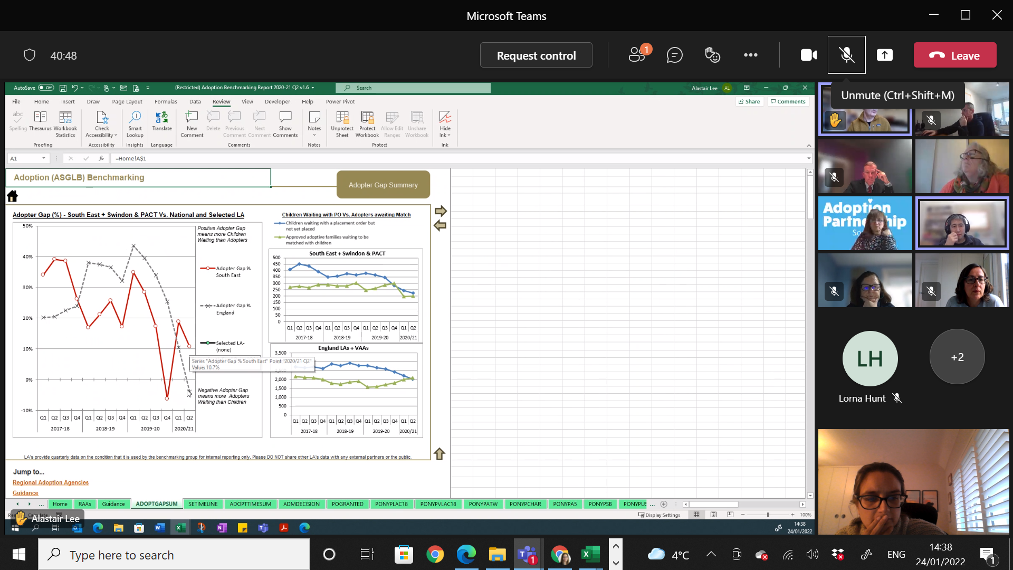
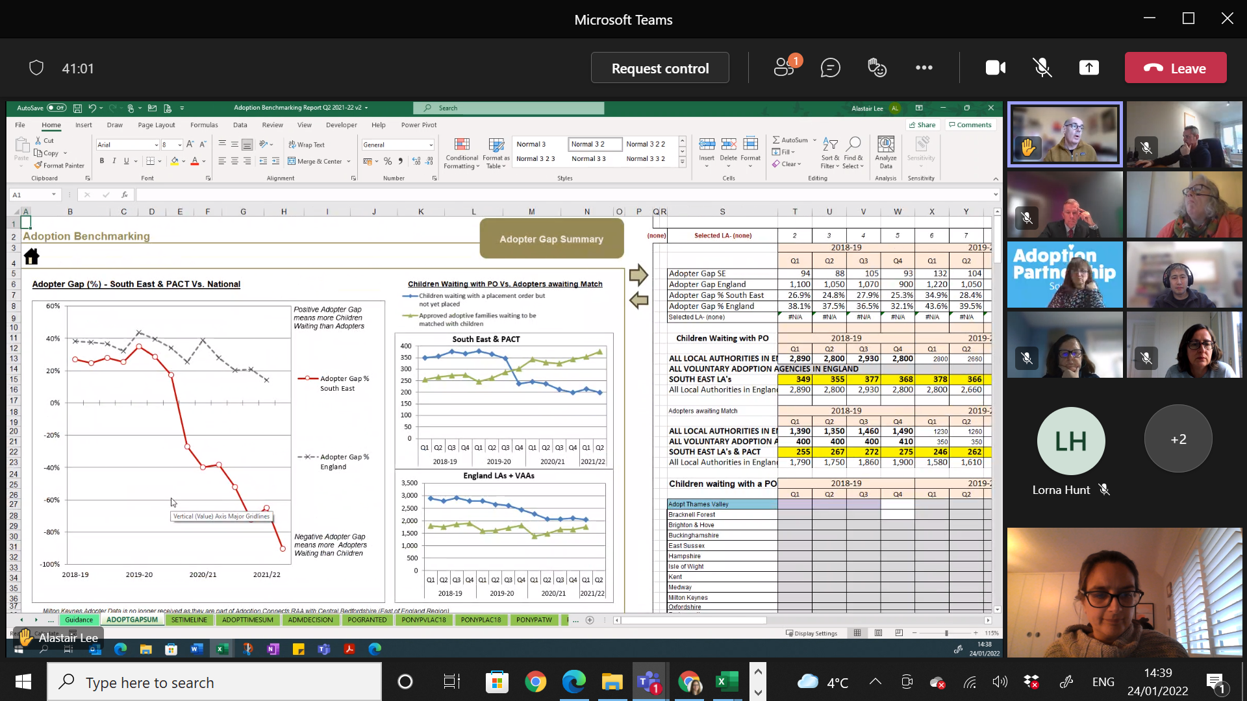
AL noted that there is variation between the LAs in the South East. SC noted that those coming through at stage 1 have been a lot more prepared than previously and so that enabled the speeding up of processes in Bucks.
KY said the question really should be - is the reason the gap is so big is that there was already a downward trend in children prior to the pandemic? KY asked the group, do you think the gap will disappear quickly with catching up and POs, do you think there are more children coming through, so the current recruitment levels are ok? Or are the figures going to stay low, which means a different approach to casting the net wide and assessing everyone that comes forward and instead we might need to be more targeted?
RR – in answer to your question in Adopt South we have seen shift in numbers and type – they are older and sibling groups and so although it looks like we have a lot waiting, 60 odd are pre-matched of the 90 odd so we don’t have a huge surplus. We have reduced our targets this year, and we have moved away from baby adopters to those that can take those older children and sibling groups. We’ve piloted a sibling worker, we have identified 28 sibling groups since April. We will let you know how that parenting worker goes for those siblings.
Action RR to feedback on impact of sibling worker in Adopt South
TR similar situation in ATV. I was expecting recovery to come sooner and much quicker. I don’t know why it is so delayed. The number of children coming through is slow. And supporting those adopters whilst they are waiting is resource intensive. We’ve had more adopters on hold for longer periods; but I don’t know when it will catch up and it does make it difficult to manage.

Item 4: Feedback re: National adoption strategy and 100 children and adopters waiting longest
The National Adoption Strategy was published last July - adopters recruited form a range of communities, adopters never deterred because of their background, prospective adopters are welcomed, barriers and bureaucracy is systematically removed, children supported to bond from outside, all adoptive children supported to achieve full potential. These are the basic pillars and ambitions of the Adoption Strategy and RAA leaders had some input into that.
The RAA leaders’ group on the basis of the strategy have a focus in three areas – recruitment, support and the child’s journey. The work programme is supported by DfE. Funding for recruitment (£1m), 500k for early permanence, to allow RAA leaders to work collaboratively. We’ve developed cross-sector work including VCS
The second area is around reducing waiting times– TR is responsible and includes the top 100 analysis. We decided it would be a good idea to look at this to see what we can learn from this at the end of 2021. To look at all the children on POs or waiting at 31 Dec to see what their status is.
KY and Corum identified the children and adopters at 30/9/21 to give us a better understanding of why they have waited the longest. The group appointed independent contractor Sue Westwood an ex RAA leader to coordinate this analysis. We started with the adopter data. All RAAs with top 100 have received a questionnaire and then a follow up interview with the link worker and team manager to explore that information in more detail, then an anonymised report is produced.
The second stage of this work with children’s data has been delayed slightly due to data sharing and should be starting soon with questionnaires due back by end March. Adopter data includes VAAs and RAAs.
Of the 100 longest waiting 11 children are in the South East and of these 6 are in ATV and three children (3, 4, and 6) in one family, 7 are white British, and remaining are Asian or mixed Asian.
MH thought those figures were quite good given we are a populous area.
Action: 100 longest waiting project to report back after surveys and interviews with LAs complete
The other work in the first workstream are pan-regional activity days across the region for all the children we haven’t been able to place successfully using the usual ways. There is a subgroup looking at foster carers who adopt – we identified that this often takes much longer than it should so this subgroup is identifying best practice and developing guidance for that area of work. This workstream also hosted a profiling event for children from BME backgrounds, run by West Yorkshire but profiling children nationally; and 1 and 3 March there were cross sector events to share best practice.
In the second workstream Ambitious for adoption is leading work around diversity. Work has included cultural humility training, and training for RAA leads last week, and improving panel diversity specifically from BAME groups.
Adoption Now is leading on a group undertaking mystery shopping and a deep dive in assessment process.
There is also a fourth group focused on raising the profile of adoption through national adoption week, national black adopters’ campaign.
Work on the Journey of the child is being led by Adoption at Heart and Nick Flavell, oversees early permanence group.
Adoption West is leading the group looking at support.
One Adoption, Adoption Counts and Adoption Heart are prototyping digital contact solution. 3 RAAs are completing a self-assessment and ATV selected to do this.
SS noted it is remarkable the amount of work that is taking place. The project management and delivery is considerable. It feels quite an exciting time and all the RAAs are involved in one of the strategic priorities.
MH said it is impressive work and good to see practitioners and their expertise being valued. LH noted there is strong working relationship between VAAs and RAAs with a real child focus.

Item 5: AOB and RAA feedback:
No AOB raised. No specific RAA feedback raised as covered in other items.

Action log: This action log was updated on March 31 2022
 | Action | Responsible | Date issued | Status
57 | TR/RR to feedback on top 100 analysis and actions (once surveys and interviews complete | RR/TR | Jan 2022 | Open
56 | RR to feedback on impact of sibling worker (in 6-12 months) | RR | Jan 2022 | Open
55 | MH to feedback to national board the SE position on contact: contact is a critical area and important for national strategic consideration, however there needs to be focus separately on SG and adoption; and the language needs to be changed away from contact | MH | Jan 2022 | Open
54 | MH to invite KK to July or October meeting | MH | Jan 2022 | Open
53 | Terms of reference were agreed | All | Jan 2022 | DECISION
52 | All to send any comments or amendments to terms of reference to Rebecca | All | Oct 2021 | Complete
51 | Book April 2022 meeting in person in Crawley | RE | Oct 2021 | Complete
50 | Item on January agenda re: 100 longest waiting children and adopters | RE/KY | Oct 2021 | Complete
49 | RE to work with board to draft bid to regional recovery fund for work on SG | SG | July 2021 | Complete
48 | Consider how to have a further in depth conversation about contact | MH | July 2021 | Complete
47 | LH to circulate details of all party parliamentary group (added to minutes and email) | LH/RE | April 2021 | Complete
46 | Medway to share SG training materials with group, RE to circulate | HS/RE | April 2021 | Complete
45 | LAs to contribute to SG benchmarking pilot | All | April 2021 | Complete
44 | Circulate template that Corum has developed to collect SG data in London | KY/RE | April 2021 | Complete
43 | Update and circulate ASGLB South East membership list | RE | April 2021 | Complete
42 | New vice chair to be confirmed at next meeting. Lorna Hunt confirmed as Vice chair | MH | Jan 2021 | Complete
41 | Items for future consideration (as a consequence of themes coming out of national board) added to forward plan | RE | Jan 2021 | complete
40 | AL to work with KY to look at breakdown of adopters and their experience through the process and where and if different groups drop out. | AL KY | Oct 2020 | Complete
39 | KY to work with AL to draw data together regarding SG. RE to follow up with KY and AL to timetable this in for a deeper discussion in 2021. | AL KY RE | Oct 2020 | Item in April 2021
38 | All to publicise offer of support for SGs and direct to Grandparents Plus, sign up needs to be before Nov | ALL | Oct 2020 | Complete
37 | RE to send out Adoption Guide/blueprint | RE | July 2020 | Complete
36 | Send to RE to send around to group training relating to Public Law recommendations, and information on kinship care week | LP | July 2020 | Complete
35 | provide feedback to KY on dashboard | All | July 2020 | Complete
34 | MH to escalate need to extend flexibilities, particularly relating to timing of DBS and medicals | MH | July 2020 | Complete
33 | To circulate monthly data from survey to RE so it can be shared with board members between the meetings | KY | July 2020 | Ongoing
32 | Future agenda item on race, adoption and Special guardianship | RE | July 2020 | Complete
31 | Standing item on agenda on feedback from RAA leaders | RE | July 2020 | Complete
30 | Share content of RAA leaders work relating to barriers to adoption which includes ethnicity | SS | July 2020 | Complete
29 | Share papers from Adopt Thames Valley: learning log, risk assessment and COVID 19 paper | TR | May 2020 | Complete
28 | Share feedback from ASGLB SE with South East DCS group (as per bullets below) | MH | May 2020 | Complete
27 | Share feedback from ASGLB SE with national board about emerging trends in the South East:  - some evidence of delay in adoption order hearings and care proceedings,  - a mixed picture on enquiries with some RAAs and LAs reporting the same levels  - little evidence that adoption introductions are being delayed  - more demand for mother and baby placements  - a particular impact on SGs of COVID-19 (particularly older and vulnerable carers)  - support for the new flexible ASF arrangements  - Little use of the new regulations as in the main RAAs and LAs have been able to manage | KY | May 2020 | Complete
26 | Investigate if percentage of ASF that goes to SG has increased from 12% (as a result of changes brought in from COVID-19). No updated data available as of Mid July. | KY | May 2020 | Complete
25 | Update terms of reference to include focus on both special guardianship and adoption and to update existing membership | RE | Jan 2020 | Complete
24 | All to respond to schools admission code consultation particularly on aspects relating to adoption | All | Jan 2020 | Complete
23 | All to send Corum details of any Asian families who may be interested in participating in research/sharing their story | All | Jan 2020 | Complete
22 | Discuss with DCSs different options for greater judiciary input into the board/regional approach, and RE to approach RM from CAFCASS to encourage him to attend the board | MH/RE | Jan 2020 | Complete
21 | MH to consider future item on adopter mindset around trans-racial placements– which is often about placing black and mixed race children in white families, but could be placing to BAME families. | MH | Jan 2020 | Complete
20 | Bucks to present Bucks’ approach to permanency at next ASGLB | NW | Jan 2020 | Complete
19 | NW and LP to meet to consider current post-order practice and how we can improve this regionally – both quick wins and longer term. | NW/LP | Jan 2020 | Complete
18 | KY to produce regional and national benchmarks in data returns | KY | Jan 2020 | Complete
17 | KY to continue to push to improve the quality and completion of family finding data | KY | Jan 2020 | Complete
16 | AL to consider what information could be produced for a future detailed item at the board on SG, SG breakdown and age. | AL | Jan 2020 | Complete
15 | All to provide info to LP on any information relevant to the digital hub for kinship carers. | All | Jan 2020 | Complete
14 | ALL to contact AL if they do not have access to the restricted data on the SESLIP website. | All | Jan 2020 | Complete
13 | AL to let the board know of anything they can do to help with lobbying DfE about case management system suppliers. | AL | Jan 2020 | Ongoing
14 | MH to consider whether future item or separate workshop on insights from evidence (i.e. turning data to insight) | MH | Jan 2020 | Complete
15 | To provide feedback to KY on the adoption blueprint before Christmas | All | Nov 2019 | Complete
12 | Bring back adoption blueprint as an agenda item at a future meeting | MH/RE | Nov 2019 | Complete
11 | Raise adoption blueprint at RAA leaders group on 22 Nov | SS | Nov 2019 | Complete
10 | Get feedback on centres of excellence, specifically how they have fed into adoption blueprint. Answers: Centres of excellence have funding and are in a better position to make use of those guides | KY | Nov 2019 | Complete
9 | Circulate invites and encourage attendance at permanency workshops facilitated by CORUM | All | Nov 2019 | Complete
8 | See if there is any insight as to the reasons underlying the small minority of less positive perceptions about virtual heads’ responsibilities around adoptees | KY | Nov 2019 | Complete
7 | Significant item on data benchmarking and requirements at next meeting | AL | Nov 2019 | Complete
6 | Ensure any work in the in-house fostering project at a sub-regional footprint uses those groupings flexibly | RE/PG | Nov 2019 | Complete
5 | AL to work with complex LAC project (Mark Evans and Rosemary Perry) and in-house fostering project (RE) to see whether it is possible to map where children are (both those adopted and in long term fostering and SGO arrangements). | AL | Nov 2019 | Complete
4 | Share presentation on mockingbird | TR | Nov 2019 | Complete
3 | Add item on ASF preparation | RE | Nov 2019 | Complete
2 | RE to contact the board’s PAs to get feedback as to whether to continue the download or to revert to previous emailing of documents | RE | Nov 2019 | Complete
1 | RE to work with MH to set future meeting dates | RE/MH | Nov 2019 | Complete

Proposed agendas
Future items:
- Contact and support to birth families; possible conference
- Support: Examples of best practice, benchmarking on use of ASF in the south east, can we look at subregional variation between RAAs? Which areas are securing most ASF support (for adoption/SG)/best practice
- Reasons for approved adopters waiting (is it bureaucratic/procedural, adopter choice)
- Analysis on disruption
Standing agenda items
- National board feedback
- RAA leaders’ feedback
- RAA round-up

