Minutes – South East regional fostering leads meeting

Chair: Deborah Glassbrook, Brighter Futures (Reading)
Meeting details: January 26 via MS Teams 10.30-12 noon
Attendees: James Ball (West Sussex); Adrian Sewell (East Sussex); Alastair Lee (data, East Sussex); Anisha Reed (Wokingham); Jackie Clark (Portsmouth); Jo Conlon (Slough); Liz Shields (Bucks); Theresa Gardiner (Medway); Gemma Pavey (Brighton and Hove); Jackie Giles (Oxfordshire); Seamus Jennings (Reading); Karl Davis (West Berks); Keith Langley (West Berks); Peter Hodges (Bracknell Forest); Mark Vening (Kent), Nicola Anthony (Kent), Martin Smith (Southampton), Natalie Bugeja (Windsor and Maidenhead), Yemi Ukwenu (Slough), Sarah Smith (Hampshire), ,
LAs not represented:, Isle of Wight, Milton Keynes, Surrey (All three Las also not at November meeting)
(supported by Rebecca Eligon, SESLIP)

Minutes from November
The minutes from last meeting were agreed. Discussion on actions from previous meeting included:
- Waiting until outcome of care review and any direction around regionalisation before deciding whether to progress regional fostering website. JG – Oxfordshire, Cathy Seiderer – Brighton and hove – possibly interested; LS (Bucks) thinks it is really important that something that promotes the south east is created but not sure about their capacity to contribute, JC would be interested (Portsmsouth).
Action: Review regional fostering website post-care review at Oct meeting
- AL had a lot of contact and useful feedback on the dashboard, and on the basis of positive reception from LAs following up to get additional funding to make it more user friendly

Priority setting for the coming year
A full discussion was had relating to areas of strength and opportunities for regional working and improvement relating to fostering.
Areas of strength related to:
- Stable and quality experienced staff
- Quality practice including trauma informed approaches
- Recruitment
- Foster carers
- Training

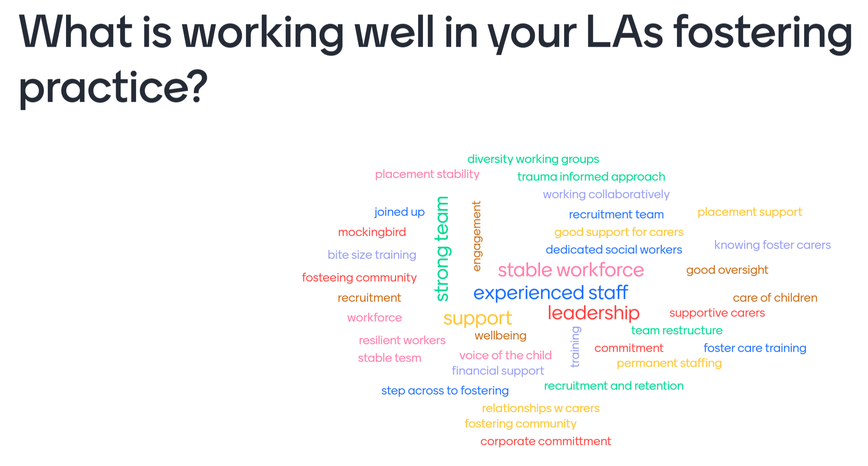
Areas of potential for regional working included:
- Sharing/jointly delivering training for staff on fostering
- Sharing/jointly delivering training for foster carers (JB, KL, SS)
- Supporting foster carer groups (and Las) to positively engage with unionisation trend (MS). LS noted a case in Bucks where foster carer was represented by union. LS to share learning and legal advice
Action; LS to share legal advice received in relation to case where unions involved, re: foster carers and employment rights.
- Sharing /jointly delivering training for panel members
- Sharing panel members across different Las, especially those from diverse backgrounds (SS, NB, PH, MS, KL, JC all interested in a project on this)
- Anti-racist approaches in fostering including recruiting and supporting black and Asian carers, and matching and ensuring the right support. MS noted they recently had an agency advisor deliver a very good course on this JB also noted good practice in this area (Vivien).
Action: JB and MS to share contact details.
- Hosting an annual regional carer conference
Action: Any further comments on Terms of reference to RE prior to next meeting and then these will be adopted
Action: DG noted that as chair she would want to be clear about the impact of group if it took forward any actions in the opportunity areas identified.

Opportunity areas that can be addressed regionally:

Mystery shopping: Reading.

Practice sharing: Reading
Reading/Brighter Futures shared practice around their approach to Kinship care, including their combined assessment approach. The presentation is embedded below.
Action: SJ to share template

Update DfE funding bids: Mockingbird and Inside out
RE provided an update on the Mockingbird and Inside out projects.
Inside Out has 11 participating authorities out of 19: Bracknell Forest, Buckinghamshire, Kent, Surrey, Windsor and Maidenhead, Milton Keynes, West Sussex, Wokingham, Reading, Brighton and Hove and Hampshire
And Mockingbird with 12 participating LAs (4 are existing trailblazer LAs (Slough, Surrey, Portsmouth and Oxfordshire) and 8 will be setting up their first Mockingbird constellations- Bucks, Southampton, West Berks, West Sussex, Wokingham, Reading/Brighter Futures, Bracknell Forest, Medway))
The full bids are available here: https://seslip.co.uk/download-file/1119
Update on Mockingbird:
- The Mockingbird DfE-funded project in the South East continues to progress satisfactorily in January 2022. Two project meetings have been held as a region and direct communication is ongoing between Fostering Network and the participating LAs.
- Of the 8 participating LAs, two have had initial meetings with Fostering Network and their coach, 6 LAs have meetings scheduled. However, two LAs have yet to confirm initial meetings. Three out of 8 LAs have submitted their initial Foundation Review (the readiness self assessment required as part of the process), the remaining LAs are expected to submit their Foundation Reviews by the end of the month and to then start to mobilise their first constellation.
- All LAs have received their contracts with Fostering Network in the first week of January and financial arrangements held by Wokingham are all in hand.
- Some LAs are expecting slightly slower starts than others due to restructures and other capacity issues but overall progress is satisfactory.
Update on Inside out
Rebecca Eligon was appointed as Inside out project manager in late November. The project manager met with nearly all the LAs in December to explore likely areas of interest which are summarized overleaf. One LA has been slightly delayed in engagement due to illness, one LA is not sure if they have capacity to participate.
Most LAs have provided finance lead details to enable the £13k per LA to be transferred.
Monthly learning meetings are now in the diary to May 2022.
The January project meeting scoped an evaluation for the project and this will be ready to be finalised by February.

Standing items
Issues for Chair to escalate to DCS colleagues and response to issues escalated last time:
- No issues identified
Ideas or projects for future consideration
- No ideas/projects identified other than those at item 2

AOB
None
Action log: This action log was updated on January 20 2022. Shaded lines, actions are complete
 | Action | Responsible | Date issued | Status
10 | RE to contact IoW Milton Keynes and Surrey who have had no reps at the last two meetings | RE | Jan 2022 | Open
9 | Terms of reference to be finalised and uploaded to SESLIP website. | RE | Jan 2022 | Closed
8 | JB and MS to share contact details for training delivered on anti-racist practice | JB and MS | Jan 2022 | Open
7 | Discuss at April meeting which of the areas for regional collaboration the group want so take forward first | All | Jan 2022 | Open
6 | LS to share legal advice received in relation to case where unions involved, re: foster carers and employment rights. | LS | Jan 2022 | Closed
5 | Rebecca to draft Terms of reference and regional priorities for consideration at next meeting | RE | Oct 2021 | Closed
4 | Any LAs interested in forming project team to develop regional recruitment website contact Rebecca. Revisit this action in October 2022 pending outcome of Care review and capacity of Las to take forward. | All | Oct 2021 | Open
3 | Reading to share practice and mystery shopping at January meeting | SJ | Oct 2021 | Closed
2 | All to contact Alistair Herbert to arrange support with using the fostering projection tool. Fostering projection tool to come back once further work complete. (Agenda | All | Oct 2021 | Open
1 | All to publicise regional online SG conference | All | Oct 2021 | Closed

