Minutes – South East regional early help network

Attendees: Chair Grainne Siggins (Bracknell Forest); Celia Lamden (East Sussex), Sarah Gee (Bracknell Forest); Elaine Morgan Bracknell Forest and regional lead for SE supporting families programme); Rachael Park-Davies (Windsor and Maidenhead/Achieving for Children); Stuart Collins (Kent); Kelli Scott (Wokingham), Lin Ferguson (Windsor and Maidenhead/Achieving for Children, soon to be Slough rep); Vicky Rhodes (Brighter Futures/Reading), Carly Bain (lead for family hubs for south East based in IOW), Fran Shaul (Portsmouth), Maria Godfrey (Oxfordshire), Melinda May (Milton Keynes), Kelly Pierce (Portsmouth), Alastair Lee, (Data Lead East Sussex), Becky Surman (Brighton and Hove).
Apols: Gareth Morgan (Bucks); Surrey (Lisa Burshill), West Sussex (Jenny Boyd), Southampton (Steph Murray), Medway (Kelly Cogger)
Meeting details: November 18 2021, 3.30-5pm
Item 1: SESLIP Early Help data review:
AL presented and informed the group that the regional group has been collecting EH data from 2017, produced quarterly. AL noted that it isn’t ideal and needs reviewing. The plan for reviewing is through the data accelerator project. There will be a dedicated resource to coordinate the work around data requirements for benchmarking.
SC reflected that the challenge of getting EH data is the size of what we call EH is so variable (for example he has a PRU as part of EH) but perhaps if we concentrate on a few core things, 3-5 themes, even if we deliver them differently, we could start to get some commonality.
MG concurred this is a real problem that she always hears from her data people. MG also noted that she recently wanted some data around benchmarking assessment times. There wasn’t a knowledge of this regional work happening.
AL said the plan is to run the development of the EH data project through the regional data group, plus this group.
BS asked if there is a connection between this work through the data accelerator project (i.e. what is an assessment) and the other group supporting families is looking at getting more benchmarking around (e.g. substance misuse).
Action: SG: requested a refresher data demo – for this group as part of the data accelerator project.
GS asked what is the timeline for the project – AL said they are recruiting to posts in the new year, then 18 months to deliver. The key thing we need to work on is definitions – for example assessment and contact are very different.
VR as we are all thinking about how to prove the impact. VR we led a successful bid where we are looking at replicating the troubled families/supporting families data hub and making sure we align those learnings are really important.
Action: AL to ensure learning from supporting families/troubled families influences the EH data accelerator
Item 2: Priorities discussion
RPD reflected that family hubs seem a strong theme for others, and they are also a strong theme for AfC. Helping LAs with the transition to family hubs being announced by government is interesting given where we are on the journey.
KP noted relationships are a key issues, for example Maternity services and early intervention practitioners getting alongside EH. There is a lot of work downstream, but trying to do more work upstream seems important and we are doing a report that can be shared in dec looking at the difference this sort of approach can have
Action KP to share report on the impact of bringing together health and EH
SC reflected that our language can vary significantly between different LAs–what we call things locally a family hub, youth settings, children’s setting; talking about case work, other people talk about whole family approaches. SC noted that some things with different labels might be the same thing. It might be useful to use this group to generate some understanding about the differences in language. For us casework is an end to end process that links with step up step down and social care.
VR agreed that we are all going to have different thresholds. EH sits under different directorates, in some places everything including EH might come through a single front door, in other places there is a tiered front door, with multi-agency response to EH cases. VR reflected that many people put the range of their programme as a thing they were proud of. In Brighter Future we run Domestic Abuse group work as part of EH, that wasn’t run in my last authority. Would be good to compare what we include in scope.
Action: RE to arrange to baseline the EH offer across the region. All LAs to respond. Agreed this should be item on next agenda.

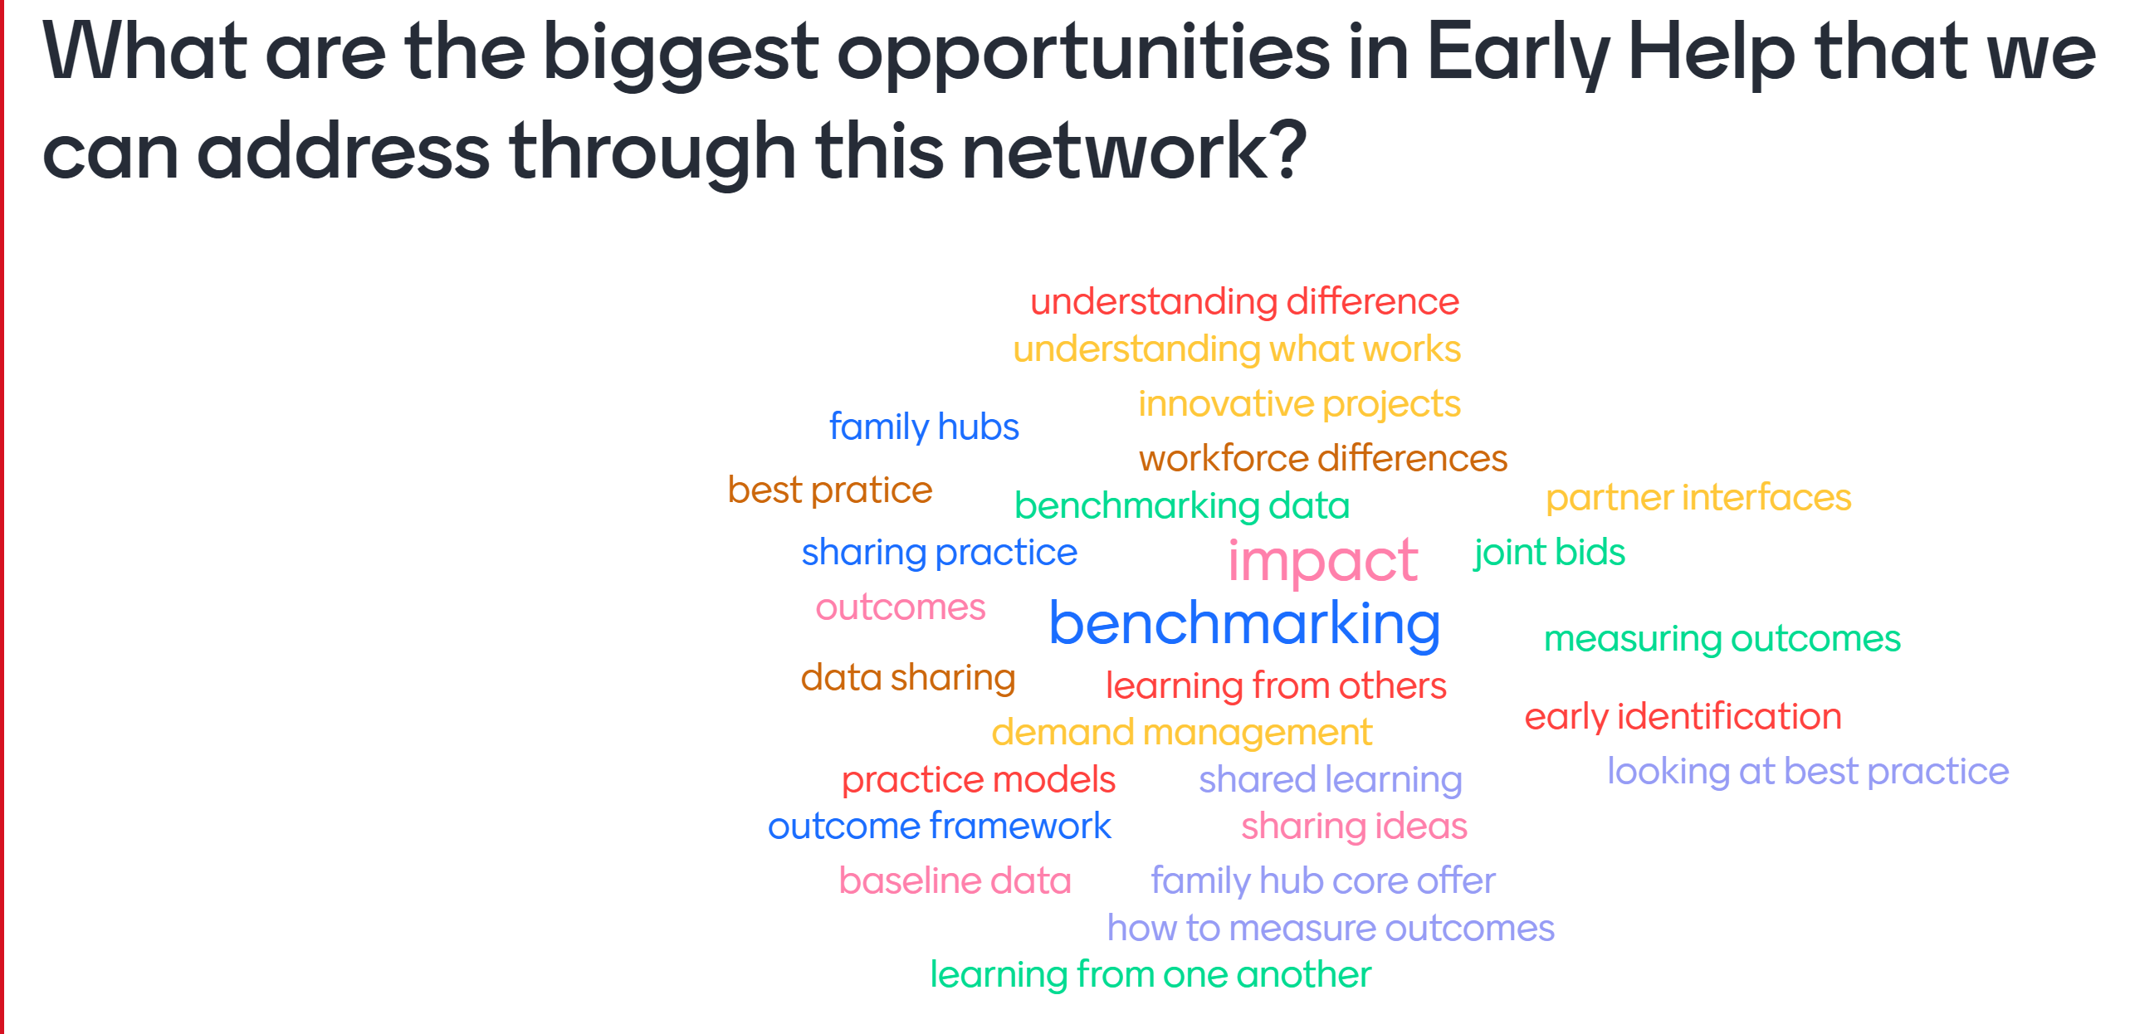
The group agree that key themes the group would like to focus on in the future relate to outcomes, benchmarking, sharing practice, and family hubs.
AL noted that the data accelerator is about process whereas DLUC one feels more like about outcomes. He noted that 7 regions and 2 London boroughs have signed up so we can identify best practice back with this group.
CB confirmed that she holds the regional coordinator role for family hubs and is looking at how LAs in the south east can adopt that model, funded by DfE. CB asked all to contact her to discuss their individual LAs.
Action: All to contact CB on regional family hub work.
Action: CB to present quarterly on progress of the regional family hub work to this network
SG asked if they already have a model can they be eligible, CB thought yes.
Item 3: Terms of reference
The terms of reference were agreed by the group. SC agreed to act as vice chair.
Action: RE to upload terms of reference to the SESLIP website
Item 4: Proposed standing items
The proposed standing items were agreed as:
- issues for Grainne to escalate to DCS colleagues
- ideas or projects for future consideration
- practice sharing (one LA to share something that they are proud of/best practice) at each meeting
- one themed discussion item

Action log: This action log was updated on March 4 2022. Shaded actions are closed or complete
 | Action | Responsible | Date issued | Status
8 | RE to amend terms of reference naming SC as vice chair and upload to SESLIP website. RE to diarise ToR for annual review | RE | Nov 2021 | Closed
7 | AL to present quarterly to this group on progress of data accelerator | AL | Nov 2021 | Ongoing
6 | CB to present quarterly to this group on progress of regional family hubs work | CB | Nov 2021 | Ongoing
5 | RE to send benchmarking out to all 19 LAs and to summarise findings as item on next agenda | RE | Nov 2021 | Closed
4 | All to contact CB on regional family hub offer of support | All | Nov 2021 | Closed
3 | KP to share report on the impact of bringing together health and EH with rebecca to circulate to the group | KP | Nov 2021 | Open
2 | AL to ensure learning from supporting families/troubled families influences the EH data accelerator | AL | Nov 2021 | Closed
1 | Refresher data demonstration for the early help network at a future 2022 meeting | AL | Nov 2021 | Open

