Action log and notes September 2022
South East regional early help network

Chair Grainne Siggins DCS Bracknell Forest
Meeting details: Monday September 12 12.30-2pm via MS Teams
Attendees: Sophie Butt (Hampshire), John Foster (data), Carly Bain (IoW), Gareth Morgan (Bucks), Maria Godfrey (Oxfordshire), Jenny Boyd (West Sussex), Julie Greer (Nat cen for family hubs, regional coordinator and SEND specialist), Gill Noble, Kelly Cogger (Medway), Stuart Collins (Kent), Vicky Rhodes (Reading), Laura Taylor for Steph Coomber (West Berks), Jo Templeman (Brighton and Hove), Jo Goldfinch
Item 1: The notes and actions from May were agreed.
Item 2: Family hubs
Julie and Carly presented an update on Family hubs in the South East. There is one LA in the first tranche of transformation and 6 LAs in transformation 2. There is funding to December 2022 to support regional working which Carly is coordinating alongside Julie. This covers: working alongside the National Centre for Family Hubs; implementing and enhancing Family Hubs, facilitating a Community of Practice, offering bespoke support and promoting regional work nationally. JG abd CB also shared dates for upcoming visits and workshops:
Next workshop  Theme: Youth  Tuesday 13th September  9.20-11.30 | Next visit  Isle of Wight  Friday 23rd September  10 – Midday

Action: All to contact Carly and Julie to be added to regional learning and with any examples of practice to be shared or to offer to host a visit; and to contact them to attend workshop or visit.
Item 3: Early Help Data standards project
JF presented progress in developing national EH data standards since last meeting. JF reflected on the basis of feedback from LAs, including many in the South East, that there had been some iteration to the likely child level data which would be mapped:

Potential measures (child level) | Revised set of measures (child level)
- Number of contacts  - Number of referrals in period  - Percentage of re-referrals in period  - Number of Early Help Assessments completed in period  - Step-ups to social care in period  - From open early help case  - From early help assessment  - Step-downs from social care in period  - From open social care case  - From social work assessment  - Number of open children at end of period | - Number of contacts in period (either % to EH if combined front door or all if discreet)  - Number of referrals or new EH episodes starting in period  - Re-referrals/repeat new episodes in quarter  - Number of Early Help Assessments completed in quarter  - Step-ups to social care in period  - Step-downs from social care in period  - Number of open children at period end

JF explained that the first set of benchmarking would be trialled likely using existing data sources and will continue to update the group quarterly on progress
Item 4: Kent
SC shared Kent’s approach to EH which was very well received in their recent Ofsted inspection. Ofsted said ‘“Early help practitioners base their work on the development of purposeful relationships and creative direct work to gain a sound understanding of the child’s voice, wishes and feelings within their family network.’ “Children and their families have access to a good range of early help support services.” “When progress is not evident or circumstances change, the interface between early help and statutory social work services is clear and work is appropriately transferred between services to ensure a prompt response.’’ “As intervention concludes, a structured framework of moving forward plans provides families with guidance and information to continue to help themselves”
SC reflected on the whole system EH response which included partners a well as a universal offer via family hubs and a bespoke Adolescent Service alongside more traditional EH intensive family support.
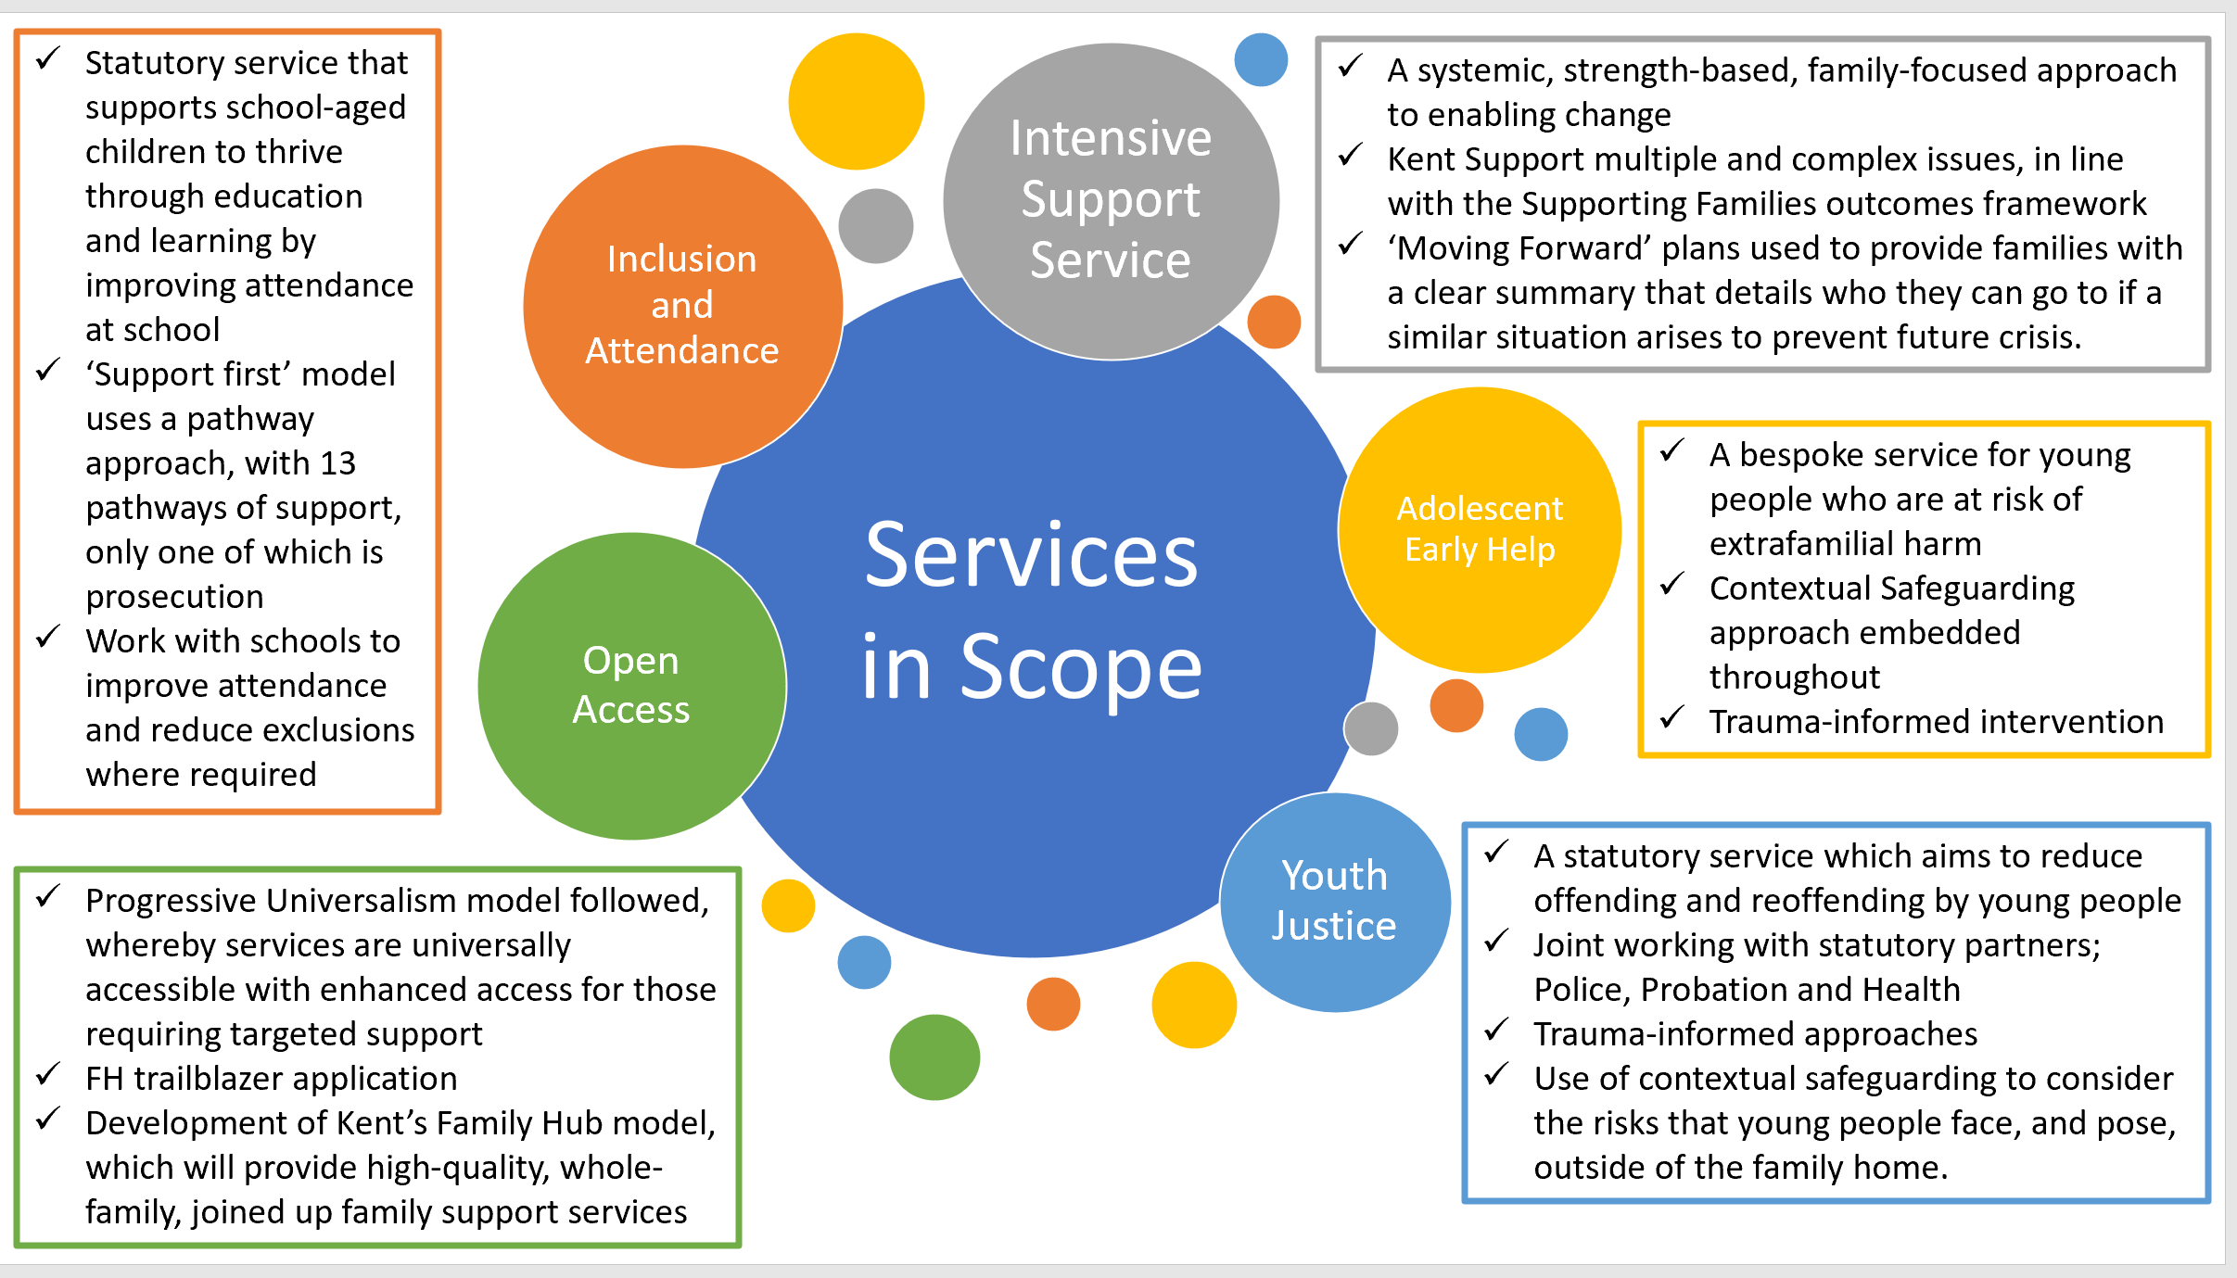
LT reflected that West Berks have faced similar challenges on a culture change journey to Kent which is about enabling and supporting partners to take an active role, and not just passing on to the LA.

Action log: This action log was updated on November 30 2022. Shaded actions are closed or complete
 | Action | Responsible | Date issued | Status
18 | All to let JF know if they want to be added to the EH data project mailing list | All | May 2022 | Complete
17 | All to contact JG or CB if you want to be on Family Hub mailing list, receive or volunteer to write blogs, receive updates from workshops, research etc. | All | May 2022 | Complete
16 | Future discussion on cost of living, Care review (EH and CIN being brought together), EH being required to support CAMHS cases due to long waiting lists | RE | May 2022 | Complete
15 | Jo Templeman, Carl Burton, Stuart (Kent), Vicky Rhodes, Simon Dear (IOW) to get together to discuss narrative (and if possible data/finance) to explain business case for early help | RE to convene | May 2022 | Complete
14 | All to provide feedback to CB and JG on how best to engage your LA around family hubs | All | Mar2022 | Complete
13 | All contact Georgie to arrange user research interviews, and John on ideas for project scope. | All | Mar 2022 | Complete
12 | RE to share raw responses from EH mapping with data to insight team | RE | Mar 2022 | Complete
11 | KS to feedback on multi-agency (referral?) process at future meeting (Wokingham) | KS | Mar 2022 | Did not happen
10 | Rachael (RPD)(achieving for children) to circulate EH strategy and partnership advisory board terms of reference | RPD | Mar 2022 | Complete
9 | RE to map caseloads and thresholds | RE | Mar 2022 | Ongoing
8 | RE to amend terms of reference naming SC as vice chair and upload to SESLIP website. RE to diarise ToR for annual review | RE | Nov 2021 | Closed
7 | AL to present quarterly to this group on progress of data accelerator | AL | Nov 2021 | Ongoing
6 | CB to present quarterly to this group on progress of regional family hubs work | CB | Nov 2021 | Ongoing
5 | RE to send benchmarking out to all 19 LAs and to summarise findings as item on next agenda | RE | Nov 2021 | Closed
4 | All to contact CB on regional family hub offer of support | All | Nov 2021 | Closed
3 | KP to share report on the impact of bringing together health and EH with Rebecca to circulate to the group | KP | Nov 2021 | Did not happen
2 | AL to ensure learning from supporting families/troubled families influences the EH data accelerator | AL | Nov 2021 | Closed
1 | Refresher data demonstration for the early help network at a future 2022 meeting | AL | Nov 2021 | Closed

