South East Region Adoption Leadership Board
AGENDA: July 11 2023, 9-10.30
Invitees: Dr Mac Heath (CHAIR Milton Keynes), Lorna Hunt VICE CHAIR (Chair Adopt Thames Valley and PACT), Kevin Yong (CORUM and National ASGLB Sponsor), Hilary Loades Bannon (Brighter Futures/Reading), Richard Morris (CAFCASS), Rachel Reynolds (Adopt South), East), Vanessa Glenn (ADM Adopt South), Amy Coombs (Adoption Partnership), Rebecca Eligon (SUPPORT Sector Led Improvement Programme)
Apols: Michael Wilson (Adopt South), Need a new Slough rep, Carol Atkins (Bucks), Teresa Rogers (Adopt Thames Valley),

Item 1: The actions were agreed from the last meeting.
Item 2: RM shared reflections from CAFCASS relating to courts and the work that was underway to build relationships. Members of the board reflected on the importance of relationships between RAAs, LAs and courts, and the culture/attitude which was impacting both decisions about adoption but also receptiveness to it as a means to achieving permanence.
Item 3: Other issues contributing to delays: MH opened a discussion about the other issues contributing to delays including delays to DBS checks, delays to health assessments, different policies about how quick to push adopters and recording/data differences about how various LAs and RAAs count when you start (i.e. the very first conversation, after first visit, only when assessment form is started. Colleagues reflected there are a number of complex and variable issues which are contributing to delays outside of the court process many of which were beyond the control of RAAs. RAA representatives noted that for some issues (DBS, medicals), it would be helpful for LAs to also lobby for greater timeliness but that ultimately they were beyond our control.
Item 3: KY presented the Q4 dashboard for 2022/23. It showed that overall adoption orders were marginally up (383 in 2020/21 then 379 in 2021/22 and 401 in 2022/23) in the region but placements and placement orders were down.
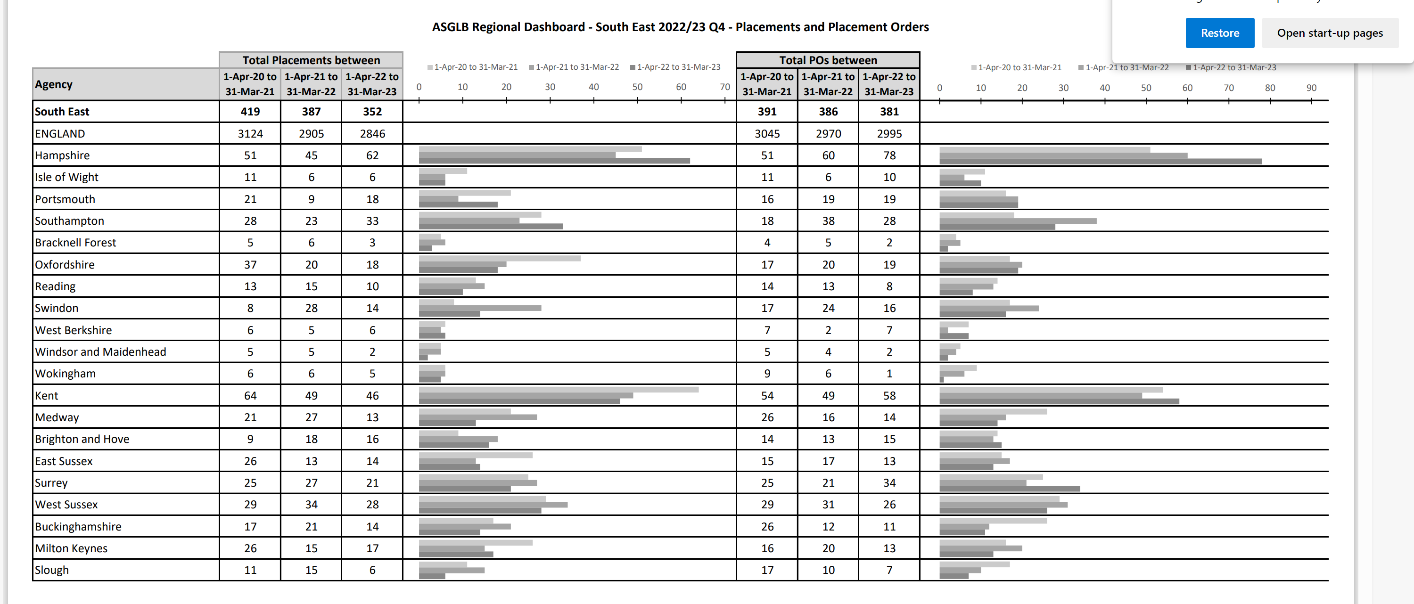

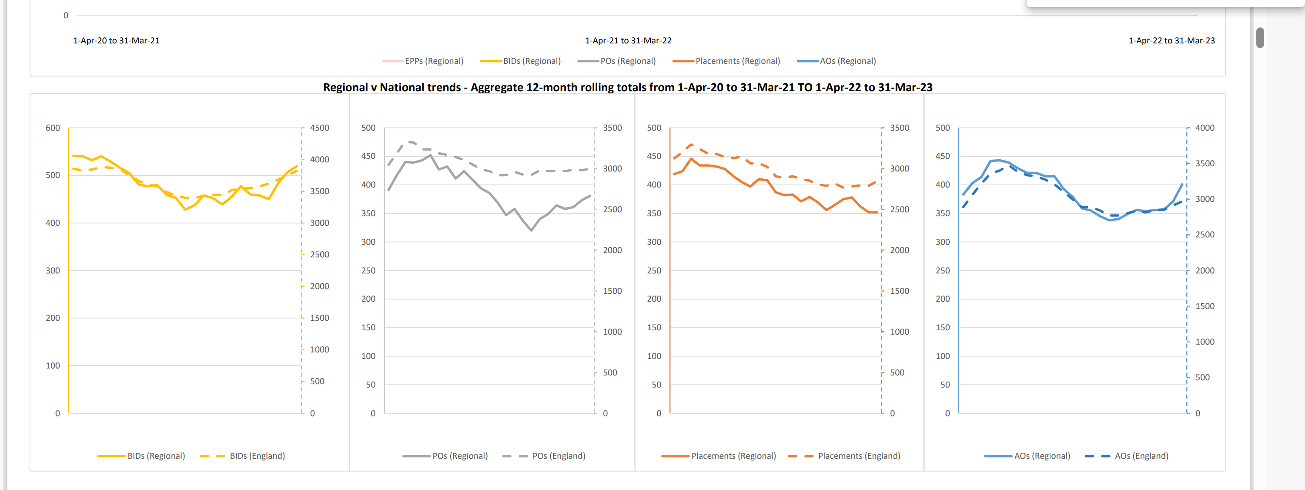
Timeliness is below target in the South East, mirroring national trends but there are some RAAs which are managing to hit timescales.
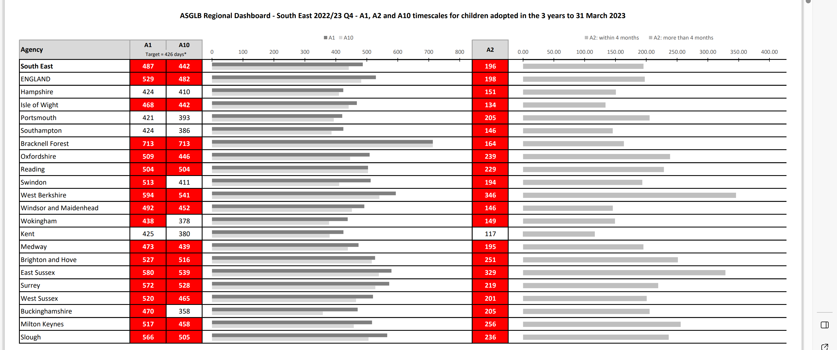
The trend of oversupply of adoptors is continuing, although the gap could be closed very quickly
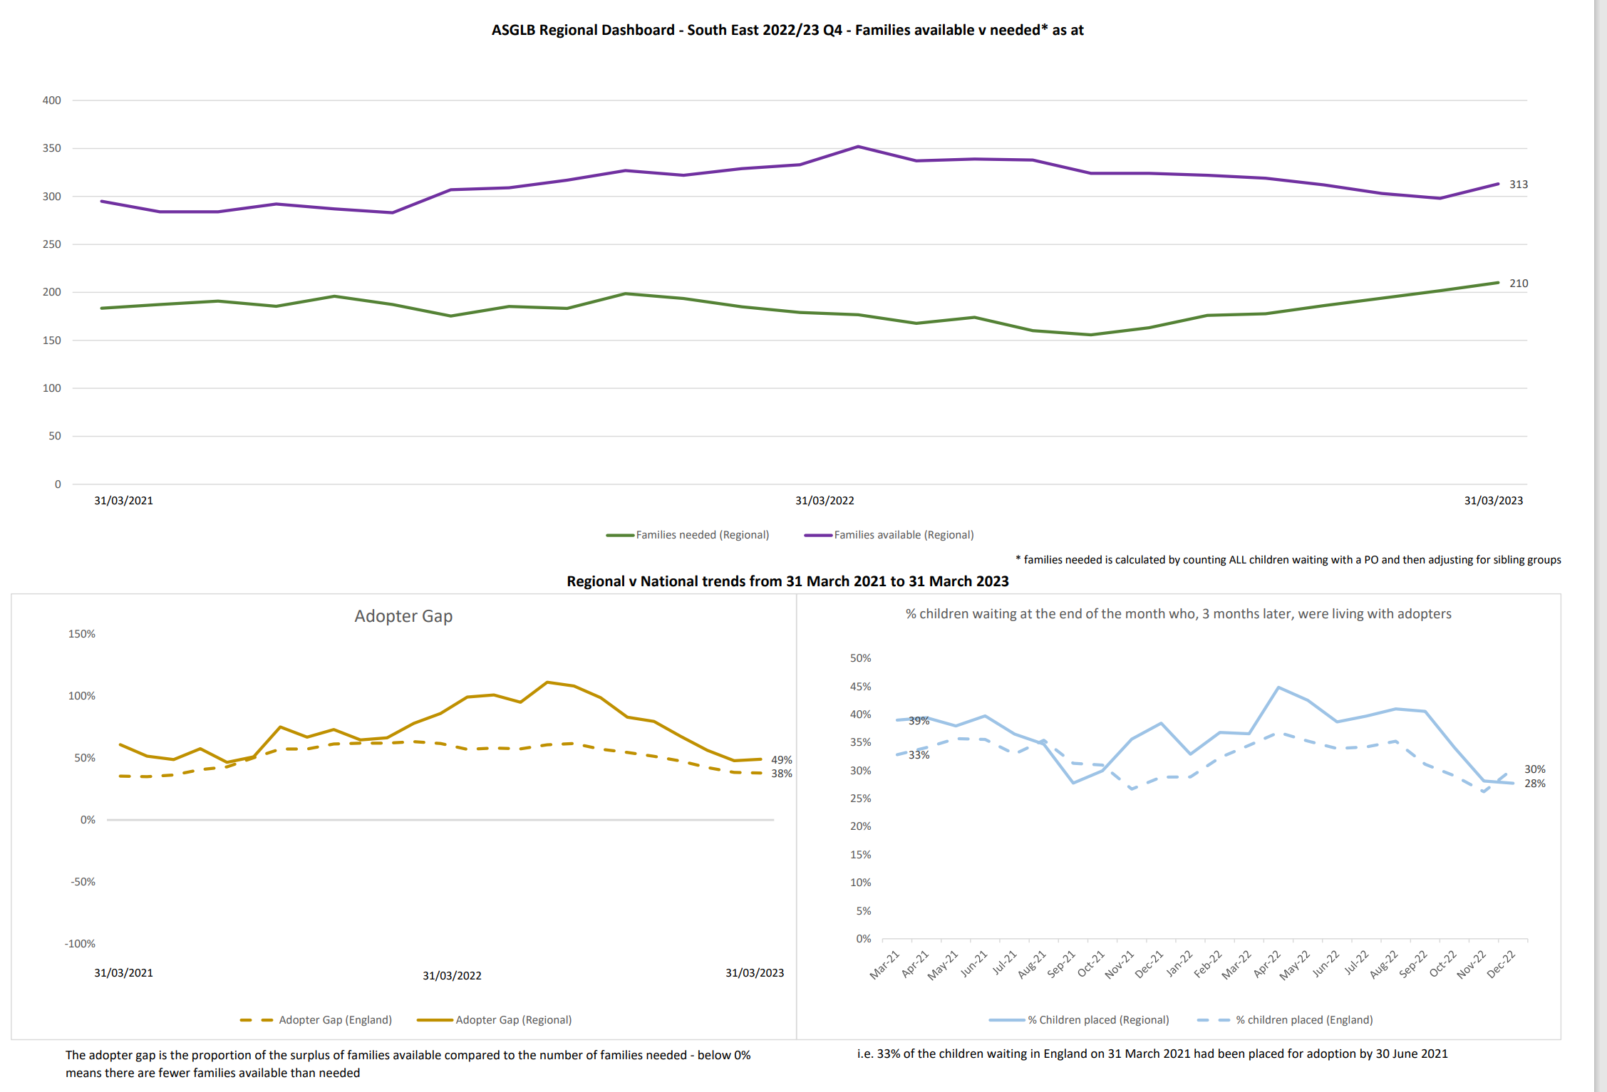
Item 4: RAA round up was completed by exception, with no RAAs identifying significant issues to be escalated.
Item 5: Members agreed to let Rebecca know of any future items that require discussion at the October board which will be the third board with a sole focus on adoption, and following the national disbanding of the national ASGLB.
Future items for discussion:
- Support to birth families (possible online conference area deep dive discussion)
- Analysis on disruption

Action log: This action log was updated on 13 October 2023
 | Action | Responsible | Date issued | Status
73
72 | Discussion on strengthening policy/practice regarding birth families. What is good practice, how might we share it? Idea of online conference? Discuss on Oct agenda | MH | Oct | Closed
71 | Discuss analysis on disruption (could KY produce something for Jan meeting?) | KY | Oct 2024 | Open
70 | Review whether new ALB is working after Jan2025 meeting (1 year) | MH and all | Oct 2024 | open
69 | MH to liaise with Sarah Johal around future direction of travel | MH | April 2023 | closed
68 | Item at next meeting on strategic and practical direction in South East Courts | RE | April 2023 | Closed
67 | Refresh the membership list in ToR (done) get a new rep for Slough (to do) | RE/MH | April 2023 | Partly complete
66 | future discussion on reasons underlying delay. Discussed at July meeting | RE | April 2023 | closed
65 | RE MH and LH to meet to review terms of reference, meeting dates to align with operational regional meeting and resolve membership and oversight of Kinship (meeting with Sarah Daly to agree) | RE MH LH | Jan 2023 | Closed
64 | RE to benchmark pay, training and support from different LAs re: kinship care | RE | Oct 2022 | Closed (move to kinship care group)
63 | RE to set up buddying scheme to pair up SG practitioners from different LAs to share practice | RE | Oct 2022 | Closed move to kinship care group)
62 | MH to flag issues re: SG oversight at DCS meeting | MH | Oct 2022 | Closed
61 | RE and LP to set up first lunch and learn for Kinship Care week, and schedule the remaining sessions | RE LP | Oct 2022 | Closed
60 | MH to write to DCS group to consider Bucks joining an existing RAA | MH | April 2022 | Closed
59 | MH to raise issue of contact/family time at national board as a task to consider nationally | MH | April 2022 | Closed
58 | MH to meet LP and RE to consider next steps for Special Guardianship | MH | April 2022 | Closed
57 | TR to feedback on top 100 analysis and actions (once surveys and interviews complete) | RR/TR | Jan 2022 | Open
56 | RR to feedback on impact of sibling worker (in 6-12 months) | RR | Jan 2022 | Open
55 | MH to feedback to national board the SE position on contact: contact is a critical area and important for national strategic consideration, however there needs to be focus separately on SG and adoption; and the language needs to be changed away from contact | MH | Jan 2022 | Ongoing
54 | MH to invite KK to July or October meeting | MH | Jan 2022 | Complete
53 | Terms of reference were agreed | All | Jan 2022 | DECISION
52 | All to send any comments or amendments to terms of reference to Rebecca | All | Oct 2021 | Complete
51 | Book April 2022 meeting in person in Crawley | RE | Oct 2021 | Complete
50 | Item on January agenda re: 100 longest waiting children and adopters | RE/KY | Oct 2021 | Complete
49 | RE to work with board to draft bid to regional recovery fund for work on SG | SG | July 2021 | Complete
48 | Consider how to have a further in depth conversation about contact | MH | July 2021 | Complete
47 | LH to circulate details of all party parliamentary group (added to minutes and email) | LH/RE | April 2021 | Complete
46 | Medway to share SG training materials with group, RE to circulate | HS/RE | April 2021 | Complete
45 | LAs to contribute to SG benchmarking pilot | All | April 2021 | Complete
44 | Circulate template that Corum has developed to collect SG data in London | KY/RE | April 2021 | Complete
43 | Update and circulate ASGLB South East membership list | RE | April 2021 | Complete
42 | New vice chair to be confirmed at next meeting. Lorna Hunt confirmed as Vice chair | MH | Jan 2021 | Complete
41 | Items for future consideration (as a consequence of themes coming out of national board) added to forward plan | RE | Jan 2021 | complete
40 | AL to work with KY to look at breakdown of adopters and their experience through the process and where and if different groups drop out. | AL KY | Oct 2020 | Complete
39 | KY to work with AL to draw data together regarding SG. RE to follow up with KY and AL to timetable this in for a deeper discussion in 2021. | AL KY RE | Oct 2020 | Item in April 2021
38 | All to publicise offer of support for SGs and direct to Grandparents Plus, sign up needs to be before Nov | ALL | Oct 2020 | Complete
37 | RE to send out Adoption Guide/blueprint | RE | July 2020 | Complete
36 | Send to RE to send around to group training relating to Public Law recommendations, and information on kinship care week | LP | July 2020 | Complete
35 | provide feedback to KY on dashboard | All | July 2020 | Complete
34 | MH to escalate need to extend flexibilities, particularly relating to timing of DBS and medicals | MH | July 2020 | Complete
33 | To circulate monthly data from survey to RE so it can be shared with board members between the meetings | KY | July 2020 | Ongoing
32 | Future agenda item on race, adoption and Special guardianship | RE | July 2020 | Complete
31 | Standing item on agenda on feedback from RAA leaders | RE | July 2020 | Complete
30 | Share content of RAA leaders work relating to barriers to adoption which includes ethnicity | SS | July 2020 | Complete
29 | Share papers from Adopt Thames Valley: learning log, risk assessment and COVID 19 paper | TR | May 2020 | Complete
28 | Share feedback from ASGLB SE with South East DCS group (as per bullets below) | MH | May 2020 | Complete
27 | Share feedback from ASGLB SE with national board about emerging trends in the South East:  - some evidence of delay in adoption order hearings and care proceedings,  - a mixed picture on enquiries with some RAAs and LAs reporting the same levels  - little evidence that adoption introductions are being delayed  - more demand for mother and baby placements  - a particular impact on SGs of COVID-19 (particularly older and vulnerable carers)  - support for the new flexible ASF arrangements  - Little use of the new regulations as in the main RAAs and LAs have been able to manage | KY | May 2020 | Complete
26 | Investigate if percentage of ASF that goes to SG has increased from 12% (as a result of changes brought in from COVID-19). No updated data available as of Mid July. | KY | May 2020 | Complete
25 | Update terms of reference to include focus on both special guardianship and adoption and to update existing membership | RE | Jan 2020 | Complete
24 | All to respond to schools admission code consultation particularly on aspects relating to adoption | All | Jan 2020 | Complete
23 | All to send Corum details of any Asian families who may be interested in participating in research/sharing their story | All | Jan 2020 | Complete
22 | Discuss with DCSs different options for greater judiciary input into the board/regional approach, and RE to approach RM from CAFCASS to encourage him to attend the board | MH/RE | Jan 2020 | Complete
21 | MH to consider future item on adopter mindset around trans-racial placements– which is often about placing black and mixed race children in white families, but could be placing to BAME families. | MH | Jan 2020 | Complete
20 | Bucks to present Bucks’ approach to permanency at next ASGLB | NW | Jan 2020 | Complete
19 | NW and LP to meet to consider current post-order practice and how we can improve this regionally – both quick wins and longer term. | NW/LP | Jan 2020 | Complete
18 | KY to produce regional and national benchmarks in data returns | KY | Jan 2020 | Complete
17 | KY to continue to push to improve the quality and completion of family finding data | KY | Jan 2020 | Complete
16 | AL to consider what information could be produced for a future detailed item at the board on SG, SG breakdown and age. | AL | Jan 2020 | Complete
15 | All to provide info to LP on any information relevant to the digital hub for kinship carers. | All | Jan 2020 | Complete
14 | ALL to contact AL if they do not have access to the restricted data on the SESLIP website. | All | Jan 2020 | Complete
13 | AL to let the board know of anything they can do to help with lobbying DfE about case management system suppliers. | AL | Jan 2020 | Ongoing
14 | MH to consider whether future item or separate workshop on insights from evidence (i.e. turning data to insight) | MH | Jan 2020 | Complete
15 | To provide feedback to KY on the adoption blueprint before Christmas | All | Nov 2019 | Complete
12 | Bring back adoption blueprint as an agenda item at a future meeting | MH/RE | Nov 2019 | Complete
11 | Raise adoption blueprint at RAA leaders group on 22 Nov | SS | Nov 2019 | Complete
10 | Get feedback on centres of excellence, specifically how they have fed into adoption blueprint. Answers: Centres of excellence have funding and are in a better position to make use of those guides | KY | Nov 2019 | Complete
9 | Circulate invites and encourage attendance at permanency workshops facilitated by CORUM | All | Nov 2019 | Complete
8 | See if there is any insight as to the reasons underlying the small minority of less positive perceptions about virtual heads’ responsibilities around adoptees | KY | Nov 2019 | Complete
7 | Significant item on data benchmarking and requirements at next meeting | AL | Nov 2019 | Complete
6 | Ensure any work in the in-house fostering project at a sub-regional footprint uses those groupings flexibly | RE/PG | Nov 2019 | Complete
5 | AL to work with complex LAC project (Mark Evans and Rosemary Perry) and in-house fostering project (RE) to see whether it is possible to map where children are (both those adopted and in long term fostering and SGO arrangements). | AL | Nov 2019 | Complete
4 | Share presentation on mockingbird | TR | Nov 2019 | Complete
3 | Add item on ASF preparation | RE | Nov 2019 | Complete
2 | RE to contact the board’s PAs to get feedback as to whether to continue the download or to revert to previous emailing of documents | RE | Nov 2019 | Complete
1 | RE to work with MH to set future meeting dates | RE/MH | Nov 2019 | Complete

