Fostering regional group meeting notes and action log July 2023
Chair: Sarah Daly DCS Portsmouth
Meeting details: Thursday July 13 10-11.30 via MS Teams
Item 1 and 2: Introductions, Minutes and action log from the July meeting were agreed
Item 3: Mystery shopping. Foster carers attended to share the findings from the mystery shopping which they conducted over the summer. Over Summer 2023 6 foster caring families (including two couples) reviewed and provided feedback on 19 local authority and 7 IFAs. In total the foster carers look at 26 different websites.
The foster carers had a range of backgrounds (mix of gender, single/couples, age and ethnicity) and levels of experience (from 20+ years to a new foster carer who has just been assessed). They were from the following local authorities: Brighton and Hove, West Berks, Portsmouth, Hampshire.
The foster carers used a template to ensure a consistency of approach which was developed with fostering managers who are part of the regional fostering group, and which was further iterated and developed to take on board ideas from the carers.
- Website structure and how high up the website is when searched for on google
- Ease of locating information about fees, support, respite/holidays, assessment process, information events, training, transferring, Ofsted rating, FAQs, different types of fostering
- Ease of contacting the LA/IFA including amount of information needed, whether there was direct email/Phone number
- Diversity and inclusion
- Strengths and areas for development
The best websites were easy to navigate, had compelling case studies, inclusive imagery and content, and explained why you should foster for them. The content was up-to-date with information events planned in the future (not the past). All of the best websites had good search function, FAQs and used simple language. The strongest websites felt like they painted a realistic (and not overly optimistic) picture of what it means to be a carer and you felt you could believe them.
Others:
- did not make pay and support clear
- had poor navigation, with foster carers feeling they had to go around in loops, or couldn’t get back to the home page
- hid the enquiry button/email, did not respond to enquiries or had too much personal information requested up front
The 5 LAs and 2 IFAs which scored most highly overall were (in no particular order):
- Surrey Fostering - Surrey County Council (surreycc.gov.uk)
- Kent Home - Kent Fostering
- Reading/Brighter Futures - Reading Fostering
- Portsmouth Home - Foster Portsmouth
- Brighton and Hove Brighton & Hove fostering team (fosteringinbrightonandhove.org.uk)
- ISP Fostering Children PPC (ispfostering.org.uk)
- Blue Sky Blue Sky Fostering
The foster carers developed a blueprint of best practice that identified the features of the most strongly performing websites.
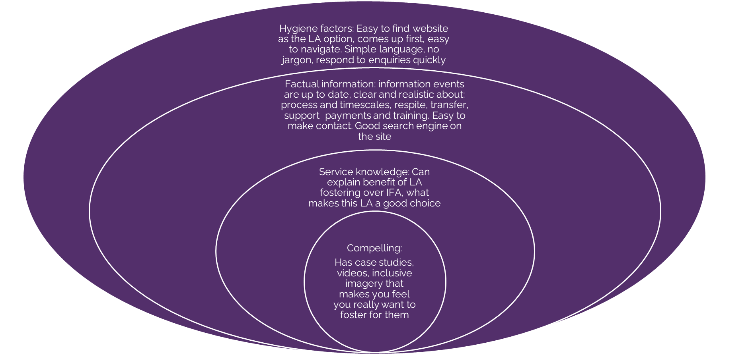
SD and colleagues thanked the foster carers for their work on this and noted it was timely given the development of a new regional fostering recruitment website.
Item 4 Quick Fire questions:
- UASC welcome pack/book: Cathy from Brighton and Hove is asking for whichever LA said at a previous meeting they have a good pack/book if they could please share it to the group cathy.seiderer@brighton-hove.gov.uk
Answer/Action : RE to circulate UASC documentation from Martin Tuck to Cathy
- LA as registered provider of supported accommodation: We in Oxfordshire have 4 supported living provisions that we deliver all with slightly different specs. Can I ask if any of you are registering as an LA as providers of supported accommodation and if so whether you are registering under one umbrella or registering provisions individually . Thee seems a lot of debate out there as to what is best. Sarah sarah.duerden@oxfordshire.gov.uk
Answer: Colleagues noted that this is an interesting approach but not one they are pursuing.
Three questions from Catherine Tilzey in West Sussex catherine.tilzey@westsussex.gov.uk
- Sessional workers that support foster carers: We are considering how we could develop and use sessional workers in Fostering. Sometimes when we speak to people in enquiries, they are not ready to foster but may be ready to support fostering households in a sessional worker capacity. Are any local authorities doing this and if they are how do they approve/appoint sessional workers via the fostering recruitment enquiry route? Have local authorities got a process in place to recruit sessional workers, that have an interest in fostering and perhaps becoming foster carers at a later date? We think this could be a really positive way of growing and developing our fostering family and supporting our existing fostering households. It would seem intrusive and costly in time and finance to complete a fostering assessment in these situations. What are other people doing?
Answer: All colleagues agreed there would be much benefit in having a more structured offer for those not yet ready to foster. Suggest this is taken forward as part of phase 2 of the recruitment hub.
- Emergency foster care: We are looking at developing an emergency foster carer package as this is currently an area of need for us and we do not have the foster carers we need, available to support us in emergency situations for our children. Are there any local authorities that have got an established emergency foster carer package up and running for children and young people that need foster carer in emergency and very immediate situations. Are there any local authorities that would be able to provide any information about what this looks like and how successful it has been?
Answer: some LAs had respite carers, which they sometimes use for emergency care. Many noted that they couldn’t afford to have carers who were solely ‘emergency’, although agreed that for some who would otherwise retire it may be a good way to keep them on the books.
- Initial call and visit templates: And finally we are doing some work at the front door at streamlining our initial call and initial visit template, with a keen focus on Equality, diversity and inclusion. Are there any local authorities that would be willing to share their initial call and Initial visit templates to support us in thinking about our development in this area.
Answer: LAs to share templates with West Sussex and to consider how this might be taken forward as part of the hub.

Two questions from Sarah Smith in Hampshire:
- Panel member payment: I have been asked to review the renumeration to fostering panel members and wanted to ask my regional colleagues what they are currently paying.
Action: LAs to share foster panel member payscales with SS to collate
- Thrive in fostering: I have been asked to consider The Thrive Approach to social and emotional wellbeing | The Thrive Approach as an approach in the fostering and residential sector. I am ware of some great success with this programme in primary school but wondered if any of you have used this in fostering and residential and have any feedback you can offer?
Answer: no LAs had experience of Thrive in fostering.

Item 5 Fostering recruitment and retention project: RE updated the group on progress with the recruitment and retention project that the project manager and programme manager were in place, that the DCS group and foster carer reference group were established and many of the design sessions for the new hub had been diarised for November. The plan is to complete design work before Christmas so that build work can happen over the Spring with a planned launch date in April.

Action log: This action log was updated 22 Feb 2024. Shaded lines, actions are complete
 | Action | Responsible | Date issued | Status
37 | Idea of 1. foster care assistants/offer and assessment approach for those not yet ready to be foster carers and 2. Development of guide for first calls/conversations to be developed through hub | RE/AMA | Oct 2023 | Open
36 | LAs to share foster panel member payscales with SS to collate | SS | Oct 2023 | Open
35 | Action : RE to circulate UASC documentation from Martin Tuck to Cathy | RE | Oct 2023 | complete
34 | If any further LAs wish to submit information (caseload and number of carers recruited) please send to Rebecca. Will need number of carers recruited in 2022/23 for all LAs in fostering hub. | RE | July 2023 | Closed
33 | Brighton and Hove said their website is being updated over the summer and please ensure that mystery shopping does not happen until after the relaunch | RE | July 2023 | complete
32 | Future discussion – increasing quality of ISW assessments (October 2023) | RE | April 2023 | Complete
31 | RE to contact Louise toward the end of the year to see if any feedback from Home Office re: DBS classification. | RE | April 2023 | Complete
30 | RE to benchmark caseloads for supervising social worker and numbers of carers/placements recruited in the last year. | RE | April 2023 | Complete
29 | RE to circulate previous research with foster carers. | RE | April 2023 | Complete
28 | RE to set up website mystery shopping run by foster carers for October 2023 | RE | Jan 2023 | Complete
27 | JD to distribute contact details for trainer and amended foster care agreement. SS worker in Hampshire to connect with Brighton and Hove worker. – Anti-racist practice | JD | Jan 2023 | Complete
26 | JG to share the training provider: anti-racist practice | JG | Jan 2023 | Complete
25 | CS, JG and MG to share how to contact Ukraine hosts to see about receptiveness to foster. RE Add to agenda for future meeting. | MG, JG, CS | Oct 2022 | Complete
24 | RE to circulate previous research on USPs of LA fostering | RE | Oct 2022 | complete
23 | MT to provide welcome book/pack examples for UASC to RE to circulate to the group | MT | Oct 2022 | complete
22 | SD to check if Ofsted ok with return to virtual visits given increasing covid risks? | SD | Oct 2022 | Complete
21 | LS to circulate CCTV policy from Bucks | LS | July 2022 | Complete
20 | MV to circulate Kent slides | MV | July 2022 | Complete
19 | KL (West Berks- circulated) and JC (Portsmouth) offered to share their recruitment crib sheet. | KL and JC | July 2022 | Complete
18 | Bucks to do mystery shop for Jan (poss testing online/email contact), review mystery shopping in Jan | LS | July 2022 | Complete
17 | Can we monitor and discuss Ukraine again next meeting | DG | April 2022 | Closed
16 | Chair to escalate issues re: Inside Out | DG | April 2022 | Closed
15 | West Sussex to share retention officer JD | JB | April 2022 | closed
14 | Kent to share practice next time | MV | April 2022 | Closed
13 | Map management structures and roles, map respite/sleepover offer through survey | RE | April 2022 | Closed
12 | Draft model of excellence for next time based on learning over the last several waves | RE | April 2022 | Closed
11 | Next waves of mystery shopping are Bracknell Forest (July), then Milton Keynes (October) then Bucks (Jan) | RE | April 2022 | Closed
10 | RE to contact IoW Milton Keynes and Surrey who have had no reps at the last two meetings | RE | Jan 2022 | Closed
9 | Terms of reference to be finalised and uploaded to SESLIP website. | RE | Jan 2022 | Closed
8 | JB and MS to share contact details for training delivered on anti-racist practice | JB and MS | Jan 2022 | Closed
7 | Discuss at April meeting which of the areas for regional collaboration the group want so take forward first (discuss with new chair) | All | Jan 2022 | Closed
6 | LS to share legal advice received in relation to case where unions involved, re: foster carers and employment rights. | LS | Jan 2022 | Closed
5 | Rebecca to draft Terms of reference and regional priorities for consideration at next meeting | RE | Oct 2021 | Closed
4 | Any LAs interested in forming project team to develop regional recruitment website contact Rebecca. Revisit this action in 2023 pending outcome of Care review and capacity of Las to take forward. Being taken forward as part of DfE regional proposal | All | Oct 2021 | closed
3 | Reading to share practice and mystery shopping at January meeting | SJ | Oct 2021 | Closed
2 | All to contact Alistair Herbert to arrange support with using the fostering projection tool. Fostering projection tool to come back once further work complete. (Agenda for Jan 2023) | All | Oct 2021 | Closed
1 | All to publicise regional online SG conference | All | Oct 2021 | Closed

