Notes and action log
South East regional Early Help network

Attendees: Chair Grainne Siggins DCS Bracknell Forest
Meeting details: June 8 2023, 10-11.30 via MS teams
Attendees: Grainne Siggins, DCS chair, Amanda Hales-Owen (NHS), Clare Hayes (West Sussex),), Gareth Morgan, (Bucks), Helen Kilby (Oxfordshire), Rachael Park-Davis (RB Windsor and Maidenhead, Achieving for Children), Sarah Batchelor (Bracknell Forest), Sophie Butt (Hampshire), Celia Lamden (East Sussex), Jo Templeman (Brighton and Hove), Julie Greer (Anna Freud and regional lead on family hubs), Kelli Scott (Wokingham), Delia Mann (Oxfordshire), Rebecca Eligon, (SESLIP Support)

Item 1: discussion of early help benchmarking
RE introduced the benchmarking and paused throughout for discussion. The first item discussed was total number of families open to early help. JT noted that they had just restructured, and figures not typical in Brighton and Hove, they lower. RPD reflected that in AfC the numbers are the number of children they are working with on 1-2-1 basis, so doesn’t include things like school assemblies or an open access parenting courses. CL and GM agreed that the figures are only those open to level 3. CH reflected that they had increased level 2 by 72% as a result of school work in West Sussex.
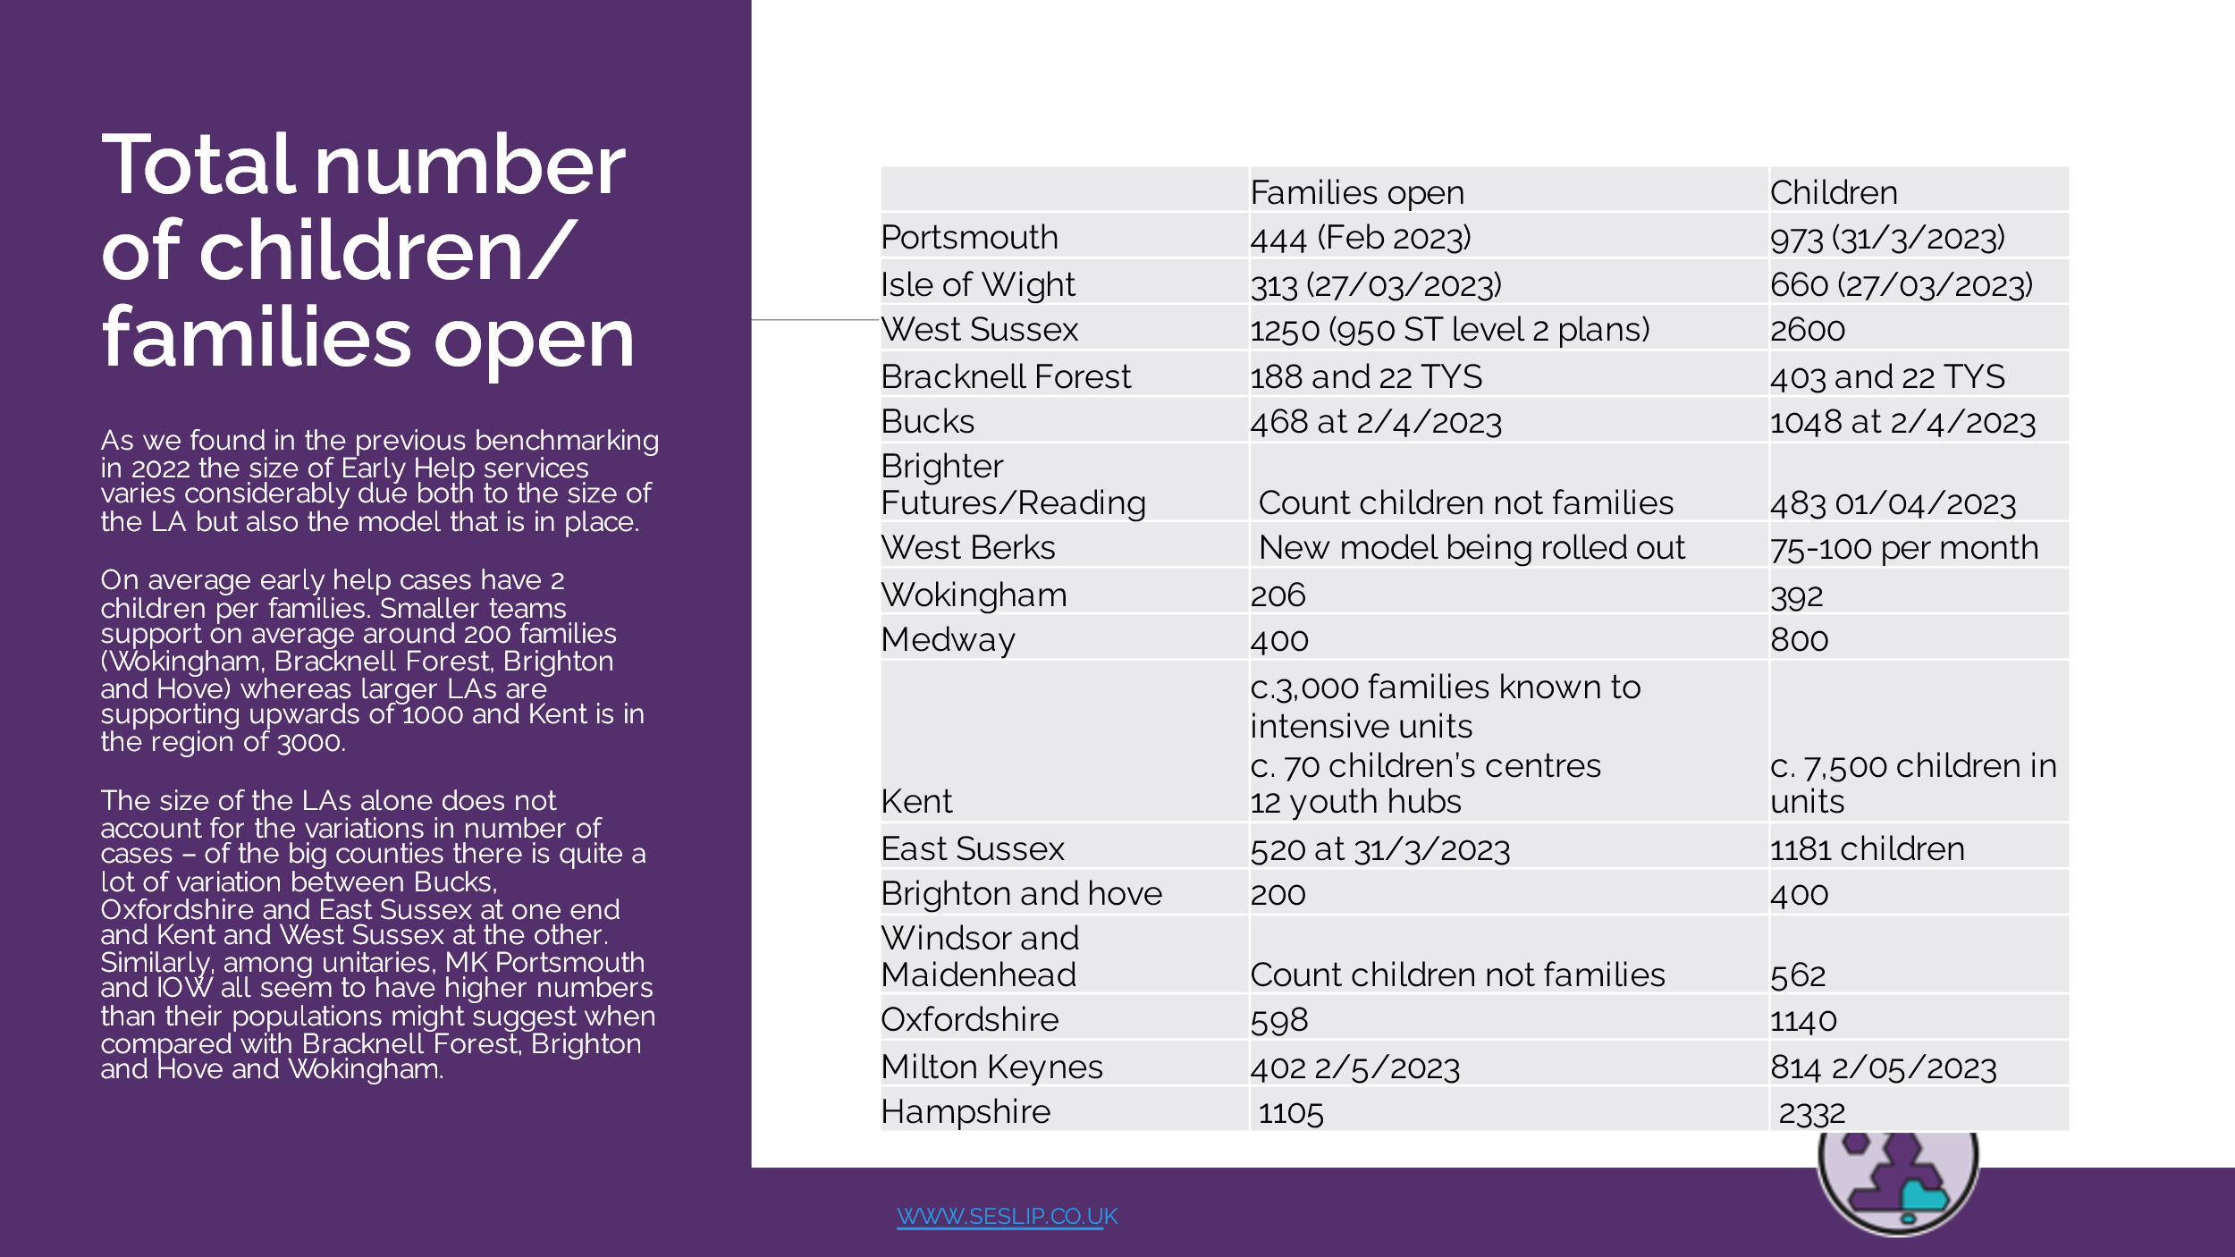
The group then moved on to discuss caseloads. CH said it felt relatively reassuring to see similar caseloads across the region as staff are pushing back and saying their caseloads are too high. CL noted it was important to understand that sometimes caseloads are higher in more rural areas to take travel into account. GM said in bucks they are more focused on a minimum amount of contact time – once a week, once a fortnight, another nuance. I agree it is reassuring we sit in the middle, and it feels ok. We have regular and intensive model that have different levels of intervention which then impacts on case numbers. JT asked if CL could circulate document they had in E Sussex which split % time on face to face visits, travel admin.
Action: CL to circulate document on percentage of time spent on various tasks
CL said she would circulate the document although they have moved to a different model now which is about managing a wait list, with a screening process and we are looking at the process from start to finish.
AHO noted that one of the things they’ve been looking at is caseloads in Children’s social care. They are being asked why in the family safeguarding model they have lower caseloads than family support workers – AHO asked if others are getting that same pushback.
DM said in Oxfordshire there has been a little bit of pushback from family help colleagues – they have a higher caseload – we’ve managed that by talking about complexity and the different types of visiting. Our data – is up to 18-25 children.
CL noted that in E Sussex social workers have caseloads of 20, but they are less likely to meet with families more than once a week. We’ve looked at our caseloads and said EH can’t be so low, but equally trying to bring down to toward social work caseload levels.
JT said in Brighton and Hove there have been lots of conversation. They have a pod model where the SW supports child through their journey. We are taking money out of pods to put into early help. We have now built social workers into early help teams.
SB said in Hampshire they have 17. I was wondering talk about family help and early help. Are you others talking about family help re: what is coming in. CL responded they are the targeted children in social care.
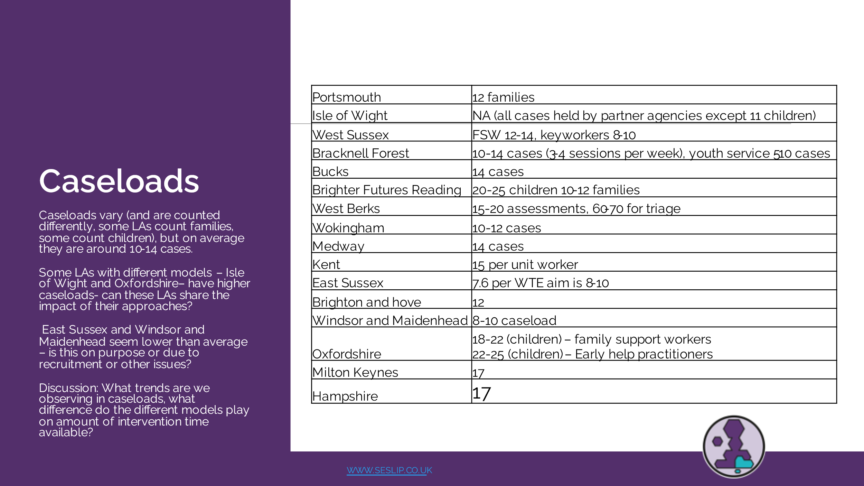
We then moved on to look at average duration of intervention.
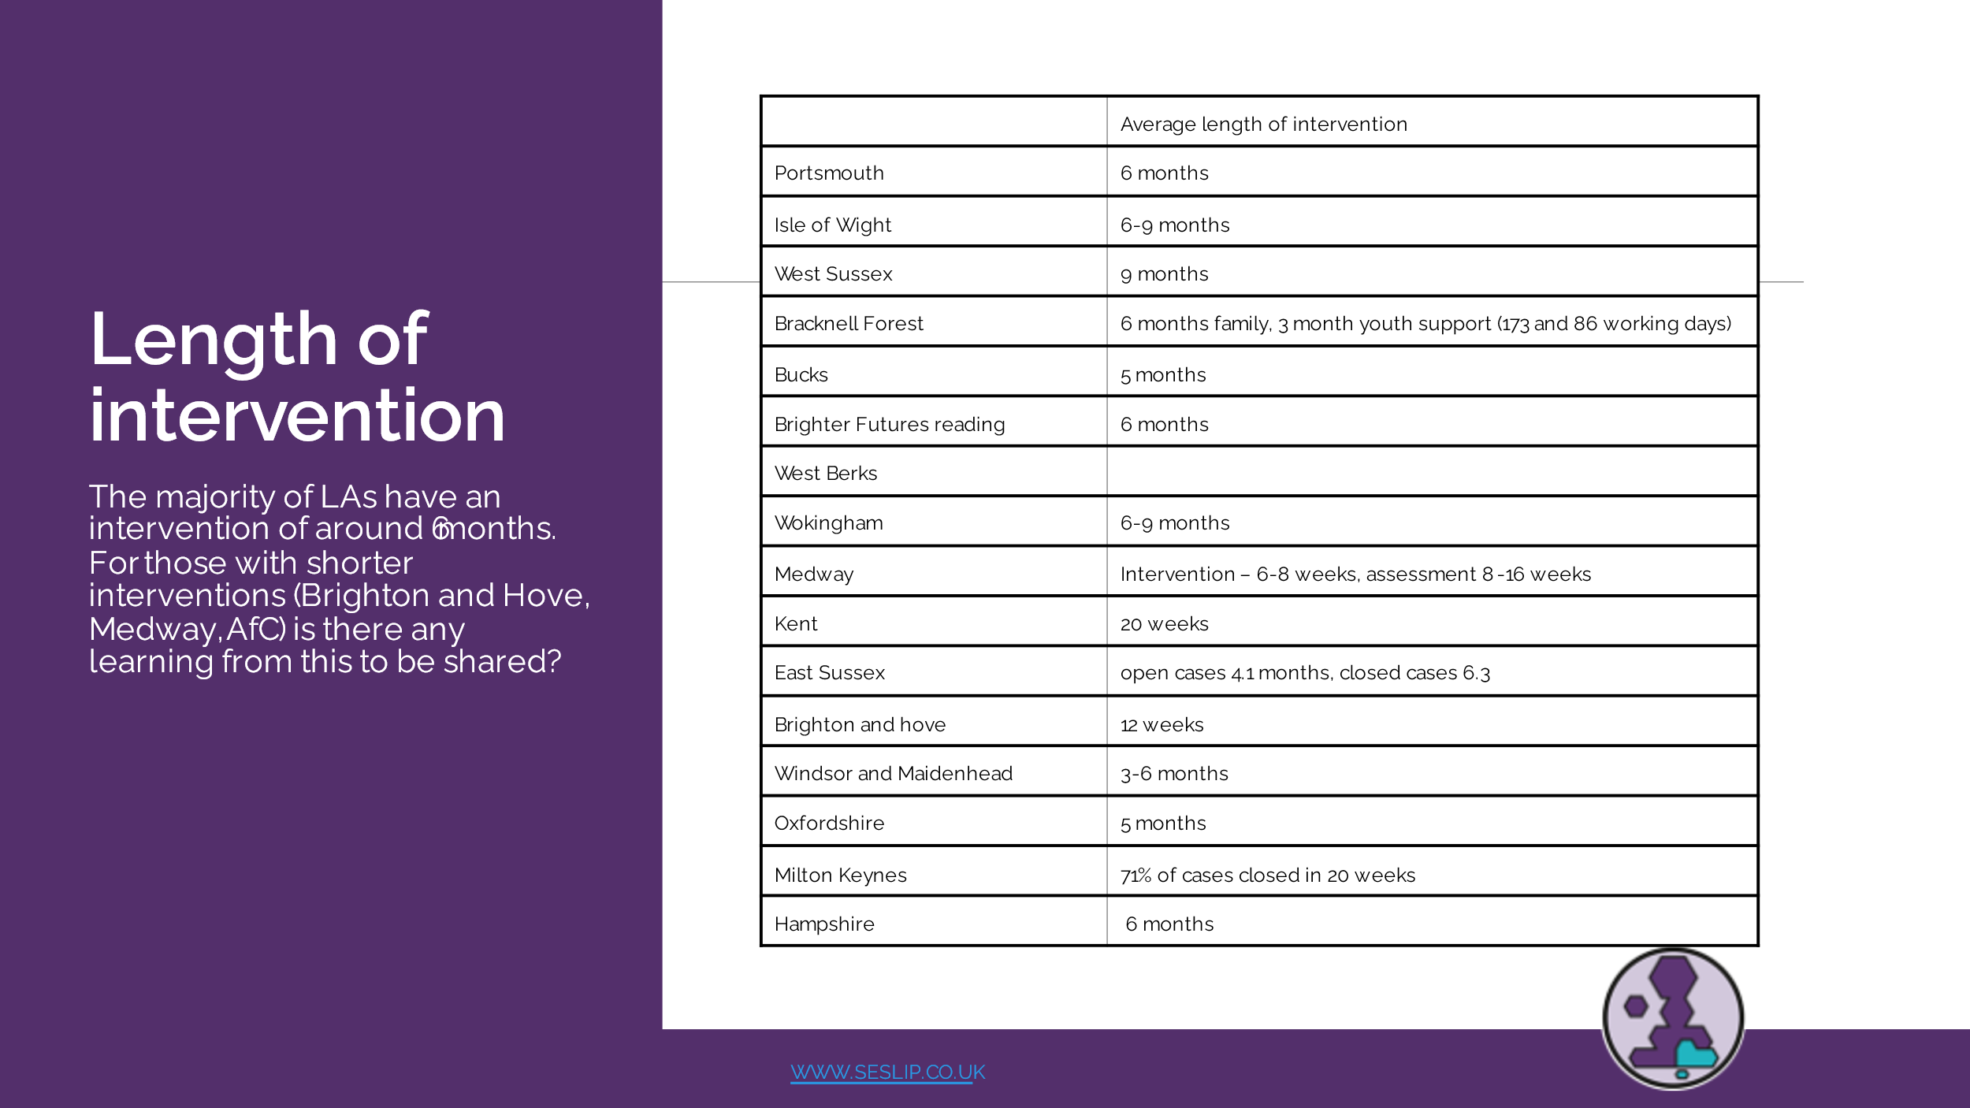
CH said West Sussex is the longest with intensive support about a year, after a year we find intervention less productive. Although CH followed up and confirmed the average figure was more like 9 months.
AHO said they look closely at re-referral rates- we are quite tight on 6 months duration. AHO was interested in those cases with a shorter period of time does that impact on re-referral? CL said they did a light touch approach in covid and we had a lot more re-referrals which led us to believe that if you don’t do the intensive work you end up with more re-referrals. We are aiming 3-6 months.
JT said re-referral is limited to 3 months, and re-referral was high at 30%, but also introduced short term level 2 work, but we have now redesigned the model in Brighton and Hove. There were two reasons – one was about not taking step downs from social care, and also length of interventions
CH said in West Sussex they have a longer intervention but going on to social care is 4% and returns to us is 6% we offer a 5 session only type of approach. The impact of the approach is shown.
RPW said they have been talking instead of elapsed time about dosage, if you are seeing someone 12 months once a month, and you could see them once or twice a month in 6 months. Historically we have had a wait, so we have tried to reduce the wait, but see people less frequently. We are thinking about dosage.
Finally, the group discussed wait lists
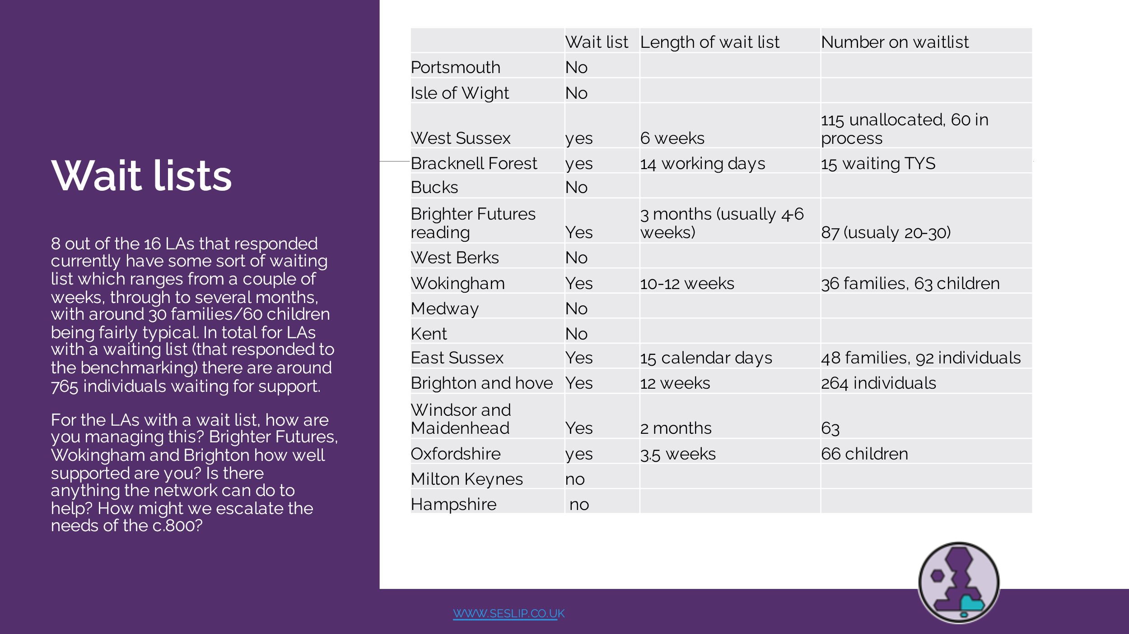
SB said they have progressed triage system on duty in Bracknell Forest so at the point of allocation a home visit and a lot of information gathering has been done. Because of that model they are sticking to their 6 month intervention target. SB reflected that historically it has taken a long time to engage which delays intervention, but having a more robust duty approach is hopefully going to reduce or keep the intervention time and wait list in check.
CL shared that a lot of the re-referrals are neurodiverse children, we pull out and then 3 months down the line they then have different beahviours and they are re-referred. Trying to support parents with children that aren’t neurotypical is a trend that is increasing. We are seeing parents come back. We have given the strategies but it just isn’t enough.
GS asked if any innovative or other work with partners that people are undertaking?
RPD said they deliver incredible early years in AfC. It is a really nurturing programme for creating that resilience. We do see parents coming back in.
GS reflected that those waiting lists seem a bit better than when we previously discussed as a group and some LAs seem to be managing risk effectively. How have you done that?
SB said they don’t have a waiting list in Hampshire. Had one this time last year. SB noted that it was hard to get down and we had to work with partners. Different districts did it differently, we hold all meetings virtually. Some areas extended meeting, some put extra meetings in. Hub managers doing an initial triage and then speaking to partners. Some districts put on extra courses. The key barrier for us is the capacity and availability of partner agencies. We don’t want LAs to be responsible. I was interested if other’s experience were similar
CL said in East Sussex their waiting list has been longer in the past due to high vacancies, we have graded posts up and offered apprenticeships we are now fully staffed. Staff were moving on, the regrading has made a difference
JT said they had changed their model to address demand. We have increased capacity at L2 and L3 work in Brighton and hove. Now we are all on all one system – we had all sorts of spreadsheets and now we’ve just introduced a triage duty system. The wait list is for L2 L3 and parenting interventions. One of our KPIs is about reducing waiting times.
GS said it was encouraging to hear how wait lists and demand is being managed - it isn’t that people don’t get input, LAs are managing risk through conversation on an ongoing basis.
HK said Oxfordshire we increased numbers up from 18 to 25. We moved workers around from centres as well.
JT said she feels optimistic it will have reduced by later in the year. Not sure realistic to say a particular target
CH said they are working on 15 working days to allocation, there would be activity in the meantime.
DM said in their model they are working with adult-facing practitioners on MH and family practitioner looking at families in early help (as well as social care), offering support whilst waiting.
GS asked, on SB’s point from earlier is anyone else experiencing issues with partners? RPW – a lot of our partners are from VCS and they’ve had a real challenge post-covid. That’s impacting on capacity.
SB said schools, school nurses, health visitors are all very stretched.
Action: Future item on response to stable homes built on love – how people are changing things.
Action: future item on Learning from Early Help JTAI.
Action: update slide deck to include Hampshire data and recirculate
Action: JT asked if anyone updating EH/family hub strategy. Can we share around that. We are about to update family hub 3 year strategy. Celia said our family hubs strategy is 2 year because our funding finishes, we would welcome thinking about broader different strategy. Gareth and Bucks to share approach.
Item 3: Julie Greer attended to share training available and relaunching community of practice relating to Family Hubs.
Portsmouth have a different model – jointly funded by health and council – Amanda Hales Own to meet up.
Item 4: Early Help data project
There was a written item from the data to insight team replicated below. Everyone noted the 11 Aug deadline.
- Collection template is now live and LAs are encouraged to download and complete at the end of Q1
- We have visited most regional groups now to promote the project and take feedback
- Deadline for submission is 11th August
- A benchmarking tool will then be available for completing LAs, again from the D2I website.
We’re excited to finally launch our Early Help Data Partnership quarterly collection, commencing at the end of Q1 this year. This voluntary collection will allow those local authorities providing data, and only those LAs, access to an Early Help focused benchmarking tool.
This is similar to the RIIA quarterly collection, focusing on 9 key EH benchmarking measures, as well as a small number of contextual questions. We appreciate Early Help looks different in each local authority and the measures may not be an exact fit – but through lots of consultation and collaboration, we’ve tried to find measures that would be the best fit for the most authorities. We’re open to iterating on this process and the measures, so welcome feedback and notes – either via email or within the notes section of the collection tool itself.
This collection is open to any LA – not just our original partners for developing the project – and the deadline for submissions is Friday 11th August.”
The link to the collection tool is below (though you’ll need to be a member of our website). Early Help Quarterly Collection Sheet | Data to Insight
Future meeting dates:
- Friday September 15 9.30-11am
- Thurs December 7 10-11.30
Action log: This action log was updated on September 11 2023. Shaded actions are closed or complete
 | Action | Responsible | Date issued | Status
26 | Future item on early help and family hub strategies | RE | June 2023 | Complete
25 | CL to circulate document from E Sussex (although not used anymore) on % time spent on various tasks | CL | June 2023 | Ongoing
24 | Future item from Surrey on EH JTAI | RE | June 2023 | Open
23 | EH benchmarking to be circulated with Hants data included | RE | June 2023 | Complete
22 | RE to benchmark waiting list and caseloads. | RE | Dec 2022 | Complete
21 | RE to develop case studies of EH workers from across the region to explain the journey and range of experience that can lead to a career in EH | RE | Dec 2022 | Open
20 | RE and GS to meet and agree how to publish. RE to make changes required to the text and get a designed up version produced for next meeting | RE/GS | Dec 2022 | Complete
19 | JF to set up separate meeting with Amanda Hales Owen to discuss data to insight EH project amanda.halesowen@solent.nhs.uk | JF | Dec 2022 | complete
18 | All to let JF know if they want to be added to the EH data project mailing list | All | May 2022 | Complete
17 | All to contact JG or CB if you want to be on Family Hub mailing list, receive or volunteer to write blogs, receive updates from workshops, research etc. | All | May 2022 | Complete
16 | Future discussion on cost of living, Care review (EH and CIN being brought together), EH being required to support CAMHS cases due to long waiting lists | RE | May 2022 | Complete
15 | Jo Templeman, Carl Burton, Stuart (Kent), Vicky Rhodes, Simon Dear (IOW) to get together to discuss narrative (and if possible data/finance) to explain business case for early help | RE to convene | May 2022 | Complete
14 | All to provide feedback to CB and JG on how best to engage your LA around family hubs | All | Mar2022 | Complete
13 | All contact Georgie to arrange user research interviews, and John on ideas for project scope. | All | Mar 2022 | Complete
12 | RE to share raw responses from EH mapping with data to insight team | RE | Mar 2022 | Complete
11 | KS to feedback on multi-agency (referral?) process at future meeting (Wokingham) | KS | Mar 2022 | Did not happen
10 | Rachael (RPD)(achieving for children) to circulate EH strategy and partnership advisory board terms of reference | RPD | Mar 2022 | Complete
9 | RE to map caseloads (combined with 22) | RE | Mar 2022 | Combined
8 | RE to amend terms of reference naming SC as vice chair and upload to SESLIP website. RE to diarise ToR for annual review | RE | Nov 2021 | Closed
7 | AL to present quarterly to this group on progress of data accelerator | AL | Nov 2021 | Ongoing
6 | CB to present quarterly to this group on progress of regional family hubs work | CB | Nov 2021 | Ongoing
5 | RE to send benchmarking out to all 19 LAs and to summarise findings as item on next agenda | RE | Nov 2021 | Closed
4 | All to contact CB on regional family hub offer of support | All | Nov 2021 | Closed
3 | KP to share report on the impact of bringing together health and EH with Rebecca to circulate to the group | KP | Nov 2021 | Did not happen
2 | AL to ensure learning from supporting families/troubled families influences the EH data accelerator | AL | Nov 2021 | Closed
1 | Refresher data demonstration for the early help network at a future 2022 meeting | AL | Nov 2021 | Closed

