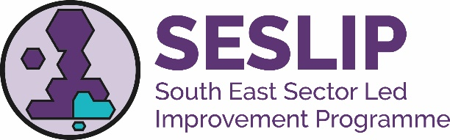
South East Region Kinship Network

Terms of Reference – June 2023

Background
The South East Regional Kinship Network was established in June 2023.

Aim
The South East Regional Kinship Network is overseen by the South East Region Directors of Children’s Services and support is funded through the Sector Led Improvement Programme

“The overall aim is to provide sector-led leadership and support to Kinship practice in the south east, understanding and supporting practice development and bringing together issues of common concern and/or good practice to facilitate the good outcomes for children and young people in the region”

Objectives
To achieve this aim, the Network will have the following specific objectives:

- To identify and feed in specific areas of good practice and key concerns to the regional DCS group;
- To agree regional responses to national consultations and make representations on key issues relating to Kinship Care (including connected carers and special guardianships)
- Through the analysis of data and other information, to understand key strengths and opportunities for improvement in the south-east relating to kinship;
- Through the analysis of data and discussion, to identify key lines of enquiry for the region and commission specific, in-depth pieces of work as appropriate;
- To ensure that national messages are cascaded throughout the region as appropriate.

Ways of Working
- The network Sponsor will be a DCS in the South East region; currently this is Dr Mac Heath DCS Milton Keynes. Any change of Sponsor will be approved by the South East DCS Group;
- The Network will undertake to report to the South East DCS group, where this will be published on the SESLIP website;
- The network will appoint from its membership one or more Chairs and Vice Chairs who will support the SESLIP appointed consultant in devising agendas, chairing the meeting as required and take part in national events/conference calls as required on behalf of the group; the vice chair is currently Lucy Peake, Chief Exec Kinship;
- The network wishes to be as inclusive as possible. Membership is open to all 19 local authorities/children’s trust. Members should be of sufficient seniority to represent their organisations at a strategic level as well as to understand the Kinship operations in their LA;
- The network will develop an annual work programme reflecting regional priorities and issues;
- The network will meet quarterly);
- Depending on the work programme, specific project groups or task and finish groups may be set up to complete identified pieces of work.

Review

- The network will review this Terms of Reference on an annual basis.

June 2023

