Fostering regional group meeting notes and action log December 2025

Date:
Chair: Sarah Daly DCS Portsmouth
Attendees: Alison Miller (Milton Keynes), Carly Arnold, (Southampton), Cathy Seider (Brighton and Hove), Jackie Clark (Portsmouth), Mark Vening (Kent), Fiona MacKirdy (Surrey), George Matthew (Slough), John Donnelly (Brighton and hove), Karl Davis (West Berks), Julie Mcnally (Oxfordshire), Peter Hodges (Bracknell Forest), Rachel Farrell (Bucks), Tina Ashaye(not sure LA?), Anisha Reed (Southampton), Sarah Smith (Hants), berni Farmer (Isle of Wight), Keith Langley (West Berks), Rebecca Eligon (SESLIP)
Item 1: Minutes and actions from last meeting agreed.
Item 2: Brighton and Hove’s approach to supporting foster carers in first year
Cathy Seiderer shared insight they had gathered from:
- Our foster carers through the survey / forums and other discussion
- National picture – fostering network
- Research – various research – UK and worldwide
- Social work principles – basic knowledge
Through this they identified a number of challenges which foster carers face in their first year:
- Lack of Resources specific to the learning and needs for support in that initial first year
- Needs of children
- Sufficiency and matching opportunities
They identified the impact of not having something in place – cost to people, children and to Councils
- Carers don’t feel that they are providing the care they want to.
- Care of children not consistent or best for children.
- Foster carers own children impacted – impact on length of fostering
- Placement stability – impact on children short and longer term and on carer
- Leave fostering sooner than they would have – impact on sufficiency-
- Don’t recommend fostering to others – impact on recruitment
- Spend on resources
They distilled some key messages for foster carers in their first year:
- You wont remember everything you are taught
- Its ok not to know
- You learn in your fostering journey as well.
- You are supported – evidence of this
- This is an adjustment for you and your family (change management)
- Knowing who is who and what their role is
- Celebrate wins and notice small changes
And reviewed their approach to support:
- Preparation to Foster (Skills to Foster) including a Back to Basics
- Buddy * to also support at pre meetings and matching and considerations etc
- Pre-approval support group to new carers support group
- Attachment specialist contacts if needed
- Space to share among peers to say it is ok if you aren’t sure
- Therapeutic Parenting Group – Children in Care Psychologists
- Things we are thinking for the Future
- Network meetings and communication
- Fostering Support Officer?
- Additional support for other members of household
- Very close connection – SSW meets carers pre panel or at panel. Very close relationship between assessing social worker and supervising social worker on matching.
- Start mandatory training before they are approved- front loading as much as possible
SS said in Hampshire they have a foster carer induction programme and would be happy to part of group to look at that. JC said they are also looking at what they are building on Portsmouth. JM, Oxfordshire would like to part of this too. SS said It would be great to share some resources in this area and virtual wellbeing sessions across the region
Action: Oxfordshire (Julie McNally) Hampshire (Sarah Smith), Brighton and hove (Cathy Seiderer) and Portsmouth (Jackie Clark) to catch up outside the meeting on sharing practice/approaches re: support to foster carers in the first year.
Made a proactive effort around mental health, wellness walks, menopause, faith, physical activity. We know that foster carers might not put themselves first to think about it. We’ve created a you matter support hub. We are trialling a wellness action plan, the foster carer fills in as part of the assessment. What matters to you, what would make it easier and gets reviewed alongside the medicals and health and safety in the house.
What are the things that we put onto foster caresrs outside of the children which create stress. It is fine to do meditation but what is the unnecessary stress. It identified the paperwork, relationships with child social worker.
JC said in Portsmouth they are developing team around a foster carer training, as well as team around the child.
SS said that it would be helpful to share some of the support and wellbeing across the region. Especially as so much of it is online.
GM said in Slough they are doing similar work, ESOL foster carers group, men’s support group as well as front loading training.
SD said that role around the children’s social worker and the lived experience of being a foster carer so they can understand and build that into the care planning work is really helpful.
Item 2: Surrey Foster carers charter
FM presented the development work and the approach to the Surrey Foster Carers charter. She reflected that they had a charter for some time but there was low awareness, and wasn’t clear what impact it had.
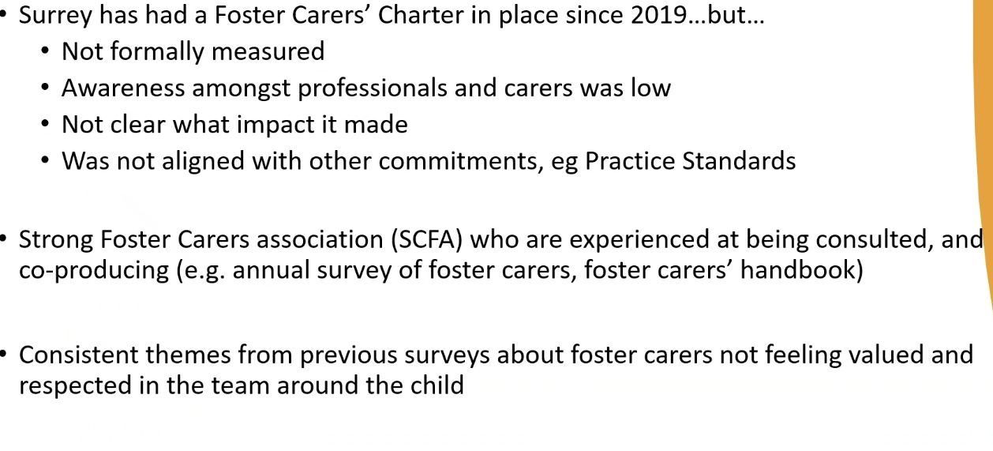
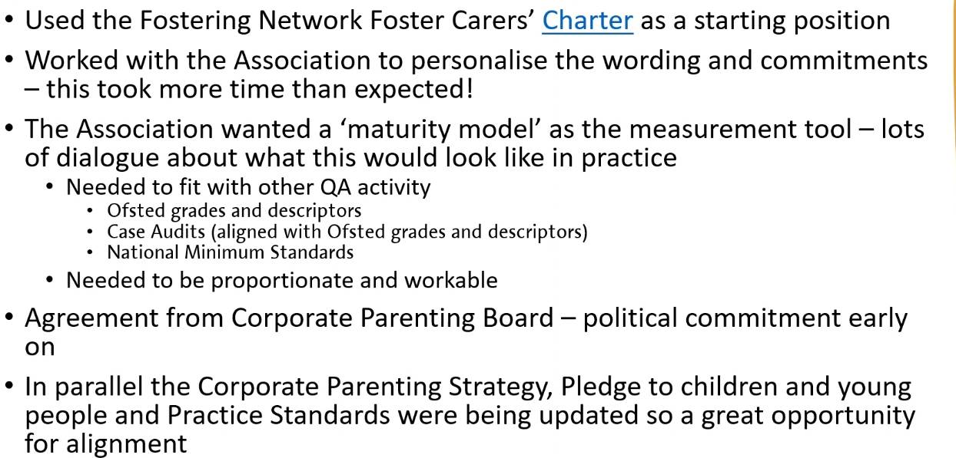
FM reflected that the collaborative process took time.
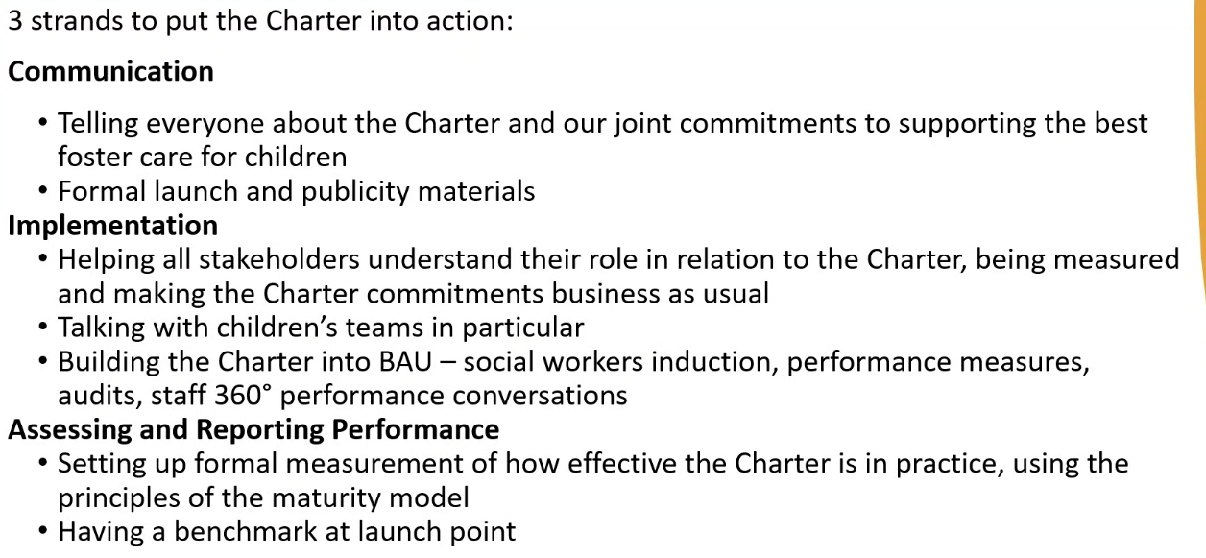
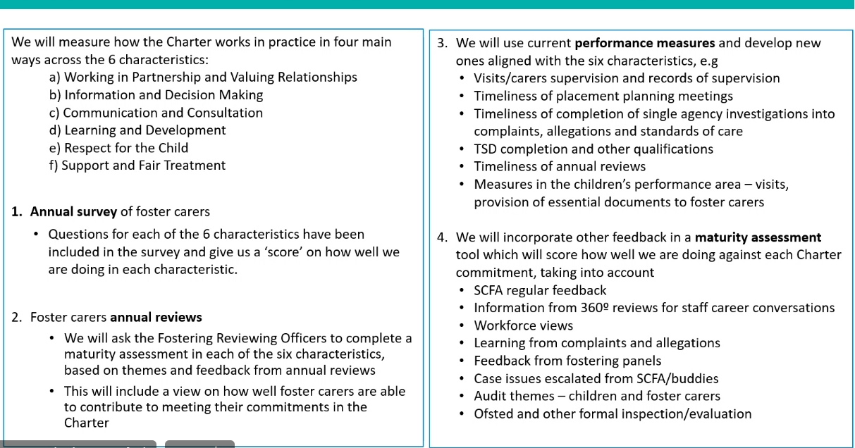
FM explained that Surrey has developed and approach where they can get a clear visual on the characteristics of charter and how that is being applied (see overleaf).
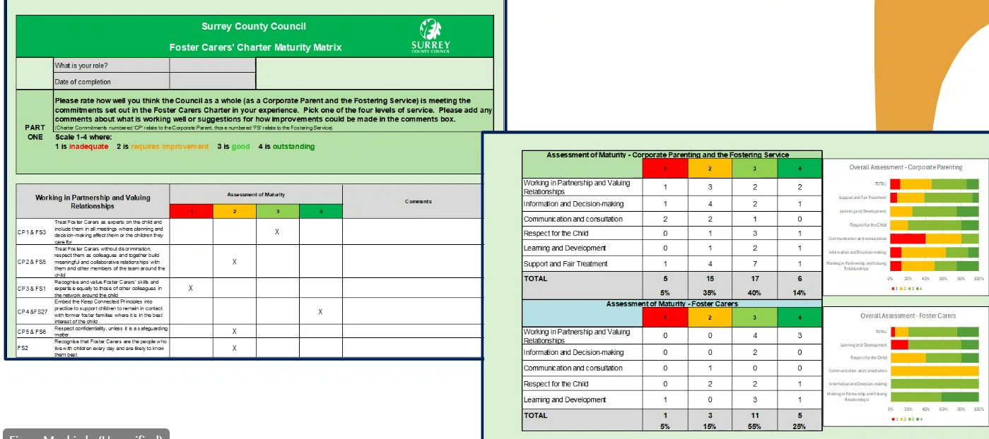
SD said was an impressive piece of work. SD asked about political buy in. FM said members are on board.
Standing items:
Issues for future discussion: The group said they would like a future discussion on delays to medical.
Action: SD asked the group to find out and report back: What is driving delays is it capacity, payment, or it isn’t part of the commissioned offer, is it costing too much? What is the issue. Have you escalated in place-based partnerships and ICB risk logs?
AOB
GM asked if anyone uses VR training with foster carers? BF said they use it in assessments to get people to consider the types of issues they will come across, with carers experiencing compassion fatigue to reconnect with the child and their trauma. It can be very powerful. KL said they had used it in past but West Berks not using it anymore, did use Cornerstone in Skills to foster and existing carers. It was a good tool in helping foster carers in trauma. We were spending about £16k so we had to stop due to cost. PH said they also used to use it, but Virtual school uses it to which is funded separately which helped to justify cost.
Items for next time: impacts of spending review on fostering (esp. re: impact of kinship reform and pathfinders), medicals and what is causing delay. Alison Miller to share on Milton Keynes experience of fostering inspection.

Action log: updated 27 Feb Shaded lines, actions are complete
 | Action | Responsible | Date issued | Status
45 | SD asked the group to find out and report back: What is driving delays is it capacity, payment, or it isn’t part of the commissioned offer, is it costing too much? What is the issue. Have you escalated in place-based partnerships and ICB risk logs? | ALL | Dec 2024 | open
44 | Oxfordshire (Julie McNally) Hampshire (Sarah Smith), Brighton and hove (Cathy Seiderer) and Portsmouth (Jackie Clark) to catch up outside the meeting on sharing practice/approaches re: support to foster carers in the first year. | JM SS CS JC | Dec 2024 | open
43 | SD to draft letter to ICBs in region setting out the impact of delays in medical assessments | SD | Oct 2024 | complete
42 | HB to share business case/thinking behind salaried foster carers (c.£60k, 10 months a year, 3 carers on rotation) | HB | Oct 2024 | open
41 | PH, KL and SA to meet to get a consistent approach to police input across the Thames valley. | PH KL SA | Oct 2024 | Complete
40 | Brighton and Hove to share support for foster carers in first year and wellness action plan | CS | Oct 2024 | Complete
39 | Mark Vening and Peter Hodges to have a quick catch up and report back re: DBS accessibility | MV PH | Mar 2024 | Complete
38 | SS to speak to Oxfordshire to see if there is anything we can learn from the duty senior prac. | SS | Mar 2024 | complete
37 | Idea of 1. offer and assessment approach for those not yet ready to be foster carers and 2. Development of guide for first calls/conversations to be developed through hub | RE/AMA | Oct 2023 | complete
36 | LAs to share foster panel member payscales with SS to collate | SS | Oct 2023 | closed
35 | Action : RE to circulate UASC documentation from Martin Tuck to Cathy | RE | Oct 2023 | complete
34 | If any further LAs wish to submit information (caseload and number of carers recruited) please send to Rebecca. Will need number of carers recruited in 2022/23 for all LAs in fostering hub. | RE | July 2023 | Closed
33 | Brighton and Hove said their website is being updated over the summer and please ensure that mystery shopping does not happen until after the relaunch | RE | July 2023 | complete
32 | Future discussion – increasing quality of ISW assessments (October 2023) | RE | April 2023 | Complete
31 | RE to contact Louise toward the end of the year to see if any feedback from Home Office re: DBS classification. | RE | April 2023 | Complete
30 | RE to benchmark caseloads for supervising social worker and numbers of carers/placements recruited in the last year. | RE | April 2023 | Complete
29 | RE to circulate previous research with foster carers. | RE | April 2023 | Complete
28 | RE to set up website mystery shopping run by foster carers for October 2023 | RE | Jan 2023 | Complete

