Fostering regional group meeting notes and action log October 2024

Chair: Sarah Daly DCS Portsmouth
Attendees: Alison Miller, Milton Keynes, Nikky Brown Southampton, Cathy Seider, Gemma Pavey Brighton and Hove, George Matthew, Slough, Saima Arif Slough, Karen Devine Brighton and Hove, Keith Langley West Berks, Lorna Peterson Bucks, Maria Cordrey Kent, Sarah Smith Hants, Peter Hodges Bracknell Forest, Rachel Farrell Bucks, Sharon Godfrey Milton Keynes, Carly Arnold, Jackie Clark, Lucy Hawkins, Holli Blackburn, Wokingham, Rebecca Eligon
Item 1: Minutes and actions from last meeting agreed. Group noted the delays to DBS causing an impact for children’s placement.
PH from Bracknell Forest said that in relation to reg 24 it is their experience that police are reluctant to provide police or records check. They tell us we need to do checks. PH wanted to know if this is an issue across the region? SA said in Slough they don’t have the issue, yet they are in the same area. MC also said they were not having those issues.
Action: PH, KL and SA to meet to get a consistent approach to police input across the Thames valley.
SS noted that they aren’t sure if it is just Hampshire but they are also getting a lot of issues with medical delays with so many GPs refusing to do this work and they are needing to pay for private medicals. Or we have GP surgeries charging a lot of money. MC said they are experiencing the same in Kent and they continually liaise with Deputy Designated Nurse to address
Action: SD to draft letter re: ICB leads around medical delays and the role they play in supporting foster carers
Item 2: Themed discussion: preventing placement breakdown:
NB from Southampton shared information about their placement stability panel which was established to reduce placement breakdown.
The purpose of the group is to:
- Prevent children in care experiencing disruption to their lives and relationships caused by placement breakdowns
- Provide high support through resources and intervention at the earliest opportunity when potential risks of breakdown are identified
- Support the coordination of robust multiagency responses that strengthen placement stability for children in care
- Support children in care to maintain long term relationships in foster homes and achieve permanence

Fostering supervising social workers refer to multi-agency weekly panel. Building bridges is 8-12 week support for families in home, more intensive. If possible foster carers are also invited to be part of the conversation alongside the social worker for the child. The panel is chaired by the head of service, it is also attended by service managers, clinical psychologist, virtual school head, LAC nurse and lead IRO.
The learning so far is that:
- Best outcomes are when cases are discussed early at first signs of vulnerability
- It has been helpful to include foster carers
- Having multi-agency input has been helpful (especially clinical input and virtual school head
- Has been helpful to have clinical lead and building bridges additional support
- At least 30 mins is needed to discuss each case in the depth required
The next step is to look at cases rated amber (rather than Red) as a preventative step. Through this approach there was only one breakdown over the summer. It is usually much higher
SS asked what the clinical lead does. NB said there is a lead clinician who is an occupational therapist but trained more broadly. She offers consultation to children’s social workers rather than direct work, sharing resources that workers can use.
SD asked if they are identifying placements at risk early enough. NB said the RAG rating enabled people to be more honest, but it is still a work in progress. Some carers don’t ask for support until it is crisis point.
SA asked how many are discussed a week. We have had 6 a week, which is too many. To start with we looked at fostering, now it has been expanded to families at risk of breakdown. Sometimes we have no referrals. Had good attendance from residential, IFA and foster carers.
KD asked if this is in addition to placement stability meetings. NB said yes it is, as it brings in a wider group of professionals and stakeholders. It is a reflective space to generate ideas and get other teams involved fairly quickly.
SS said in Hampshire they have have increased support to foster carers through Hampshire’s Hive model (similar to Mockingbird), but the idea of bringing people together rather than around the child is helpful.
CS said in Brighton and Hove we are looking at first year of fostering so that they are prepared and not likely to break down. Some of the children going into fostering have increasingly complex needs.
Action: Brighton to share how to prepare foster carers in first couple years.
KL sounds a combination of what we do in West Berks Life Chances panel (we don’t have foster carers at that meeting, we do RAG rating) and we also have team around the placement meetings. Sounds like you’ve brought everything together in one panel.
JC: Mockingbird has proven to be successful in placement stability and sharing it with other carers. Also hold monthly placement stability meetings to RAG rate an identify wobbles. We have foster carer mentors and out of hours support. One suggested they would be prepared to be an out of hours mentor and that is something we want to build on as well.
CA Just started thinking about out of hours support with our foster carers forum. A number of carers came forward as well as being a first port of call. There was a sense people would be more comfortable making that call to another foster carer. In Southampton just started with a family practitioner who supports with stage 1 and 2 process for new applicants, she is then their family practitioner for the first 12 months after approval. She is then their link.
LP said as part of our new duty hub in Bucks, we have placement support workers - SSW/CSWs can refer into the Hub for placement support to go into placements at the point of identifying where there may be the risk of instability. We also make good use of our Mockingbird hubs county wide.
KD said it sounds great and involving foster carers in out of hours what might you pay them? CA said we would need to pay them.
KL said they have their own model similar to Hive and mockingbird and are linked up with foster carers and kinship carers are using that Hub support first. KL agreed that people want to go to peers first.
JC said in Portsmouth our new carers have a foster carer mentor to support them from the point of approval for first 3 months . We also have a support group for carers in the assessment process to promote developing supportive relationships.
CS has a wellness action plan in (how do you take care of yourself) for our foster carers which is reviewed every year.
Action: Share wellness action plan approach from Brighton and hove.
JC: intensive fostering bridging placement is under development and keen to talk to others who might be developing this.
SS wants to discuss how we manage urgent care (same day placements and out of hours). We are reviewing how we are doing this, who recruits urgent care placements and how does it work.
HB said in Wokingham they are at early stages of a business case for salaried foster carers. Who will be paid to have placements 10 months a year, 3 carers working in rotation on £60k a year. They receive good financial rewards, employment benefits and two months off. They will be providing a home to most complex cases as an alternative to residential. For example, remand.
Action: HB to share business case and thinking re: salaried foster carers once further developed
LP What is working well in our Fostering Service are monthly Joint Learning sessions which include both foster carers and SWs where we will focus on specific relevant topics/bring in speakers etc- it's a great learning together opportunity and useful forum for supporting carers re: practice.
AOB
Possible agenda next time is: spending review and implications for fostering, salaried carers, surrey foster carer charter, Brighton wellness action plan and support to 1st year
Item 3: LA fostering south east
SD asked people for general feedback on the new fostering hub as she hadn’t attended the last DCS meeting. KD said a lot of feedback is that marketing has taken longer than we would have hoped, so data on demand into the hub is really from our own marketing efforts. There has also been a request for greater AD involvement as there is a possible disconnect between DCSs and Ads.
Item 4: regional care cooperatives:
Mark Evans joined to sharethe background and relevance of the RCC work to fostering:
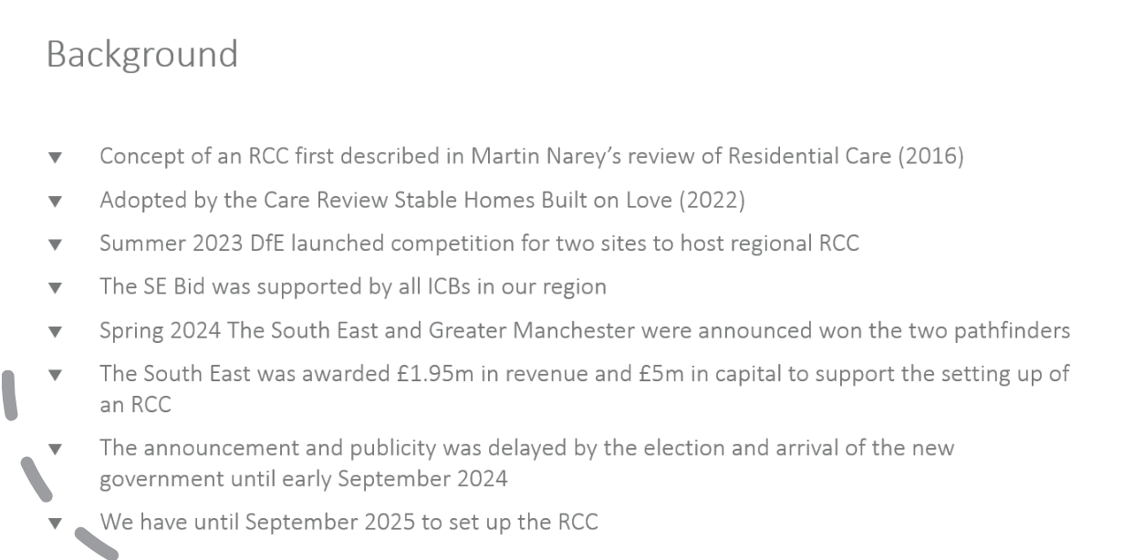
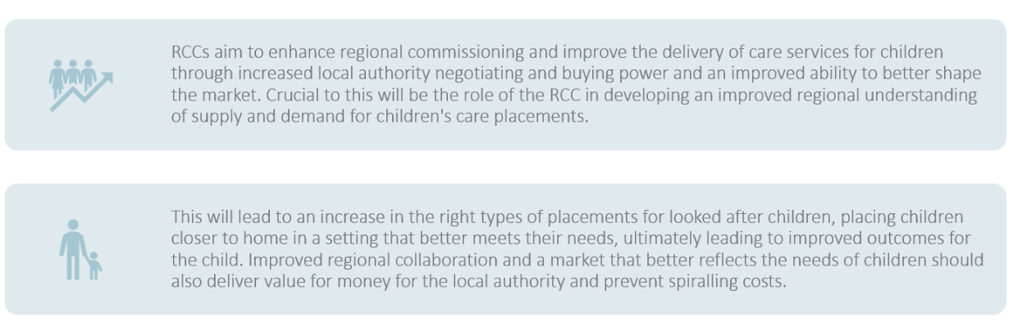
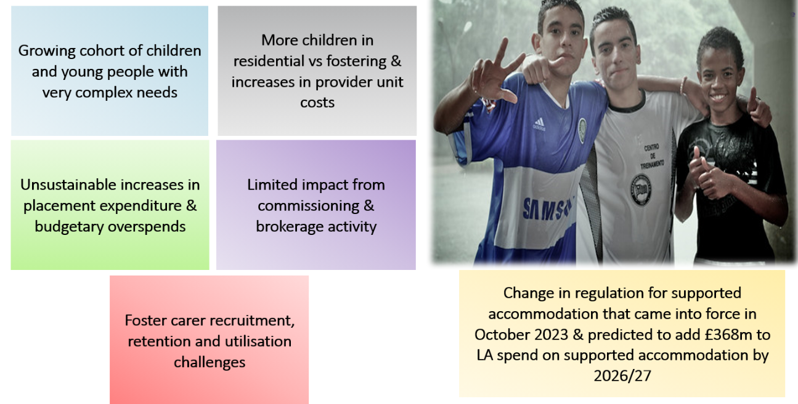
We are seeing children in residential care who shouldn’t be there. So whilst we are concentrating on high cost group, without growing foster capacity and developing UASC approach will be tricky.
There are some minimum requirements on what we need to do through the south east regional care cooperative:
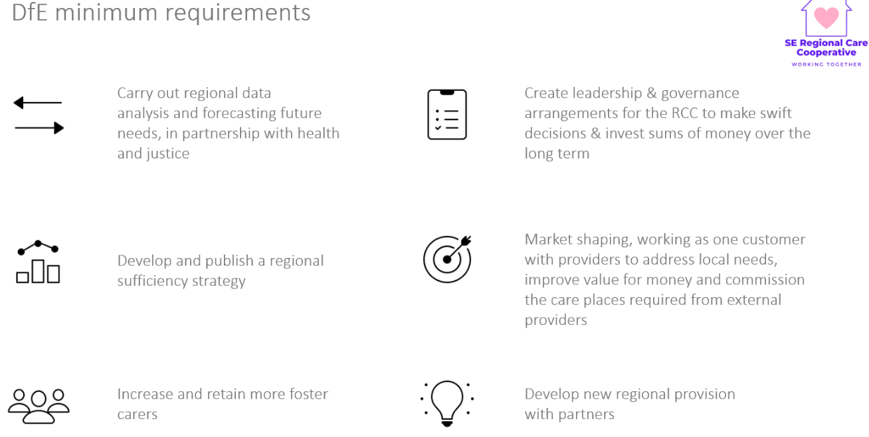
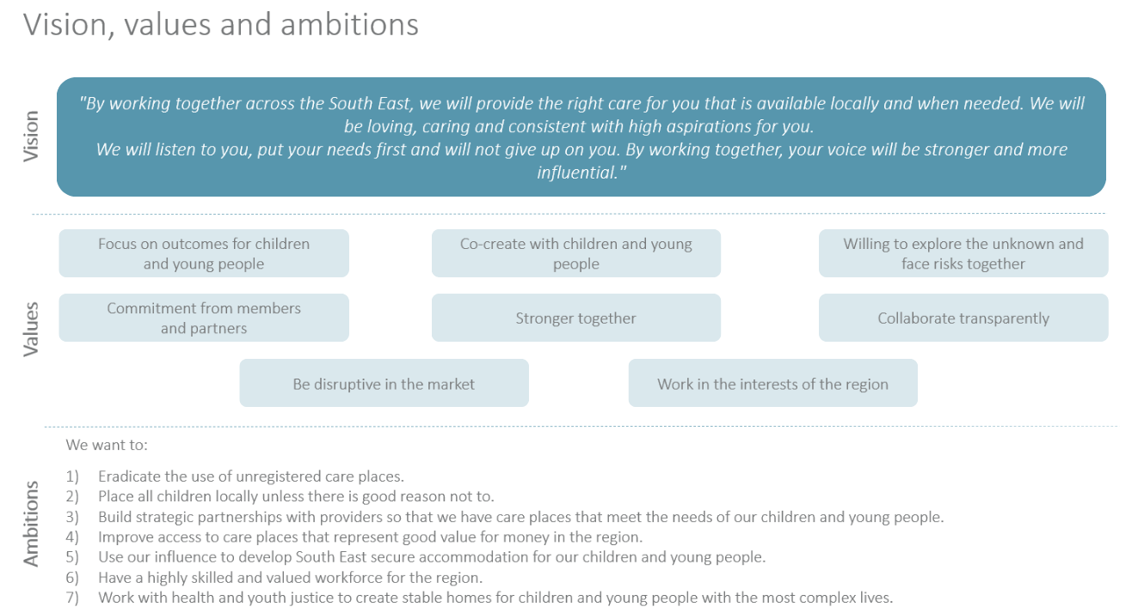
Looking at a structure around 20 people in the region
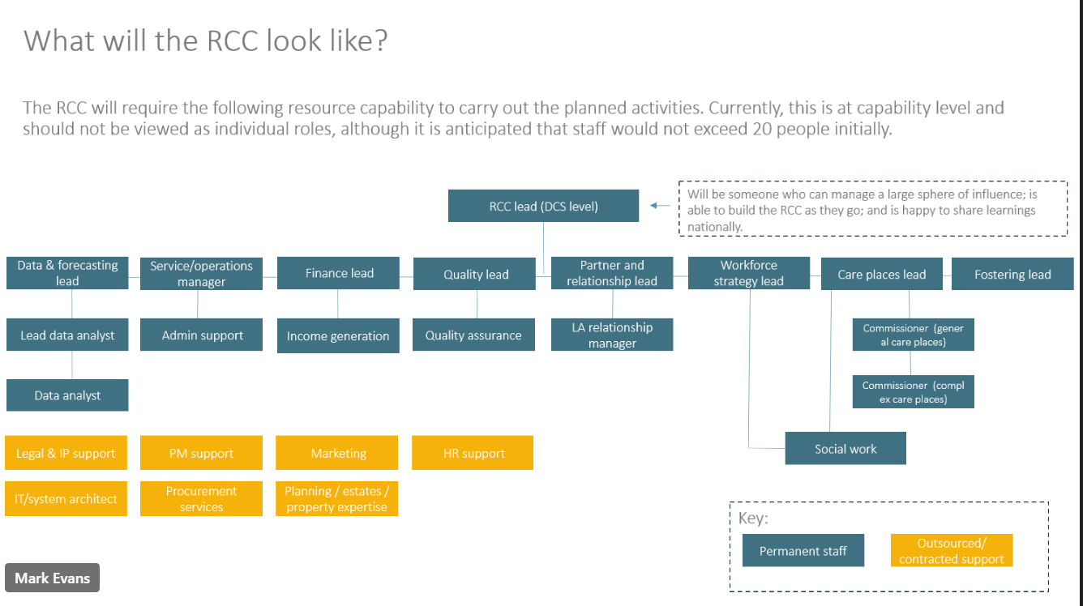

Action log: updated Dec 3 2024 Shaded lines, actions are complete
 | Action | Responsible | Date issued | Status
43 | SD to draft letter to ICBs in region setting out the impact of delays in medical assessments | SD | Oct 2024 | complete
42 | HB to share business case/thinking behind salaried foster carers (c.£60k, 10 months a year, 3 carers on rotation) | HB | Oct 2024 | open
41 | PH, KL and SA to meet to get a consistent approach to police input across the Thames valley. | PH KL SA | Oct 2024 | ?
40 | Brighton and Hove to share support for foster carers in first year and wellness action plan | CS | Oct 2024 | Complete
39 | Mark Vening and Peter Hodges to have a quick catch up and report back re: DBS accessibility | MV PH | Mar 2024 | Complete
38 | SS to speak to Oxfordshire to see if there is anything we can learn from the duty senior prac. | SS | Mar 2024 | complete
37 | Idea of 1. offer and assessment approach for those not yet ready to be foster carers and 2. Development of guide for first calls/conversations to be developed through hub | RE/AMA | Oct 2023 | complete
36 | LAs to share foster panel member payscales with SS to collate | SS | Oct 2023 | closed
35 | Action : RE to circulate UASC documentation from Martin Tuck to Cathy | RE | Oct 2023 | complete
34 | If any further LAs wish to submit information (caseload and number of carers recruited) please send to Rebecca. Will need number of carers recruited in 2022/23 for all LAs in fostering hub. | RE | July 2023 | Closed
33 | Brighton and Hove said their website is being updated over the summer and please ensure that mystery shopping does not happen until after the relaunch | RE | July 2023 | complete
32 | Future discussion – increasing quality of ISW assessments (October 2023) | RE | April 2023 | Complete
31 | RE to contact Louise toward the end of the year to see if any feedback from Home Office re: DBS classification. | RE | April 2023 | Complete
30 | RE to benchmark caseloads for supervising social worker and numbers of carers/placements recruited in the last year. | RE | April 2023 | Complete
29 | RE to circulate previous research with foster carers. | RE | April 2023 | Complete
28 | RE to set up website mystery shopping run by foster carers for October 2023 | RE | Jan 2023 | Complete
27 | JD to distribute contact details for trainer and amended foster care agreement. SS worker in Hampshire to connect with Brighton and Hove worker. – Anti-racist practice | JD | Jan 2023 | Complete
26 | JG to share the training provider: anti-racist practice | JG | Jan 2023 | Complete
25 | CS, JG and MG to share how to contact Ukraine hosts to see about receptiveness to foster. RE Add to agenda for future meeting. | MG, JG, CS | Oct 2022 | Complete
24 | RE to circulate previous research on USPs of LA fostering | RE | Oct 2022 | complete
23 | MT to provide welcome book/pack examples for UASC to RE to circulate to the group | MT | Oct 2022 | complete
22 | SD to check if Ofsted ok with return to virtual visits given increasing covid risks? | SD | Oct 2022 | Complete

