Notes and action log 
South East regional Early Help network
Dec 2024

Attendees: Chair Grainne Siggins DCS Bracknell Forest, Audrey Johnson Bracknell Forest, Alison Carver Hampshire (on behalf of Sophie Butt), Celia Lamden (East Sussex), Charlene Hornsey (west Sussex), Anna Clarke IoW , Katie Eason (Hants), Amanda Hales owen, Jo Templeman (Brighton and hove), John Foster (Data to insight), Eliza Marland (Oxfordshire), Steph Mountain (Southampton), Jamie O’Leary (, Rachel Park davies (Achieving for Children), Becky Kundi (Slough), Sacha Rymell (Medway), Victoria Gibbs (slough), Adam Thomas (Surrey), Steph Coomber (west Berks) SESLIP Support: Rebecca Eligon
Meeting details: 9 December 2024 10.30-12
ITEM 1: Introductions and review of action log
The action log and minutes were agreed
ITEM 2: Early help quarterly data
There are 9 measures, quite process focused, step up step downs, outcomes met for cases closing. There has been a significant increase in contacts at the front door, but only a 7% increase of referrals to social care. Therefore, the demand into early help has increased, from 191 per 10,000 to 274 per 10,000.
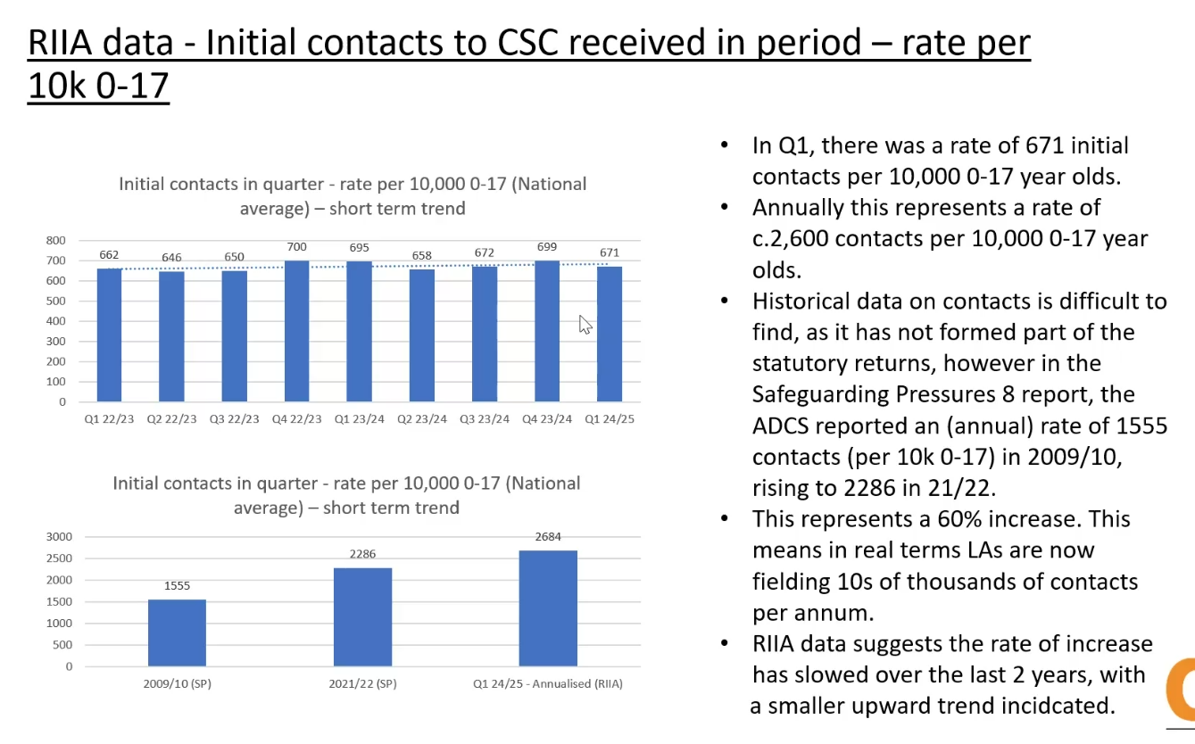
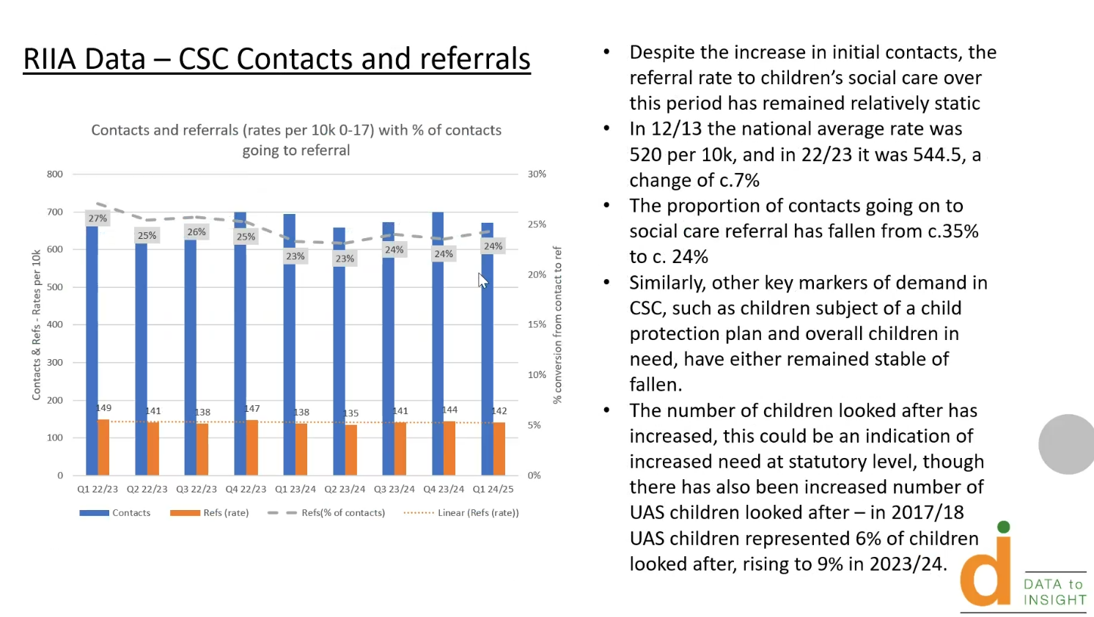
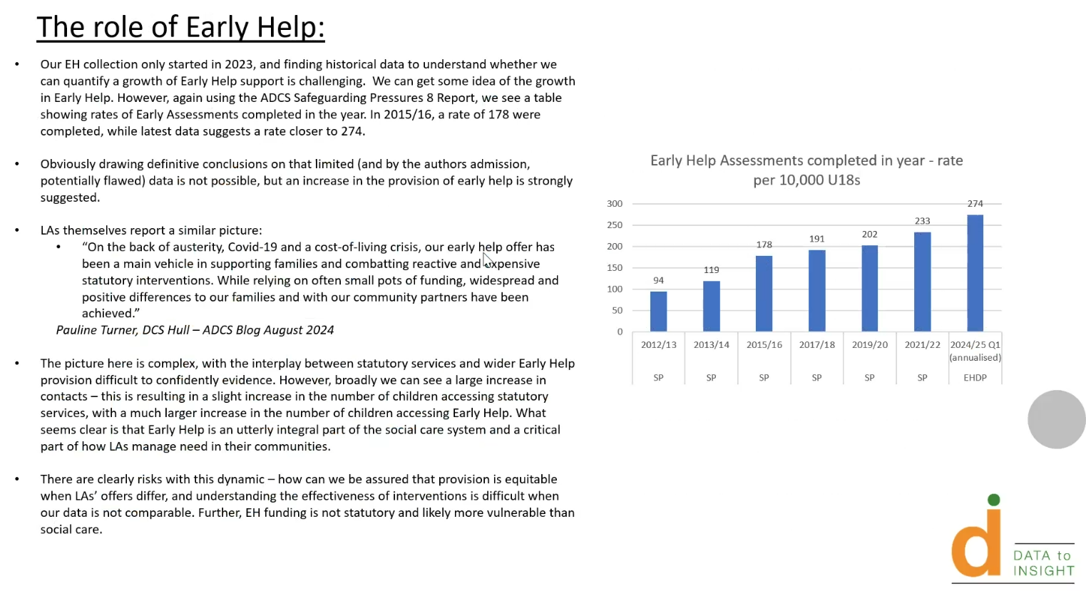
What the national picture is showing us:
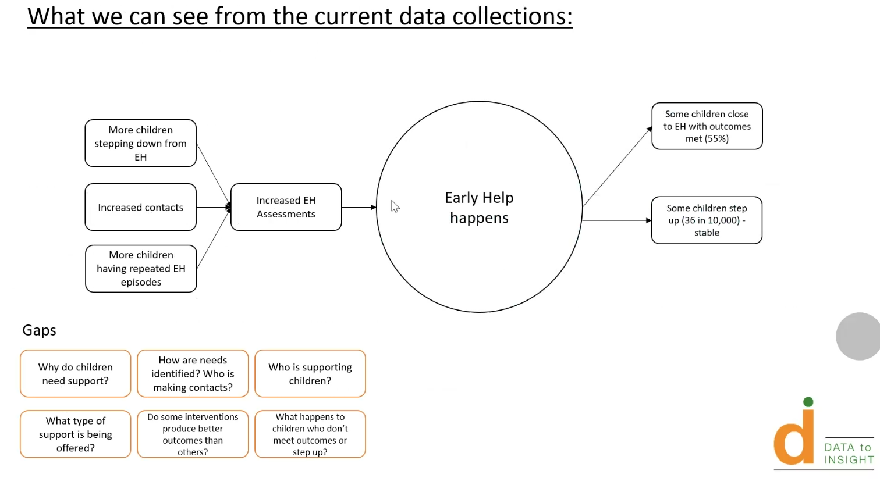
Questions that need to be answered locally, including what needs and why are children stepping up and down, what sort of support is being offered are important to consider. These are factors which will be driving the design in LAs around future family help services as part of children’s reform.
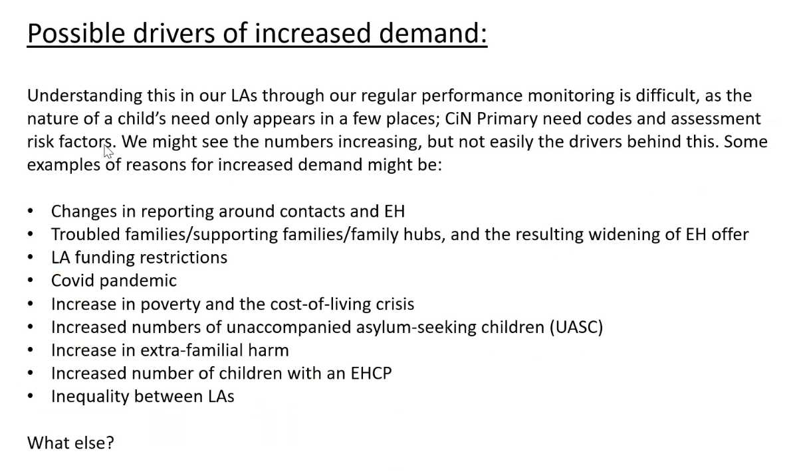
Question: RE asked if the data is national or regional? JF said it is national as data submissions from the south east have been patchy as some Las not responding routinely.
Nationally the data set is showing a lot more children are stepping down than are stepping up to social care.
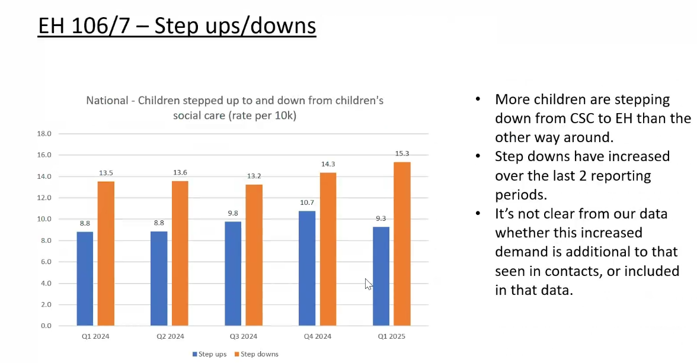
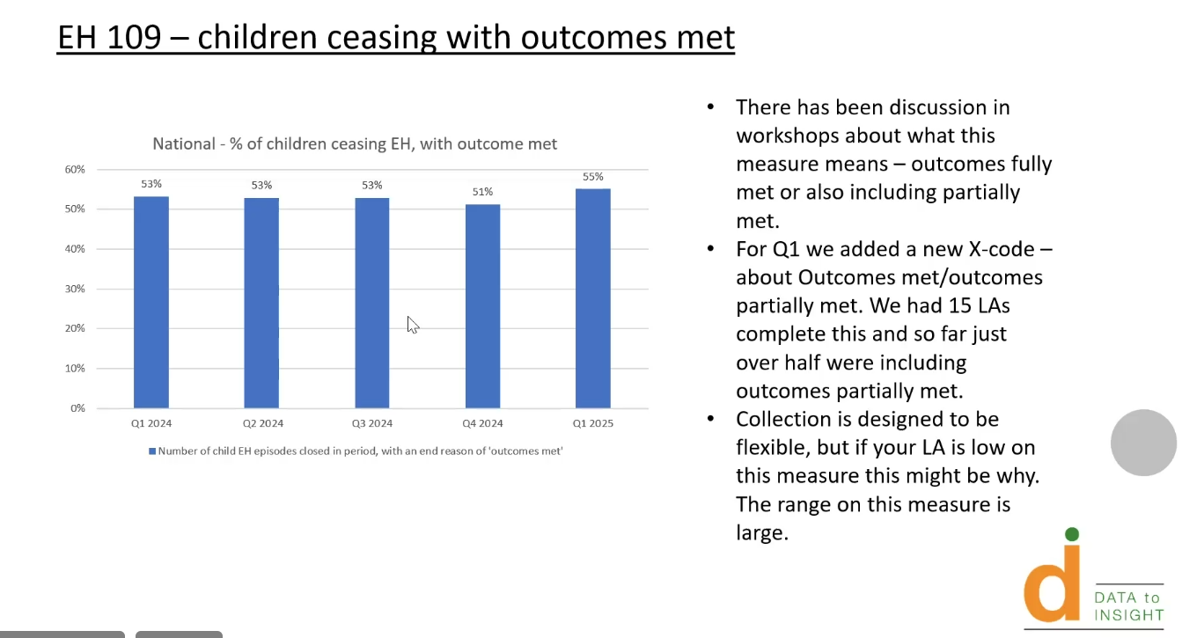
GS asked if LAs were doing anything locally to fill the gaps that JF had identified. RPD said we only use evidence based programmes as interventions.
AT said in Surrey are using the supporting families framework to help focus on outcomes
CL said in East Sussex they are focusing in next 18 months to strengthen level 2 offer in the VCS in recognition that the LA can’t do everything. EH and Social care struggle to ‘close with confidence’ if we had more confidence in capacity in the system we would lower our re-referral rate from 25%. The demand is huge and we need to work more coherently with partners that is a system wide approach.
AHO said it would be helpful to understand the LAs that have received family hub funding or have progressed with their family help model to see if there were better outcomes in those cohorts.
Action: JF will look at the cohorts of LAs that have received family hub funding or are family help pathfinders to see the impact on the 9 measures in the early help dataset.
Action: RE to email GS with the LAs who are not submitting to follow up with DCSs as they may not be aware.
AJ said in Bracknell Forest they have a different position as referrals have gone down, but not to pre-covid level. Children with SEND were coming in at a much lower rate than others in terms of re-referral. The trend around fewer children stepping up than stepping down. Like Surrey we use the Supporting Family outcomes. There is a big focus on schools and the third sector, but the step down into the rest of the system still needs more work.
ITEM 2: Supporting families
GS reflected that we all had been chasing government for some time and there has been some good news regarding funding continuation. There is an expectation that LAs will continue to use the funding for the purposes intended at the same level for 2024/25.
Funding from last period is agreed again and the payment by results for the rest of the financial year is suspended. Guidance is still to follow about whether or not the ring fence will be maintained or conditions of the grant will be (so there may be a risk in some LAs that it will be used for other priority areas).
GS shared that it would be helpful for EH leaders to speak to directors of finance
CL said we have had to give notice on one of our contracts because the notice came so late. There is no ring fence and so there is still a lot of uncertainty. It felt safer to do it that way around.
AC said we have managed to hold on to core council staff and similarly we have shared with providers that funding is uncertain and so they have put people on notice. They are looking to us as the LA for bridging plans and we don’t know which is a very challenging position.
AT said in Surrey as a two tier we used to distribute part of districts and boroughs, but we have given notice on all those contracts and that has caused pressure. We are all in that waiting phase around the specifics and are trying to navigate it very quickly.
CH said that they had heard that the payment by results element would totally go. GS said this would be a big reduction in terms of investment in the system.
AHO said they are in the same position in Portsmouth about giving notice on contracts due to 3 month notice period. We were told that mid-November we should know, and whilst it is reassuring to know money is coming it is really late in the year.
SC said same in West Berks - notice given on all SF funded roles/contracts/commissioned services, sadly.
Point for escalation and discussion: GS teasing out that the overall investment/funding coming in will be less and that this needs to be called out.
CL said SF grant covers all sorts of services up to level 4, the worry without the ring fence we will just be able to prop up statutory but transformation and reform will be extremely difficult.
CH said: n West Sussex we deliver the programme entirely in house so like everyone we are waiting to find out how much grant we will be allocated from the transformation grant and the children and families grant
Discussion: GS asked for reflections around a new family support offer and how that is going to be legislated for: Keeping children safe, helping families thrive - GOV.UK (published Nov 2024). A lot of mention of statute, although no timelines and it was silent on the impact of this on partners. It was explicit around LAs, but less so regarding partners, and there is a risk that unless partners are mandated to take on additional responsibilities they are unlikely to do so.
AT said they are trying to process it all.
Action: Next meeting to discuss how LAs are responding to the reforms.
Action log: This action log was updated on 27 Feb 2025 Shaded actions are closed or complete
 | Action | Responsible | Date issued | Status
45 | JF will look at the cohorts of LAs that have received family hub funding or are family help pathfinders to see the impact on the 9 measures in the early help dataset. (to report in June) | JF | Dec 2024 | Open
44 | RE to email GS with the six LAs who are not submitting EH data to follow up with DCSs as they may not be aware. Complete (not sure if GS has chased DCSs) (Buckinghamshire, Isle of Wight, Milton Keynes, Portsmouth, Southampton, West Berkshire ) | RE | Dec 2024 | Open
43 | HH to present the headline findings and themes from Oct 2024 National Centre for Family Hubs Conference: Shaping the future of family support | HH | Sept 2024 | closed
42 | SM from domestic abuse commissioner to present at future meeting on findings relating to early help | SM/RE | Sept 2024 | closed
41 | GS to escalate via ADCS and South East DCSs on any further news re: funding for Supporting Families | GS | Sept 2024 | closed
40 | DL to follow up with SC West Berks, ES Oxfordshire, CL East Sussex on community based family hubs. | DL | June 2024 | closed
39 | Reps to get in touch with CD if you can volunteer to be part of the oversight and development group around complications relating to excess weight from each ICB. RE will write out. Donna Leedham and Adam Thomas volunteered. CD to circulated terms of reference. | RE | June 2024 | closed
38 | ES said she would be interested if any other LAs could share how they report on outcomes/impact from Comm EH. If anyone is doing this well would like to hear from you - emily.smout@oxfordshire.gov.uk | All | June 2024 | closed
37 | Agree focus of next meeting in June to be on first lot of Early Help benchmarking | RE/JF | Mar 2024 | complete
36 | Contact Dan Council for disabled children via Daniel Stavrou dstavrou@ncb.org.uk if you would like to access the support presented at the regional meeting (free for Family Hub funded LAs) | All | Dec 2023 | complete
35 | Only Brighton and Hove, Slough and East Sussex have submitted full data for the EH data benchmarking. If your LA wants to submit and benefit from full benchmarking please contact John Foster. John.foster@eastsussex.gov.uk | All | Dec 2023 | complete
34 | AJ to brief GS on escalation regarding Supporting People and provide feedback to group | AJ/GS | Dec 2023 | complete
33 | DL and BS to work with RE to draft escalation letter regarding supporting families | DL BS RE | Dec 2023 | complete
32 | DL to share contact details of Surrey EH lead (Adam Thomas) | DL | Dec 2023 | Complete
31 | Themed discussion on Payment by results for supporting families at next meeting | All | Sept 2023 | closed

