# Notes and action log Text Description automatically generated with low confidence South East regional Early Help network

Attendees: **Chair Grainne Siggins** DCS Bracknell Forest

**Meeting details:** June 17 2024 10.30 -12 via MS teams

**Attendees:**

Amanda Hales-Owen (Portsmouth), Jo Templemen (Brighton and hove), Anna Clarke (IoW seconded to cover Carly’s maternity), Charlene Hornsey (West Sussex), Jonny Bradish (Brighter Futures/Reading), Celia Lamden (East Sussex), Carly Bain (IOW), Eliza Marland (Oxfordshire), Steph Coomber (West Berks), Marize Viljoen (Southampton), Steph Mountain (Southampton), Rachael Park Davis (RBWM), Audrey Johnson (Bracknell Forest), Jhaswinda Bathe (Slough), Adam Thomas (Surrey), Sophie Butt (Hampshire), Julie Greer (Anna Freud), Huma Haque (Anna Freud), Charlotte (NHS), Emily Smout (Oxfordshire). Donna Leedham (Bracknell Forest)

Apologies: Donna Briggs (Slough), Kelly Cogger (Medway)

**ITEM 1: Introductions and review of action log**

The action log and minutes were agreed .

**ITEM 2: Data benchmarking**

JF said this is the first presentation of the data. Data to insight is funded by ADCS, DHLUC, DfE and hosted in East Sussex. The aim of the project is to undertake benchmarking to reduce burden on LAs. Data will be submitted in the same way as others. It is averages or anonymised but will let you see the content which is available for your LA. 70 LAs submitted in Q3. LAs have usually submitted historic so you will be able to compare against others and more than half in the country.

Data looks at initial contact per child (not per family) and show a decline in the summer months. There is also a similar pattern for cases opened.

CL reflected that it may be gaps in capacity and workers being off/vacancies. JF said It isn’t seen so much in social care the dip but that is an interesting point.

JF reflected that the spread of data is much more clustered around the average of 20% for recontact (new episode starting within 12 months of a previous episode) and it doesn’t show the summer Q2 dip. 20% is similar to social care. It may be that children already known are more likely to be picked up even over the summer.

See an increase in both starting and ceasing after Q2. The numbers open are pretty stable around 200.

There does not appear to be a correlation between EH and social care/CIN. Very slight correlation for levels of EH and social care. CP plans no relationship at all, but CLA is a slight correlation. Around 0.3 would indicate a correlation. You may expect more EH to be correlated with lower CLA but perhaps what we are seeing is a reflection of need.

No real correlation between % of LSOA in 10% most deprived and EH (correlation coefficient of 0.21). This was surprising to attendees at the meeting, and perhaps agree with JFs suggestion that the wrong measure of deprivation is being used.

Data also presented step up and step down. The flow is that more children are going from social care to early help, than the other way, but the flow is increasing over time.

The final data looks at outcomes and it Looks like in about 50% of cases outcomes are met.

ES (Oxfordshire) asked if this is community or LA early help. JF said it was down to LAs to define.

**Action:** ES said she would be interested if any other LAs could share how they report on outcomes/impact from Comm EH..if anyone on the call is doing this well would like to hear from you - [emily.smout@oxfordshire.gov.uk](mailto:emily.smout@oxfordshire.gov.uk)

AJ reflected they are looking at different measures around both outcomes and timeliness in Bracknell Forest. AJ says most of the data makes sense, apart from the lack of correlation between deprivation and EH. JF agreed and said further consideration about the deprivation might be helpful.

The tool is on the data to insight website and you can choose the LAs you compare against.

CH said if we look at key worker in West Sussex it would be in those areas of deprivation, but the broader work on school avoidance, mental health is reaching right across and outside of those areas of high deprivation.

**Action;** All to identify any additional lines of enquiry that people would like picked up.

**ITEM 3: Family Hubs**

JG said she has been Regional Improvement advisor since 2021 and cover south east and south west in one day a week, and Huma will be taking the role on going forward. Huma said she works at the national centre for family hubs. HH said she has been out to IoW and plans to come to visit more LAs in the South East. A number of things coming up have had to be paused due to purdah. JG was hoping to pull together a resource relating to attendance but that has been paused.

A new piece of research for the DHSC looking at barriers for LA on Start for Life. We will share the link as soon as it is available.

Dingley’s Promise Changemakers, Southampton is already involved, this is training for EY. If you are not aware please do share out with your VCS as well.

JG shared reflections from recent IoW visit on what was particularly successful:

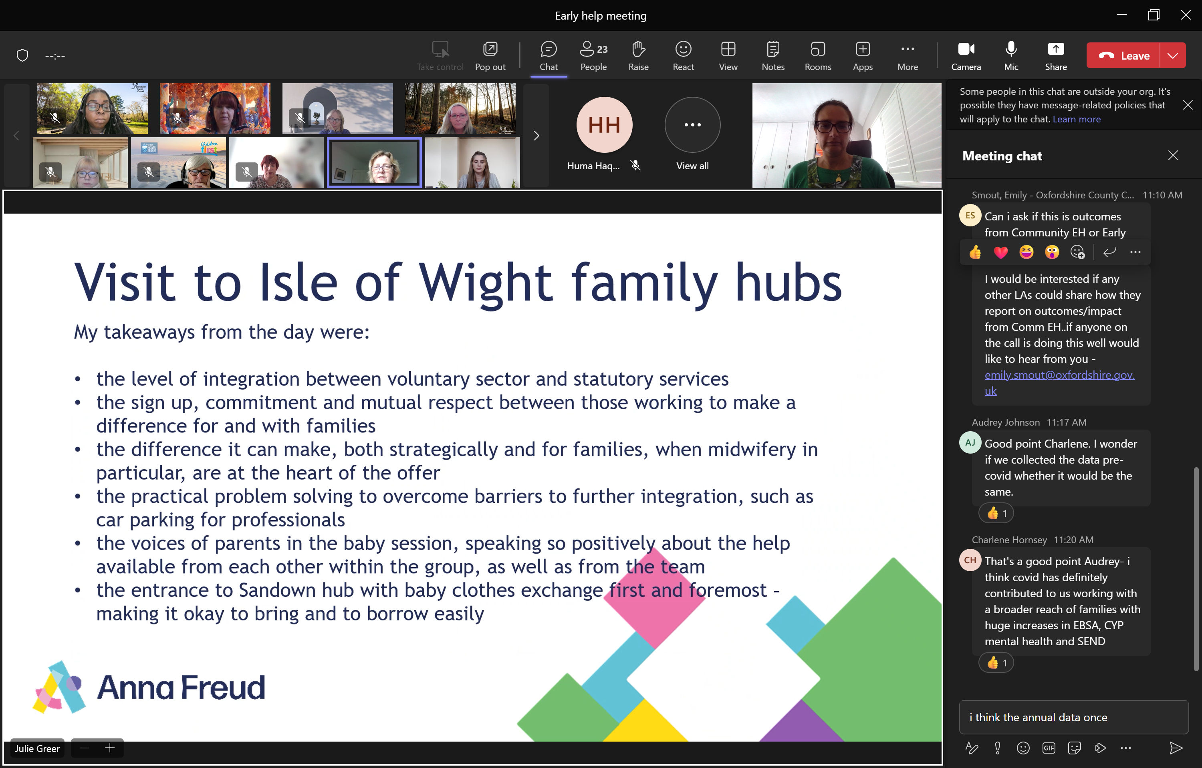

JG shared the research relating to early pregnancy support.

JG also shared train the trainer 4 day intensive training for those who work with children and young people with autism.

CD shared clinics that are set up relating to complications relating to excess weight. There is one in Surrey and one in Hampshire and IoW and CD was looking to set up an oversight and development group for the region and was looking for volunteers for quarterly meeting.

**Action:**  Reps to get in touch with CD if you can volunteer to be part of the oversight and development grop around complications relating to excess weight from each ICB. RE will write out. Donna Leedham and Adam White volunteered. CD to circulated terms of reference.

The DA Commissioner’s office will be preparing a report that will consider how children are affected by domestic abuse. As a part of this, they would like to understand what provision is available in family hubs and the role family hubs play in supporting families in this area of work.  Two focus groups have been organised to hear views and feedback from family hubs. Both are on **16th July** and participants need to register by following the link in each PDF attached (and see email below). The groups are as follows:

* For strategic leaders at 2.00 – 3.30pm [Microsoft Virtual Events Powered by Teams](https://events.teams.microsoft.com/event/66745982-a555-4abf-b926-5ce274c2d12b@f24d93ec-b291-4192-a08a-f182245945c2)

* For front-line staff from 11 – 12.30 [Microsoft Virtual Events Powered by Teams](https://events.teams.microsoft.com/event/2538ad3b-c60d-4e77-906d-a679522deebe@f24d93ec-b291-4192-a08a-f182245945c2)

**How are LAs delivering family hubs:**  DL wanted to ask which LAs are delivering a community-based model? CL in East Sussex, we are a huge county we have 12 family hubs that have transformed from children’s centres. We are integrated with health visiting, GPs don’t really want to share their space, we are trying in Eastbourne, an area of high need, we are struggling to find appropriate community space. Some public services have turned into housing. It is a great idea, but we have struggled to bring it into fruition.

Steph Coomber in West Berks, we don’t do it, but we would like to. Family hubs sit under education and we are looking to bring it into childrens and do exactly that. Would be interested to learn more together.

ES Have locality community support offer and happy to discuss that with you (Oxfordshire isn’t funded for Family hubs.

**Action:**  DL to follow up with SC West Berks, ES Oxfordshire, CL East Sussex on community-based family hubs.

**ITEM 4: Standing items:**

**• issues for Grainne to escalate to DCS colleagues**

Grainne shared the feedback from the Supporting People escalation from before Christmas. It is pasted below:

1. **Changes in eligibility:**As you may be aware, as part of the third phase of the programme, there was a change to the framework around Supporting Families, and also changes to how that framework is being applied.  These changes mean that from October 2023 onwards that cases need to meet three out of ten criteria in order to be considered eligible under the programme (up from 2 criteria previously).  At our regional South East Early Help meeting it was noted that this shift has perhaps caused some unintended consequences, with families who are in receipt of holistic, system-wide and preventative early help(the core intended beneficiaries of the programme) no longer being deemed eligible.  Officers are noting that cases in the cohort are now being increasingly drawn from social care in order to meet the eligibility criteria.

The new Supporting Families outcomes framework was implemented following large scale involvement and co-production with colleagues in local government and other government departments. As a framework it is intended to enable a broader, comprehensive and standardised approach to identification needs and outcomes for families which gives a framework for PbR claims but more broadly to understand the needs and outcomes of all families supported in local areas. In terms of claims we have worked closely with areas to understand the impact of the shift from 2 in 6 to 3 in 10 – some areas initially reported an increase in families they could identify, and others a decrease. We have been encouraging areas who have seen a decrease to look at the detail behind the recording of needs and outcomes and many have found that case recording wasn’t necessarily reflecting the full needs of the family and therefore more families were eligible than the data was originally indicating. We have seen many areas using the new Outcomes Framework to re-visit and re-focus on the importance of whole family working to ensure that all needs are appropriately identified and worked with (increasing the chance of good outcomes and sustainability) and are also subsequently recorded correctly. In terms of social care, we have also encouraged areas to include social care families – whilst the programme’s main focus is increasing activity and improving practice in Early Help Systems, we also want to see whole family working happening in children’s social care.

However, we have recognised the challenges a number of areas have raised with us in relation to the funding and delivery environment and as a result Minister Johnston has agreed to increase the proportion of upfront funding and reduce the funding connected to payment by results in 24/25. This change is intended as a marker to underline the importance of this preventative support for the long-term stability of the sector, which is a shared priority across local and central government. Individual funding allocations were issued to areas at the end of February. We hope this supports your continued investment and development of the Early Help System.

1. **Claim window:** As the Supporting Families programme draws to a close in March 2025, and because of the need to demonstrate sustained change over six months in order to make a claim, it means that the final families for whom LAs will be able to claim will need to be closed by September 2023. This effectively shortens the case working period by six months, with the final year of implementation only operating for six months. This is not reflected in the targets that have been set for individual LAs, which are greatest in this final year.

This has been a feature of the programme since it began due to the 6 months sustainment period. For this particular phase, whilst those families supported in the last 6 months would not be eligible for claim under this phase of the programme, it is also true that claims submitted from April 2022 would have been for families supported prior to April 2022, in effect meaning there is still 3 years of delivery. In terms of your request, unfortunately we are unable to extend the claim period to September 2025. We are unable to commit to funding beyond the current spending review period which an extension to the claim window would require.

1. **Private company:** A company, involving three ex-employees from the National Supporting Families Programme, has been proactively contacting Local Authorities around the country. This company is offering to help with data analysis and data manipulation to increase the cohort of eligible claims that LAs are able to make. This company is charging on a payment by results basis (with £300 per successful fee claim being paid to the company).

We are aware of a company fitting the description, and also others who are working with LAs and partners to develop data maturity. The programme does not have any affiliation with this company and has not contracted them to do any work on behalf of the programme. Alison has discussed this with Supporting Families colleagues in the South East region and their concerns. Our advice for LAs and partners would be to ensure that any engagement with private companies considers how any contracted work supports the overall vision for the medium and long term in the local area, and doesn’t focus solely on short term gains.

SB thanked the group for escalating and said it was helpful feedback. CH said we never had an issue up until last year, we did do some intensive work and we hope we can continue on the trajectory. 30-40% of CIN work was claimable and that will make a difference. JT we are way off our targets, the increases were very significant but the funding didn’t touch the sides. We are counting social care but we have started to do that. We are also at significant risk.

**• ideas for projects for future consideration**

No new ideas

**• agreeing themed discussion for next meeting**

Adam Thomas, Surrey on JTAI, Siobhan Gazely DfE and standing items.

**AOB:**  None

**Action log:** This action log was updated on June 17 2024. Shaded actions are closed or complete

|  |  |  |  |  |
| --- | --- | --- | --- | --- |
|  | **Action** | **Responsible** | **Date issued** | **Status** |
| **40** | DL to follow up with SC West Berks, ES Oxfordshire, CL East Sussex on community based family hubs. | DL | June 2024 | open |
| **39** | Reps to get in touch with CD if you can volunteer to be part of the oversight and development group around complications relating to excess weight from each ICB. RE will write out. Donna Leedham and Adam Thomas volunteered. CD to circulated terms of reference. | RE | June 2024 | closed |
| **38** | ES said she would be interested if any other LAs could share how they report on outcomes/impact from Comm EH. If anyone is doing this well would like to hear from you - [emily.smout@oxfordshire.gov.uk](mailto:emily.smout@oxfordshire.gov.uk) | All | June 2024 | closed |
| **37** | Agree focus of next meeting in June to be on first lot of Early Help benchmarking | RE/JF | Mar 2024 | complete |
| **36** | Contact Dan Council for disabled children via Daniel Stavrou dstavrou@ncb.org.uk if you would like to access the support presented at the regional meeting (free for Family Hub funded LAs) | All | Dec 2023 | complete |
| 35 | Only Brighton and Hove, Slough and East Sussex have submitted full data for the EH data benchmarking. If your LA wants to submit and benefit from full benchmarking please contact John Foster. [John.foster@eastsussex.gov.uk](mailto:John.foster@eastsussex.gov.uk) | All | Dec 2023 | complete |
| 34 | AJ to brief GS on escalation regarding Supporting People and provide feedback to group | AJ/GS | Dec 2023 | complete |
| 33 | DL and BS to work with RE to draft escalation letter regarding supporting families | DL BS RE | Dec 2023 | complete |
| 32 | DL to share contact details of Surrey EH lead (Adam Thomas) | DL | Dec 2023 | Complete |
| **31** | Themed discussion on Payment by results for supporting families at next meeting | All | Sept 2023 | closed |
| **30** | John to circulate list of LAs who haven’t submitted data to EH benchmarking | JF | Sept 2023 | closed |
| **2**9 | Refresh our understanding of timetable for stable homes built on love especially EH and CIN service implications , GS to update as a standing item | GS | Sept 2023 | closed |
| **28** | CB to circulate description of differently qualified workers in Hampshire and present at next meeting (Carly Bains) (CB sends apologies so deferred to March 2024) | CB | Sept 2023 | closed |
| **27** | DL/AJ to share JD for new role in Bracknell Forest Family Support advisor coordinator that works with schools to build capacity. (Donna and Audrey) | DL/AJ | Sept 2023 | closed |
| **26** | Future item on early help and family hub strategies | RE | June 2023 | Complete |
| **25** | CL to circulate document from E Sussex (although not used anymore) on % time spent on various tasks | CL | June 2023 | Closed |
| **24** | Future item from Surrey on EH JTAI (Adam Thomas). Due for Sept | RE | June 2023 | Closed |
| **23** | EH benchmarking to be circulated with Hants data included | RE | June 2023 | Complete |
| **22** | RE to benchmark waiting list and caseloads. | RE | Dec 2022 | Complete |
| **21** | RE to develop case studies of EH workers from across the region to explain the journey and range of experience that can lead to a career in EH | RE | Dec 2022 | closed |
| **20** | RE and GS to meet and agree how to publish. RE to make changes required to the text and get a designed up version produced for next meeting | RE/GS | Dec 2022 | Complete |
| **19** | JF to set up separate meeting with Amanda Hales Owen to discuss data to insight EH project amanda.halesowen@solent.nhs.uk | JF | Dec 2022 | complete |
| **18** | All to let JF know if they want to be added to the EH data project mailing list | All | May 2022 | Complete |
| **17** | All to contact JG or CB if you want to be on Family Hub mailing list, receive or volunteer to write blogs, receive updates from workshops, research etc. | All | May 2022 | Complete |
| **16** | Future discussion on cost of living, Care review (EH and CIN being brought together), EH being required to support CAMHS cases due to long waiting lists | RE | May 2022 | Complete |
| **15** | Jo Templeman, Carl Burton, Stuart (Kent), Vicky Rhodes, Simon Dear (IOW) to get together to discuss narrative (and if possible data/finance) to explain business case for early help | RE to convene | May 2022 | Complete |
| **14** | All to provide feedback to CB and JG on how best to engage your LA around family hubs | All | Mar2022 | Complete |
| **13** | All contact Georgie to arrange user research interviews, and John on ideas for project scope. | All | Mar 2022 | Complete |
| **12** | RE to share raw responses from EH mapping with data to insight team | RE | Mar 2022 | Complete |
| **11** | KS to feedback on multi-agency (referral?) process at future meeting (Wokingham) | KS | Mar 2022 | Did not happen |
| **10** | Rachael (RPD)(achieving for children) to circulate EH strategy and partnership advisory board terms of reference | RPD | Mar 2022 | Complete |
| **9** | RE to map caseloads (combined with 22) | RE | Mar 2022 | Combined |
| **8** | RE to amend terms of reference naming SC as vice chair and upload to SESLIP website. RE to diarise ToR for annual review | RE | Nov 2021 | Closed |
| **7** | Data to insight to present quarterly to this group on progress of data accelerator | AL | Nov 2021 | Closed |
| **6** | JG to present quarterly to this group on progress of regional family hubs work | CB | Nov 2021 | Closed |
| **5** | RE to send benchmarking out to all 19 LAs and to summarise findings as item on next agenda | RE | Nov 2021 | Closed |
| **4** | All to contact CB on regional family hub offer of support | All | Nov 2021 | Closed |
| **3** | KP to share report on the impact of bringing together health and EH with Rebecca to circulate to the group | KP | Nov 2021 | Did not happen |
| **2** | AL to ensure learning from supporting families/troubled families influences the EH data accelerator | AL | Nov 2021 | Closed |
| **1** | Refresher data demonstration for the early help network at a future 2022 meeting | AL | Nov 2021 | Closed |