Notes and action log 
South East regional Early Help network
Sept 2024

Attendees: Chair Grainne Siggins DCS Bracknell Forest; Anna Clark (Isle of Wight), Siobhan Glazey (DfE family hubs), Amanda Hales-Owen (Portsmouth), Audrey Johnson (Bracknell Forest), Huma Haque (National Centre Family Hubs), Ingrid Crisnan (Kent), Jo Templeman (Brighton and Hove), Eliza Marland (Oxfordshire), Stephanie Mountain (Southampton), Rachel Park-Davies (Windsor and Maidenhead), Victoria Gibbs (Slough), Subhalaxmi Mukherji (domestic abuse commissioner), Adam Thomas (Surrey), Charlene Hornsey (West Sussex), Nikki Lloyd (Medway), Steph Coomber (west Berks), Victoria Gibbs (Slough), Vijoen Marize (Southampton) SESLIP Support: Rebecca Eligon
Meeting details: Monday 16 September 10.30-12
ITEM 1: Introductions and review of action log
The action log and minutes were agreed
ITEM 2: Sharing practice/themed discussion: Surrey Adam Thomas and colleagues to share surrey experience of early help JTAI 2023
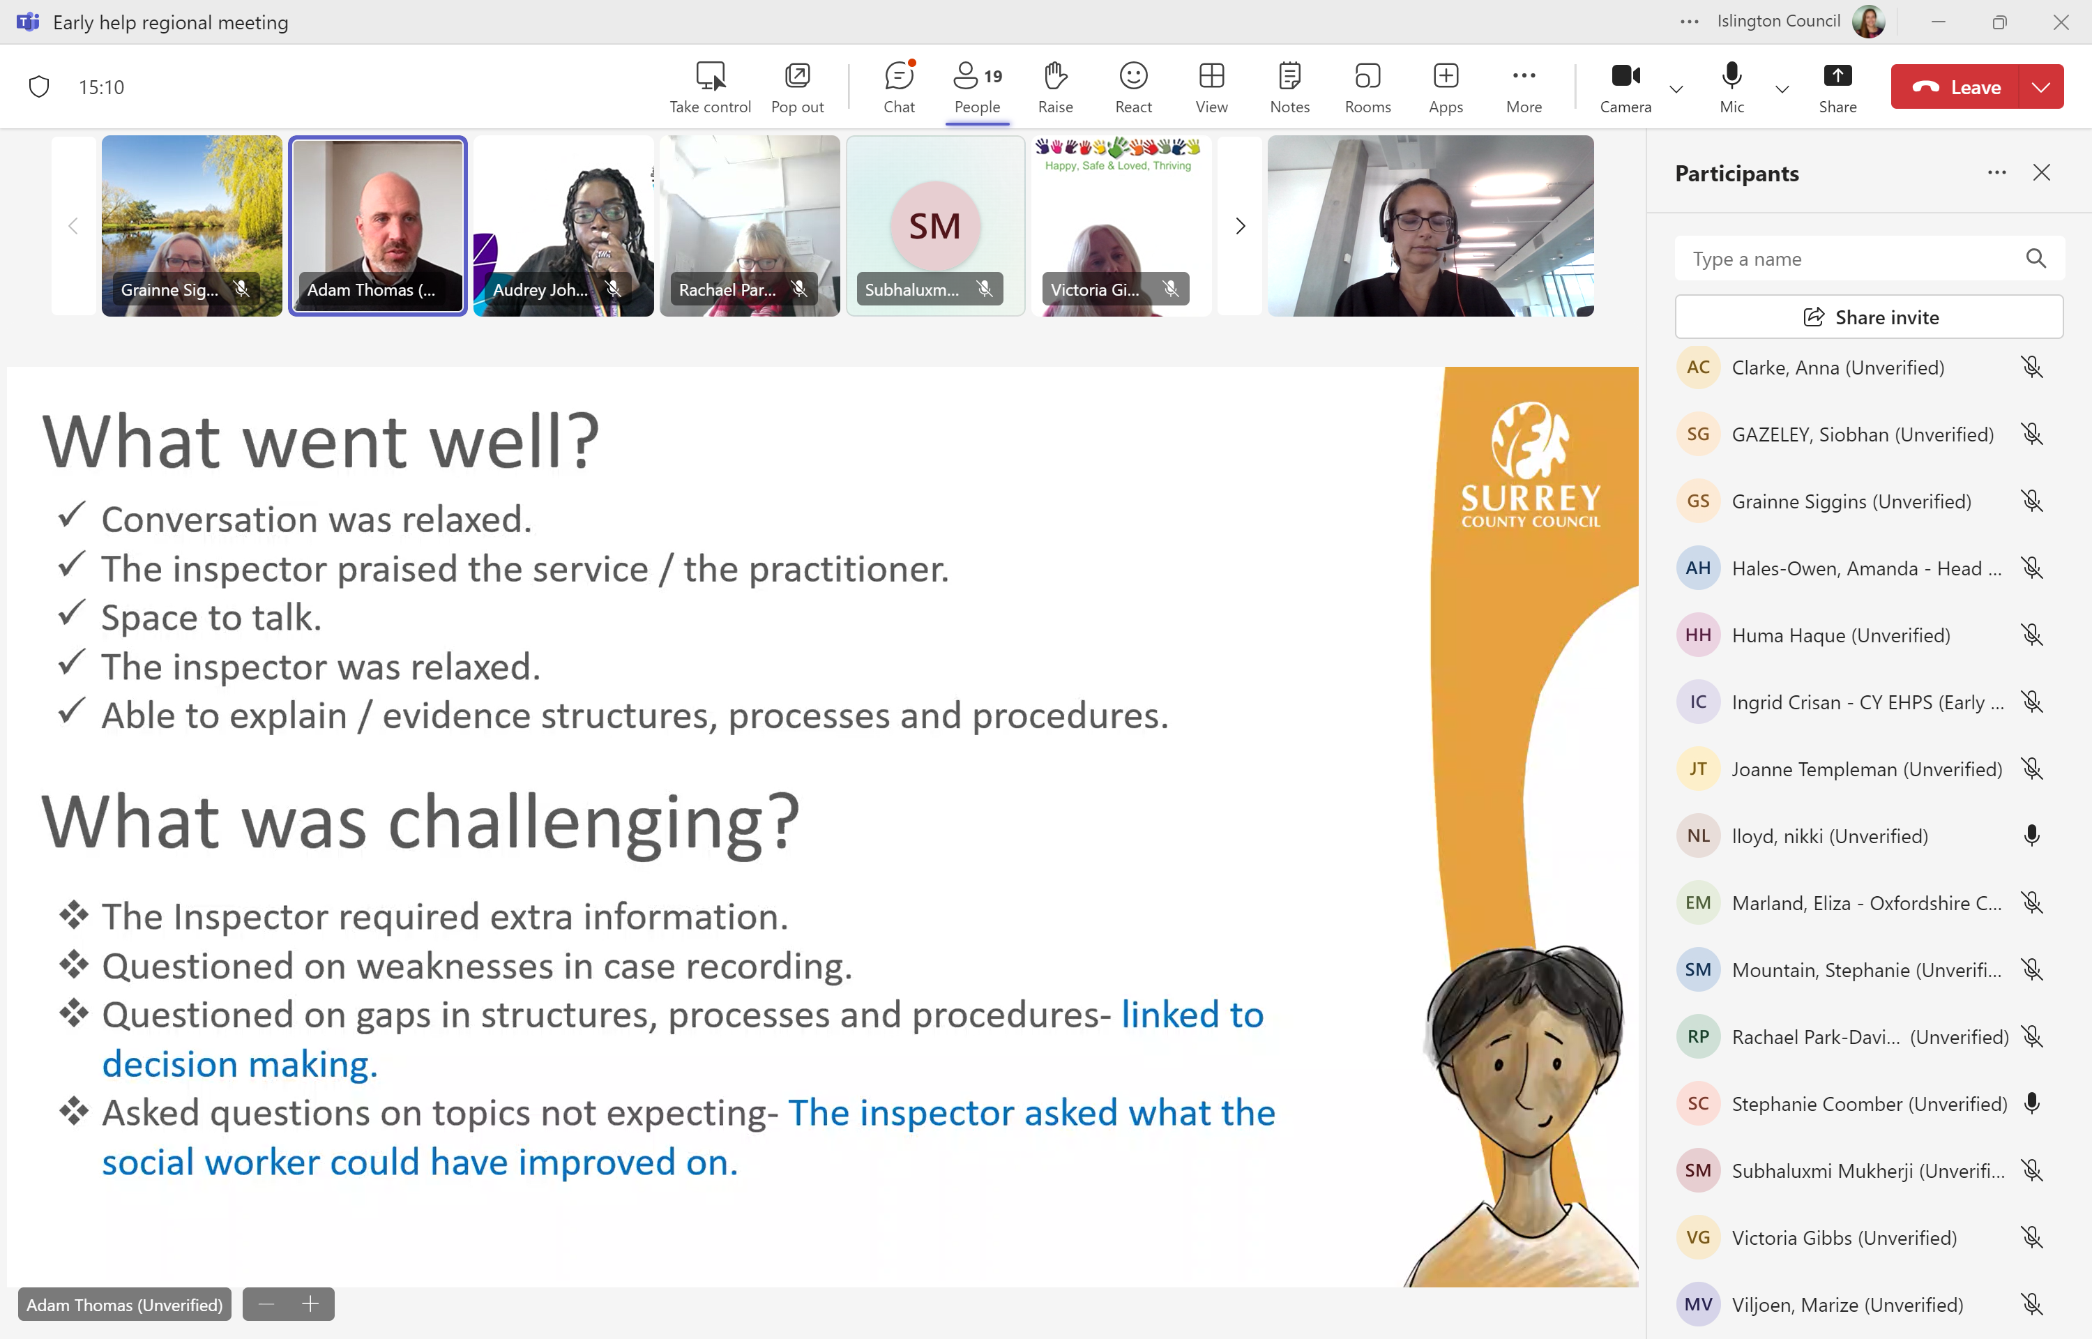
Inspection was held a while ago now in February 2023. Surrey was second LA to receive JTAI early help inspection. Had representations from police, health, education and Ofsted. It felt very Ofsted led. We were expecting more of a partnership focus, but it was very focused on thresholds, and front door. Was 2 weeks prep and 1 week on site. Deep dive on 6 children’s experience, joining meetings interviews etc. Audits felt quite social care focused. Some questions about medication. Repeated questions about thresholds, consent, decision-making, professional curiosity.
Experience was positive. A written statement of action was prepared and sent back in August. The JTAI actions were largely around statutory support, step up and step downs. 4 key areas for development – 1. clear robust governance with the right messages going to the executive. 2. The impact and flow of communication 3. Feedback for referrers and families when they are requesting support. 4. Clear purpose when specialists involved in wider teams around family.
GS asked What did frequency of MA audits look like? What difference did the inspection make? AT said it had made a difference.
RPD said their JTAI on front door also felt very intense and Ofsted focused, forensic in nature, so that is similar to the Surrey experience.
Eliza, had one in Gloucestershire, was very positive and felt very partnership focused. We left feeling good and so did partners.
ITEM 3: DfE intro: Siobhan Gazely, DfE south east delivery team lead for family hubs in the south east for the department for education.
SG explained their role was solely relating to family hubs, so wouldn’t be able to answer about wider early help or family help agenda. SG reflected there was much change within the department and things still have not been confirmed post election. Sg confirmed only have funding agreed until March 2025. There is a two stage process. There will be a budget 31 oct for 2025/26 and a longer term piece through spring to agree the multi-stage budget for future and longer term. DfE is currently focused on 2025/26.
AHO said they are keen to understand the impacts as soon as possible for staff as many on 3 month notice. SG has had similar feedback we have been making the case to have certainty by at least the end of Oct. SG said is early November good enough. SG will get back on rollover and get back.
RE asked if the same timescales for supporting families as for family hubs. SG said yes.
Action: Rebecca to follow up with Siobhan and Grainne to get clarity as soon as possible on funding
ITEM 4: Standing item: Family Hubs Huma Haque : South East Lead.
HH updated the group about upcoming South East Community of Practice sessions. Please email huma.haque@annafreud.org to attend. There is two more session scheduled for 11 december 10-11.30 and 26 February 10-11.30. HH also publicised the upcoming National Centre for Family Hubs Conference in October: Shaping the future of family support. VG asked what impact of the programme so far. GS noted that not all Las will be able to attend the national conference
Action: headlines from National Centre for Family Hubs Conference at the next meeting
ITEM 5: Domestic abuse: Subhalaxmi shared the work of the domestic abuse commissioner and opportunities to get involved. Action: SM to come to future meeting to share insights
ITEM 6: Supporting people: How are LAs preparing for closedown? What is it looking like in terms of hitting targets
In KCC SF funding is covering a lot of EH posts. We really need clarification – there are 56 family hubs across the county. There is no doubt that I would want Supporting Families rather than Family Help from a Kent perspective.
AJ said in Bracknell Forest we are looking at what we are funding and we hadn’t funded core staff, but had funded super numery through covid and whilst the numbers of referrals into EH have gone down, they have not declined to precovid level. We are in a good position in terms of meeting targets.
AT in Surrey they had someone from DfE talking about SF grant, it was very much what SG also said and they are aiming to give an answer by Oct 30. Said felt like less appetite for payment by results in this government. This government had heard the message that the system wants simpler longer term funding arrangements – that is obviously quite encouraging. In Surrey we use much of our Supporting Families grant to fund external services, and are in a similar position with added pressure from those providers and their staff
SC said In West Berkshire we also didn't fund core staff, we are applying for transformation funding to try and move some of the SF funded posts to perm roles now that we have tested them as fixed term and can evidence the 'worth/benefit' of having those roles. This is predominantly roles supporting my family plans (earlier help plans). We are struggling to meet the SF targets but if the funding did continue next year we are going to revisit where the funding sits (currently with YJST but would move to early response hub).
Action: GS to escalate/find out if any other info available via ADCS re: funding
ITEM 7: Standing items: No actions or items relating to the standing items
• issues for Grainne to escalate to DCS colleagues
• Any updates re: Stable Homes built on Love relating to EH/CIN (Grainne)
• ideas or projects for future consideration
• agreeing themed discussion for next meeting

Action log: This action log was updated on December 2 2024 Shaded actions are closed or complete
 | Action | Responsible | Date issued | Status
43 | HH to present the headline findings and themes from Oct 2024 National Centre for Family Hubs Conference: Shaping the future of family support | HH | Sept 2024 | closed
42 | SM from domestic abuse commissioner to present at future meeting on findings relating to early help (confirmed will present at first meeting in 2025) | SM/RE | Sept 2024 | In progress
41 | GS to escalate via ADCS and South East DCSs on any further news re: funding for Supporting Families | GS | Sept 2024 | closed
40 | DL to follow up with SC West Berks, ES Oxfordshire, CL East Sussex on community based family hubs. | DL | June 2024 | closed
39 | Reps to get in touch with CD if you can volunteer to be part of the oversight and development group around complications relating to excess weight from each ICB. RE will write out. Donna Leedham and Adam Thomas volunteered. CD to circulated terms of reference. | RE | June 2024 | closed
38 | ES said she would be interested if any other LAs could share how they report on outcomes/impact from Comm EH. If anyone is doing this well would like to hear from you - emily.smout@oxfordshire.gov.uk | All | June 2024 | closed
37 | Agree focus of next meeting in June to be on first lot of Early Help benchmarking | RE/JF | Mar 2024 | complete
36 | Contact Dan Council for disabled children via Daniel Stavrou dstavrou@ncb.org.uk if you would like to access the support presented at the regional meeting (free for Family Hub funded LAs) | All | Dec 2023 | complete
35 | Only Brighton and Hove, Slough and East Sussex have submitted full data for the EH data benchmarking. If your LA wants to submit and benefit from full benchmarking please contact John Foster. John.foster@eastsussex.gov.uk | All | Dec 2023 | complete
34 | AJ to brief GS on escalation regarding Supporting People and provide feedback to group | AJ/GS | Dec 2023 | complete
33 | DL and BS to work with RE to draft escalation letter regarding supporting families | DL BS RE | Dec 2023 | complete
32 | DL to share contact details of Surrey EH lead (Adam Thomas) | DL | Dec 2023 | Complete
31 | Themed discussion on Payment by results for supporting families at next meeting | All | Sept 2023 | closed
30 | John to circulate list of LAs who haven’t submitted data to EH benchmarking | JF | Sept 2023 | closed
29 | Refresh our understanding of timetable for stable homes built on love especially EH and CIN service implications , GS to update as a standing item | GS | Sept 2023 | closed
28 | CB to circulate description of differently qualified workers in Hampshire and present at next meeting (Carly Bains) (CB sends apologies so deferred to March 2024) | CB | Sept 2023 | closed
27 | DL/AJ to share JD for new role in Bracknell Forest Family Support advisor coordinator that works with schools to build capacity. (Donna and Audrey) | DL/AJ | Sept 2023 | closed
26 | Future item on early help and family hub strategies | RE | June 2023 | Complete
25 | CL to circulate document from E Sussex (although not used anymore) on % time spent on various tasks | CL | June 2023 | Closed
24 | Future item from Surrey on EH JTAI (Adam Thomas). Due for Sept | RE | June 2023 | Closed
23 | EH benchmarking to be circulated with Hants data included | RE | June 2023 | Complete
22 | RE to benchmark waiting list and caseloads. | RE | Dec 2022 | Complete
21 | RE to develop case studies of EH workers from across the region to explain the journey and range of experience that can lead to a career in EH | RE | Dec 2022 | closed
20 | RE and GS to meet and agree how to publish. RE to make changes required to the text and get a designed up version produced for next meeting | RE/GS | Dec 2022 | Complete
19 | JF to set up separate meeting with Amanda Hales Owen to discuss data to insight EH project amanda.halesowen@solent.nhs.uk | JF | Dec 2022 | complete
18 | All to let JF know if they want to be added to the EH data project mailing list | All | May 2022 | Complete
17 | All to contact JG or CB if you want to be on Family Hub mailing list, receive or volunteer to write blogs, receive updates from workshops, research etc. | All | May 2022 | Complete
16 | Future discussion on cost of living, Care review (EH and CIN being brought together), EH being required to support CAMHS cases due to long waiting lists | RE | May 2022 | Complete
15 | Jo Templeman, Carl Burton, Stuart (Kent), Vicky Rhodes, Simon Dear (IOW) to get together to discuss narrative (and if possible data/finance) to explain business case for early help | RE to convene | May 2022 | Complete
14 | All to provide feedback to CB and JG on how best to engage your LA around family hubs | All | Mar2022 | Complete
13 | All contact Georgie to arrange user research interviews, and John on ideas for project scope. | All | Mar 2022 | Complete
12 | RE to share raw responses from EH mapping with data to insight team | RE | Mar 2022 | Complete
11 | KS to feedback on multi-agency (referral?) process at future meeting (Wokingham) | KS | Mar 2022 | Did not happen
10 | Rachael (RPD)(achieving for children) to circulate EH strategy and partnership advisory board terms of reference | RPD | Mar 2022 | Complete
9 | RE to map caseloads (combined with 22) | RE | Mar 2022 | Combined
8 | RE to amend terms of reference naming SC as vice chair and upload to SESLIP website. RE to diarise ToR for annual review | RE | Nov 2021 | Closed
7 | Data to insight to present quarterly to this group on progress of data accelerator | AL | Nov 2021 | Closed
6 | JG to present quarterly to this group on progress of regional family hubs work | CB | Nov 2021 | Closed
5 | RE to send benchmarking out to all 19 LAs and to summarise findings as item on next agenda | RE | Nov 2021 | Closed
4 | All to contact CB on regional family hub offer of support | All | Nov 2021 | Closed
3 | KP to share report on the impact of bringing together health and EH with Rebecca to circulate to the group | KP | Nov 2021 | Did not happen
2 | AL to ensure learning from supporting families/troubled families influences the EH data accelerator | AL | Nov 2021 | Closed
1 | Refresher data demonstration for the early help network at a future 2022 meeting | AL | Nov 2021 | Closed

