February 2024 Notes and action log 
South East regional Kinship network

Chair Dr Mac Heath, DCS Milton Keynes
Meeting details: 26 February 2024 2-3.30pm
Item 1: Introductions: MH welcomed the group to the third meeting of the Kinship SESLIP network. He confirmed the increasing importance of kinship to the region and the establishment of this group, as a clear signal of intent and commitment to growing our practice and creating space for senior leaders in Kinship across the South East.
Item 2: Update from Kinship on national Kinship strategy: Lucy Peake, Chief Executive from Kinship presented on the National Kinship strategy.
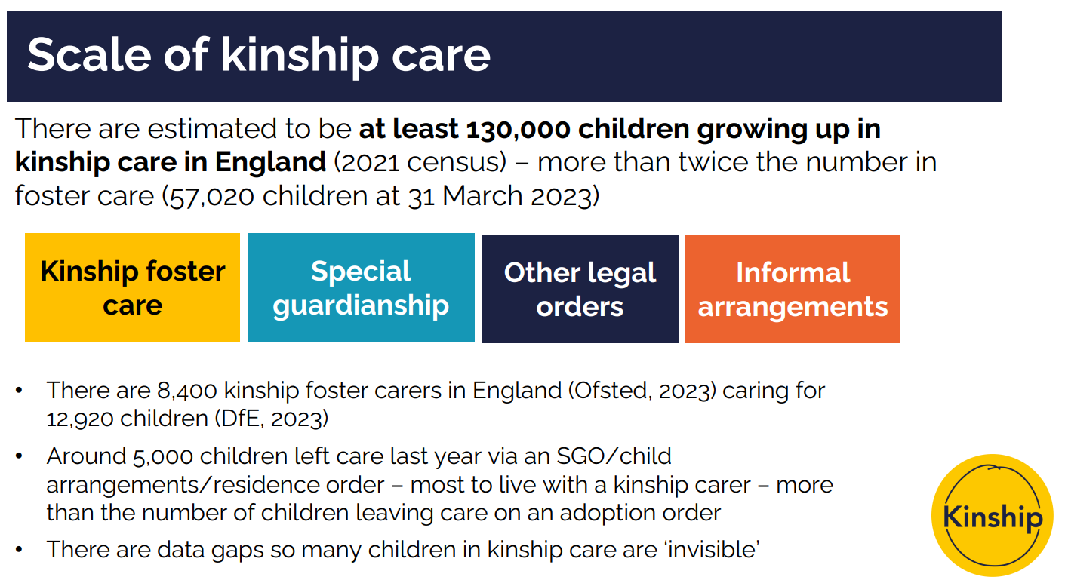
Lucy Peake covered the main scope of the National Kinship Care Strategy for England newly published December 2023
- Sets out Government’s plans, new commitments and £20m investment over 2024-5
- Some progress, but lacks required ambition and investment
- Some support still determined by legal order
Financial allowances
- 4-year trial in up to 8 local authorities
- Special guardians who care for previously looked after children will receive allowance at same rate as fostering allowance
- 67% children in kinship care growing up in deprived household (census, 2021)
Extended educational support
- Expansion of Virtual School Head role to champion educational attendance, attainment and progress of all children in kinship care
- In addition, kinship carers with an SGO or CAO, regardless of whether or not the child was previously in care, will be able to access advice and information from the Virtual School, on request
A renamed Adoption and Special Guardianship Support Fund, from January 2024
- Provides funding for Regional Adoption Agencies or local authorities to pay for therapeutic support for children in kinship care, limited to those previously looked after with a SGO or CAO.
- Only 13% applications to ASF were for special guardianship families
Supporting kinship carers at work
- New Government guidance published – best practice for supporting kinship carers at work, including adapting HR policies and signposting to support
- DfE will introduce new leave and pay entitlements for kinship carers in its own workforce
- Government encourages employers to follow Kinship’s Kinship Friendly Employer Scheme – early adopters are John Lewis, Tesco and cardfactor
Information, training and support for kinship carers, including peer support
- Strategy reaffirms Government’s commitment to establishing a new national offer of training and support for all kinship carers
- Kinship awarded £3m/18 months contract to design and deliver a bespoke package for all kinship carers, including informal carers, launching April 2024
- Partners include NAVSH, Place2Be, Anna Freud and BookTrust
- We’re involving kinship carers in the design and delivery of the service and want to collaborate with local authorities to develop and connect services and support
- Strategy commits to further funding for national Peer Support Service for all kinship carers (currently delivered by Kinship until June 2024)
Governance and strategic
- National Kinship Care Ambassador
- National Kinship Care Advisory Board and Kinship Care Reference Group
- Engaging and supporting family networks earlier
- Updated Kinship Care Statutory Guidance for Local Authorities, expected Spring 2024 – will seek to improve standards and consistency in local authority practice
- New definition of kinship care introduced
- Improving local authority practice, including through Ofsted (more training for inspectors and greater clarity of focus on kinship care in inspections)
- Law Commission review of legal orders
- Data on kinship care – linking DfE and MoJ data sets to understand more about formalised kinship care; systematic review of research to be published Spring 2024, identifying what works to improve children’s outcomes
- Independent advocacy for children in kinship care to help them understand their rights and entitlements
Item 4: Standing items: No issues for escalation.

Action log: This action log was updated on 13 Nov 2024. Shaded actions are closed or complete
 | Action | Responsible | Date issued | Status
9 | RE to organise regional kinship care conference for the summer | RE | Feb 2024 | complete
8 | RE to circulate presentations from Nov 2023 meeting | RE | Nov 2023 | Complete
7 | All to get in touch with Fiona Summers or LP or kinship directly via their website to explore how South East Kinship carers can benefit from the training programme. | All | Nov 2023 | Complete
6 | terms of reference agreed and to be published on SESLIP website | RE | June 2023 | Complete
5 | detailed discussion at next meeting on learning from different approaches to resourcing kinship. | RE | June 2023 | Complete
4 | West Sussex (Bridget McDermott) to send kinship charter to RE to circulate to rest of group | RE | June 2023 | Complete
3 | RE to incorporate further data from LAs and to recirculate benchmarking ahead of next meeting | RE | June 2023 | Complete
2 | Focused future discussion on ASF. Is there appetite to fund a regional ASF SG champion/support worker to have a practical role at increasing ASF coming into the region for SGOs? | RE | June 2023 | Complete
1 | All to confirm to RE the lead representative/s for your LA going forward. | RE | June 2023 | complete

Future meeting 2024 dates:
- 16 Nov 2.30-4pm (focused discussion resourcing kinship teams)
- 26 February 2-3.30pm (focused discussion on national kinship strategy)
- 16 May 2-3.30pm (focused discussion ASF)
- 16 July 2-3.30pm

