# Fostering regional group meeting notes and action log March 2024

Chair: Sarah Daly DCS Portsmouth

**Meeting details: February 27 2024 11-12.00 via MS Teams**

Attendees: Carly Arnold Southampton, Rebecca Blunn, Hampshire, Kate Chapman Oxfordshire, George Mathew Slough, Matthew Edwards AfC, Julie McNally Oxfordshire, Peter Hodges Bracknell Forest, Selena Makepeace Bucks, Sarah Smith Hampshire, Yemi Ukwenu Slough, Saima Arif Slough, Gemma Pavey Brighton and Hove, Sinead Roche , Berni Farmer IOW, Joanne Kearney, Mark Vening Kent

**1.Introductions, review minutes and action log**

Minutes and action log from last time were agreed

**2. Open discussion: Working with ISWs on fostering assessments and how to get the best out of them. All to share practice on challenges and what is working well.**

SD reflected that in Portsmouth there I some use ISWs to address for fluctuations in demand (used 1-2 in last year). We were worried that we might lose them as we shifted our practice away from using them.

YU and MG reflected that in Slough tried to use an ISW to cope with an influx but we had a negative experience and so try to stick in house. We need to look at who is available and with positive recommendation.

CA in Southampton said we only had to use in the last 5 months and we needed social workers to do supervising social worker roles rather than assessments. Had a few teething problems, identifying skilled ISW in form F. We do have a couple that we will continue to use. We have had practical issues around paying them which hasn’t been helpful. Seeing an improvement in quality of assessments and timeliness. We are still assessing the pros and cons and using it going forward.

ME shared in AfC that they are looking at the work in three parts 1. viability and assessment work 2. frontline social work and 3. the connected carers. ME reflected that they are flatlining on Form Fs, we have a huge amount of viability and connected work and that is where the demand is.

SD asked are we leaning in to ISWs when we are in bulges in assessment need or is it about covering vacancies?

PH said in Bracknell Forest, being in a small unitary we have a limited capacity and when we don’t have a full team we go out to ISWs. Are there opportunities to work as a region more consistently with ISWs that people we would recommend.

PH said they also have staff who have capacity to do work outside contracted hours.

SS said in Hants their ISW luckily have worked with HCC for a long time so we don't find the same issues others are having  and because HCC are large and have separate teams we don't have the issue of competing need as some others do. We only use ISW's for influx, we don't have any vacancies in the assessment team

**Action: see if there are any staff or ISW who can work across south east**

**3.Practice sharing – Oxfordshire**

Oxfordshire shared practice in relation to a new post introduced a year ago and practice over the last year. Employed a FT senior practitioner to focus on in house placements and retention of existing foster carers. This practitioner runs two sets of quarterly meetings – one on recruitment and retention and all FC are invited and another set of reflective practice quarterly meetings which social workers attend with foster carers.

In Oxfordshire there are foster carers who are recruited to be care coordinators – pay up 5 hours a week, £11.44 and mileage, trying to broaden that role.

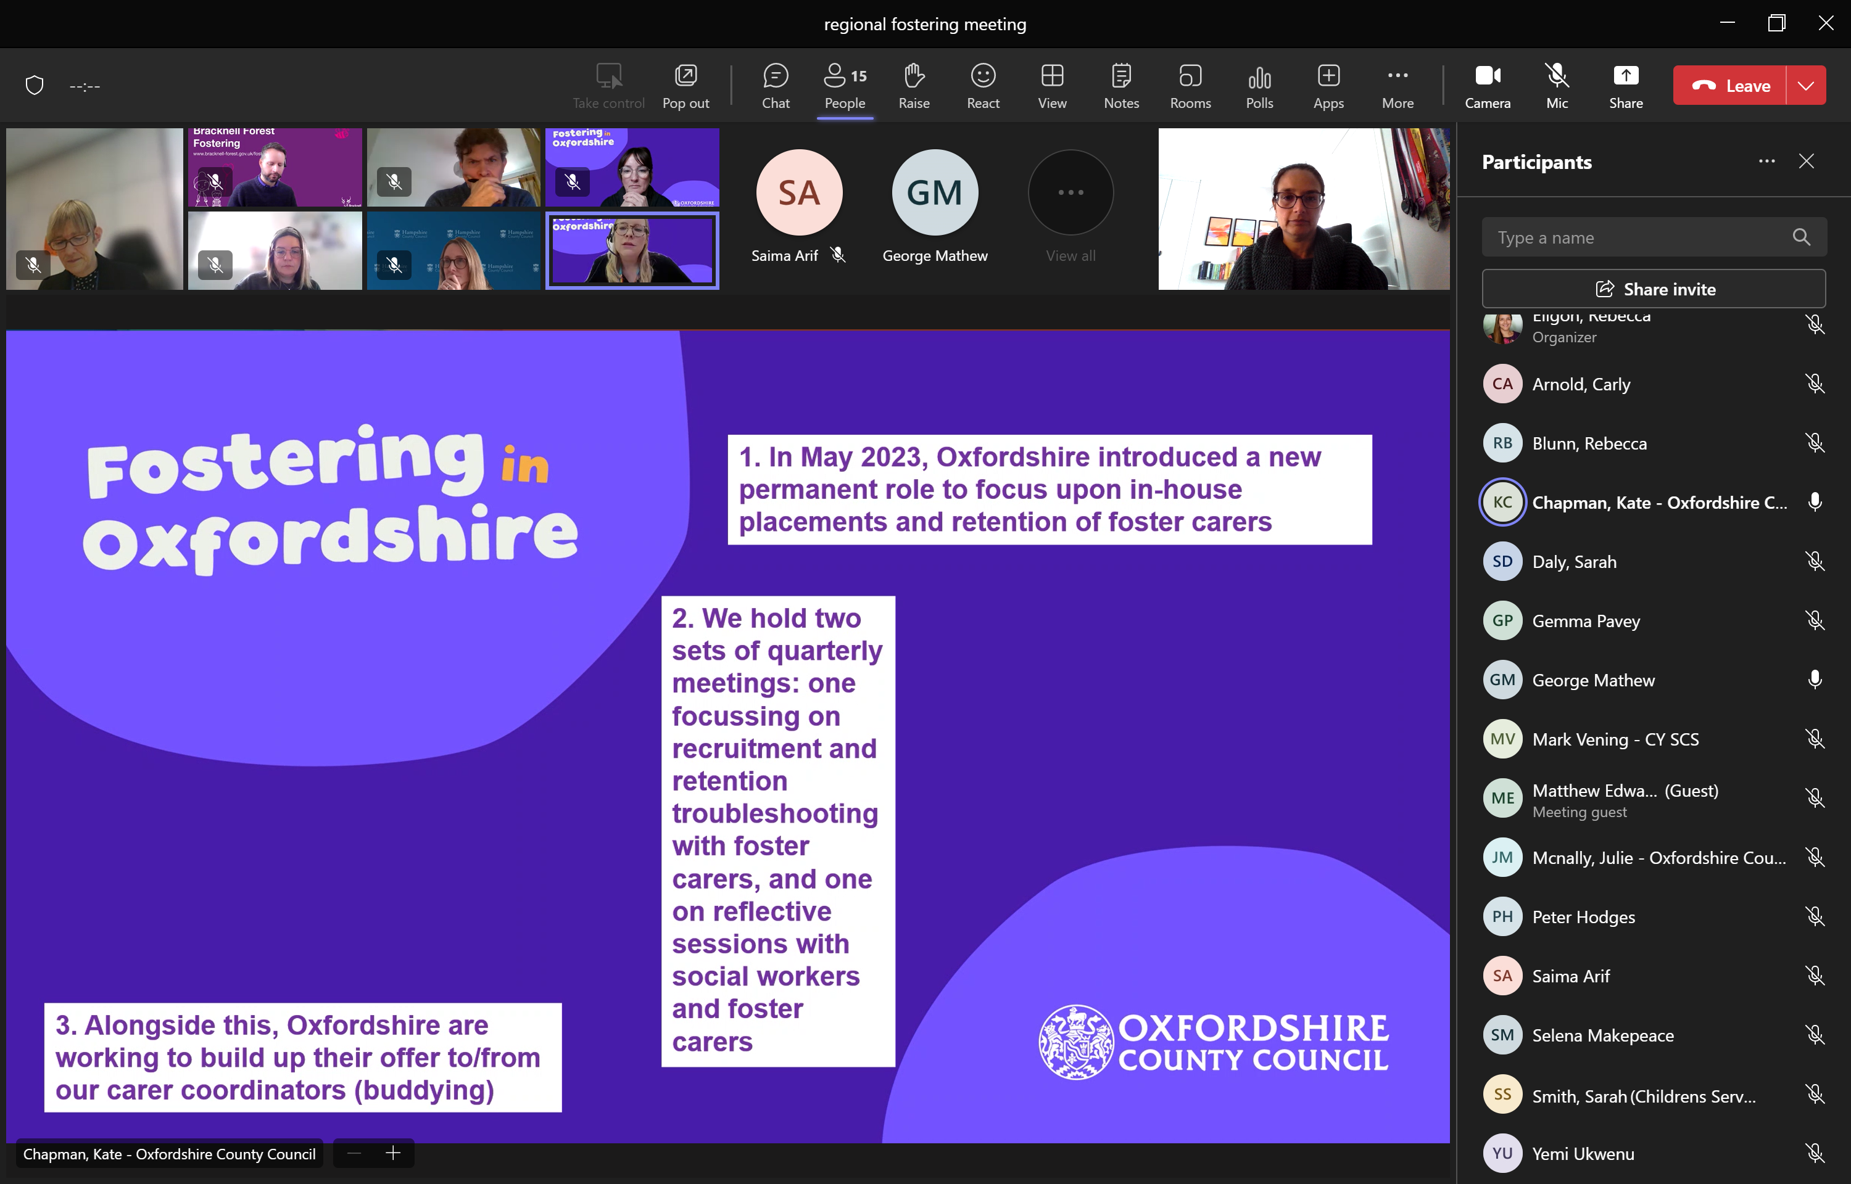

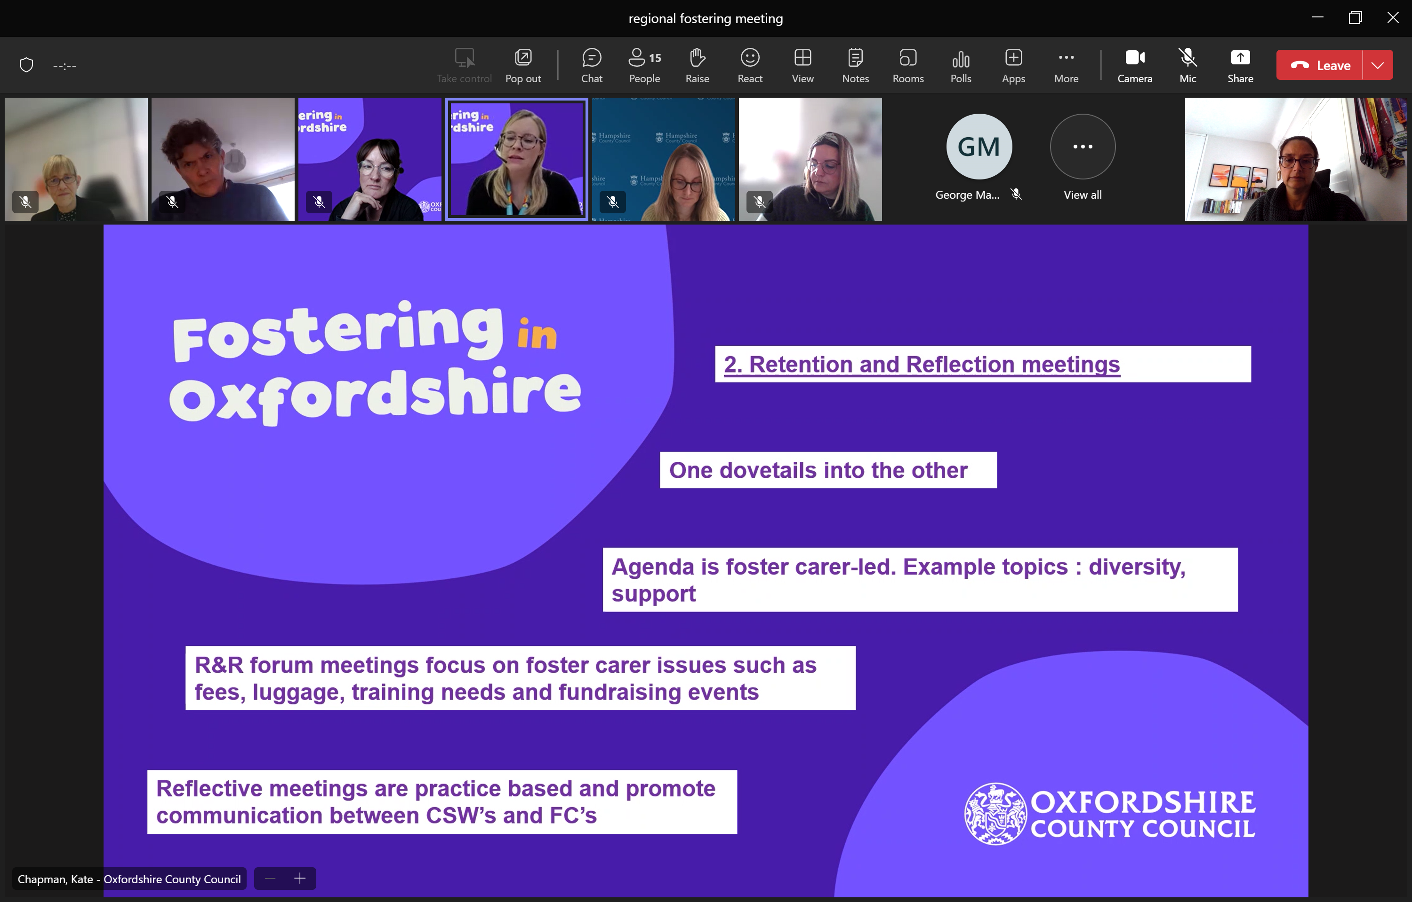

SD asked if the CSW are engaged and seeing the benefits. Oxfordshire said yes they are starting to hear experience of foster carer and apply it to their practice. They are creating fostering champions in the CSW teams. Sometimes it can feel a bit them and us so trying to break those barriers down through these regular meetings.

Oxfordshire currently has about 7 care coordinators, they all have different areas of expertise. Some love to talk at training at initial visit, others like to help with crisis. Too early to see what impact on retention and placement stability. Would have different 3 duty workers liaising with brokerage about vacancies.

JM said the first session was themed (diversity) and led by the FCs which was very much welcomed; and provided an opportunity to learn in a deeper way, all professionals roles, impact on children etc.

**Action:**  SS to speak to Oxfordshire to see if there is anything we can learn from the duty senior prac.

ME said he loved  the foster carer-led approach re agenda and input....we have fc's chairing all our forums etc and we have seen attendance shoot up as a result.

**4. Adult and Children’s Barring List checks for foster carers (Item requested by Kent)**

**There are issues relating to timeliness and accessibility of the DBS check lists to support both foster carer approval and staying put arrangements.**  MV noted we can access the child barring list, have challenged DBS but hit a brick wall in getting feedback regarding the adult barring list. MV wanted to know if other LAs are accessing the adult DBS barring list when vetting foster carers or just the list that says they should be barred from working with children.

CA said a similar issue in Southampton. We were doing standards of care and we found criminal info came through from adult barring list which we hadn’t been made aware of. But the DBS won’t allow us to do the adult checks. And similarly when foster carers want staying put and do the DBS in advance we’ve not been able to do that.

PH reporting the same issue in Bracknell Forest. What they are saying is about working with vulnerable adults and they have become a lot more rigorous in recent years. I don’t know what the solution is. Is there something we can do as a region to talk about those anomalies (staying put and parent and child placements) and reasons that we would need to access both lists. CA saying starting renewal process 6 months prior and still not getting back. RB said there are challenges in the new way of accessing and uploading ID onto the app because we are having to take more time with foster carers to help them with this.

**Action:** Mark and Peter to have a quick catch up and report back re: DBS accessibility

**5. Programme Update DfE funding: Mockingbird and recruitment hub project update**

RE provided a project update as follows:

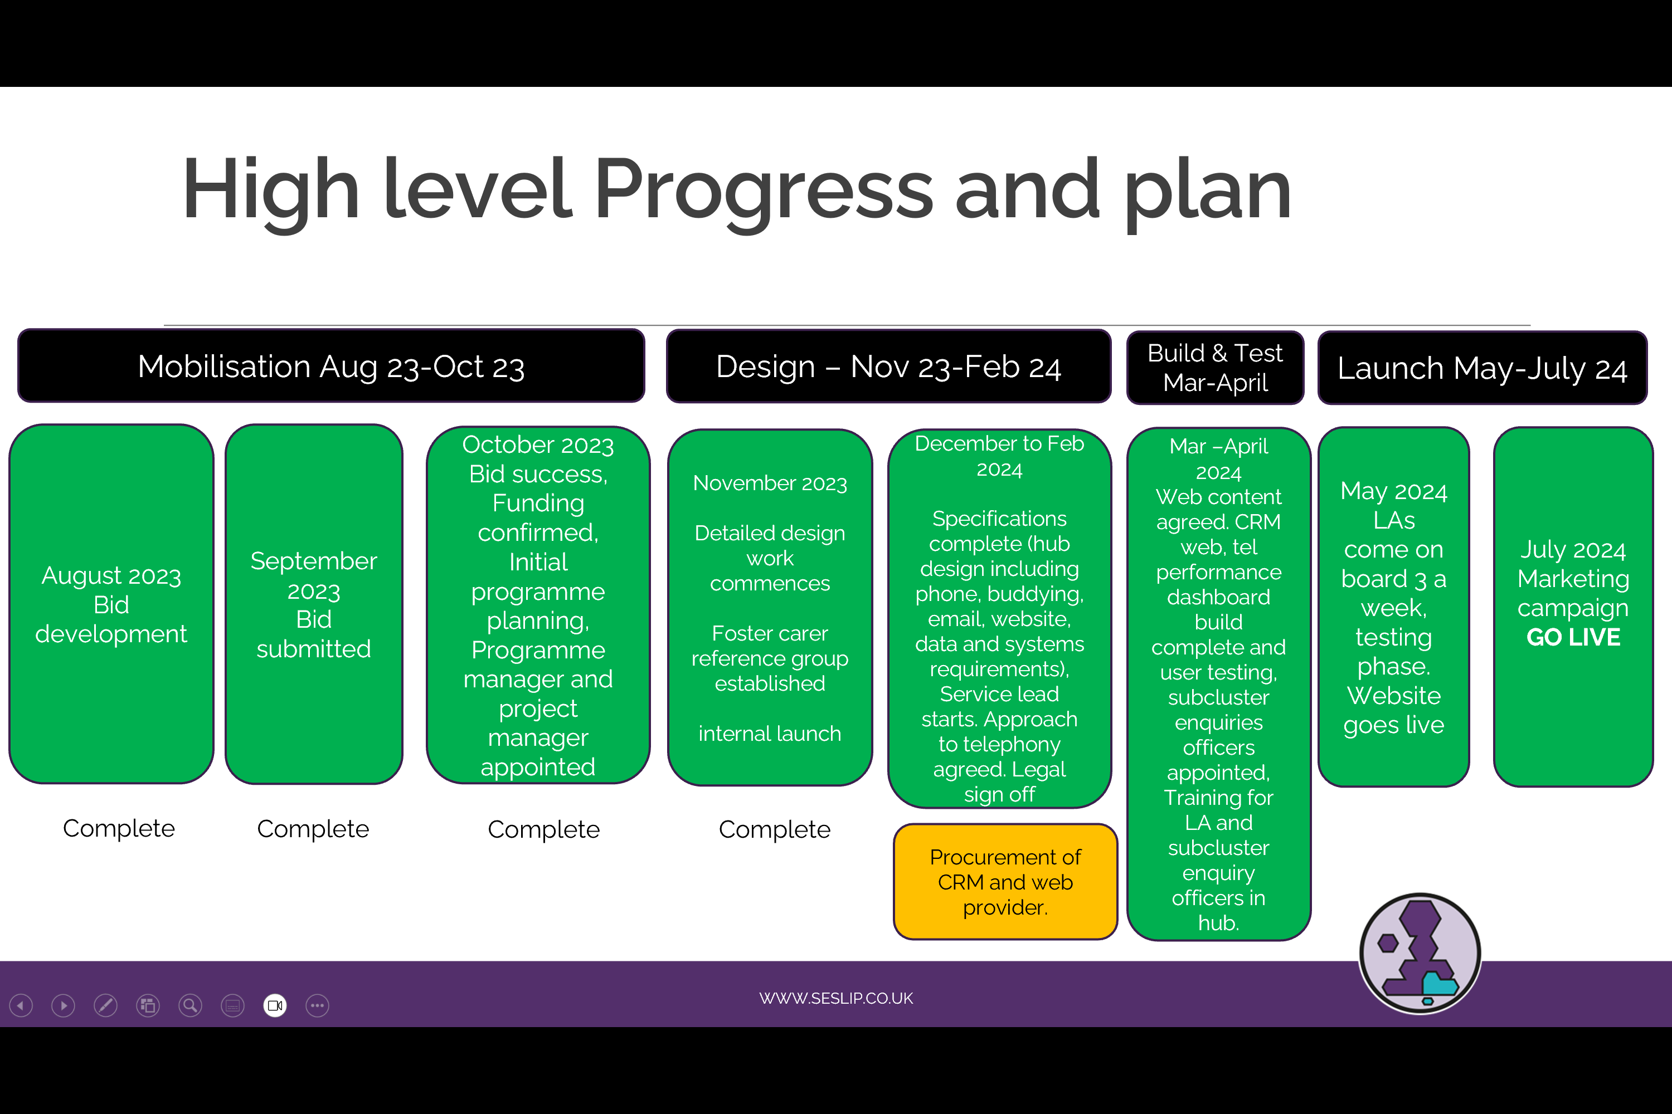

**6. Standing items :**issues for chair to escalate to DCS colleagues: ideas or projects for future consideration, AOB

Kate asked how people have fared - overall as we approach year end – how are we looking at recruitment and deregistration. Oxfordshire feels like it is a worse picture this year than last. Matthew Edwards – how does that link with our offer. It is a challenge. RB one of the things we find hard is understanding when we are having peaks and quiet periods. Are other LAs quiet when we are quiet. Are there months when we are all quiet. Can we look at this in a future meeting?

Next meeting

October TBC

Dec 9 2024 3-4.30pm

**Next time: themed discussion Steph from Southampton presenting on placement disruption, natural peaks and troughs in the year**

**Action log: updated 18 October 2024** Shaded lines, actions are complete

|  |  |  |  |  |
| --- | --- | --- | --- | --- |
|  | **Action** | **Responsible** | **Date issued** | **Status** |
| **39** | Mark Vening and Peter to have a quick catch up and report back re: DBS accessibility | **MV PH** | **Mar 2024** |  |
| **38** | SS to speak to Oxfordshire to see if there is anything we can learn from the duty senior prac. | **SS** | **Mar 2024** |  |
| **37** | Idea of 1. offer and assessment approach for those not yet ready to be foster carers and 2. Development of guide for first calls/conversations to be developed through hub | RE/AMA | Oct 2023 | complete |
| **36** | LAs to share foster panel member payscales with SS to collate | SS | Oct 2023 | Open |
| **35** | Action : RE to circulate UASC documentation from Martin Tuck to Cathy | RE | Oct 2023 | complete |
| **34** | If any further LAs wish to submit information (caseload and number of carers recruited) please send to Rebecca. Will need number of carers recruited in 2022/23 for all LAs in fostering hub. | RE | July 2023 | Closed |
| **33** | Brighton and Hove said their website is being updated over the summer and please ensure that mystery shopping does not happen until after the relaunch | RE | July 2023 | complete |
| **32** | Future discussion – increasing quality of ISW assessments (October 2023) | RE | April 2023 | Complete |
| **31** | RE to contact Louise toward the end of the year to see if any feedback from Home Office re: DBS classification. | RE | April 2023 | Complete |
| **30** | RE to benchmark caseloads for supervising social worker and numbers of carers/placements recruited in the last year. | RE | April 2023 | Complete |
| **29** | RE to circulate previous research with foster carers. | RE | April 2023 | Complete |
| **28** | RE to set up website mystery shopping run by foster carers for October 2023 | RE | Jan 2023 | Complete |
| **27** | JD to distribute contact details for trainer and amended foster care agreement. SS worker in Hampshire to connect with Brighton and Hove worker. – Anti-racist practice | JD | Jan 2023 | Complete |
| **26** | JG to share the training provider: anti-racist practice | JG | Jan 2023 | Complete |
| **25** | CS, JG and MG to share how to contact Ukraine hosts to see about receptiveness to foster. RE Add to agenda for future meeting. | MG, JG, CS | Oct 2022 | Complete |
| **24** | RE to circulate previous research on USPs of LA fostering | RE | Oct 2022 | complete |
| **23** | MT to provide welcome book/pack examples for UASC to RE to circulate to the group | MT | Oct 2022 | complete |
| **22** | SD to check if Ofsted ok with return to virtual visits given increasing covid risks? | SD | Oct 2022 | Complete |
| **21** | LS to circulate CCTV policy from Bucks | LS | July 2022 | Complete |
| **20** | MV to circulate Kent slides | MV | July 2022 | Complete |
| **19** | KL (West Berks- circulated) and JC (Portsmouth) offered to share their recruitment crib sheet. | KL and JC | July 2022 | Complete |
| **18** | Bucks to do mystery shop for Jan (poss testing online/email contact), review mystery shopping in Jan | LS | July 2022 | Complete |
| **17** | Can we monitor and discuss Ukraine again next meeting | DG | April 2022 | Closed |