Preparing for Adulthood regional network
Date: | 23rd July 2025
Chairs: | Amanda Percy – Portsmouth City Council, Simon Brown – Chichester College
Venue: | Teams – link to the transcript and recording is here
Attendees:
Amanda Percy |  | Jo Dixon – Transition RBWM
Simon Brown |  | Julie Lambert – East Sussex CC
Malcom Reeves – Whole School SEND |  | Louise Saunders - NSEF
Shallon Smith – Portsmouth City |  | Jo Campbell – East Kent College
Deborah Copeland – Hampshire CC
Kelly Hull – East Sussex CC
Liz Wilson – Sparsholt College
Notes
1. Introductions & Welcome
Simon welcomed attendees and Julie and Simon welcomed Louise from NSEF. We acknowledged that attendance was low due to many colleagues being on summer holidays.
2. National Updates
- Julie Pointer
- PfA Network Page now live on the Seslep website. Link is here resources will be posted following the meeting.
- Internships Work entering its fourth year with new resources and action plan. Link is here
- Inclusion in Practice webinar discussed positive inclusion in schools. Early evidence report is here
- Disabled Children’s Partnership campaign 'Fight for Ordinary' highlighted.
- PhD Publication by Wickham Bosworth on supported internships. Call to DfE for more research and evidence on SI’s
- SE Regional Young Person’s Network in development as part of the RIIA work. Email Julie at julie.pointer@ndti.org.uk if you would like to be involved. More to be shared at next meeting
- Update from Amanda Percy on Change Programme – White Paper due out in the Autumn, focus on inclusion and mainstream. Portsmouth have been looking at what they can do:
- Focus on Inclusion and Lifestyle in Portsmouth.
- Recruitment for a Post-16 Inclusion Advisor underway.
- Emphasis on short-term opportunities to impact inclusion.
We agreed it would be good to have a broader update at the next meeting
- Malcom Reeve – WSS – Slide below
- Year 4 of the Universal SEND Services Contract underway.
- Community Join-Up Projects launched in all 9 DfE regions.
- South East Group to focus on transitions from school to post-16.
- National group to explore Inclusion and Belonging in mainstream settings.
- Regional meetings now set up for SE 25th September, 4th December and 5th Feb. Please let Malcom know if you would like to attend.

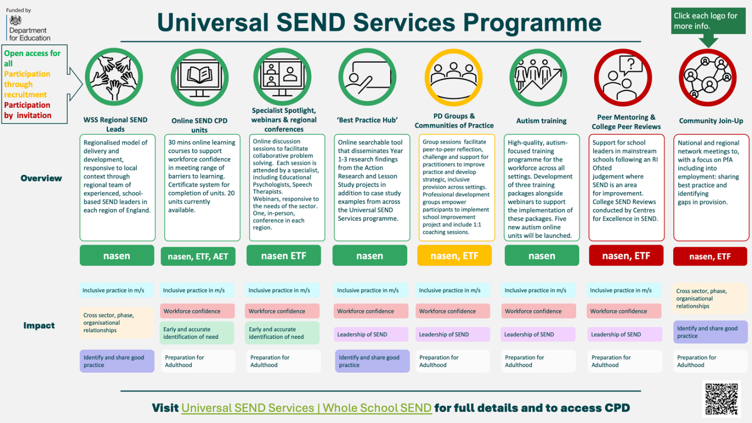

3. Louise Saunders – National SEND Employment Forum. Louise updated the group on the work of NSEF and the conversations they have been having with DWP regarding the Access to Work challenges. Slides attached.
- NCEF now has 250+ members.
- Challenges with Access to Work and reduction in claimable weeks. NSEF have submitted a series of questions from members and are awaiting responses.
- Positive engagement with DfE on Maths & English funding flexibility.
- Employer Ambassador Training available via DFN Project Search as part of the Internships Work programme. Julie advised we are awaiting a list of employer ambassadors that can be shared with LA’s to support their employer engagement.
NSEF are welcoming new members and if you would like to join please email Louise – louise.saunders@nationalgrid.com

4. Pan-Berkshire SEND Employment Forum (Jo Dixon)
- New initiative to unite six Berkshire LAs for shared SEND employment strategy.
- Aim to pool resources and employers across borders.
- DfE supportive of the model, which is already happening in West London and the Black Country
Amanda requested that we feed back once the forum has started.
5. Discussion: Local Authorities as Employers
- Emphasis on LA responsibility to model inclusive employment.
- Examples from Portsmouth and Castle School shared.
- Importance of job coaches, social value partners, and commissioning ethics highlighted.
Supported Apprenticeships
- Examples from East Sussex and Essex discussed.
- Interest in comparing outcomes between internships and apprenticeships. Suggested as an agenda item
6. Transition Challenges
- Concerns raised about EHCPs and specialist providers influencing placements.
- Issues with delayed or misaligned transitions and tribunal cases.
- Need for early planning and quality assurance.
Agenda item for September meeting

7. Planning for Next Year
- Julie to send out a poll to determine best meeting dates/times.
- September meeting to focus on transition outcomes.
- Encourage broader representation from colleges and schools.
Action Summary
Action Item | Owner | Deadline
Share PfA Network resources and links | Julie Pointer | With minutes
Invite Sarah Christopher to next meeting | Amanda Percy | September
Share Whole School SEND slides | Malcolm Reeve | With minutes
Share NCEF slides and training links | Julie Pointer | With minutes
Update on Pan-Berkshire Forum | Jo Dixon | Next meeting
Provide data on supported apprenticeships | Kelly Hull | Next meeting
Send poll for 2025–26 meeting dates | Julie Pointer | August
Add transition outcomes to September agenda | Amanda & Julie | September

AOB
- No AOB
25th September 10 – 12 on Teams. Link is here

