South East Region Adoption Leadership Board
Meeting notes and action log: July 2024
Invitees: Dr Mac Heath (CHAIR Milton Keynes), Lorna Hunt VICE CHAIR (Chair Adopt Thames Valley and PACT), Kevin Yong (CORUM), Rebecca Eligon (SUPPORT Sector Led Improvement Programme), Carole Atkins (Bucks), Claire Cocoran (in place of Teresa), Roselind Moodey
Apols: Richard Morris (CAFCASS), Sarah Skinner (Adoption PARTNERSHIP),Rachel Reynolds (Adopt South), Michael Wilson (Adopt South), Teresa Rogers (Adopt Thames Valley),
- Introductions and previous minutes
The group agreed the previous minutes and actions
- Discussion about contact
MH reflected that contact and family time is a critical issue around placement stability. Also a question on how do we keep adoption and adoption practice at the top of agenda.
LH – we say it is likely that you will need to keep in contact with the child’s family in our advertisement for adopters. There is a real shift around expectations. My question is what capacity is there in the RAA to support the birth family to make it as safe and best for the children possible. My reflection is that will take money and investment. The ASGSF will need to play a role given the complex needs and trauma experienced by families. The last thing you want is for children to end up in residential following an adoption breakdown.
CC we have devised a contact tool to have realistic contact plans. Gives everyone assurance that potential risks and positives of contact have all been considered. We have many plans and need to agree individually with each LA working with ad hoc workers. We have agreed funding for bespoke contact team which is really good news. It needs so much work beforehand, at the contact itself and then after, it is a good 10 hours a year for every contact.
CA said it is a similar situation for us, even though we are Bucks in partnership with PACT since Jan so a small a relatively new partnership. We have strategic boards operating. Moved to a default position that direct contact is the expectation unless there is a compelling reason not to, so people are coming prepared for that, but as LH said they are interested in the support needed. We have one FT letterbox worker, now called family liaison to recognise the wider role they undertake.
MH reflected in the drive to recruit adopters there is a risk we might mis-sell to them the expectations around contact. MH asked if he thought prospective adopters had realistic expectations. CC said they are very clear about needs and requirements because there is no point setting unrealistic expectations. CC said Adoption England is doing good work, carry clout and setting clear expectations.
ACTION: Suggest at a future meeting look at PLO working group report – Justice Judd is chairing it, draft report was due at beginning of year, so should be out soon in time for next meeting.
CA and CC said courts seem to be much less keen on adoption, and being asked to do dual SGO and adoption assessments which take a huge amount of time even though the court will always go with the SGO.
CA said two children aged 2 and 3.5 and has been going on for 2 years, that can’t be in the child’s interest.
MH asked how join up is working across RAAs following on from the regionalisation of fostering. CC gave an example of a Bristol child in Reading and they had come to an agreement about the place for contact being provided by Reading to reduce travel across the region.
Item 2 data:
KY presented the trends until the end of March 2023. Adoption Orders and placements stable around 3000 in England for the last three years. Last year there was a bit of an increase following the lag and backlog from Covid. We might see an increase as we see those children get placed. As with last quarter we are continuing to see a gap between the number of adopters and children, and the pipeline for assessments is still not large enough to think the children will get adopters. There are two regions – east and SE – that don’t have that gap but everywhere else does.
KY said one area to explore is if a person can take two children or an older child then we should always explore that in terms of matching. LH said that is often easier said than done. CC gave an example of a family that had been approved for a sibling group but then ended up with early permanence. And when adopters go on linkmaker they see children and have a choice, some will be trusting of the assessing social worker, but others want to lock on to a child.
KY concluded that overall the need to recruit more adopters continues.
CA asked and said the data still seems to be showing younger children, and KY said yes that is the trend. KY said average sibling size was 1.2 sibling for the last 5 years but increased in last year to 1.25.
Item 3: Case Management systems
KY introduced a piece of work led by Social finance and with data to insight, our three organisations got together with DfE to look at what makes a good case management system. We didn’t come up with an answer to that. Two big providers liquid logic and mosaic have 80% of market. We did some analysis on procurement.
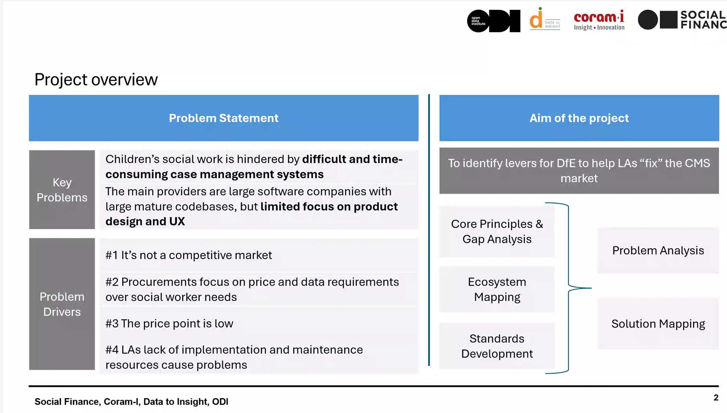

KY said that it might be an ecosystem of applications working together not a single case management system.
Identified two key issues – usability (user experience and innovation to support practice like voice to typed text capability, picture uploads) and interoperability (info sharing for safeguarding with police health school and integration with other systems like finance systems)
Few LAs switch so no incentive for providers to be responsive and switching costs are high.
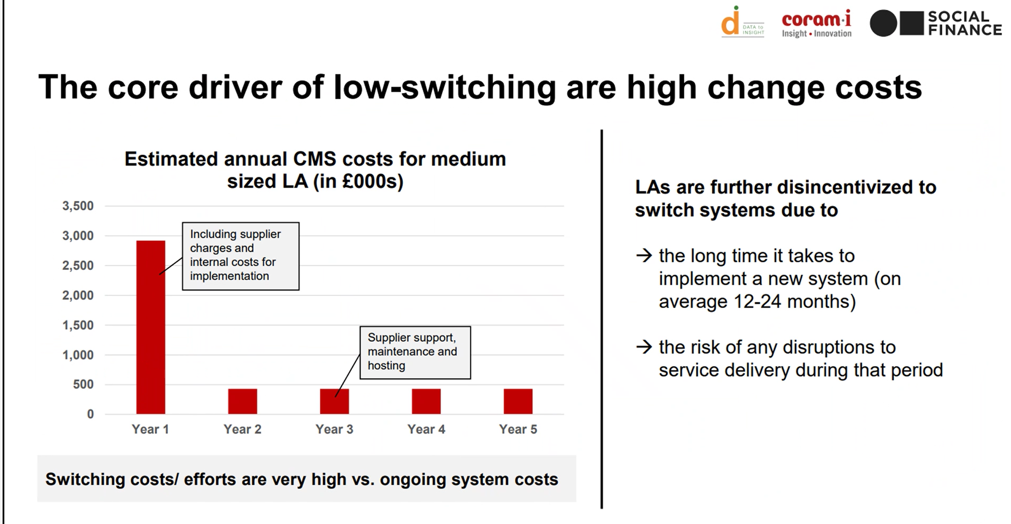

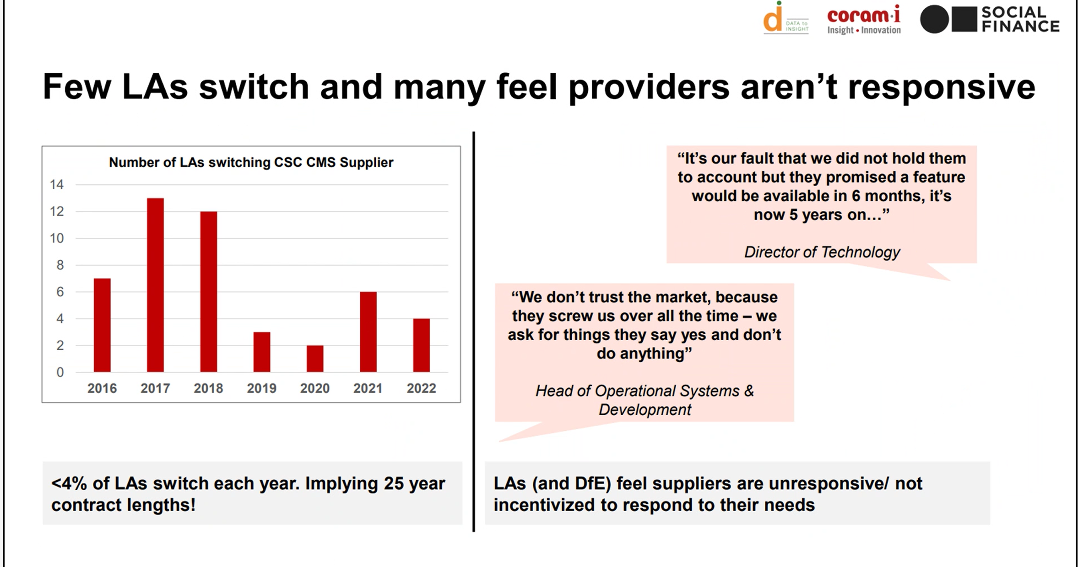
KY said the report advocates for more open access systems. MH thanked KY for his work

Action log: This action log was updated on 11 September 2024
 | Action | Responsible | Date issued | Status
78 | future meeting look at PLO working group report – Justice Judd is chairing it, draft report was due at beginning of year, so should be out soon | RE | July 2024 | open
77 | LH to check rate for medical advisors with CORUM BAAF. LH confirmed between £75-£100 per assessment | LH | April 2024 | complete
76 | Group to build into their own performance monitoring/reflections that one or two per RAA/2-3% feels the right proportion of disruptions. | all | Feb 2024 | complete
75 | MH said if DCSs are asked then our position is we are conflicted/mixed in respect of our views on changes to the rule the 3-year rule. | MH | Feb 2024 | complete
74 | KY asked MH to flag with DCSs the need for LAs to work more closely with RAAs to improve quality of data. | MH | Oct 2023 | complete
73 | KY noted there was a project on case management systems and KY to keep group updated on that. | KY | Oct 2023 | complete
72 | Discussion on strengthening policy/practice regarding birth families. What is good practice, how might we share it? Idea of online conference? Discuss on Oct agenda | MH | July 2023 | closed
71 | Discuss analysis on disruption (could KY produce something for Jan meeting?) | KY | July 2023 | complete
70 | Review whether new ALB is working after Jan2025 meeting (1 year) | MH and all | July 2023 | complete
69 | MH to liaise with Sarah Johal around future direction of travel | MH | April 2023 | closed
68 | Item at next meeting on strategic and practical direction in South East Courts | RE | April 2023 | closed
67 | Refresh the membership list in ToR (done) get a new rep for Slough (to do) | RE/MH | April 2023 | complete
66 | future discussion on reasons underlying delay. Discussed at July meeting | RE | April 2023 | closed
65 | RE MH and LH to meet to review terms of reference, meeting dates to align with operational regional meeting and resolve membership and oversight of Kinship (meeting with Sarah Daly to agree) | RE MH LH | Jan 2023 | Closed

