Fostering regional group meeting notes and action log September 2025

Date: 23rd September 2025 2-3.30pm
Chair: Sarah Daly DCS Portsmouth (apologies)
Attendees: Rebecca Eligon (SESLIP support, chair), Carly Arnold (Southampton), Cathy Seiderer (Brighton and Hove), Dave Crewe (Portsmouth), Carol Norrington (Surrey), George Mathew (Slough), Sam Horton (Hants), John Donnelly (Brighton and Hove), Keith Langley (West Berks), Kimberley Showell (West Sussex), Maria Cordrey (Kent), Mark Vening (Kent), Michelle Jackson (in place of Holli) (Wokingham), Nicola Sankey (West Sussex), Peter Hodges (Bracknell Forest), Kerry Bailey (Portsmouth), Sam Howard (Bracknell Forest), Sarah Smith (Hants)
Item 1: Minutes and actions from last meeting agreed.
Item 2: Agreement of scope and timescales for fostering community project
RE presented the scope, deliverables and proposed project plan for the fostering community project.
Action CS asked that “those for whom the time isn’t right” is added to the group who want to foster but cannot in the fostering community project. RE to add this to project plan.
The group confirmed they are happy with the proposed approach which will now be taken forward and will report back to the regional group quarterly.
Item 3: discussion of IFA placement costs
RE shared some of the benchmarking of placement costs produced by 6 LAs in the summer which is pasted below, the first set of figures include IFA placements, the second is residential only.
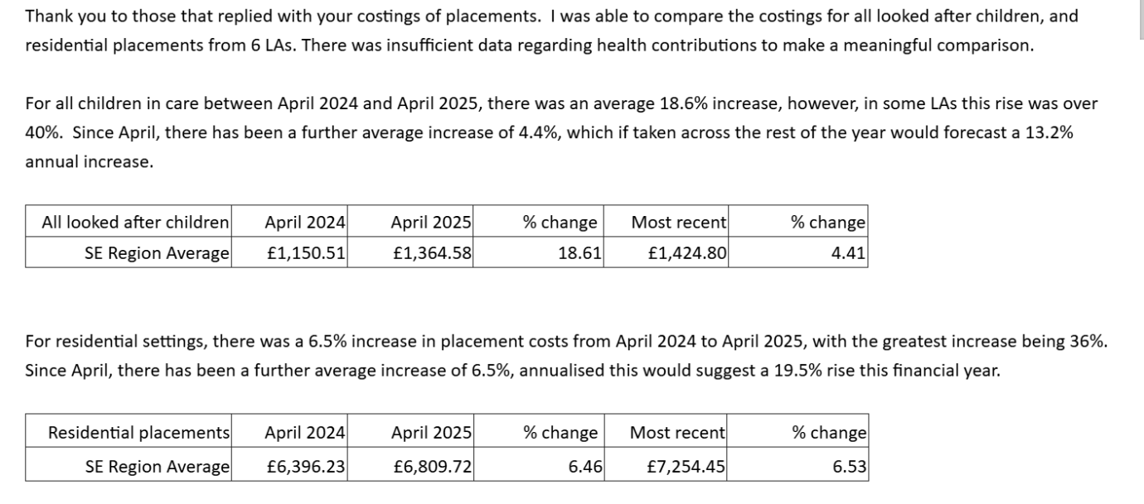
SS reflected that the context is very challenging and these increases see in line with what is being experienced in Hants. MC said in Kent they had seen an increase of £5.5k a week for resident to £7.3k a week on average. MC shared that in Kent they had been focusing for a number of years on a structured approach to bringing children from residential into in-house fostering, called ‘Step Across to Fostering’. This included an enhanced offer to in-house foster carers, specialised support. MC reflected that 7 children had stepped across this financial year. There is also a separate project being led by the disabled children’s service which includes capital works to make rooms available for children with physical disabilities. This is in part being funded by disabled families grant. Both projects are open to kinship as well as fostering.
PH from Bracknell Forest reflected that there can be hidden costs which sometimes are not included in benchmarking (e.g. additional costs for staffing, 1.1, 2:1 support. PH said he cannot think of a single residential placement in recent times which hasn’t had 1:1 for 6 weeks which is then very difficult to step back from. There is often only one choice and so that is driving up costs as well.
PH reflected that many IFAs are coming off frameworks and then adding 20% and more to fees. This is a trend that other LAs are also observing.
PH asked how other LAs are managing their forecasting relating to different types of placement need.
Action: RE to connect PH with the Data to Insight placement modelling tool which can be used to model placement types and costs using 903 return data.
JD shared that in Brighton and Hove they are also seeing the biggest financial pressures in relation to residential placements and they too are focusing on stepping down. He refleted that children are being placed in residential not because their needs dictate it, but because that is the only option.
Item 4: Tracs and iCompass
CS from Brighton and Hove introduced Colin Bell from Tracs and iCompass. Colin explained that tracs is a practical web-based tool for PAs and social workers with a list of 33 tasks to help get young people ready for independence. It allows them to track progress, and YP can also access a version. ICompass is more of a qualitative tool to aid conversations around leaving care and independence
www.icompassuk.org
https://www.tracsuk.org
Action: Any LAs interested in finding out or for a demo more can contact Colin on colin@tracsuk.org
Item 5: issues for escalation and agenda items for next meeting
No issues for escalation to DCSs, agenda item next time to focus on fostering community project. March 2026 meeting to hear from MC in Kent on the step across and children with disabilities led project.
Action log: updated 26 September Shaded lines, actions are complete
 | Action | Responsible | Date issued | Status
52 | Any LAs interested in finding out or for a demo of Tracs or ICompass e can contact Colin on colin@tracsuk.org | All | Sept 2025 | open
51 | RE to connect PH with the Data to Insight placement modelling tool which can be used to model placement types and costs using 903 return data. | RE | Sept 2025 | complete
50 | CS asked that “those for whom the time isn’t right” is added to the group who want to foster but cannot in the fostering community project. RE to add this to project plan | RE | Sept 2025 | complete
49 | MC to share out of hours policy | MC | July 2025 | complete
48 | RE to convene a design meeting with those that are interested, and to liaise with DfE about this new idea. This to be the main item at the next regional meeting. | RE | July 2025 | complete
47 | GS and SD to meet with MH to discuss how this group can be used moving forward to help provide a space for LAs to provide feedback/identify key issues to ensure the success of the hub moving forward. | SD | March 2025 | open
46 | SD has agreed to escalate and take to the regional DCS group that there are issues around cost and pace/delays regarding foster carer medicals. | SD | March 2025 | open
45 | SD asked the group to find out and report back: What is driving delays is it capacity, payment, or it isn’t part of the commissioned offer, is it costing too much? What is the issue. Have you escalated in place-based partnerships and ICB risk logs? | ALL | Dec 2024 | complete
44 | Oxfordshire (Julie McNally) Hampshire (Sarah Smith), Brighton and hove (Cathy Seiderer) and Portsmouth (Jackie Clark) to catch up outside the meeting on sharing practice/approaches re: support to foster carers in the first year. CS to convene this group. | JM SS CS JC | Dec 2024 | complete
43 | SD to draft letter to ICBs in region setting out the impact of delays in medical assessments | SD | Oct 2024 | complete
42 | HB to share business case/thinking behind salaried foster carers (c.£60k, 10 months a year, 3 carers on rotation) when it is ready | HB | Oct 2024 | No longer relevant
41 | PH, KL and SA to meet to get a consistent approach to police input across the Thames valley. | PH KL SA | Oct 2024 | Complete
40 | Brighton and Hove to share support for foster carers in first year and wellness action plan | CS | Oct 2024 | Complete
39 | Mark Vening and Peter Hodges to have a quick catch up and report back re: DBS accessibility | MV PH | Mar 2024 | Complete
38 | SS to speak to Oxfordshire to see if there is anything we can learn from the duty senior prac. | SS | Mar 2024 | complete
37 | Idea of 1. offer and assessment approach for those not yet ready to be foster carers and 2. Development of guide for first calls/conversations to be developed through hub | RE/AMA | Oct 2023 | complete

