Kinship regional group meeting notes and action log June 2025

Date: 9 June 2025
Chair: Mac Heath (Milton Keynes)
Attendees: Alitha Lee Townsend (Slough), Christa Beach (Hants), Cassie Atherton (East Sussex), Clark Mcauley (Surrey), Jo Conlon (Slough), Karen Devine (Brighton and Hove), John Foster (data to insight), Fiona Summers (Kinship), Alexandra Lambert (Brighter futures/Reading), Karl Davis (West Berks), Kelly wilkes (West Sussex), Lucy Peake (Kinship), Natalie Bugeja (Afc), jo Moore (Kent), ), Maryke McCarthy (Bucks), Rachel Farrell (Bucks), Ashley Schofield (IoW), Charlotte Davey (Oxfordshire), Lisa Murrell (Brighter futures), Ananada Bodenstein (West Berks), Rebecca Eligon (SESLIP support)
Item 1: Minutes and actions from last meeting agreed.
Item 2: Second regional kinship benchmarking
JF presented the data from the second wave of kinship benchmarking. He said data will be reissued with Medway’s data included. No amends received for Q3.
MH related we have more SGOs, but also more SGO breakdowns.
Quite a lot of variation and affected by small numbers on a quarter by quarter basis in terms of the proportion ceasing to be looked after.
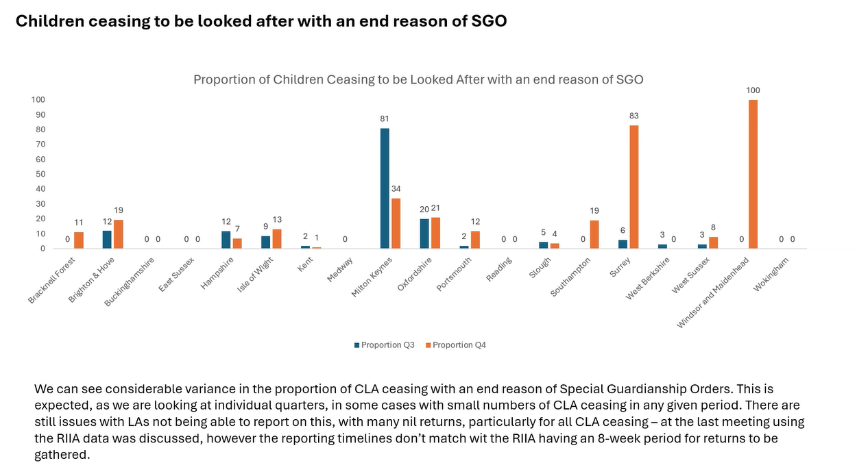
But when you look at the two quarters combined and look against nationally and regionally you can see it was the same as nationally, but when the data started again in 2020 the regional figures were lower than nationally but mirrors the trends seen nationally with 8.1% ceasing due to SGO in our latest quarterly figures.
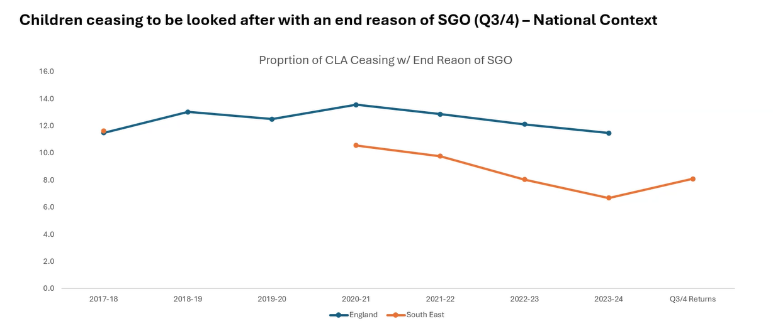
Looking at approvals combined data over the two quarters, there have been more temporary approvals than full approvals.
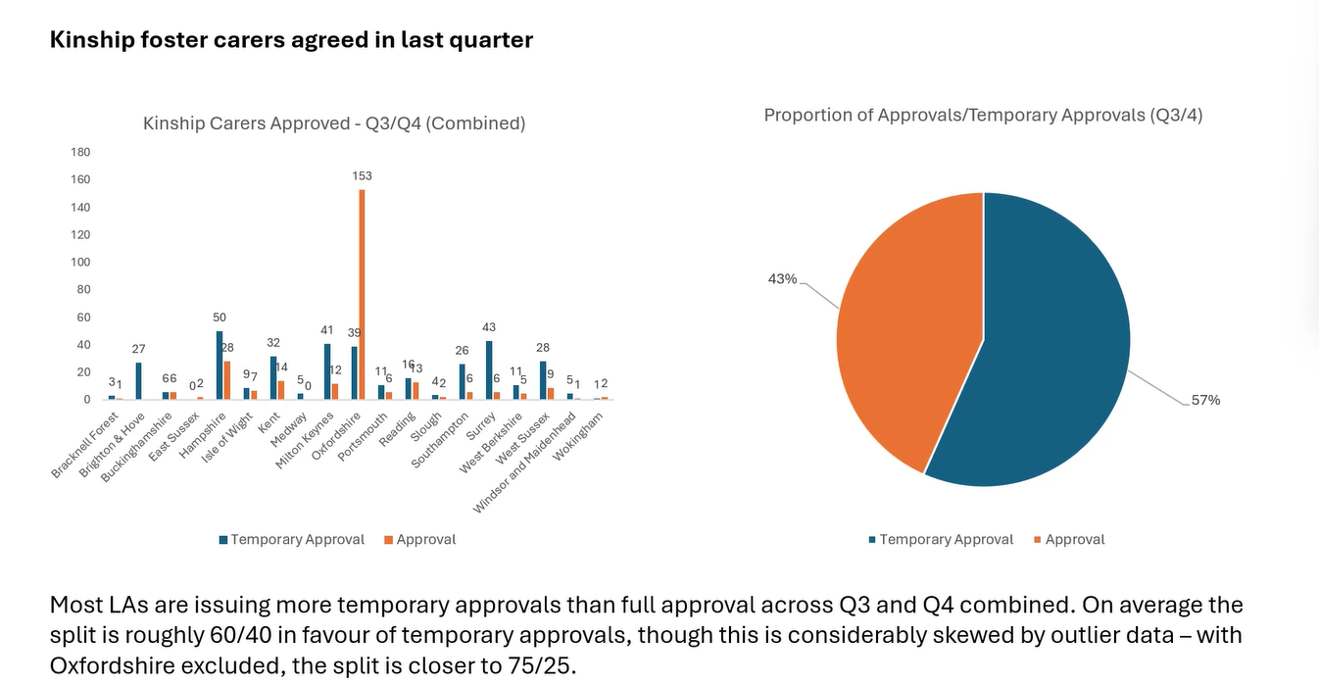
In Oxfordshire there is a very big drive on SG and kinship approvals, and a new kinship team which is driving some of the data. CD said that they aren’t having DBS issues, but are affected by some issues with medicals. KD said lower numbers of approvals are due to DBS delays in Brighton and Hove.
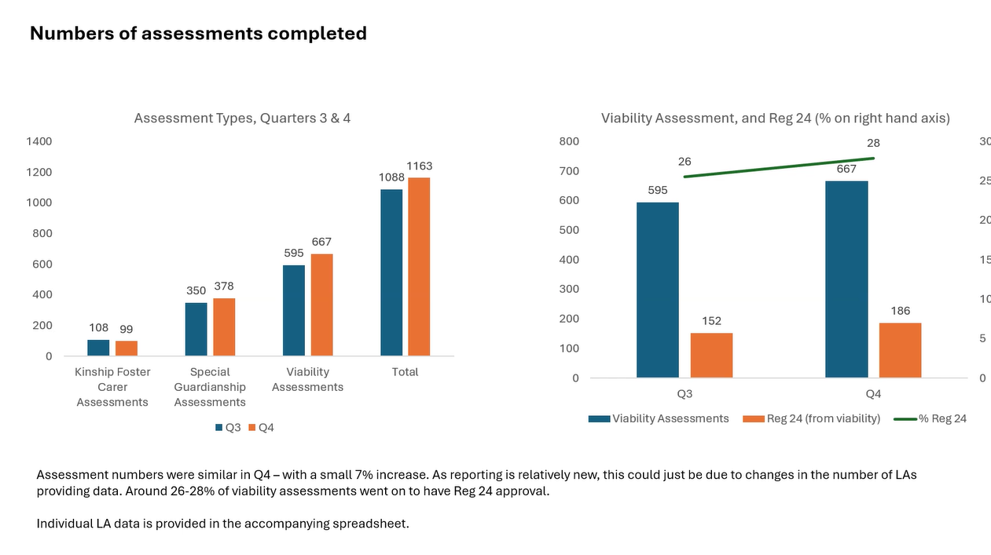
Assessment numbers are quite consistent as is the proportion in Kinship care.
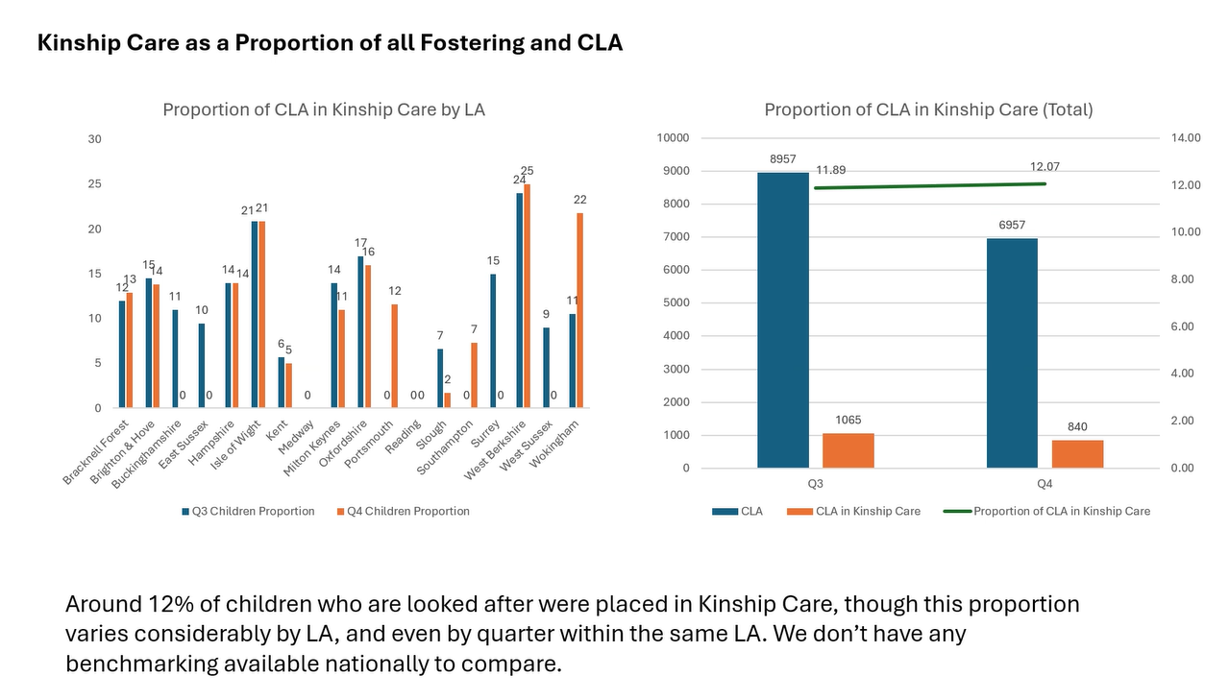
LP said it would be helpful to have an England figure, for example the proportion in Kinship care (which has been going up).
Action: JF said he will bring in national comparison wherever possible.
LP asked if there was a strategy to move to kinship fostering. CD said they had started a no detriment policy which is about the right support at right time, but moving to SGO to give children permanence wherever possible.
AB said they are not recording the push they are making for family adoption especially if children are under 5.
CB said in Hants we also have lots that are granted an SGO without being CLA, as an alternative to care proceedings. In Hants they match ASGSF for some young people
LP asked if we could bring the narrative together with the slides
Action: RE and John to bring together narrative from the minutes and looking at annual trends.

ITEM 3: possible areas of funding
RE outlined there was a possibility to bid for funding as part of the regional settlement and additional funding which DfE will be providing to SESLIP. MH noted that any proposals from the group would still need to be agreed by DCSs and would need to be considered against other regional priorities. RE had sent in advance some ideas for regional funding but it was up to the group to decide the ideas they wanted to put forward.
KD said more support around coproduction would be helpful to get the views of those that the service isn’t touching. Piloting some sort of edge of care/kinship breakdown offer would be really beneficial.
RF said that the data work we can continue with so don’t need additional funding. Agree with the point around breakdowns and this being an area of focus for any new funding, and how we are collectively responding to the loss of the ASGSF to move away from the postcode lottery.
CB said in Hants they are definitely interested in co-producing kinship offers/having a regional offer. We have a specific post SGO team so we could focus on breakdowns and work regionally with this would be helpful.
KW is trying something new has a rapid response meeting with any sort of placement at risk, bringing together education, health, early help with family safeguarding before it is too late. KW is happy to share terms of reference.
Action: KW to share terms of reference for placement breakdown rapid response meeting
The group agreed to put forward two ideas for DfE funding:
- Some regional work with a range of kinship carers of all types to coproduce and understand what they need/want in a local offer. LAs could opt in to be part of this coproduction work which could be coordinated regionally.
- Preventing kinship breakdown: Work already happening in West Sussex (rapid response) and starting in Hants (across localities) on preventing breakdown - so this could be about gathering learning to share with the region on the impact of these initiatives (and the invest to save case). Kinship - have 2 navigator programmes (endorsed by Foundations). Do we want to trial this in the region or something else with directly employed/internal capacity? The group agreed to put forward a proposal to trial Kinship navigator programmes starting with the online programme.
action: RE to write up two areas of funding for dfe consideration Kinship breakdown support and coproduction of local kinship offer.
Item 4: Kinship DfE pilot
Nobody is aware of a bid coming from the South East for the kinship payments DfE pilot. Many LAs on the call reported they already have a no detriment policy and so were not eligible. NB from AfC said they applied for the Foundation/DfE Kinship funded supports and we do intend to apply for the DfE kinship allowance as we have not managed to get the 3 LAs to agree this previously
AOB
Lucy asked of any LAs doing interesting work with birth and other children (for foster and kinship families)?
NB said in AfC do quarterly children’s things, yearly conference and fun day.
KD said they also do a smaller offer specifically for birth children who are in kinship, including an annual tea party (SGO, CAO and their children). It would be nice to do more. KD said they also able to attend all fostering events and activities.
CB have Hampshire hives and kinship foster carers have access to that. Hampshire do Christmas and summer activity days which link to support groups.
Ananda said they moved from coffee mornings to regular social events for SG, CAO and kinship foster carers. There can be a lot of guilt and shame to be a kinship foster carers. One of the hubs is specifically focusing on kinship foster carers.

Action log: This action log was updated on 4 June 2025. Shaded actions are closed or complete
 | Action | Responsible | Date issued | Status
16 | RE to put forward DfE bids for coproduction of local offer, and prevention of placement breakdown through Kinship Reach and Kinshio connects | RE | June 2025 | complete
15 | KW to share terms of reference for placement breakdown rapid response meeting | KW | June 2025 | ongoing
14 | JF include national comparison data where available in benchmarking, and JF and RE to produce an annual narrative with trends once four quarters of data collected | RE | June 2025 | Ongoing
13 | JF to produce different metrics for proportions of kinship households measuring against the different baselines to allow both national comparison and also to have insight into the proportion in kinship arrangements. JF will recalculate metrics against the CLA figure in the RIIA collection. | JF | March 2025 | Complete
12 | All to consider offer from Kinship around training and get back to LP if you would like support | All | March 2025 | complete
11 | All to review benchmark data and make amendments to any incorrect data. Send amends to John.foster@eastsussex.gov.uk . JF to meet LAs individually | All | March 2025 | complete
10 | RE to contact data to insight to take the project forward, and secure funding from SESLIP to support this work. MH and RE to meet outside of the meeting to take forward. | RE/MH | Nov 2024 | complete
9 | RE to organise regional kinship care conference for the summer | RE | Feb 2024 | complete
8 | RE to circulate presentations from Nov 2023 meeting | RE | Nov 2023 | Complete
7 | All to get in touch with Fiona Summers or LP or kinship directly via their website to explore how South East Kinship carers can benefit from the training programme. | All | Nov 2023 | Complete
6 | terms of reference agreed and to be published on SESLIP website | RE | June 2023 | Complete

Upcoming meetings
4 Dec 2-3.30pm
Previous meeting themes:
- 16 Nov 2023 2.30-4pm (focused discussion staffing structures and resourcing kinship teams)
- 26 February 2024 2-3.30pm (focused discussion on kinship strategy)
- May and July 2024 meetings Cancelled to allow attendance at kinship south east conference
- July 8 2024 – regional kinship conference hosted in Surrey
- November 2024 2-3.30 (focused discussion on kinship Care Statutory Guidance) and agreed to progress with regional data benchmarking
- March 2025 ASGLF and first cut of baseline kinship benchmarking data (Q 3 Oct-Dec 2024)
- June 2025 second wave quarterly regional data, DfE funding (kinship payment and ideas for regional funding)

