Kinship regional group meeting notes and action log September 2025

Date: September 9 2025
Chair: Mac Heath (Milton Keynes)
Attendees: Lucy Peake (Kinship, Vice Chair), Alitha Lee Townsend (Slough), Alison Miller (Milton Keynes), Dave Crew (Portsmouth), Caroline Smith (Kent), Maryke McCarthy (Bucks), Rebecca Eligon (SESLIP support), John Foster (data to insight), Fiona Summers (Kinship), Aimee Dennis (Portsmouth), Peter Hodges (Bracknell Forest), Tim Fisher (Kinship), Julie McNally (Oxfordshire), Clark McAuley (Surrey), Eszter Kovacs (wokingham), Mark Vening (Kent), Ashley Schofield (IoW), Lisa Apps (East Sussex), Natalie Bugeja (Afc), Wendy Queralt (Oxfordshire), George Layzell (Medway), Ananada Bodenstein (West Berks), Karen Devine (Brighton and Hove),

Item 1: Minutes and actions from last meeting agreed.
Item 2: Second regional kinship benchmarking
JF presented the data from the third wave of kinship benchmarking. Considerable variation in SGO numbers between LAs.
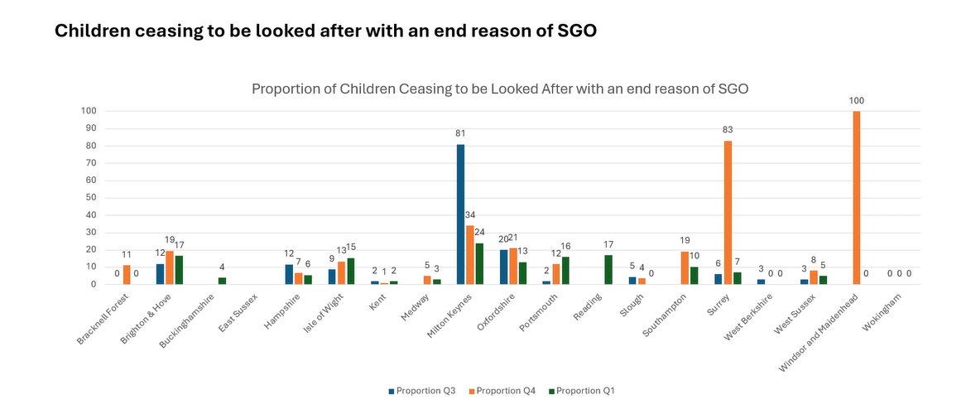
The number ceasing to be looked after with a reason of SGO has declined over the year figures in the South East are lower than the national figures, but JF reflected it may be worth revisiting the data.
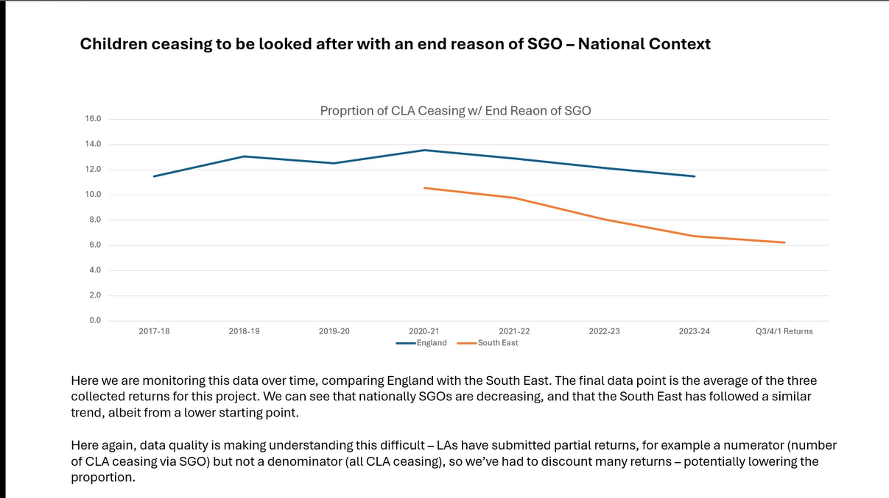
As seen last quarter there are more temporary than full approvals. Oxfordshire was an outlier but it was one quarter only.
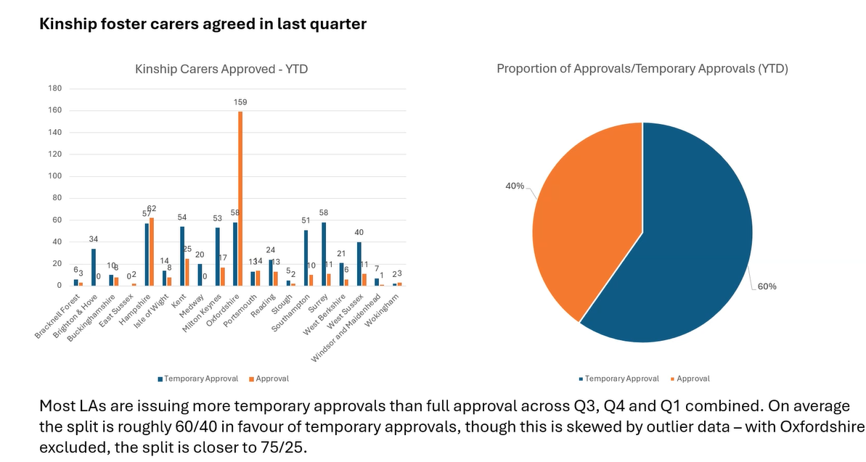
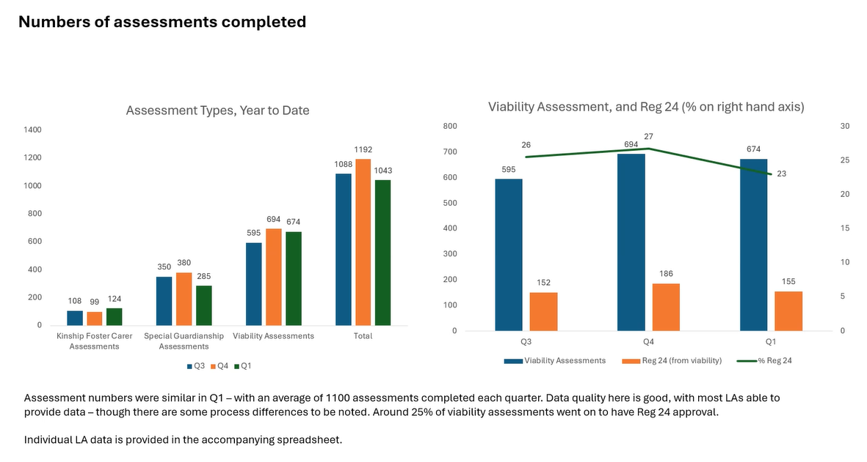
Different assessment types have been similar in the region although worth noting that not all LAs split their work that way.
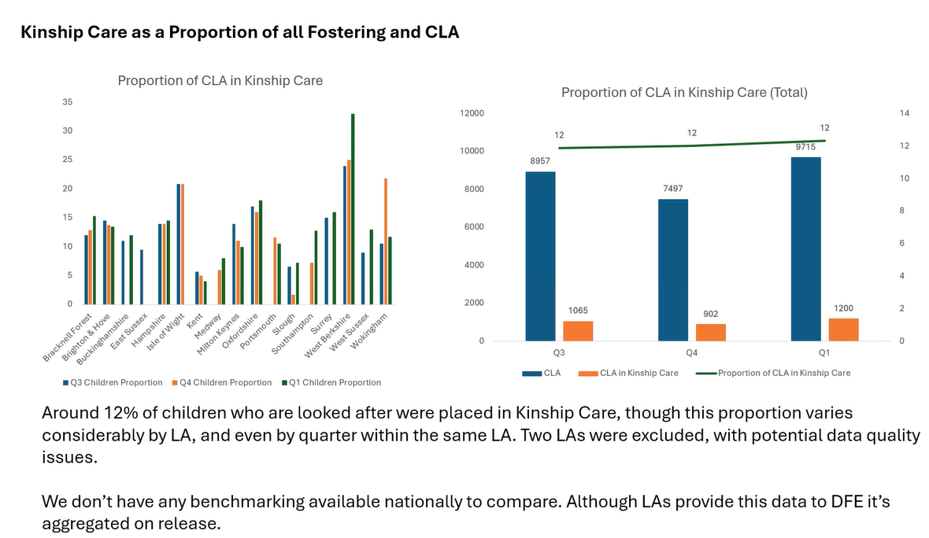
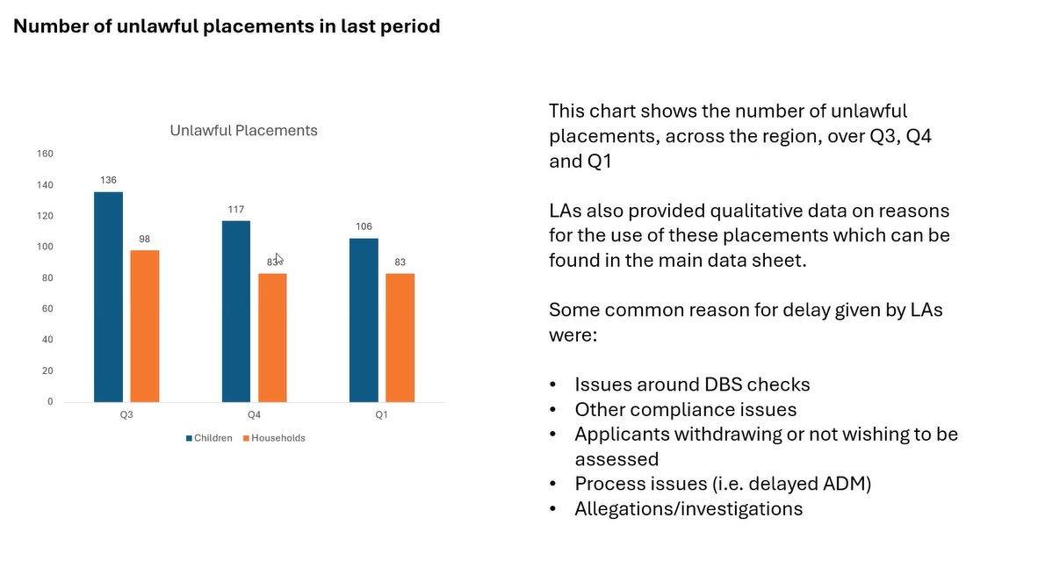
DBS checks is by far the biggest reason for unlawful placements.
LP asked if this data is useful in helping understand reasons behind breakdown and numbers leaving care to live with family.
KD reflected that the data is describing what we are doing, not influencing change and it doesn’t tell us the answer to what drives kinship breakdowns.
LP said understanding those numbers and who your carers are is critical and an important piece of foundational work if you are to coproduce a local offer.
AD from Portsmouth reflected that the way we capture is so bitty, might be in private fostering, front door in MASH, or a new SGO application for another family member. We feel we have a good offer, and around 200 children in the city and many have gone into SG to move away from state involvement and to access ASGLF.
Action: Lucy to consider what other data points for national comparison may be available. The Law Commission review is an opportunity to discuss those issues
NB from AFC shared that they are updating liquid logic from the front door to identify kinship at the outset. And there will be a kinship link to work alongside whomever the caseholder is. Whether it is SGO, private fostering, formal or informal. This is one of the ways the Afc is delivering the reforms relating to family meetings and FGDM.
Action: All to note deadline for next submission as JF will be presenting annual data returns as well as quarterly trends. 13 November submission date

ITEM 3: Kinship policy update: How the sector is responding to the new expectations in relation to kinship care.
ST provided an update on the national policy context. Reflected the new ministerial change with Josh McAllister replacing Janet Daby will likely mean an increased focus on delivery of social care reforms.
ST updated on the expansion of the kinship care pay pilot with successful LAs to be notified this month. Expecting an announcement as part of kinship care week, possibly? DfE were pleased with number of applications. Kinship is in discussions with DfE about the means testing model and providing more clarity about this.
Children’s wellbeing and school bill making its way through parliament. Parental leave review is underway and for the first time kinship carers have been recognised in that space. That will be an area of focus for Kinship - lobbying in this area (i.e. employment, adoption/mat leave equivalents for kinship carers etc.)
ASGSF, ministerial statement last week which confirmed funding extended to next financial year and applications can be submitted with more formal consultations next year.
MH reflected on what a pace that things are moving at, and also alongside major changes in relation to ICB, devolution, local government reorganisation and a SEND white paper.
NB reflected on the needs and capacity to support connected carers and reviewing that decision down the track and particularly the capacity to support people who are out of borough who need support in the place where they live.
MH said it is important to think about the reciprocal arrangements we can put in place to support children across the region.
ITEM 4: Areas of funding
RE updated that the group had been successful in securing three elements of funding through the recent DfE RIIA funding:
- To pilot Kinship reach (an online connector programme for kinship carers)
- To develop a business case for kinship connects (a face to face offer) to be delivered in the next financial year if a business case can be developed
- To augment existing coproduction with kinship carers to help LAs develop their kinship local offer (£15k)
Colleagues from Kinship outlined kinship connects and possible approaches to coproduction that could be pursued at a regional level.
Action: All LAs to get back by Sept 26 if they are in or out of Kinship Reach. Rebecca to meet with Kinship directly to develop business case for an inperson regional offering to come back to a future meeting. Kinship to develop a costed proposal for £15k to support coproduction of the kinship local offer in LAs.

Action log: This action log was updated on 29 Sept 2025. Shaded actions are closed or complete
 | Action | Responsible | Date issued | Status
19 | All LAs to get back by Sept 26 if they are in or out of Kinship Reach. Rebecca to meet with Kinship directly to develop business case for an inperson regional offering to come back to a future meeting. Kinship to develop a costed proposal for £15k to support coproduction of the kinship local offer in LAs. | RE | September 2025 | Complete
18 | All to note deadline for next submission as JF will be presenting annual data returns as well as quarterly trends. 13 November submission date | All | Sept 2025 | open
17 | Lucy to consider what other data points for national comparison may be available. The Law Commission review is an opportunity to discuss those issues | LP | September | open
16 | RE to put forward DfE bids for coproduction of local offer, and prevention of placement breakdown through Kinship Reach and Kinshio connects | RE | June 2025 | complete
15 | KW to share terms of reference for placement breakdown rapid response meeting | KW | June 2025 | complete
14 | JF include national comparison data where available in benchmarking, and JF and RE to produce an annual narrative with trends once four quarters of data collected | RE | June 2025 | ongoing
13 | JF to produce different metrics for proportions of kinship households measuring against the different baselines to allow both national comparison and also to have insight into the proportion in kinship arrangements. JF will recalculate metrics against the CLA figure in the RIIA collection. | JF | March 2025 | Complete
12 | All to consider offer from Kinship around training and get back to LP if you would like support | All | March 2025 | complete
11 | All to review benchmark data and make amendments to any incorrect data. Send amends to John.foster@eastsussex.gov.uk . JF to meet LAs individually | All | March 2025 | complete
10 | RE to contact data to insight to take the project forward, and secure funding from SESLIP to support this work. MH and RE to meet outside of the meeting to take forward. | RE/MH | Nov 2024 | complete
9 | RE to organise regional kinship care conference for the summer | RE | Feb 2024 | complete
8 | RE to circulate presentations from Nov 2023 meeting | RE | Nov 2023 | Complete
Upcoming meetings: 4 Dec 2-3.30pm
Previous meeting themes:

- 16 Nov 2023 2.30-4pm (focused discussion staffing structures and resourcing kinship teams)
- 26 February 2024 2-3.30pm (focused discussion on kinship strategy)
- May and July 2024 meetings Cancelled to allow attendance at kinship south east conference
- July 8 2024 – regional kinship conference hosted in Surrey
- November 2024 2-3.30 (focused discussion on kinship Care Statutory Guidance) and agreed to progress with regional data benchmarking
- March 2025 ASGLF and first cut of baseline kinship benchmarking data (Q 3 Oct-Dec 2024)
- June 2025 second wave quarterly regional data, DfE funding (kinship payment and ideas for regional funding)
- September 2025: 3rd wave quarterly regional data, DfE funded projects (coproduction of local offer, kinship reach and kinship connects), policy update

