Minutes and action log 

South East regional Kinship network

Chair Dr Mac Heath, DCS Milton Keynes
Attendees: Lucy Peake (Chief Exec Kinship and vice chair), Rebecca Eligon (SESLIP Support), Alistair Herbert (data to insight), Alitha Lee Townsend (Slough), Ananda Bodenstein (West Berks), Christa Beach (Hants), Brenda Buttimer (Oxfordshire), Caroline Smith (Kent), Clark McAuley (Surrey), Jugbir Ware (West Sussex), Karen Devine (Brighton and Hove), Alexandra Lambert (Reading), Lisa Apps (East Sussex),Hilary Loades Bannon (Reading),Mark Vening (Kent), Louise Murray (Medway), Natalie Bugeja (Windsor and Maidenhead), Ashley Schofield (IoW),

Meeting details: March
Item 1: Introductions: MH welcomed the group to the fifth meeting of the Kinship leadership SESLIP network. MH reiterated importance of group. Positive support from DCSs around the importance of Kinship and improving practice especially to improve outcomes and cost avoid. Meeting with DCSs and lead members next Friday.
Action: The minutes and actions from the last meeting were agreed
Item 2: Regional data benchmarking in Kinship
AH presented first set of baseline data. AH reiterated that there are likely data points which are incorrect and other gaps which could be filled. Colleagues noted that Milton Keynes needs investigating, and West Berks data is incorrect.
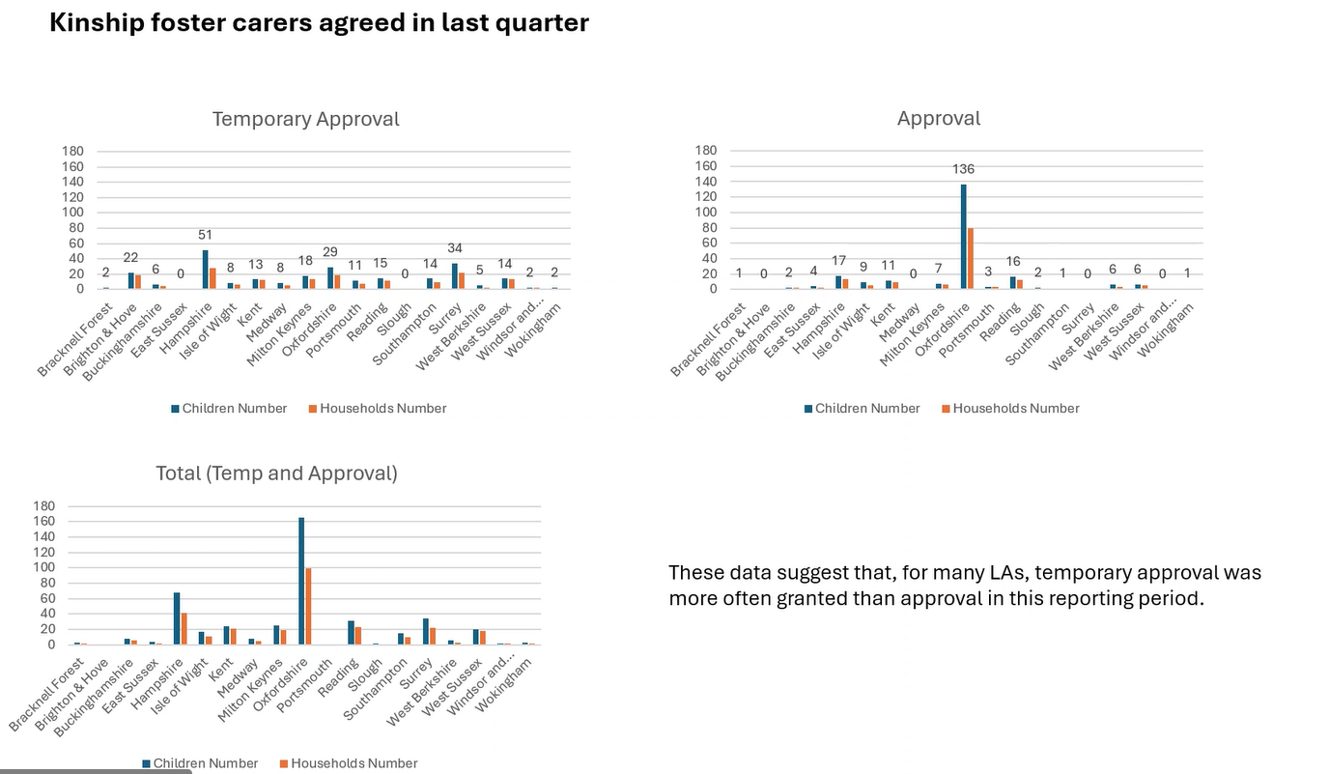
KD said some issues with medicals and DBS outside the control of the LA which mean that full approval can’t be gained which might explain the higher proportions of temporary approval. AH said there are also interesting questions to be discussed about the fact that LAs of very different sizes have relatively similar numbers of carers.
AD said over time we will start to be able to look at trends.
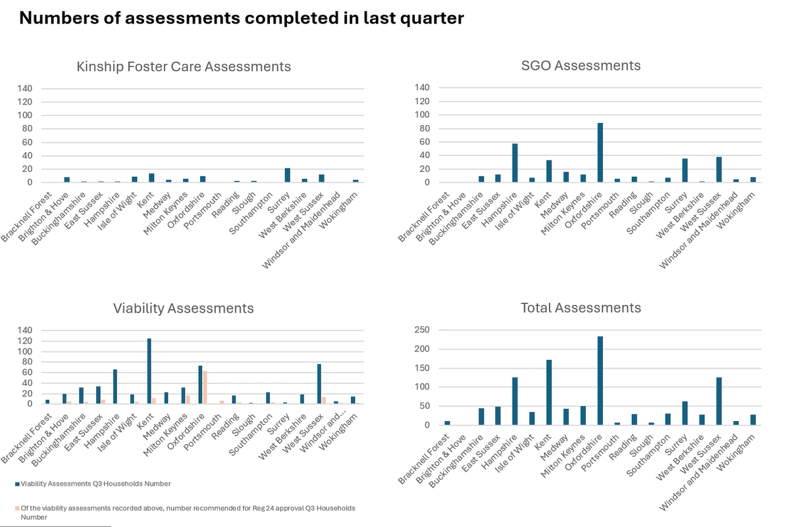
KD said it isn’t directly comparable to fostering because we are looking at the family members that are available, and that isn’t something we can control. MH agreed, and the challenge is we have been comparing kinship arrangements to fostering arrangements.
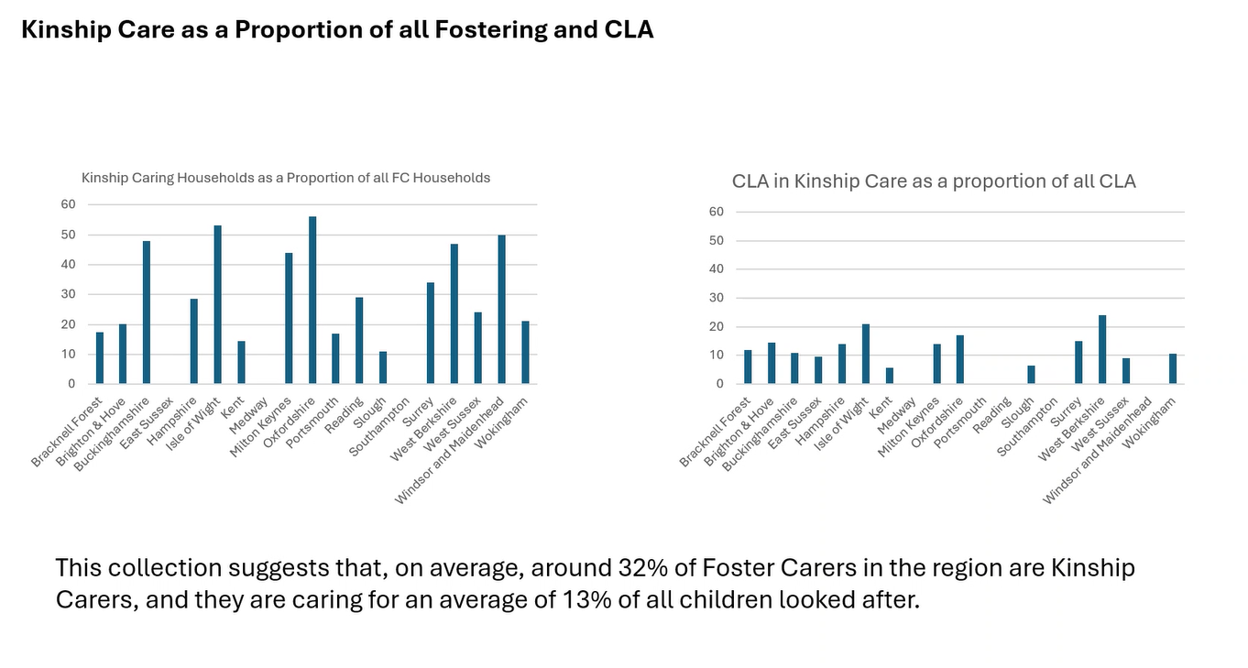
MH and LP said we need to think about what is most useful.
ACTION: JF to produce different metrics for proportions of kinship households measuring against the different baselines to allow both national comparison and also to have insight into the proportion in kinship arrangements. JF will recalculate metrics against the CLA figure in the RIIA collection.
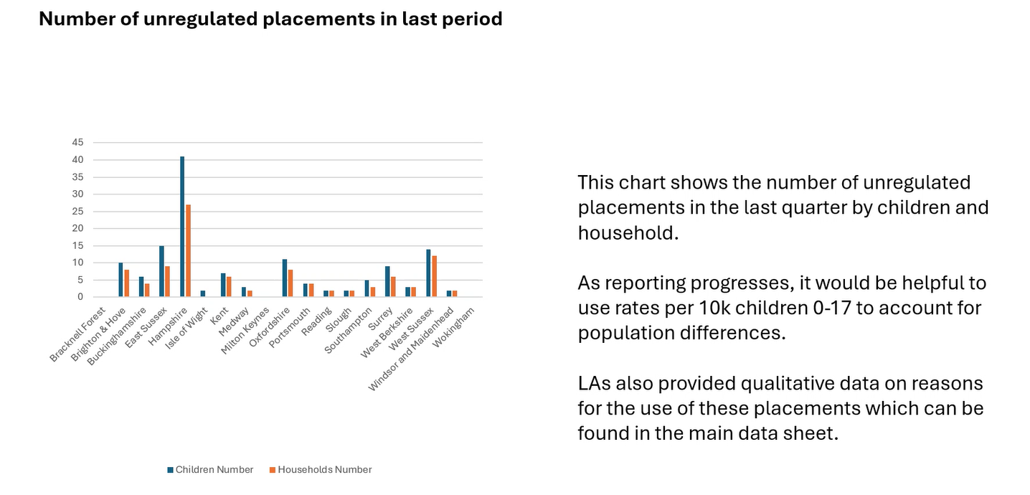
Action: JF change wording on slide above to say unlawful kinship placements (not unregulated).
Action: JF to contact leads in LAs to discuss.

Item 3: Adoption and Special Guardianship Support Fund
Shared the wording relating to the ASGSF, which has been the same for some time:

The department will shortly be finalising business planning decisions on how its budget will be allocated for the next financial year. All decisions regarding the Adoption and Special Guardianship Support Fund (ASGSF) are being made as part of these discussions. An announcement will be made as soon as possible.
ASGSF therapy applications are generally permitted to extend up to 12 months, allowing children and families to receive continuing therapy across financial years.
Applications for the fund with therapy starting in this financial year are still being accepted and processed under business as usual.

LP said they have written to secretary of state. MH and LP say they suspect the fund will continue, but there may be some reform around impact evaluation and improving administration.

AOB
LP said they have just published new research with Sheffield and Manchester Universities on value of kinship care - across all kinship care arrangements their contribution is worth £4.3bn per year (based on fostering costs as proxy) https://kinship.org.uk/our-work-and-impact/policy-and-influencing/reports-and-publications/valuing-kinship-care/
Valuing Kinship Care in England - Kinship
Valuing Kinship Care in England, published jointly by Kinship and the Centre for Care, highlights the substantial economic value provided by kinship carers in England.
LP flagged the need for us to think about the coproduction of the local offer as part of reforms.
LP said they have confirmed extension of training offer to next year. If you want to have a conversation about how to embed the Kinship delivered training in your local offer please contact Lucy. They have a target of 4,000 kinship carers. LP reflected that online delivery of training is working better than in person, and the roadshows are also working very well in terms of building confidence and relationships. Another knowledge share is planned in the spring.

Action log: This action log was updated on 4 June 2025. Shaded actions are closed or complete
 | Action | Responsible | Date issued | Status
13 | JF to produce different metrics for proportions of kinship households measuring against the different baselines to allow both national comparison and also to have insight into the proportion in kinship arrangements. JF will recalculate metrics against the CLA figure in the RIIA collection. | JF | March 2025 | Complete
12 | All to consider offer from Kinship around training and get back to LP if you would like support | All | March 2025 | complete
11 | All to review benchmark data and make amendments to any incorrect data. Send amends to John.foster@eastsussex.gov.uk . JF to meet LAs individually | All | March 2025 | complete
10 | RE to contact data to insight to take the project forward, and secure funding from SESLIP to support this work. MH and RE to meet outside of the meeting to take forward. | RE/MH | Nov 2024 | complete
9 | RE to organise regional kinship care conference for the summer | RE | Feb 2024 | complete
8 | RE to circulate presentations from Nov 2023 meeting | RE | Nov 2023 | Complete
7 | All to get in touch with Fiona Summers or LP or kinship directly via their website to explore how South East Kinship carers can benefit from the training programme. | All | Nov 2023 | Complete
6 | terms of reference agreed and to be published on SESLIP website | RE | June 2023 | Complete
5 | detailed discussion at next meeting on learning from different approaches to resourcing kinship. | RE | June 2023 | Complete
4 | West Sussex (Bridget McDermott) to send kinship charter to RE to circulate to rest of group | RE | June 2023 | Complete
3 | RE to incorporate further data from LAs and to recirculate benchmarking ahead of next meeting | RE | June 2023 | Complete
2 | Focused future discussion on ASF. Is there appetite to fund a regional ASF SG champion/support worker to have a practical role at increasing ASF coming into the region for SGOs? | RE | June 2023 | Complete
1 | All to confirm to RE the lead representative/s for your LA going forward. | RE | June 2023 | complete

Upcoming meetings
    - June 2025 2-3.30pm, 9 Sept 2-3.30pm, 4 Dec 2-3.30pm

Previous meeting themes:
16 Nov 2023 2.30-4pm (focused discussion staffing structures and resourcing kinship teams)
- 26 February 2024 2-3.30pm (focused discussion on kinship strategy)
- May and July 2024 meetings Cancelled to allow attendance at kinship south east conference
- July 8 2024 – regional kinship conference hosted in Surrey
- November 2024 2-3.30 (focused discussion on kinship Care Statutory Guidance) and agreed to progress with regional data benchmarking
- March 2025 ASGLF and first cut of baseline kinship benchmarking data (Q 3 Oct-Dec 2024)

