South East Transformation Network
meeting notes and action log November 2025

Date: 3rd November 2025 3-4.30pm
Chair: Stuart Ashley(Hants)
Attendees: Steph How (Vic Chair, Hants), Alison Munt (Bucks), Anita Stanbury (West Berks), Audrey Johnson (Bracknell Forest), Dan Buckle (Southampton), James Carter (Oxfordshire), Anna Clarke (IoW), Deborah Ennes (East Sussex), Teresa Devito (Medway), Dora Gouveia Schofield (West Berks), Jenny Thomas (Milton Keynes), Edwina Gregory-Johnson (Achieving for Children), Errol Albert (Bucks), Janet Jones (Surrey), Selina Rattu (SESLIP support), Rebecca Eligon (SESLIP support), Kirsty Morris-Selley (Milton Keynes), Hannah Leat (Hampshire), Sam Taylor (Hampshire). Kay Jones (Isle of Wight), Andrea King (Reading), Richenda Polson (Kent), Michelle Sanders (Portsmouth), Victoria Gibbs (Slough).
apologies: Estelle Kelleway (Wokingham), Hayley Rees (Wokingham), Ingrid Crisnan (Kent), Jonny Bradish (Brighter Futures, Reading), Bosede Lawal (Surrey), Wendy Evans (Milton Keynes), Collette Visagie (West Sussex), Marie Foley (West Sussex), Sarah Moran (Achieving for Children), Tom Stibbs (Brighton and Hove), Luke Varndell (Portsmouth),

Item 1: Remaining opening positions
Slough: VG presented: Aim to have new family help service bringing together targeted youth offer, early help and social work into pods led by social work team manager. There will need to be a consultation process, focus is on Slough children’s service. Small test and learn pilot with alternatively qualified workers (low level CiN/high targeted early help). Launched FGC conferences in June and rolled out family network and family led decision making training. Working with partners on a more integrated front door and have funding to work with Leeds relational practice centre to have a more conversational approach at the front door and to support partners to have that lead contact role. Early stages of MACPT development and conversation with partners. Looking to develop LCPP at senior prac level. Have engaged with children and families over the summer. Slough is looking to develop a community connector role. Question: What are early thoughts about MACPTs given we are struggling to engage partners in existing partner mechanisms? VG said still at early stages, Thames Valley police is trying to develop approach that works for all 9 LAs, trying to build on and align with existing collocation and harms outside the home strategy. Also need to resolve health contribution given ICB boundary and scope changes. DA provider has said they will collocate IDVA into MASH and MACPT.
Reading: AK there has been a very strong early help offer for many years in Reading. In the context of rapid improvement around CP and social care, we are taking a risk informed approach. We have codesigned with 500 staff a vision informed by input from over 1000 contributions from families. This has led to codesign of four family hubs in areas of greatest need (launching in March) with a focus on cultural humility, Adverse emotional experiences, alcohol and substance misuse, domestic abuse, SEND and neurodiversity has also been embedded. Also strong focus on kinship and supporting children to return home, supporting kinship as we would fostering and with specific outreach and support for kinship carers via family help. We have gone to see other places and we are moving to family safeguarding model and introducing DA, adults, substance misuse and housing into our children’s systems. Question: How have you developed family hub model. AK said have had an innovative approach to releasing capital assets from the council and schools.
Southampton: DB already combined early help and CIN in June 2025 which are based out of family hubs in 7 most needy areas. Already have family safeguarding model, struggled with recruiting partners but more success lately. Gone out to recruit for adult workers, DA workers, who will be embedded in family help. We’ve doubled FGC team from 2 to 4 FTE. Paused work on single assessment as Mosaic is developing something (according to DfE). Our challenges are around MACPT similar to those raised by other colleagues relating to health and police. We haven’t proceeded with LCPP we are taking a watching brief and waiting for more information on this. Think will need to take a joined approach with Portsmouth, Isle of Wight and Southampton. Question: is FGC team in house? It was brought in house last year following being commissioned it is focused on PLO proceedings but the aspiration is to work earlier and more broadly. Action: SR and RE to collate he case management systems that all LAs are working with so you can join up any conversations with providers.
Surrey: have intensive family support service launched and family safeguarding and C-SPA at the front door, have a vast offer universal and targeted offer and Surrey is looking to open that to a wider group of families. Have developed a small project team who are mapping business as is. Having similar conversations to understand lessons learned engaging with other family safeguarding LAs. Have a project plan with a plan to test and learn around family help. We are an early LGR adopter and moving into two LAs is an area of risk. We are appointing a community engagement lead. First partnership board in November.
West Berks: AS reflected they are developing new family help teams, and trialling one team sitting in front door, rolling out training around family network meetings for all. West Berks already has family safeguarding model with partners embedded. Plan to recruit additional LCPPs and CP Chairs are reviewing work. Front door already has key partners in place.
West Sussex: Not available to present
Windsor and Maidenhead: EGJ explained that AfC works across all three boroughs. Have family hubs since 2021. Governance is in place, recruited a practice lead, HR business partner to oversee the training needs and restructure, and recruiting to a data analyst. Recently had a review from LGA looking at spans of management control which has slowed things, but looking to have management structures in place by December and family help in place by next Autumn. Also looking to move early help advisors into the front door. Windsor and Maidenhead working with Reading on neurodiversity. Practice guidance and toolkit on family networks. A lot of work is also happening on kinship. CP chairs have dual roles as IROs so also have to consider how this will work with LCPP. Have also been doing staff engagement and roadshows to ensure people understand the FF programme, as well as engagement with safeguarding partnership and corporate colleagues. Question: raised the question about recording and tracking of family network meetings
Wokingham: Not available to present
Item 2: themed discussion: Family group decision making
DE said there has been an in-house FGC model for 20 years in East Sussex. All pre-proceedings cases are offered and about 80% take place. We were starting to offer FGCs to CIN and CP and early help. The natural progression is to roll out to all practitioners and so right from the start with a first home visit is to involve family and friends. We are piloting an approach in Eastbourne from January and building in family network meetings. FGCs will continue. The expectation is all families will have a family meeting facilitated by the caseholding worker which will lead to a family led plan. We have a comprehensive workforce development programme and feedback has been positive. Staff are already facilitating complex meetings, but there is some nervousness. We’ve created a plan template and set it up on liquid logic. We will be learning as we go.
Question: JJ was there any push back on the independence of the allocated worker facilitating the meeting. DE said they haven’t gone live but going live in January so will see whether that transpires. There is a passionate and well-respected manager who is taking the lead. There has been nervousness.
Question: DB asked if the process around FGC is helpful in stepping families out of PLO? DE said there isn’t a before and after to show that impact as the service has been in place for such a long time.
Action: DE to share family network meeting guidance
Question: Any learning on how you’ve achieved such a high take up rate? DE said there is an expectation that is part of the culture, persistence of staff to identify the network. Follow up question on PLO to proceedings?
Possible future action: Consider benchmarking conversion of PLO to proceedings in LA with established FGC vs those without . 43% PLO don’t go to court proceedings in Milton Keynes where FGCs are well embedded with 80% take up.

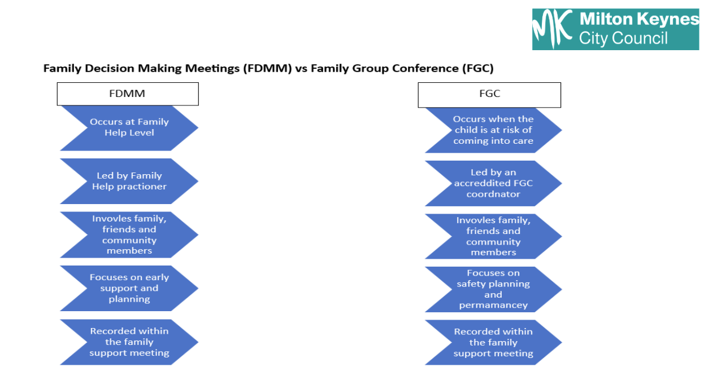
JT presented on Milton Keyne’s approach to family group decision making. She reflected it is important to recognise the issues families are grappling with in CP/PLO are different to CIN.
Lots of useful learning: need for neutral space, need to be trauma-informed, ensuring information shared sensitively and making sure family is happy with information shared. There is often a genogram. Also have 80% take up with FGC. Setting clear ground rules, and encouraging families to set their own ones before the meeting is also important.
Key questions:
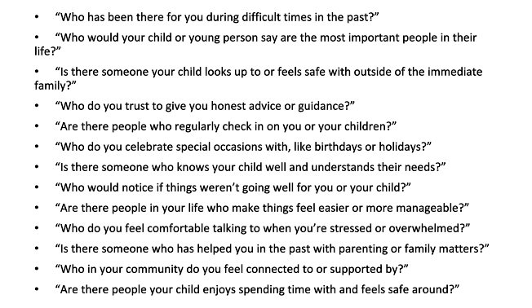
And initial list of ground rules
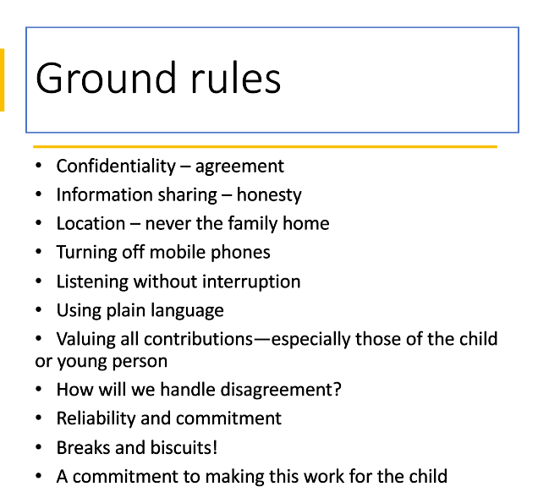
It can be easy for the child to be forgotten. Sometimes the child attends for part of the meeting or their voice/wishes are made clear through an advocate or lead practitioner.
Challenges identified:
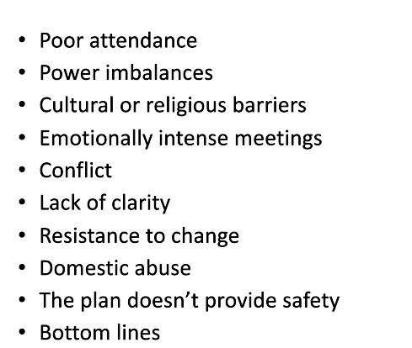

Item 3: Isle of Wight family hubs – transformation sharing
CB presented on IOW approach, has 142,000 living in coastal rural community. There is a lot of hidden rural poverty and an aging population.
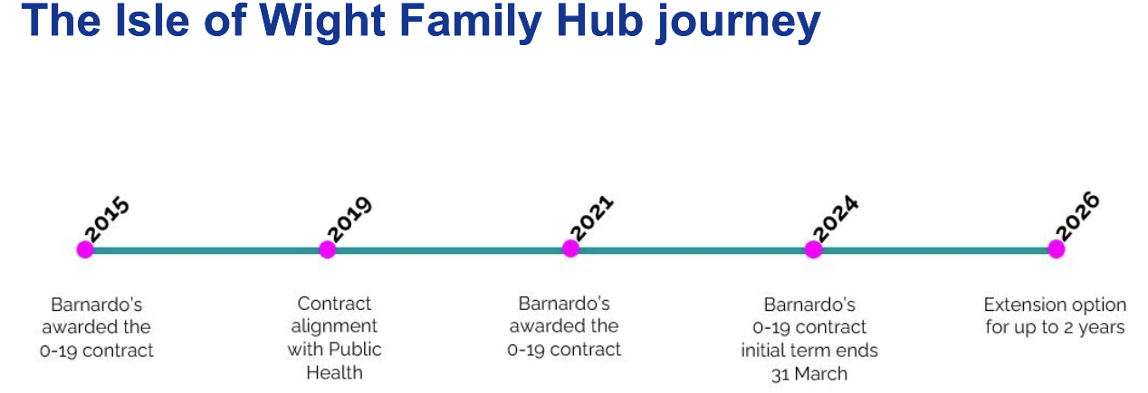
Launched family offer in 2024 which includes a portal for practitioners. Slides are attached which cover the scale of transformation which has made huge strides in ensuring partners are part of delivery.
Item 4: Focus items for next time
To be agreed via email.

Action log: updated November 6 Shaded lines, actions are complete
 | Action | Responsible | Date issued | Status
1 | Priorities for the group listed in the Terms of reference to be amended in light of discussion at the end of the meeting. | RE SR | Sept 2025 | Complete
2 | IoW to present at future meeting about their family hubs model. | KJ | Sept 2025 | Complete
3 | Next meeting to hear from Reading/Brighter Futures, Slough Children first, Southampton, Surrey, West Berks, Wokingham, West Sussex and Achieving for Children | Presenting LAs | Sept 2025 | Complete
4 | Next meeting to hear from remaining LAs: West Sussex and Wokingham | Presenting LAs | November 2025 | Open
5 | SR and RE to collate he case management systems that all LAs are working with so you can join up any conversations with providers. | SR RE | November 2025 | Open
6 | West Sussex and Milton Keynes to share family network meeting guidance | DE JT | November 2025 | Open
7 | SR and RE to benchmark conversion of PLO to proceedings in LA with established FGC vs those without . 43% PLO don’t go to court proceedings in Milton Keynes where FGCs are well embedded with 80% take up. | SR RE | November 2025 | Open

