South East Transformation Network
meeting notes and action log September 2025

Date: 26th September 2025 2-3.30pm
Chair: Stuart Ashley(Hants)
Attendees: Steph How (Vic Chair, Hants), Audrey Johnson (Bracknell Forest), Janet Jones (Surrey), Anita Stanbury (West Berks), Bosede Lawal (Surrey), Jonny Bradish (Brighter Futures, Reading), Dan Buckle (Southampton), Errol Albert (Bucks), Hannah Leat (Hampshire), Deborah Ennes (East Sussex), Sam Taylor (Hampshire), Anna Clarke (Isle of Wight), Kay Jones (Isle of Wight), Jonny Bradish (Brighter Futures, Reading), Ingrid Crisnan (Kent), Teresa Devito (Medway), Wendy Evans (Milton Keynes), Edwina Gregory-Johnson (Achieving for Children), James Carter (Oxfordshire), Collette Visagie (West Sussex), Estelle Kelleway (Wokingham), Hayley Rees (Wokingham), Janet Jones (Surrey), Kirsty Morris-Selley (Milton Keynes), Marie Foley (West Sussex), Michelle Sanders (Portsmouth), Sarah Moran (Achieving for Children), Tom Stibbs (Brighton and Hove), Luke Varndell (Portsmouth), Victoria Gibbs (Slough). Selina Rattu (SESLIP support), Rebecca Eligon (SESLIP support)
Introduction: SA welcomed everyone to the first meeting of this new SESLIP sponsored group. SA reflected that the idea is to share transformation more broadly across children’s services, and not just focus on families first reforms although this is an important consideration in the current climate and the key focus of our first meeting. SA introduced himself as chair and Steph as Vice Chair and Selina and Rebecca as support from SESLIP.
Item 1: terms of reference
The group agreed the draft terms of reference. SA noted that these can be amended as we move forward. Group content to start with 6 weekly meetings particularly over next few months. Action: Priorities for the group listed in the Terms of reference to be amended in light of discussion at the end of the meeting.
Item 2: summary of regional position
SA presented the overall summary of where LAs considered themselves to be, and noted a relatively even split.
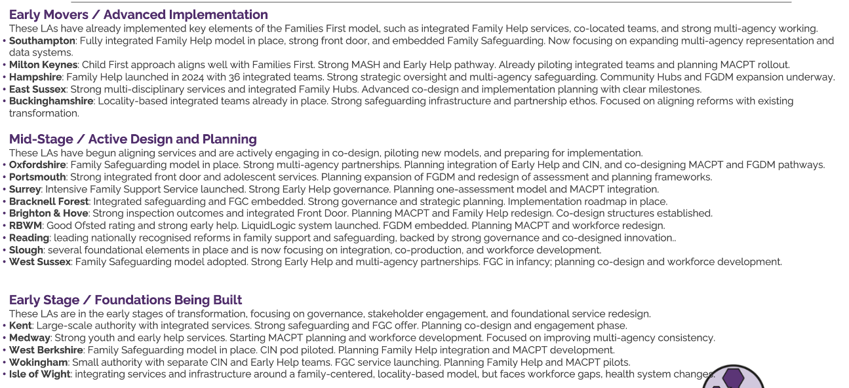
Item 3: LA updates on family first programme
SA then invited each LA to present a quick update of their current progress with FF reforms.
Bracknell Forest: AJ said in Bracknell Forest they are using family safeguarding and trauma-informed practice and building on that. Have had FGCs for 20 years and looking at expanding that team (at the moment it is focused on CiN, CP, CLA, but not yet EH arena). There is an internal team that deliver the FG conferences. Planning to coproduce approach to family group decision making but there are different views about what coproduction is, so more work is underway to get agreement about definition of coproduction. Pleased to see that we could do some thinking in this group to bring together EH assessment together with Social work assessment and to learn from those that have already designed their single assessment. Bracknell forest is revising the JSNA to help thinking about what is needed in MACPTs. There is a strong EH offer and team, there is a whole raft of training and clinical supervision and strong EH partnership. They already have an all age safeguarding partnership with good partner involvement. QUESTION: SH: asked what training and development to put such a specialist internal FGC team in place. AJ confirmed there is specific training although it is very well embedded.
Brighton and Hove: TS presented as the director. Have workstreams in place with partners, these are: MACPTs, FGDM, family help, and earlier help as well as separate task and finish groups on data and learning. We want plans to be in place by end of calendar year, next year consultation and training to then implement in July 2026. Brighton and Hove are doing pilots which extend their family help pod model of relationship-based practice which has been in place for some time. We are building on what is there. We are looking at light-touch approaches to LCPP and MACPTs. We envisage our LCPPs being involved in chairing complex strats, but not all the other parts in the guidance. We are bringing targeted early help workers and social workers into family help pods. We are getting good engagement with partners. Ongoing challenges about resources and having a pan-Sussex approach. Staff are engaging well. There is anxiety about impact of change and impact on roles. Taking a relational approach to the consultation, and a big event is planned with YP and our family advisory board to ensure input from people with lived experience.
Bucks: EA updated the group that in Bucks they moved to locality model in 2024 as part of phase 1 transformation which included family hub network model, bringing together 4 locality quadrants and best start family hubs. They have their own FGC team and they are converting into a FGDM and integrate it into family networks and prevention of entry into care offer. Across Thames Valley people are in different spaces and have been meeting separately but will move to this regional meeting instead of the smaller Thames Valley group of LAs. We have strong safeguarding approach and trying to explore what we would actually achieve with MACPTs. Keen not to pursue change for change sake. They are converting EH partnership board into FF board to oversee transformation. Question: How you have local delivery teams with a centralised MASH. SA reflected there can be a challenge of a disconnect between a centralised mash and localised delivery teams.
East Sussex: DE updated that they are building on existing practice, and also very sceptical around MACPTs, not intending to do everything listed. In a thinking space around this and working closely with West Sussex and Brighton and Hove. In east Sussex they are fully supportive of Family Help to bring duty, assessment and targeted early help teams together. Aiming to bring together the first locality in January (Eastbourne) and then rolling out to two other localities. Looking to develop single assessment and single plan. Recognise that IT solutions won’t be in place by January, and DfE guidance isn’t out til November. In our recent DfE call we said we would all potentially be paying 150 times to Mosaic and Liquid Logic and we are keen for DfE to have a role in resolving this. So, we are progressing with practice change in a way that works for us. Learned about language, we were using pilot language, we have then moved to first phase language as we will be rolling out so it isn’t a pilot that we might decide not to do. That first phase will help us to learn what we roll out more broadly. We have had an FGC model in house for over 20 years as well and very much building on that. We are starting to move that into EH space. It was historically in PLO space and beyond, planning to keep that as a traditional model but also spread it earlier in the families’ journey. Don’t like FGDM terminology but going with family network meetings, but moving for all staff to be trained on that. Focus on that internally in first year and roll out to level 2 partners, VCS etc.
Question: SH asked if existing FGC models at PLO show evidence of prevention of entry into care. DE said 90% have FGCs, 100% have the offer, but not sure the impact on entry into care.
Hampshire: Family help model went live in 2024 and also moved to more locality-based approach in each district. Like others they have built on what is working well. Thinking about FGDM, we have had family networks as part of approach for a long time, but we are looking to make that part of the process for every case that goes into PLO. Have LCPP posts in place in districts which we have found difficult to recruit to. We are looking at opportunities to develop that role. We are reviewing the MASH getting the balance between localism and consistency at the single front for which is well embedded. We launched 2 hubs in the summer and looking at how to further develop those. Looking at further locations and working with libraries on that. Got some good multi-agency buy in particularly around the hubs. Governance in place
Isle of Wight: AC said in Isle of wight they are at an early stage. They only recently separated from Hampshire in 2024 so looking at infrastructure and considering what will work for us on the Island. We have commissioned arrangements for early help and we are trailblazer for family hubs. Done work to strengthen level 2 and level 3 offer. They are looking to align a family help locality model with family hubs. Looking at reviewing JSNA. The EH board has changed to EH and prevention board. Already have workers who are differently qualified. On the IoW they need to look at the opportunities and challenges given the fact that the EH offer is commissioned. So exploring what the options are. Also focusing on staff and change fatigue. Question: JB: Asked what are you doing with staff as experiencing change fatigue KJ said that they are taking forward a ‘change together’ programme. We have monthly managers and all staff briefing to shape together the next phases of change. That is a slower process but is better at winning hearts and minds. We haven’t yet developed the plan for all of FFP, but it has been a good space to work with staff and external partners. We asked all our staff how they want us to communicate with them. Question: ST asked if there was a position on MACPTs? KJ said they have just built and launched their MASH, just introduced contextual safeguarding in the hub, with plans to bring on CAMHS and housing. Question: SA asked if in a future meeting IoW could share innovations in family hubs. KJ said yes Action: IoW to present at future meeting about their family hubs model.
Kent: In Kent there are integrated services with practitioners working with families in family hubs and different professionals in the same place. But there are not yet teams of mixed professionals. They have started to allocated ‘family help’ work to family workers IC reflected that they are very busy with programme team set up, technical work around workstream leads, project implementation, and have an analyst mapping the system, looking at continuous improvement and Lean to see what process improvements and efficiencies there are. In Kent they require a key decision to progress, so they are stuck until the legislation has been formally agreed, as it won’t be until this point that a local decision can be taken, so taking things slowly. In terms of MACPTs, challenges from ICB about their capacity. Had police colleague seconded into the programme team.
Medway: TV reflected they are at very early stages, have FGC in place, have strong Multi-agency in MASH, pace slowed by recruitment to a lot of senior posts and high recent turnover. Once posts appointed to then pace should pick up. About 1/3 of cases are CP and 2/3 CiN. Have just established programme governance
Milton Keynes: 7 workstreams in place to delivery FF, well established MASH, so developing an EH pathway in that, piloted that and saw a reduction in cases escalating. Just had family help and LCPP JDs moderated. Focused on staff engagement over summer and ready to go to consultation in November. Once 30 day consultation is up, then focus on training, partnership working. Got single assessment ready to go and we are testing that for launch in November. Have well established FGC service but has relied on relief staff but they are now making that permanent. Just produced practice guidelines for family networking from the outset. 4 MACPTs and 4 Family help. LCPPs come out at same level as deputy team managers. Question: SA asked if any teams will be based in schools. Teams are being based in localities, we will be trialling in one school as family centres can’t accommodate staff in localities. Question: EGJ asked how they had approached family help practitioner roles. There is one level for alternatively qualified MACPTs include 3 x level 3, 2 x LCPPs, they will chair conferences, QA, LCPPs visiting families they will be key around the families escalating. At start they only LA staffed. Action: include Single assessment as part of themed discussion and practice guidelines for family networking
Oxfordshire: JC said that staff engagement has been the priority. We have been reflecting on practice in the region. We see poor conversion rates in Oxfordshire (e.g. S47, ICPC etc) and tend have CP by default so we are trying to think about culture change and going back to things that worked in the past. Launching pilot in December. We won’t have a single assessment or a case management system at the point the pilot goes live. We are being supported by social work researchers and working incrementally to deliver the changes required. Reflection: SA asked the wider group if there is more to do around CP conferences and our culture around them? Sa reflected, I think we agree that there are opportunities to improve how CP works for families. And we're certainly interested (and exploring) what difference a pre-conference FGDM might make, how changes to venue/ timings could impact family participation, and so on. Our reluctance is to artificially change everything everywhere all at once, without more of a firm evidence base. Action: Add CP conferences and FGDM to priorities of group
Portsmouth: have integrated front door with partners, early help offer is strong, 5 hubs, commissioned service delivered by Homestart which includes delivery by 100 volunteers. Family safeguarding embedded in 4 locality teams and there is an adolescent service. FGC, have 80 conferences a year delivered by Day Breaks as a commissioned provider. Restorative and relational practice model. Stable workforce. FGDM is not embedded across system and seen as standalone FGC events, there are plans to shift this practice as part of reforms. Plans families come up via FGC aren’t always embedded in professional plans. Reviewing capacity in adult safeguarding teams, alongside work to bring together EH and social work. Developing a lived reference group. Got governance (two boards in place) and a programme team in place. MACPTs looking at strengthening processes to make more restorative and relational.
Due to time constraints, the remaining LAs were deferred to the next meeting
Action: Next meeting to hear from Reading/Brighter Futures, Slough Children first, Southampton, Surrey, West Berks, Wokingham, West Sussex and Achieving for Children
Item 4: Priorities for upcoming meetings:
The group agreed the following priority areas, noting that the SESLIP programme team have 7 days a month delivery capacity to progress the work.
- Sharing practice on Family network models/FGDM models
- Sharing approach to training?
- Sharing career pathway for staff without social work qualifications
- Look at impact /evidence and how we are measuring outcomes (possibly sharing FF data returns for quarterly regional benchmarking?)
- Sharing approach to CP conferences and how you are doing these differently
- Sharing approach to MACPTs (including whether you are progressing with this element of reforms) and mapping practice across the country
- Sharing approach to how you are spending transformation grant
- Sharing how you are making approach financially sustainable, including delivery of savings
- Share resources (including JDs, family meeting policy docs, single assessment, etc) through a dedicated area on SESLIP website.
- How are family help teams being based closer to communities? Which partners are involved and part of teams?
Item 5: Themed discussion topic for next time
SA outlined he was keen for the group to always hear about an example of transformation outside of Families First at each meeting.
Action: IoW to present at future meeting about their family hubs model.
.

Action log: updated 29 September Shaded lines, actions are complete
 | Action | Responsible | Date issued | Status
1 | Priorities for the group listed in the Terms of reference to be amended in light of discussion at the end of the meeting. | RE SR | Sept 2025 | Open
2 | IoW to present at future meeting about their family hubs model. | KJ | Sept 2025 | Open
3 | Next meeting to hear from Reading/Brighter Futures, Slough Children first, Southampton, Surrey, West Berks, Wokingham, West Sussex and Achieving for Children | Presenting LAs | Sept 2025 | Open

