Fostering regional group meeting notes and action log December 2025

Date: Tuesday 9th December 2-3.30
Next meeting dates: Tuesday March 17 10.30-12, Monday June 22 10-11.30 and Thursday September 24 2-3.30
Chair: Sarah Daly DCS Portsmouth (apologies)
Attendees: Rebecca Eligon (SESLIP support), Cathy Seiderer (Brighton and Hove), Keith Langley (West Berks), Mark Vening (Kent), Nicola Sankey (West Sussex), Renee Eddy (Southampton), Selina Rattu (SESLIP presenter), Holly Clune (AfC), Alison Miller (Milton Keynes), Kelly Grant O’Sullivan (Slough in place of George Mathew), Hannah Pycock (West berks), Jackie Clark (Portsmouth), Sinead Roche (East Sussex)
Apologies: Carly Arnold (Southampton), Dave Crewe (Portsmouth), Carol Norrington (Surrey), George Mathew (Slough), Sam Horton (Hants), John Donnelly (Brighton and Hove), Kimberley Showell (West Sussex), Maria Cordrey (Kent), Peter Hodges (Bracknell Forest), Kerry Bailey (Portsmouth), Sam Howard (Bracknell Forest), Sarah Smith (Hants)
Item 1: Minutes and actions from last meeting agreed.
Item 2: fostering community project
RE presented progress on the fostering community project which had been progressed with input and joint working of LAs involved in the monthly steering group from Southampton, Milton Keynes, Portsmouth, Hampshire, Brighton and Hove, East and West Sussex. CS and AM said the focus is really on creating a new pipeline and focusing on those people who contact us who we are keeping warm and for various reasons are not ready yet. RE set out the proposed approach to pay, training, assessment and approval and supervision.
SD said it was good piece of work with much progress.
KL said that they are employing existing foster carers to do this at £15ph.RE said that will be noted
Action: The group agreed with a proposal to seek funding to trial a pilot in the 7 LAs which had been part of the steering group. RE to meet with SD and DCS Mac Heath in his role as DCS chair in SESLIP to see what scale of pilot might work/be palatable for DfE to fund.
Item 3: discussion of fostering research undertaken by Selina Rattu on behalf of SESLIP
SR presented that this research Came out from discussion at AD group about rewards and benefits. Project has looked at mapping as is offer, and understanding from foster carers what matters most to them. Original intention around harmonising benefits isn’t likely to be the next step.
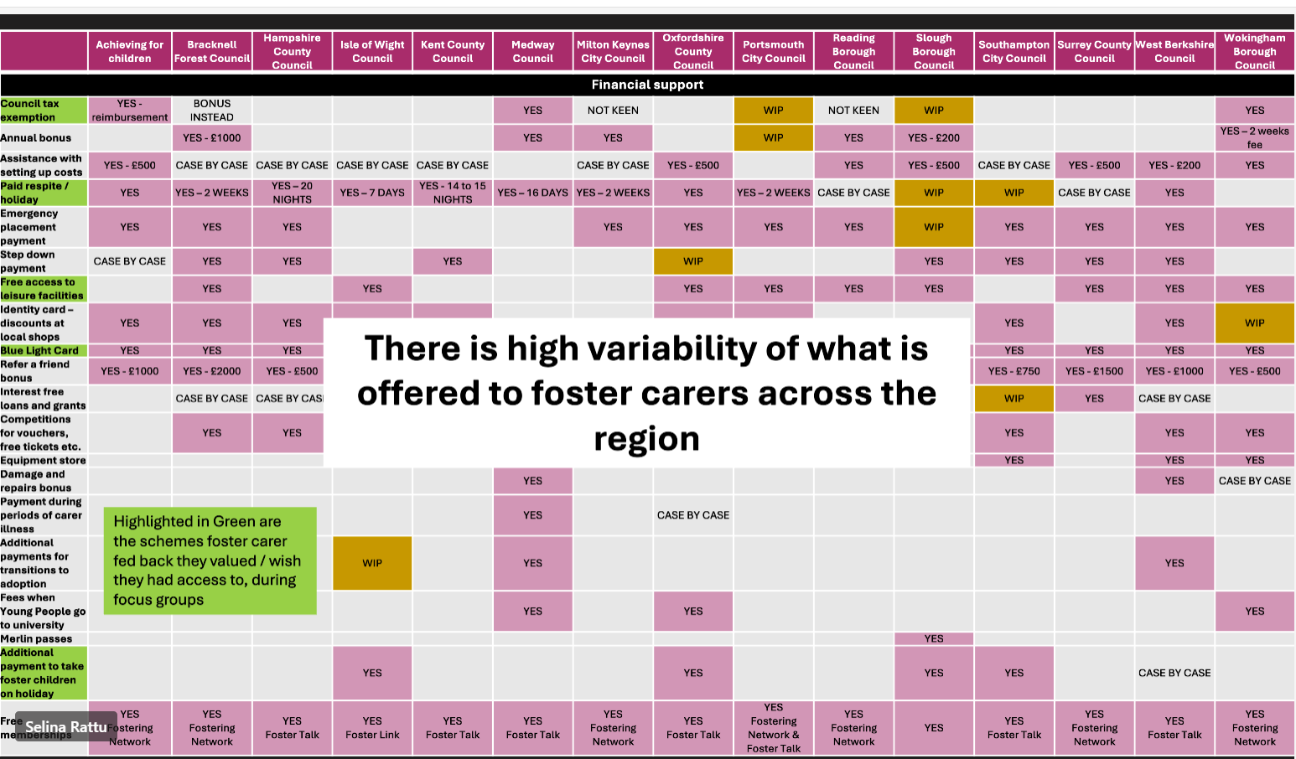
Pink are those that are in place, green are the ones that foster carers said were important and brown are the ones that are in train. There is high variability in what is available.
There was a hypothesis that when we look at fees and allowances the way we talk about payment and allowances is variable. Communication was much more complex between LAs as compared with IFAs.
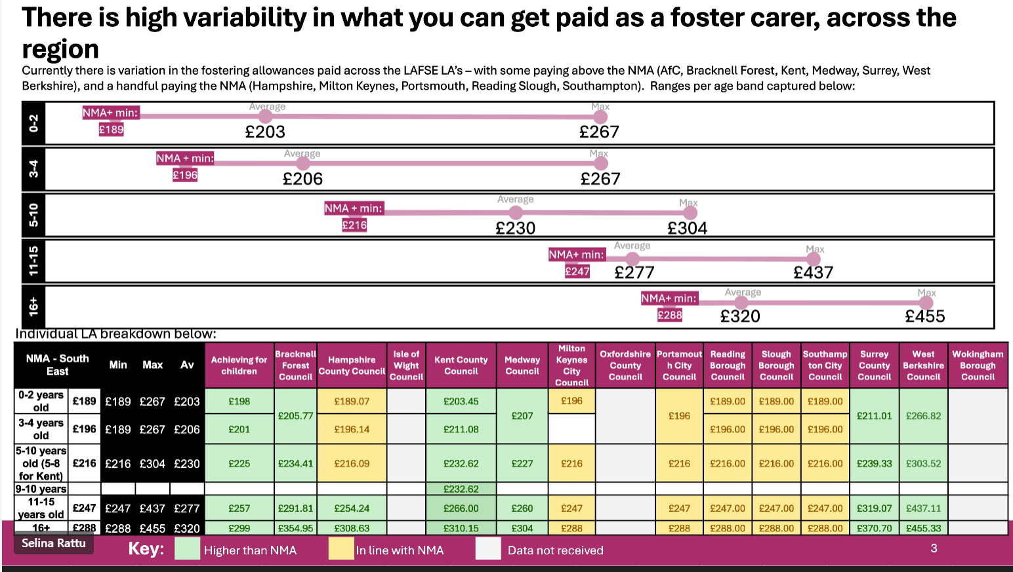
SR noted that the KPIs are the last year’s ones, so need an update
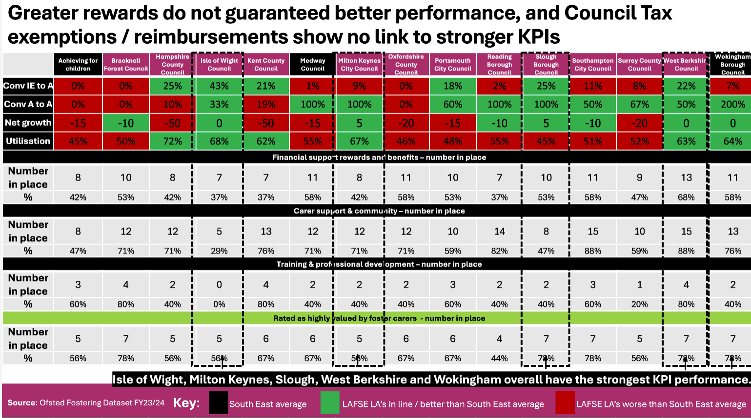
In addition to data mapping and a survey, SR also conducted focus group with foster carers.
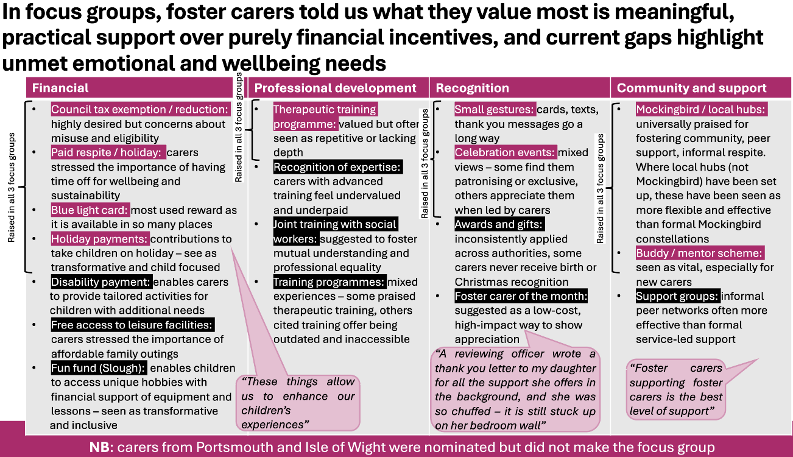
A power BI dashboard is being sent out imminently which will bring all of this data together so LAs can filter on their LA, and select LAs to compare against.
Next steps are around analysing underutilisation, mental health support at points of placement breakdown and allegations, and non- LAFSE LA. SR will be working with Ads to develop a phase 2 of this work.
Query from Clark in Surrey: I wonder if the rewards and offer presentation can have this years released data when updated and also will there be a follow up? SR said yes.
Question from JD: JD asked if the theme around respect came out strongly. SR responded that it was one of the findings when FCs were asked to develop an ideal rewards offer.
SD asked if the operational leaders in this group were clear aware of the ask around utilisation. SR said this was planned for this financial year.
AM said MK did we did their own survey. Happy to share the findings so they can be incorporated which are very similar.
AOB from Brighton and hove
Brighton and Hove are currently reviewing how we can best meet Fostering National Minimum Standards-Standard 3.8 which states;
3.8) All foster carers receive training in positive care and control of children, including training in de-escalating problems and disputes. The fostering service has a clear written policy on managing behaviour, which includes supporting positive behaviour, de-escalation of conflicts and discipline. The fostering service’s policy is made clear to the responsible authority/placing authority, child and parent/s or carers before the placement begins or, in an emergency placement, at the time of the placement.
JD is interested in what other LAs are doing for foster carers specifically on de-escalation.
HC said in Afc one of the SSW is trained as a systemic therapist and she is providing support which includes in this space which is having positive feedback. Also have NVR training
KGOS said in Slough two workers who are trained counsellors who are supporting placements. Also running a 6 week programme on trauma informed parenting in the evening. Also introducing resilient fostering. There is also a play therapist.
SR said from East Sussex said Skills to foster will be the first approach in setting out the landscape around expectations, trauma, attachment and need for trauma informed approaches pre-approval. Our SSW's are all DDP trained. Our training officer offers trauma informed parenting
Item 4: issues for escalation and agenda items for next meeting
No issues for escalation to DCSs, agenda item next time to focus on fostering community project. March 2026 meeting to hear from MC in Kent on the step across and children with disabilities led project.
AM said looking at room makers scheme from Manchester as part of funding transformation. Suggested for future meeting.
AOB
JD said what is on Josh MacAllister’s mind? SD said he is very focused on fostering and children in living in family settings.

Action log: updated 29 December Shaded lines, actions are complete
 | Action | Responsible | Date issued | Status
55 | March 2025 meeting tohear from Kent (MC) on step across and children with disabilities led project. | MC | Dec 2025 | Open
54 | The group agreed with a proposal to seek funding to trial a pilot in the 7 LAs which had been part of the steering group. RE to meet with SD and DCS Mac Heath in his role as DCS chair in SESLIP to see what scale of pilot might work/be palatable for DfE to fund. | RE | Dec | Open
53 | RE to connect Bracknell Forest with placement modelling tool from Data to insight | RE | Sept 2025 | Complete
52 | Any LAs interested in finding out or for a demo of Tracs or ICompass e can contact Colin on colin@tracsuk.org | All | Sept 2025 | Complete
51 | RE to connect PH with the Data to Insight placement modelling tool which can be used to model placement types and costs using 903 return data. | RE | Sept 2025 | complete
50 | CS asked that “those for whom the time isn’t right” is added to the group who want to foster but cannot in the fostering community project. RE to add this to project plan | RE | Sept 2025 | complete
49 | MC to share out of hours policy | MC | July 2025 | complete
48 | RE to convene a design meeting with those that are interested, and to liaise with DfE about this new idea. This to be the main item at the next regional meeting. | RE | July 2025 | complete
47 | GS and SD to meet with MH to discuss how this group can be used moving forward to help provide a space for LAs to provide feedback/identify key issues to ensure the success of the hub moving forward. NB: The hub is likely moving aligning with direction of travel with RCC | SD | March 2025 | Ongoing/  complete
46 | SD has agreed to escalate and take to the regional DCS group that there are issues around cost and pace/delays regarding foster carer medicals. SD has flagged this. | SD | March 2025 | complete
45 | SD asked the group to find out and report back: What is driving delays is it capacity, payment, or it isn’t part of the commissioned offer, is it costing too much? What is the issue. Have you escalated in place-based partnerships and ICB risk logs? | ALL | Dec 2024 | complete
44 | Oxfordshire (Julie McNally) Hampshire (Sarah Smith), Brighton and hove (Cathy Seiderer) and Portsmouth (Jackie Clark) to catch up outside the meeting on sharing practice/approaches re: support to foster carers in the first year. CS to convene this group. | JM SS CS JC | Dec 2024 | complete
43 | SD to draft letter to ICBs in region setting out the impact of delays in medical assessments | SD | Oct 2024 | complete
42 | HB to share business case/thinking behind salaried foster carers (c.£60k, 10 months a year, 3 carers on rotation) when it is ready | HB | Oct 2024 | No longer relevant
41 | PH, KL and SA to meet to get a consistent approach to police input across the Thames valley. | PH KL SA | Oct 2024 | Complete
40 | Brighton and Hove to share support for foster carers in first year and wellness action plan | CS | Oct 2024 | Complete

