Notes and action log 
South East regional Early Help network
December 2025

Attendees: SESLIP Support and chair: Rebecca Eligon, Bekki Kundi (Slough), Jackie Clementson (Surrey), Carly Wiseman (IoW), Dan Buckle (Southampton), Rachel Park-Davies (AfC), Charlene Hornsey (West Sussex), John Foster (data to insight), Sam Phippard (Hampshire), Celia Lamden (East Sussex), Susan Akinyele (Medway), Ciaran Hamlet (Oxfordshire), Shona Harris (Oxfordshire) Natasha Bishopp (regional advisor national centre family hubs)
Apologies: Chair Grainne Siggins (DCS Bracknell Forest, Audrey Johnson (Bracknell Forest Vice Chair), Michelle Williams (Medway), Estelle Kelloway (Wokingham),
Meeting details: December 11 2025 2-3.30pm
ITEM 1: Introductions and review of action log
The action log and minutes from the Sept 2025 meeting were agreed.
Item 2: Early Help data benchmarking: John Foster
Over 100 LAs submit EH data and has been running for about 18 months. Often differences are due to differences in recording. The national recording of contacts is much lower nationally than in the south east. Contacts as a proxy for demand is increasing both nationally and regionally.
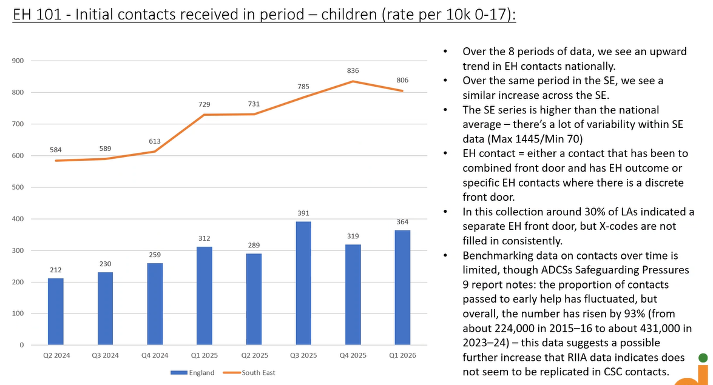
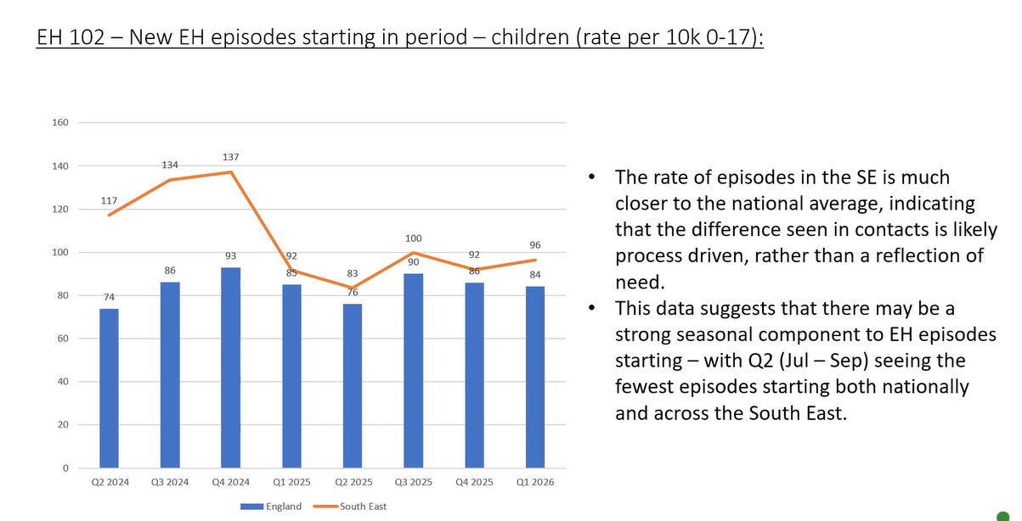
Dip in quarter 2 due to summer holidays is consistent everywhere (July-Sept). Of families who start an episode how many were previously open – 17% nationally, around the same in the South East.
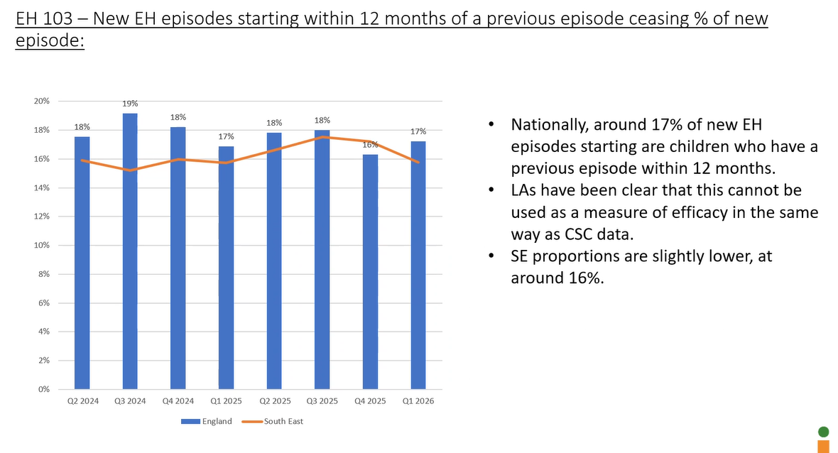
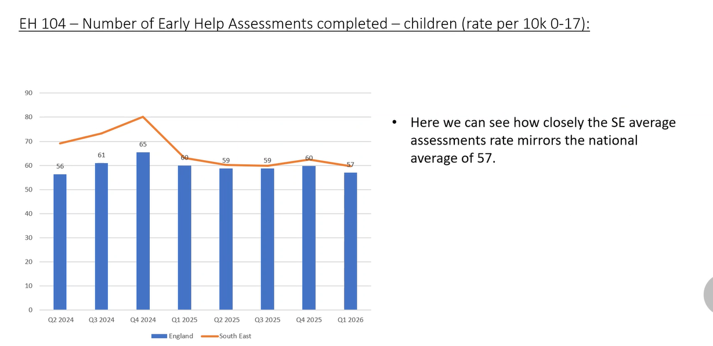
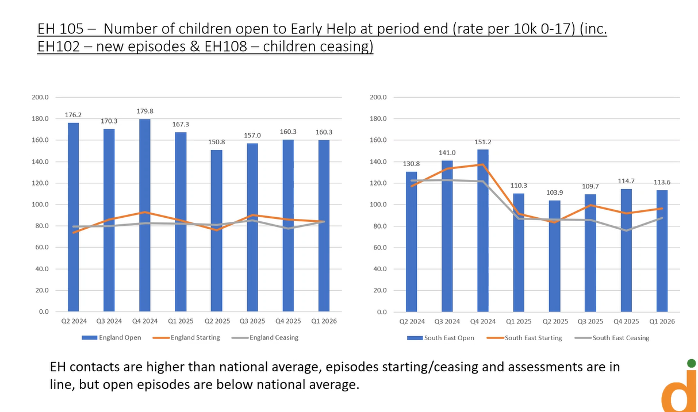
JF reflected he was hypothesising if you have lower EH is that because you have more in social care CIN, but there doesn’t appear to be the case.
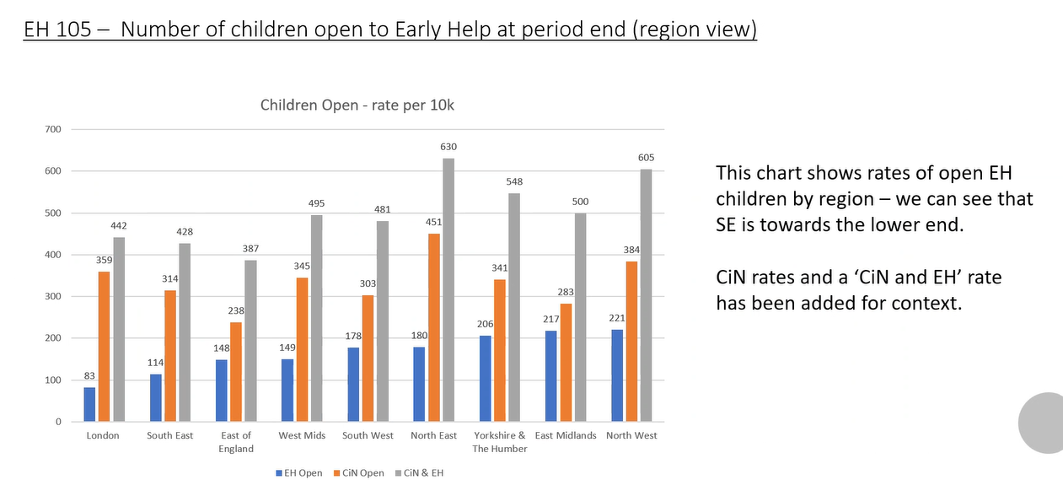
More step downs than step ups than nationally
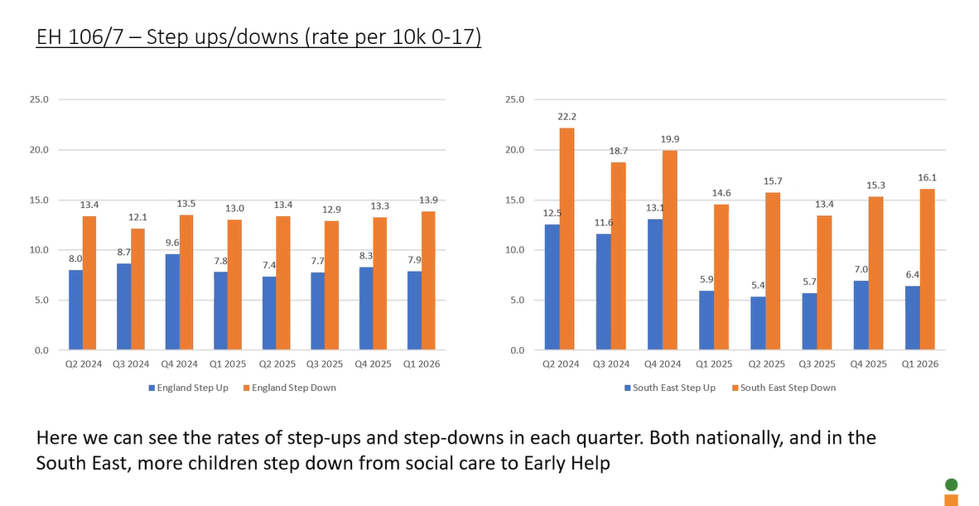
Relatively stable about 60% are closing with outcomes met in the South East
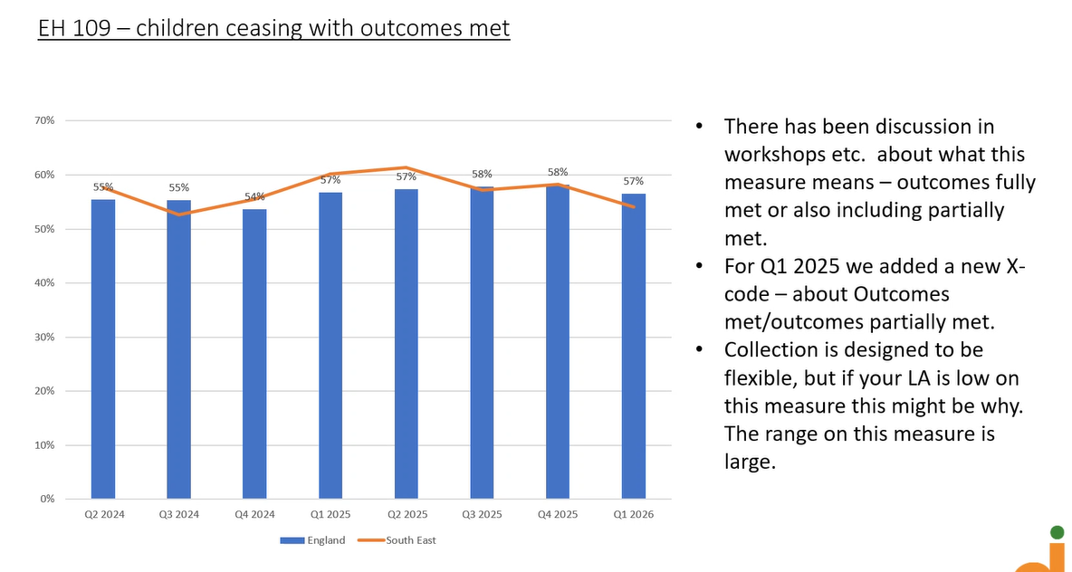
RE asked if other LAs use the data, and look at annual trends. People said yes
DB said that In Southampton it is pretty close to 50/50 ending with needs met compared with the trends presented.
Item 3: Introduction from Natasha Bishopp Regional Advisor (South East) for the National Centre for Family Hubs
A lot has happened in the last 3 months around family hubs.
- Final GLD targets have been sent to DCSs and Chief Execs.
- All LAs have received indicative funding for 3 years for Best Start Family Hubs and continuation of funding for those with FH.
- Also received home learning environment and evidenced based menu of preferred providers. DfE has Q&A on 16 Dec. There are some LAs working with providers not on the list, so dfE is setting out exemptions
- Survey – Best start in life readiness check – needs to be submitted by 12 January
- BSFH and healthy babies guidance came out last week – about branding which needs tobe displayed in all physical family hubs
- DfE webinar on 9 December are available on knowledge hub
- Best start in life plans need to be published by end of March ideally codesigned with partners and residents
- More detailed guidance on standards and delivery to come including in relation to SEND. 4 webinars between now and Jan between now and end Jan run by national centre.
RPD said they see a gap in the offer to child minders, teaching PVIs to see if that can be pursued using the menu. NB said that the offer cannot purely be for teaching.
RPD said she is excited about this but also reflected there are a lot of information and is taking over our lives. CL said the timing of the funding is interesting. The children that would be demonstrating GLD by 2028 are gone from our service and most are in settings now.
As a previously non funded LA this is very exciting, I feel we are ready but without the full guidance it is hard to plan post April 2026
SH said it is helpful to have a strategic direction, but all the webinars are too much. Would be helpful to have a RAG rating to understand which are critical.
Item 4: themed discussion: what is happening with level 2 and universal, protecting budgets for this work and any challenges. Led with intro by Celia Lamden East Sussex
CL reflected that the budget position in East Sussex is acute, there is a £15m overspend this year and £18m next year, and a lot of energy in family help pilots. The response in East Sussex is to add another layer of intervention.
East Sussex has SPOA (single point of advice)- if referees don’t hit threshold for safeguarding they get bumped out. Professionals can phone in to the new information and advice line with a scenario and get given advice and guidance, they can also request in-depth input. We know we are saying to partners that they need to hold more and so we are providing them with support via the new information line and Team Around the Family coordinators who can support them in their role as lead professional.
SPOA (our front door) may suggest they need the support of a team around the family coordinator. The TAF coordinator works with the lead professional who has made the contact to put a support package around the family. They’ve been funded by redesigning our old community advisory worker capacity.
East Sussex started the IAG line in Oct. 52% professionals, 48% - SEND, school attendance and support with parenting. People using the line have said it is nice to talk to people who care and can have an in-depth conversation. School nurse said this is invaluable. They appreciated the sign posting. So far there have been - 10 EY, 13 sec school, 6 VCSE, 11 Other – we want them to help us with level 2 families. Our ask is for them to be the trusted adult, and so we give them the TAF coordinator. We want partners to do more for us, and we can’t ask them to do more if we don’t offer anything. There are currently 2 staff on IAG – plan is to grow that and reduce SPOA/front door.
Hammersmith – few years into a similar journey.
The TAF coordinator doesn’t work with family they work with the other professionals. They support with threshold. We aren’t asking them to hold safeguarding TAF coordinator will seek advice or suggest – working alongside There is a TAF plan which is held on the child’s record.
SP – said we used to have professional lines as we moved into family help we moved away– dual model one line for parents and one for professionals. SP asked who does the assessment and where do TAF coordinators sit? CL said they sit at single point of advice (SPOA). Consultation request form. Have hour long consultation. Professionals don’t really want this, so they are filling in form as they have the conversation.
SH asked how it fits with family hubs – this is central service which is advertised in family hubs it isn’t linked.
CH We have locality and community support service that support on complex TAFs to prevent things from escalating, and they have a consultation line for professionals which has recently been open to parents. We were getting lots of calls to MASH on parental conflict and managing contact and locality workers are picking those up. We have this in place but referrals to the front door are still going up. Are you seeing a reduction as yet?
CL said 40% are coming from SPOA. The plan in the future as this approach is embedded if for everything which is safeguarding goes to SPOA and everything else to information and advice.
BK –MASH and EH has been completely separate, we now have EH Team leader in the front door, they are now pushing back and a community connector. We are bringing in a needs led conversation, key prompts to help a practitioner pre social care – who is out there that can support families. There are EH surgeries that aren’t used. Funded this by freezing posts in targeted EH, still have demand there.
SP – reworked and rebranded an SOS conversations when we used to have family support service. Now shifted that into motivational interviewing approach.
Item 5: insight and family feedback
SH introduce the item. She is keen to understand how we improve family feedback – keen to understand how other LAs are gathering feedback from families how you are bringing that together.
CL – we do a survey to all parents before we launched family hubs – got lots of information about awareness of children’s centres, we are about to relaunch as we are now 4 years in. Reaching people is difficult, will take it in to groups and activities. At the end of quarter/term – we ask people to rate five statements:
- I am generally happy with the service I received
- My needs, feelings and wishes were taken into account
- I was treated with dignity and respect by staff
- Things have changed as a result of contact with EH Keywork
- Matters relating to race, culture, heritage or religion were taken into account),
Practice in bi-borough -had text conversations – 3 questions as we closed anything. Did we help you, every 6 months all the senior managers and team managers phone staekholders and families. Once a month every manager does one audit.
BK codes that are left with every family. Practitioners have questions at assessment, TAC, and closure. Rocket Science trained young inspectors who then spoke with CYP on what they wanted. Used networks to ask parents to meet – spoke with 100 YP in the summer.

ITEM 3: Standing items:
No issues for escalation or future projects for consideration. New standing item – update from Natasha.

Action log: This action log was updated on 15 September. Shaded actions are closed or complete
 | Action | Responsible | Date issued | Status
51 | CL to share on what is happening with level 2 and universal, protecting budgets for this work and any challenges 11 dec 2-3.30pm | CL | Sept 2025 | open
50 | CO to share the contacts in each LA where the EHE and CME dashboard is sent so it can be shared more regularly between them and EH leads. CO share dashboard for information only with EH leads (with caveat it is not a league table) | CO | Sept 2025 | Open
49 | RE to put forward ideas relating to reform and family help as part of the DfE funding. NB: A new transformation group with an initial focus on reforms has been funded by the DfE and this group will consider the practical focus/products/engagement with partners that might be helpful at a regional and subregional level. | RE | June 2025 | closed
48 | CL to share reform workstreams and structures from East Sussex | CL | June 2025 | closed
47 | RE to work with Southampton to set up a lunch and learn for early help workers who may be part of future family help services | RE | March 2025 | closed
46 | GS to discuss via DCS group if any group action is needed where LAs are experiencing difficulties retaining the ring fenced grant for the delivery of reform with S151 and corporate taking the grant to fill overspends in children’s services. | GS | March 2025 | Closed
45 | JF will look at the cohorts of LAs that have received family hub funding or are family help pathfinders to see the impact on the 9 measures in the early help dataset. | JF | Dec 2024 | closed
44 | RE to email GS with the six LAs who are not submitting EH data to follow up with DCSs as they may not be aware. Complete (not sure if GS has chased DCSs) (Buckinghamshire, Isle of Wight, Milton Keynes, Portsmouth, Southampton, West Berkshire ) | RE | Dec 2024 | closed
43 | HH to present the headline findings and themes from Oct 2024 National Centre for Family Hubs Conference: Shaping the future of family support | HH | Sept 2024 | closed
42 | SM from domestic abuse commissioner to present at future meeting on findings relating to early help | SM/RE | Sept 2024 | closed
41 | GS to escalate via ADCS and South East DCSs on any further news re: funding for Supporting Families | GS | Sept 2024 | closed

