Minutes and action log 
South East regional Early Help network

Chair Dr Mac Heath, DCS Milton Keynes, Vice Chair Lucy Peake, SESLIP support rebeccaeligon@gmail.com
Meeting details: December 4 2025 via MS teams 2-3.30pm
Attendees: Alison Miller (Milton Keynes), Alitha Lee-Townsend (Slough), Ananda Bodenstein (West Berks), Carly Arnold (Southampton), Christa Beach (Hampshire), Caroline Smith (Kent), Fiona Sumers (Kinship), John Foster (Data to insight), Alexandra Lambert (Reading), Gayle Langhorn (Southampton), George Layzell (Medway), Mark Vening (Kent), Lisa Murrell (Reading), Wendy Queralt (Oxfordshire), Seema Sehgal (AfC), Tim Fisher (Kinship), Zoe Rosenfield (Brighton and hove), Sharon Godfrey (Milton Keynes), Lisa Apps (East Sussex), Clark McAuley (Surrey)
Item 1: Introduction and action log
No outstanding actions and minutes agreed.
MH set the scene around us as a regional group, reflecting as DCS he recognises the context and importance of kinship and it is key to ensure more consistency around our approach to kinship across the region. MH reflected that there is an extended DCS awayday tomorrow to look at the items we need to consider as a region together. MH reflected that the new children’s minister is very committed to fostering and kinship whilst we are also involved in seismic changes relating to devolution, boundaries, LGR, ICS and ICB changes even before changes to schools and SEND. The challenging areas are as big as they have ever been. One of the drivers we are looking at tomorrow is the scope and ambition of the RCC in the South East. The conversations we have in this group will inform those conversations in the region. The DfE is keen for us to more closely collaborate.
MH also wanted to mention a recent event for adoption leaders and that flagged adoption and special guardianship support fund, Prof Julie in Oxfordshire has done really interesting research into breakdowns of SG arrangements. He shared that we do in this group need to think about how we use the ASGSF. We often use this fund to access therapy for children in SG. The questions raised by the research are how sophisticated we are about formulation of need and how we provide that support.
Item 2: policy update
Written update from Lucy Peake who sent apologies. TF and FS provided more information:
Financial allowances pilot – we don’t know anything specific, just to expect decision about which LAs have been selected early next year.
Parental leave review – Kinship’s surveys suggest most kinship carers are working prior to taking on children placed in various types of kinship arrangements. Just under half are giving up work, and many of those say that a period of paid leave from their employer would have enabled them to balance new working and caring responsibilities. Kinship care has been included in scope for the parental leave review, so Kinship is working hard to secure the right for kinship carers for some paid leave. In November, Kinship hosted a policy workshop with kinship carers, Dept for Business and Trade (DBT), DfE, employers, local authorities, unions and other employer bodies to design a policy that will work for kinship care. There are complexities (e.g. when should paid leave start and in what circumstances) and we’re continuing to work with DBT to build workable plans. We’ll also be stepping up our campaigning, and encourage colleagues in local authorities to support this to give ourselves the best chance of securing paid for kinship carers.
Law Commission Review – they are still at research/consultation stage and we expect a formal consultation period to open in Spring 2026. TF encouraged people to engage with the consultation.
Kinship is also linking to all local offer LAs on their Compass page. About 20% of LAs have done this.
Action: All LAs to email tim.fisher@kinship.org.uk when they have published Kinship local offer so the links can be published on Compass page.
Of the smaller LAs Slough, Portsmouth and Milton Keynes have published their kinship local offer and among the larger LAs Hampshire, Surrey, East Sussex, Oxfordshire. Kent. Brighton and Hove is due to publish imminently. Medway expecting in Spring
Item 3: Kinship benchmarking
Annual data is now available and presented by JF. SGO rates are lower than nationally and hasn’t mirrored the uptick nationally.
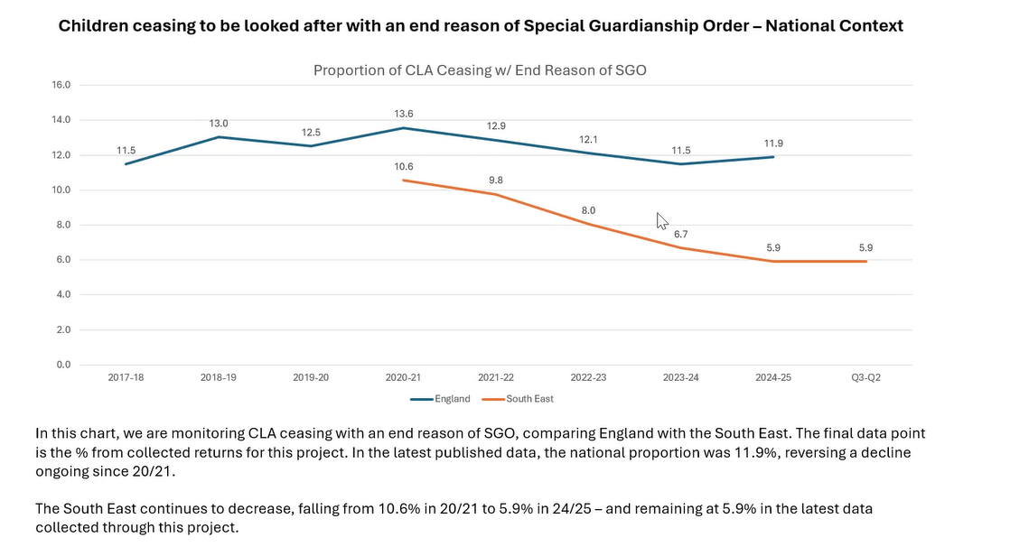
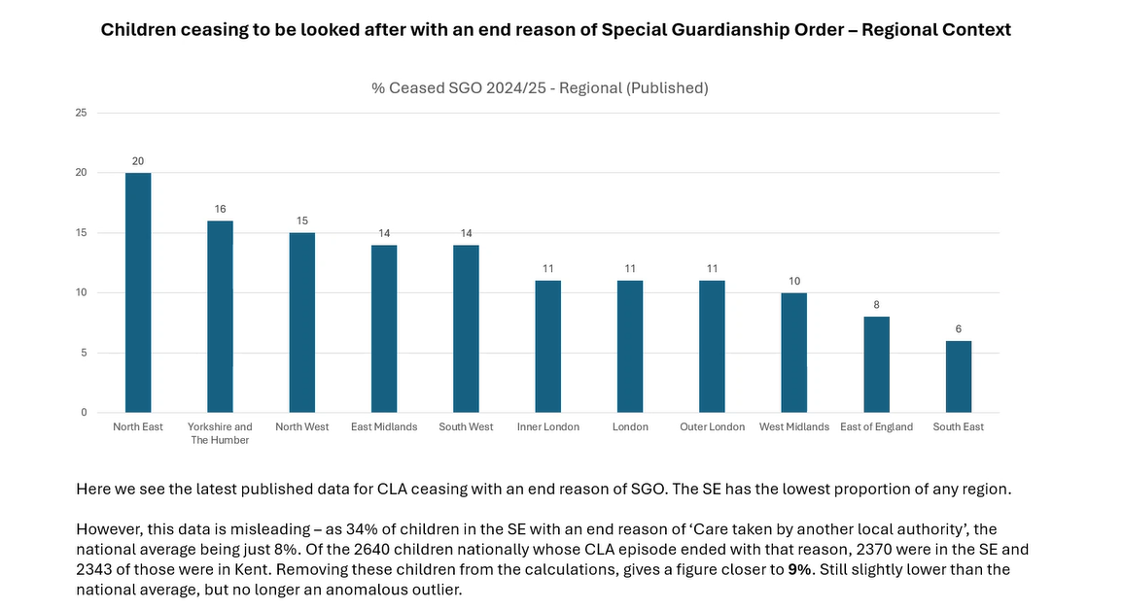
There are many more children in the south east whose CLA episode ended due to moving to another LA (due to Kent’s higher numbers of UASC). When these are taken out the South East is much more in line with the other regions at 9%.
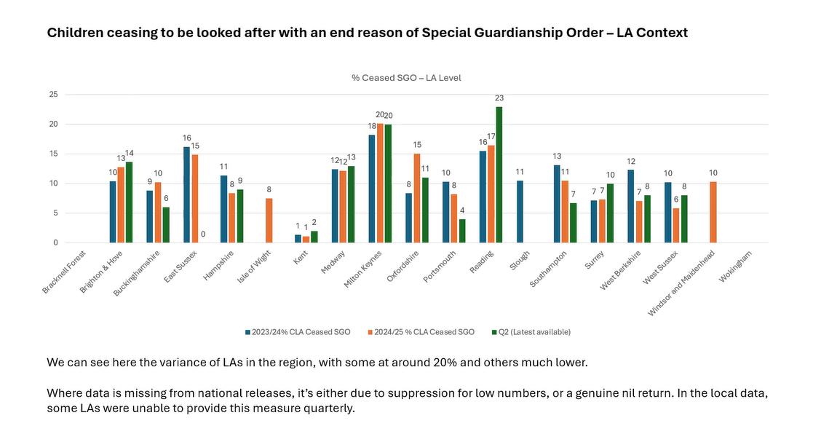
CB said we try in Hampshire for children not to be looked after and we focus on private SGOs outside of care proceedings which might explain some of the variance.
Approval trends have remained relatively consistent over the year
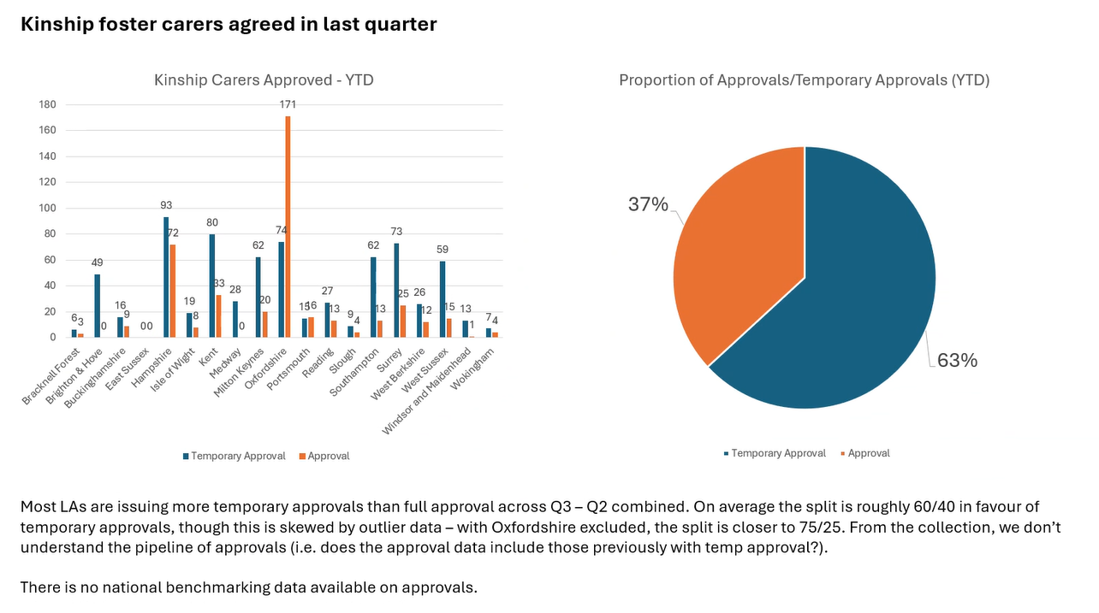
Overall assessments have slightly dipped this quarter
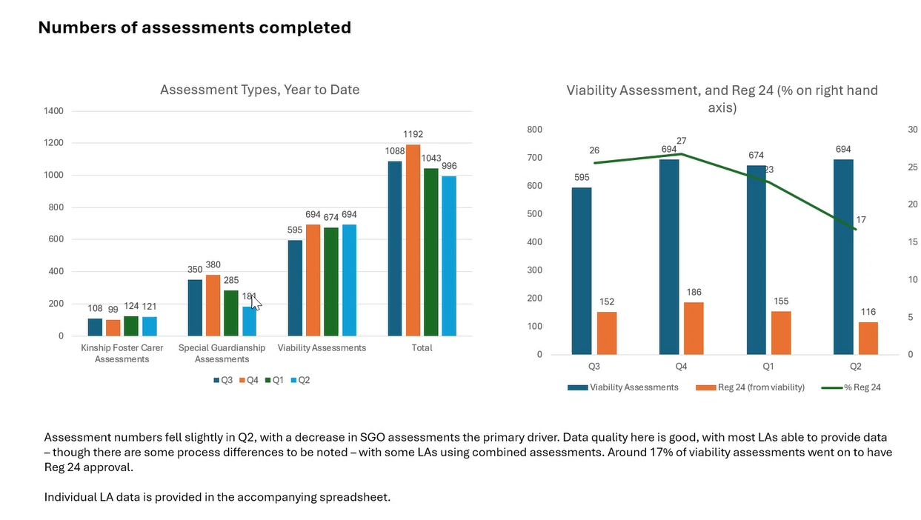
There has been a marginal increase in numbers of children in kinship care.
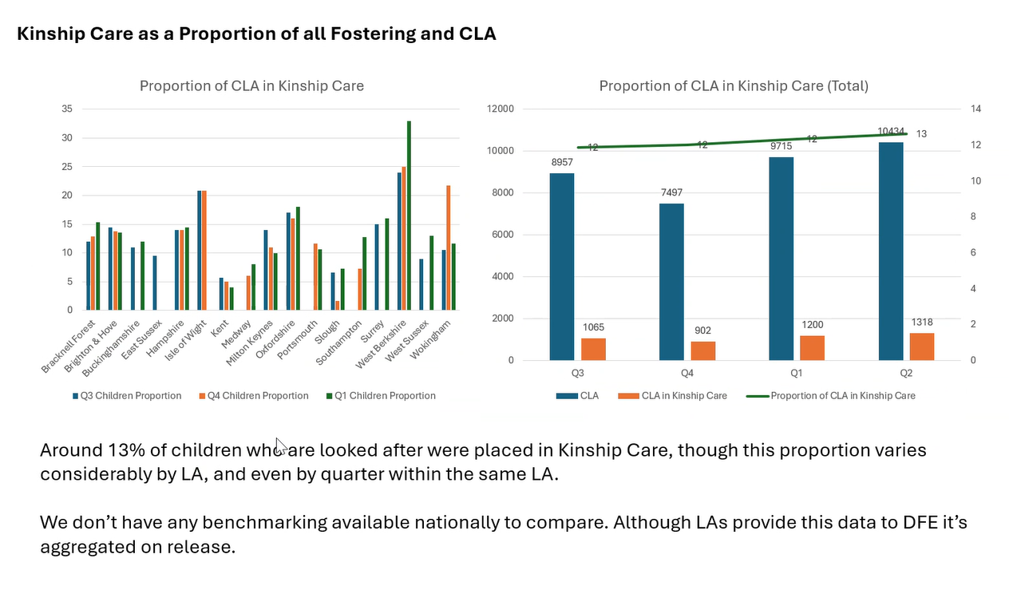
National data shows the North West has far more kinship households and carers but in terms of rate per looked after children then the South East is more in line with the average (8 kinship households per 100 CLA).
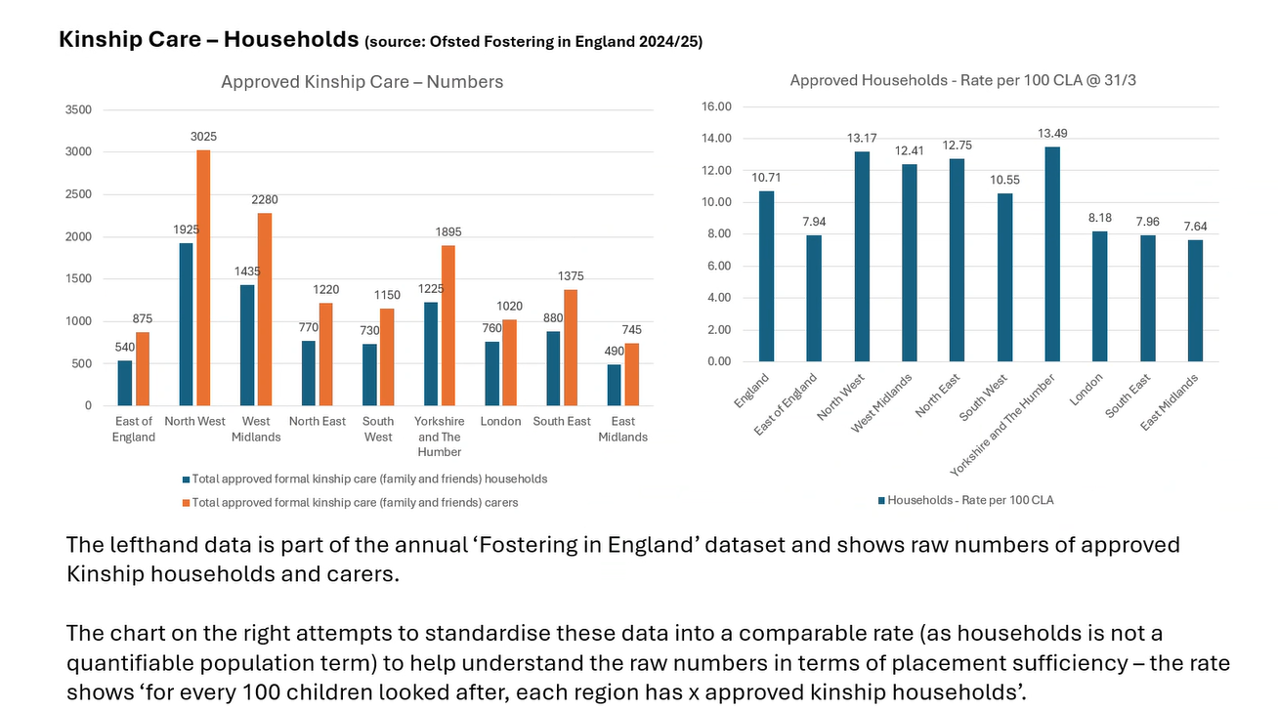
Unlawful placements have reduced over the quarters this year. GL asked if there were any outliers driving some of the regional differences? JF said yes this is likely to be the case.

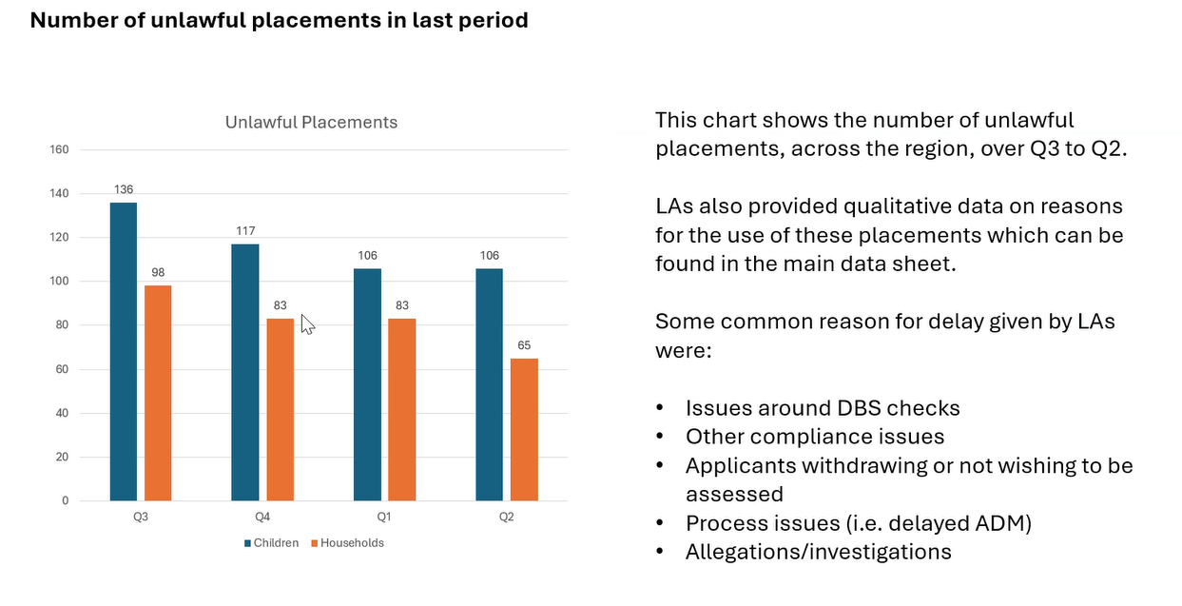
RE checked whether we wanted to carry on with Kinship benchmarking. Colleagues confirmed yes.
Action: Quarterly kinship benchmarking to continue
CS said we need to make sure we are recording in the same way.
CM asked if there is there a way to understand if there is a correlation between offer and if we are seeing more Kinship foster carers and less SGOs - is this around Kinship Foster carers feeling better supported - so we need to look at how we can support SGO's? For example in my LA we have a no detriment finance offer but only after 12 months post proceedings. I wonder if this accounts for some of the data differences.
Item 4: DfE funded projects
Kinship Reach: Update from FS on Kinship Reach, the online support offer which is bein piloted in the region. FS noted that the pilot launched in November and all LAs that were supposed to refer in the first month did so. All LAs except one are participating in this scheme. Helen is the kinship family worker working with the LAs. Just to give an idea of breadth, in 5 the first month there were 5 referrals with SG made in care proceeding, one private arrangement and one kinship foster carer.
Coproduction of the local offer: This is a three stage process, first part is getting feedback from LAs next week on what you’d like to see, where you have any gaps in understanding. The second part is engagement and getting feedback from kinship carers in the new year. The final part is to create a framework of best practice based on what kinship carers have said they want to see in your LA’s kinship local offer. LAs will then be able to use this framework and test their local offer against it.
Item 5: standing items
Upcoming meeting dates;
- 5 March 2-3.30pm Partner places – Wokingham, quarterly data, AfC – share practice journey, kinship reach and coproduction, SG rates and allowances
- 9 June 2-3.30pm
- 8 Sept 1-2.30
AOB:
Is everyone paying the minimum SG rates and allowances? Action: RE to collate this via email and present back next time
CM updated that Jahnine Davis visited Surrey. The visit focused more on kinship considerations in early help and outside formal arrangements. MH effected this was useful feedback and reflected the strategic focus nationally.

Action log: This action log was updated on Dec 22 2025. Shaded actions are closed or complete
 | Action | Responsible | Date issued | Status
22 | Quarterly benchmarking to continue
21 | RE to collate which LAs are paying the minimum fostering rates and allowances to SG carers/ or have some sort of no detriment policy via email and present back next time | All | December 2025 | Open
20 | All LAs to email tim.fisher@kinship.org.uk when they have published Kinship local offer so the links can be published on Compass page. | All | December 2025 | Open
19 | All LAs to get back by Sept 26 if they are in or out of Kinship Reach. Rebecca to meet with Kinship directly to develop business case for an in person regional offering to come back to a future meeting. Kinship to develop a costed proposal for £15k to support coproduction of the kinship local offer in LAs. | RE | September 2025 | Complete
18 | All to note deadline for next submission as JF will be presenting annual data returns as well as quarterly trends. 13 November submission date | All | Sept 2025 | Complete
17 | Lucy to consider what other data points for national comparison may be available. The Law Commission review is an opportunity to discuss those issues | LP | September | Complete
16 | RE to put forward DfE bids for coproduction of local offer, and prevention of placement breakdown through Kinship Reach and Kinshio connects | RE | June 2025 | complete
15 | KW to share terms of reference for placement breakdown rapid response meeting | KW | June 2025 | complete
14 | JF include national comparison data where available in benchmarking, and JF and RE to produce an annual narrative with trends once four quarters of data collected | RE | June 2025 | complete
13 | JF to produce different metrics for proportions of kinship households measuring against the different baselines to allow both national comparison and also to have insight into the proportion in kinship arrangements. JF will recalculate metrics against the CLA figure in the RIIA collection. | JF | March 2025 | Complete
12 | All to consider offer from Kinship around training and get back to LP if you would like support | All | March 2025 | complete
11 | All to review benchmark data and make amendments to any incorrect data. Send amends to John.foster@eastsussex.gov.uk . JF to meet LAs individually | All | March 2025 | complete

