South East Transformation Network
meeting notes and action log December 2025

Date: 19 December 2025 3-4.30pm
Chair: Steph How (Vice Chair, Hants),
Attendees: Anita Stanbury (West Berks), Janet Jones (Surrey), Ingrid Crisnan (Kent), Anna Clarke (IoW), James Carter (Oxfordshire), Collette Visagie (West Sussex), Marie Foley (West Sussex), Deborah Ennes (East Sussex), Tom Stibbs (Brighton and Hove), Dan Buckle (Southampton), Estelle Kelleway (Wokingham), Andrea King (Reading), Hannah Leat (Hampshire), Natalie Bugeja (Achieving for Children), Sam Taylor (Hampshire), Luke Varndell (Portsmouth), Victoria Gibbs (Slough), Michelle Sanders (Portsmouth), Teresa Devito (Medway), Keith Langley (West Berks), Priscilla Kurewa (Bracknell Forest), Nicola McGeown (East Sussex), Ananda Bodenstein (West Berks), Laura Travett, Selina Rattu (SESLIP support), Rebecca Eligon (SESLIP support)
apologies: Stuart Ashley (Hants), Hayley Rees (Wokingham), Jonny Bradish (Brighter Futures, Reading), Bosede Lawal (Surrey), Wendy Evans (Milton Keynes), Sarah Moran (Achieving for Children), Alison Munt (Bucks), Audrey Johnson (Bracknell Forest), Dora Gouveia Schofield (West Berks), Jenny Thomas (Milton Keynes), Edwina Gregory-Johnson (Achieving for Children), Errol Albert (Bucks), Kirsty Morris-Selley (Milton Keynes),), Kay Jones (Isle of Wight), Richenda Polson (Kent),
Item 1: Remaining opening positions
West Sussex: Collette Visagie and Marie Foley: Have strong EH service under one AD. The reflected that there is a model of family network meetings as part of family safeguarding model. But they recognise there is more work to be done to improve consistency. They don’t have an FGC model or team. There is a strong MASH and Sussex-wide engagement along with Brighton and Hove with police, the safeguarding board is chaired by police. In West Sussex have listened to others and decided to focus on what works for their families. So taking an evolutionary and not revolutionary approach. Used grant money around FGC and kinship. Family help, done a lot over the summer and moving from a children first agenda to a family first agenda. Have strong multi-agency partnerships with East Sussex and Brighton and Hove. Question from SH: Why is family meeting not sufficient why are you looking to build a new model? CV said we don’t have the independence of an FGC model, so we are looking to create a continuum.
Estelle Kellway -Wokingham - had an underinvested separate EH service with a waiting list, didn’t have FGC service (that disappeared 10 years ago), have tri-borough safeguarding model. Going for quite a significant change in delivery model bringing EH and safeguarding together moving to a pod model. Pods will be responsible for cases from targeted help through to CLA. Consultation in Jan/Feb and rollout in April. Recruiting FGC manager and coordinator and someone that can train staff on FLDM. Moving away from SoS, had family network meetings and struggled to get a consistent approach. Going to have a blended model with staff trained in meetings and FLDM as well as a separate formal FGC service. Work going on in family hub space to develop a more integrated front door, looking to launch FHs in April. A lot of culture change but also strong political and leadership commitment. Question from IC: any push back from staff and unions about EH workers holding more complex cases? EK responded: We will be collocating and there will be both social workers and non social workers in the pods, but levels of need and risk that people will hold will be similar to what they were before. They are looking to codesign a single assessment. Action: SH offered to meet up with EK to share more about Hants journey to move family practitioners to family help and where they disbanded previous early help services moving to a geographical model with targeted early help, plus level 4 and CIN.
ST asked about MACPT recruitment and partner buy in. EK said know where they want to head, but at early stages. There is a tri borough arrangement with TVP they are seeing their role as extending and building on MASH.
JJ interested in how targeted EH is happening family centres. She reflected there is no intention to bring that in to family help in Surrey. MF said they went from c50 children’s centres to around 12. Kept the Sure Start type model, but made it more of a community offer. Kept capacity in schools as well (up to level 2 capacity is retained in schools).
SH said there are large number of libraries and in Hampshire they are moving some family help teams into some libraries. SH reflected it is a mix of decisions being driven by building location, need profile and service offer which makes It complicated.
Item 2: themed discussion: Kinship
NB presented on AfC’s journey around its Kinship offer (presentation attached separately).
NB reflected that before the change, it was a separated programme overseen by 5 different ADs. There was a lack of confidence in staff and a lack of consistent practice around kinship. There was only one FGC coordinator, not well embedded in practice and staff were saying they didn’t have good understanding of reg 24.
Did a review, got feedback from different parts of the system. Created a fostering and kinship team and brought FGC into this service. This was supported by lots of training. They brought back post-SGO support from Adopt Thames Valley. They now have 2 workers that now do all viability assessments across the three LAs and a total of 10 FGC Coordinators. Afc have also developed an opt-out 3 month standard post SG support offer which everyone gets. There was a briefing for all staff which was in part co-delivered by kinship families. NB reflected that they have also shifted their wording from kinship to connected, which incorporates a wider set of relationships.
As a consequence of work in AfC there are now 50% kinship carers. Now looking a financial offer. Seen a huge increase in the number of children being placed in these sorts of arrangements.
RE reminded the group about the Kinship Reach pilot which is run by the national charity Kinship and which all LAs (apart from Kent) are participating in.
Project 28: Piloting Kinship Reach – SESLIP
Item 3: MACPT and family help projection tools
RE and SR shared two spreadsheet based tools. The first was from LIIA (the London children’s services improvement group) which estimates the amount of capacity needed in an MACPT based on inputting LA demand data. The second was for estimating possible family help structures, again based on current and future projections of demand.
Item 4: Benchmarking
SR shared benchmarking data. Action: Was agreed to set up subgroups of the LAs with the same case management system with a focus on reforms
SH noted that it was interesting that some LAs with no FGC offer still had relatively high step down from PLO figures and there wasn’t a strong correlation between LAs with high PLO step downs and high FGC take up.
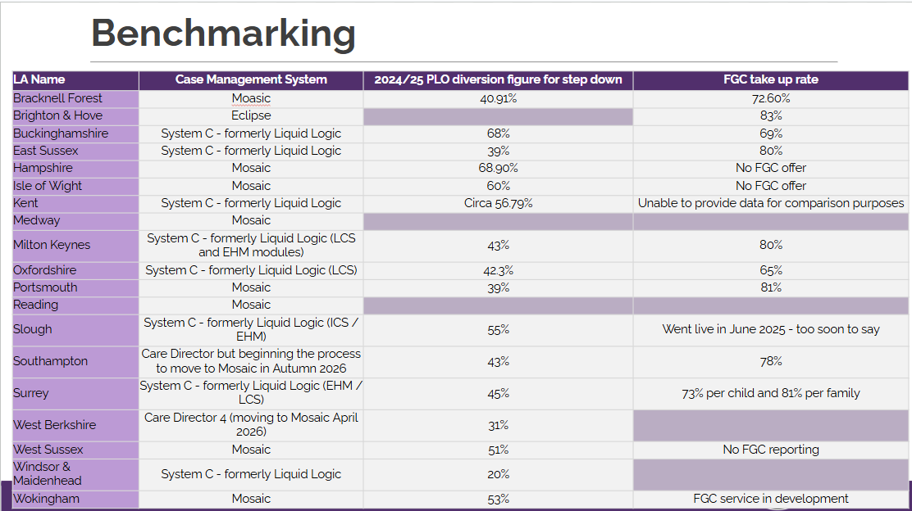
Item 5: Focus items for next time
Agreed for a focus item on MACPTs to be facilitated by ex-DCS Clare Chamberlain. Possibly a future session to be attended by DfE.
Themed discussion on Hampshire model of family workers
AOB: RE asked if any LAs had been practically progressing conversations with health colleagues around CYP MDMs or other health driven neighbourhood approaches and ensuring these were connected with neighbourhood/locality family help structures?
Andrea King – said Frimley and BOB are merging into one. They are in the process of negotiating a continued focus on children, a focus on family help and linking to their neighbourhood developments which are quite adult focused. AK reflected that a focus on SEND has enabled us to get agreement to connect – 3 chief exec briefings have taken place.
JJ reflected that as part of LGR Neighbourhood area committees are being developed as part of Surrey initiative.
Action: future item on sharing content from DfE meetings
Action: All to submit DfE delivery plan part two to SR and RE to present back to the group
Issues for escalation: None

Action log: updated December 19 Shaded lines, actions are complete
 | Action | Responsible | Date issued | Status
1 | Priorities for the group listed in the Terms of reference to be amended in light of discussion at the end of the meeting. | RE SR | Sept 2025 | Complete
2 | IoW to present at future meeting about their family hubs model. | KJ | Sept 2025 | Complete
3 | Next meeting to hear from Reading/Brighter Futures, Slough Children first, Southampton, Surrey, West Berks, Wokingham, West Sussex and Achieving for Children | Presenting LAs | Sept 2025 | Complete
4 | Next meeting to hear from remaining LAs: West Sussex and Wokingham | Presenting LAs | November 2025 | complete
5 | SR and RE to collate he case management systems that all LAs are working with so you can join up any conversations with providers. | SR RE | November 2025 | Complete
6 | West Sussex and Milton Keynes to share family network meeting guidance | DE JT | November 2025 | Partial
7 | SR and RE to benchmark conversion of PLO to proceedings in LA with established FGC vs those without . 43% PLO don’t go to court proceedings in Milton Keynes where FGCs are well embedded with 80% take up. | SR RE | November 2025 | Complete
8 | SH offered to meet up with EK to share more about Hants journey to move family practitioners | SH EK | Dec 2025 | Open
9 | SR and RE to set up subgroups of the LAs with the same case management system with a focus on reforms | SR RE | Dec 2025 | Open
10 | Jan meeting to focus on MACPTs with Clare chamberlain, and Hants family worker model | SR RE | Dec 2025 | Open
11 | future item on sharing content from DfE meetings. Consider whether to invite Jamie (DfE) to this meeting in Spring | SR RE | Dec 2025 | Open
12 | All to submit DfE delivery plan part two to SR and RE to present back to the group | All | Dec 2025 | Open

