South East Region Adoption Leadership Board
Meeting notes and action log: October 9 2025 2-3pm
Invitees: Dr Mac Heath (CHAIR Milton Keynes), Lorna Hunt VICE CHAIR (Chair Adopt Thames Valley and PACT), Kevin Yong (CORUM), Rebecca Eligon (SUPPORT Sector Led Improvement Programme), Rachel Reynolds (Adopt South), Amy Coombs (Adoption Partnership South East), Hilary Loades, Michael Wilson (Adopt South), Vicky Swift (Adoption England), Claire Corcoran (Oxfordshire)
Apols: Richard Morris (CAFCASS), Teresa Rogers (Adopt Thames valley),
- Introductions and previous minutes
The group agreed the previous minutes and actions.
MH reflected that they had a SE directors of children’s services meeting on Friday we were talking about the funding challenges in the region. He noted that a lot is dependent on the autumn statement. Increasing money has come to the region via SESLIP and a number of projects have been funded. An area we are all challenged by, is the breadth and depth of change – Family First reforms, SEND white paper. We’ve agreed we will have a longer time together in December looking to get an external facilitator to help consider the projects we want to take forward next year. I am going to ask DCSs to confirm the leads that each DCS takes across the region. MH asked the group if they felt this was the right group and should it continue, the group confirmed that it continued to be a useful way to plug into DCSs.
- Themed discussion: Amy and Vicky: proposal around £15k alloction from SESLIP
VS introduced the wider programme being led by Adoption England to support children’s social workers around permanency planning relating to adoption alongside other forms of permanency. The programme is about ensuring the right ingredients for a lifelong approach to adoption including maintaining relationships with birth families. AC said there has been issues around quality of CPRs. Corum BAAF have issued a recent new CPR form. AC noted that we can ask LA social workers to fill in a form but we do also need to support social workers about that deeper thinking. And we have discussed here before the consequences of RAAs in that some LAs are only undertaking a handful of adoptions a year and so thinking about child permanency reports, and expertise around adoption is less developed and consistent. This isn’t traditional learning, but an online portal which will be developed over the course of 2026 which could provide bite-size learning on demand to help improve confidence.
Kevin flagged that there is an opportunity to consider an AI tool as part of this project. North Yorkshire Polly (policy buddy)
https://www.leadingai.co.uk/blog/our-ai-policy-buddy-transforming-childrens-services-in-north-yorks…
https://www.local.gov.uk/sites/default/files/documents/How%20AI%20is%20transforming%20council%20ser…
MH said there is a need to consider the appetite among social workers. And his worry is the attention is on other spaces, like Family First. MH agreed with AC and VS that the gap is widening but asked, Would we have confidence that we could narrow the gap in expertise among LA social workers and managers?
VS responded that they had an online meeting and had a representative from the IRO service, permanency planning leads. VS reflected that team managers don’t have the level of experience working with birth mothers and therefore that nuanced experience of the importance of the communication and photos they receive. How do we provide opportunities for social workers and TM to hear those voices. There are amazing and very powerful films and resources that social workers won’t know where to find. MH said his worry is that it is sat and not used. So the challenge is about take up and application. AC says she shares that worry around something being created and not used.
MW said he is more supportive of this proposal over the alternative which is asking Corum BAAF to deliver training as it will be codesigned with LAs in our region and can be updated. He is not convinced the maturity is there to develop an AI approach. For me anything that increases the knowledge and experience that will enable them write a better report is beneficial.
VS said in response to the question will it land, and be taken up by the LAs in the south east, the difference would be that we could develop with social work practitioners, and rolled out with team managers.
MH asked if any dissenters, there were none. And so it was so agreed to progress with the proposal.
Action: RE to follow up outside of the meeting with AC to allocate funding and progress the project.

- Data update- Kevin Yong
KY presented the data, noting that the trends are flat, up to Q1 data (up to end of June). There has been a slight increase in BIDs, a bit of a spike previously on children waiting but that has gone down. South East continues to be one of the only regions maintaining adoption recruitment levels. But that is starting to see a downward trend
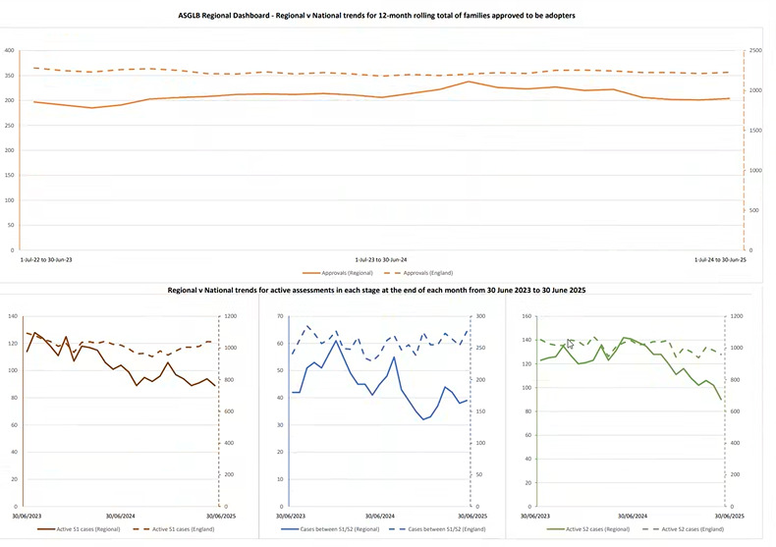
KY asked the group about the pipeline of assessments and the reduction in timescales. AC said in Kent and Medway courts there is a new portal where adopters are leading on cases, which has definitely sped things up. When they are ready they put their application through the portal and social workers respond. That has definitely led to a change in timescales. It is also happening in Reading and Oxfordshire, but not everywhere.
MW asked how IROs have responded to adopters taking the lead in adoption applications. AC responded that it was a change implemented in the court system, so it was a change that happened to LAs and RAAs, so they are not in a place to challenge around whether the case should have been progressed in this way. AC said it feels like a positive shift. LC said it is mixed nationally and it is definitely more efficient.
On the question about the pipeline CC said there is a steady trickly of enquiries and the delay is really around medical advice.
Action: MH to raise impacts of delays due to medical advice with DCS and ICB colleagues
AC noted they are not seeing a reduction in demand. HL said in terms of the pipeline of children we are being less ambitious. We are thinking about the need to not delay permanence which isn’t necessarily the right option for the child.

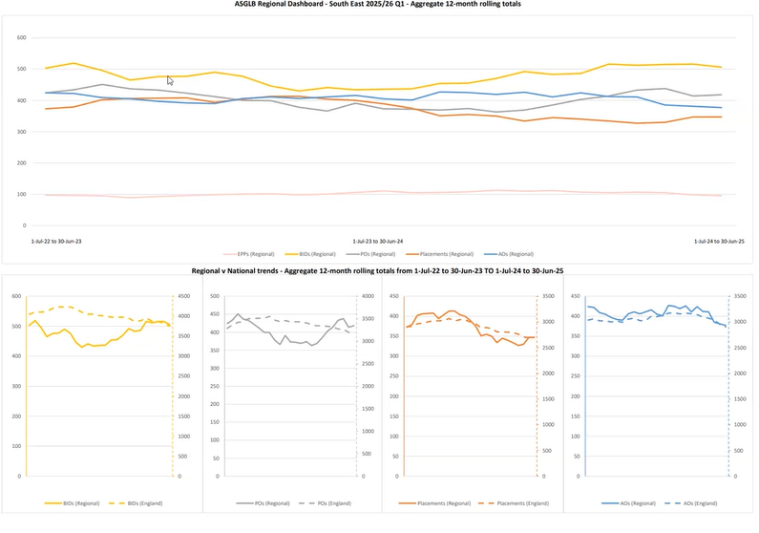
CC asked if there is more of a trend of foster carers adopting they have seen 8-9 recently. KY said some increase but the numbers are low so it is difficult to know if it is a trend or blip. KY is hearing that the assessments are more complex and less straightforward than previously. CC agreed that is often children who are younger who could have found adopters are staying with foster carers. And judges are often very supportive of applications from foster carers.
MW said they are also seeing an increase in this, especially around agency vs non agency adoptions and would welcome further discussion on this. MW said there is perhaps a need to have a blended stage 1 stage 2 process and learn from fostering regulations.
MW said the bulge in teen children is significant.
HL said they are also seeing the trend with judges supporting adoption applications from foster carers.
Action: Agenda item at next meeting on agency vs non agency adoptions and the trends that are being experienced
- Update on project on case management systems
KY updated that Case management systems are not working as well as they could and DfE are taking a two pronged approach. 1. We have the systems we have and they are looking to establish an approach to data excellence. It is about how do we support LAs to get the best out of the current systems as we know there is real variation in LA capacity and capability. The second prong is about shifting the market to ensure inter-operability between systems (especially between statutory partners). Project in this area is starting.
Action: further item on this next time led by KY

Action log: This action log was updated on Jan 09 2026
 | Action | Responsible | Date issued | Status
80 | RE to follow up outside of the meeting with AC to allocate funding and progress the project with Adoption England | AC/RE | Oct 2025 | OPen
81 | MH to raise impacts of delays due to medical advice with DCS and ICB colleagues | MH | Oct 2025 | Open
82 | Further update from KY on case management projects with DfE for next meeting | KY | Oct 2025 | complete
83 | Item at next meeting to discuss trends we are seeing in agency vs non-agency adoptions | All | Oct 2025 | complete

