Fostering regional group Agenda March 2026
Chair: Sarah Daly DCS Portsmouth
Holli Blackburn (Wokingham), Sam Horton (Hants), Karl Davis (West Berks), Kelly Wilkes (West Sussex), Selina Rattu (SESLIP consultant), Carly Arnold (Southampton), Clark McAuley (Surrey), Nicola Sankey (West Sussex), Carol Norrington Beard (Surrey), George Mathew (Slough), Kimberley Showell (West Sussex), Maria Cordrey (Kent), Mark Vening (Kent), Matthew Edwards (Achieving for Children), Rachel Farrell (Buckinghamshire), Sam Howard (Bracknell Forest), Hannah Forrest (Wokingham), Hannah Pycock (West Berks), Sarah Keenan, Ashley Schofield (Isle of wight), Charlotte Davey (Oxfordshire), Rebecca Eligon (SESLIP consultant), Siobhan Edwards, (East Sussex)
Apologies: LAs not represented Brighton and Hove, Medway, Milton Keynes
Meeting details: March 17 10.30-12 Microsoft Teams
ITEM 1: Introductions and action log: SD introduced the session and reflected there is lots going on in relation to fostering in the South East and a lot of deadlines around regional fostering in the south east and next steps.
ITEM 2: Governance: RE asked the group for any reflections relating to regional meetings and governance for SD and RE to share back with DCS and RCC colleagues. RE noted that this group has been in place since 2018 with a focus on fostering practice, but since its establishment there has also been the establishment of LAFSE (with a slightly different geographic footprint as all AfC LAs are involved), and the RCC which also has a slightly different group of LAs signed up. That said we are conscious for fostering leaders the space may feel crowded.
MC noted we are involved in 5 different meetings with LAFSE, does feel chaotic and messy. We have provided that feedback direct to LAFSE, but would be helpful for SD to share that back. Action: SD/RE to share feedback to LAFSE re: overlap of meetings which LAs are invited to.
SD noted that given the DfE steer around end to end fostering on a regional footprint she is interested in how the subregions develop around recruitment and retention and what need there will be to come together as a whole region. ME said the drive to regional fostering recruitment is inexorable, but he is concerned that this move is without evidence of impact. In AfC we are still recruiting 5/6 direct by each of our member LAs. Also seeing a reaction from panels to regionalisation around not being involved and providing that level of QA.
ME agreed that we still do need to come together to share practice, for example around a different approach for kinship as compared with fostering.
SD has said this group has been great for sharing practice. KW said I really agree with what ME said. KW would welcome a space where we can continue a conversation about what else is needed outside of regionalisation. SD said we need to lean in to place and what works in LAs.
ITEM 3: Fostering utilisation deep dive: SR presented overall findings from research with foster carers last quarter. Following this she was asked by the AD group to look at a fostering utilisation to understand low levels of utilisation. SR followed up with LAs to dig into the Ofsted data and found a more positive picture with utilisation of 63% compared with 57% in the Ofsted data set. And filled beds increased even further to 67% when respite/emergency beds were excluded from analysis. SR found that the proportion of vacant beds reduced from 20% in the Ofsted data to 12% when LAs went back to review their data submission. SR noted that therefore the picture is more nuanced than the overall picture in the Ofsted data.
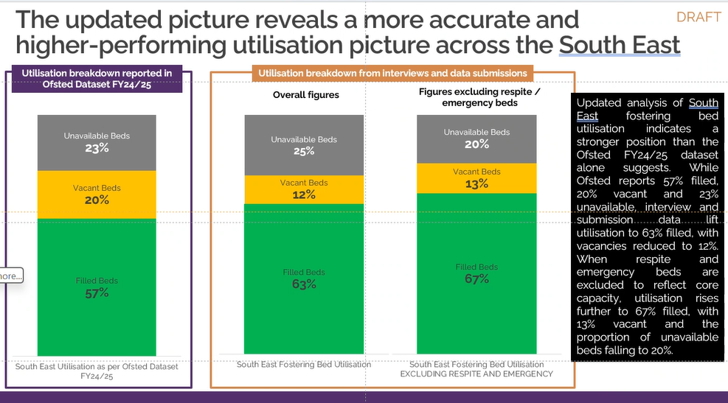
SR found that when exploring reasons for vacant beds with LAs via interview, the key areas around non take up include around complexity, children not in full time education, worry about impact on other children and logistics.
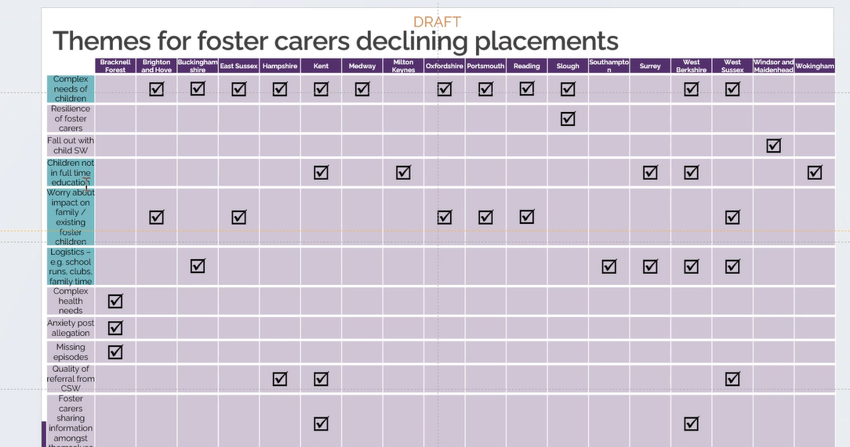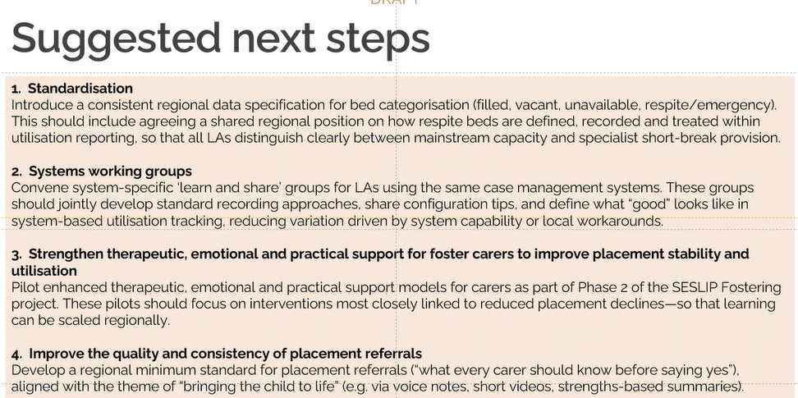
SR asked for feedback on the four suggested recommendations in the report.
SD asked, having done this work has it changed anything locally in terms of how LAs are practicing? RF said it is supporting our thinking and approach in Bucks. The challenge is having he space to think about support for foster carers, RF said a more consistent approach to counting and bed categorisation would be helpful.
GM said the piece of work was very helpful. From a data perspective was showing slough at 45% but we were counting sibling beds and respite beds whilst others weren’t. In practice the utilisation is much higher and every available bed is actually being used.
ME said he agrees on the opportunity to strengthen support for foster carers, we are interested in a Mockingbird light model so that anyone that does want connection with peers could have that. We are also interested in foster families that might want to support edge of care and working with birth families to prevent children from entering care. We have a kinship mockingbird model, we might want to have a much more flexible model moving forward.
CD said In Oxfordshire we have moved away from Mockingbird because of the expense and lack of flexibility to create our own therapeutic model. Happy for people to connect with Julie McNally on our approach.
CD asked around approach to council tax support. MC said the finding from SR’s first wave of research was that there wasn’t a direct link between Council tax rebates/discounts and recruitment and retention. RF said Bucks have had 2 years of a Perks package - council tax, car hire, leisure passes, Merlin passes, but for the third year of our project we have shifted our focus to support, training and development as a way to retain our carers
Bucks, Wokingham, and AfC have a proposed approach. Wokingham pay the whole year if you foster 35 weeks or more. GM said they tried but didn’t get it to go through in Slough. Southampton has done benchmarking and CA will share. Action: CA, HB and ME to share approach to Council Tax
Slightly related to foster carers and council tax, ME said the AfC LAs are sending a fostering recruitment letter in the council tax letter which is leading to about 4-5 enquiries per LA.
ITEM 4: Kent Case study Maria Cordrey: MC spoke about two projects in Kent – one is step across to fostering which has been running for 6 years and relaunched 2 years ago with a focus on stepping over from residential to in house fostering. Another project is at development stage which is increasing capacity of in house fostering through capital works
For the step across project.
- The children have to be under 16 and living in residential care
- The child has to want to, and be ready to live in a family home.
- The network has to agree the child’s needs can be met in a family home
- The social worker and residential home must commit to preparing the child for a move to a family home
- A detailed referral must be completed by the child’s social worker
- Child friendly profile to be used at recruitment/matching events (written by the child if possible and including a photograph)
There is a four to 6 week transition period with 2 weekly network meetings, fortnightly visits to the child in first 8 weeks and reviewed thereafter. Therapist plays an important role. There is up to 15 hours per week of support for the child and foster family from another foster carer. 3 days respite per month. Access to a specific support group just for this project.
The relaunch 2 years ago included a review of payments which includes a weekly retainer and an additional weekly retainer if the carer has another bedroom for at least four weeks to help with establishing the relationships and supporting early transition. There is age-related maintenance and reward payments from the point the child moves in. There is a complex payment from the point the child moves in, paid for the first 18 months and reviewed three monthly. There is a settling incentive after the child has lived with carers for one month and further incentive payments at 4, 8.12 and 18 months.

14 children have used the service so far with a savings of about £3m if they had stayed in residential care. 11 of the children remain with their fostering family. The other three children returned to residential but the fostering families remain connected.

Project two: MC then shared that they are in development stages for a second project in two parts – the first is fostering adaptations for disabled children using DfG, to create a bedroom. They have Identified 5 disabled children and the project is being delivered jointly by the strengthening independence service (Kent’s children with disabilities service) and the fostering service. The aim is for 5 children who are currently in residential care to move into foster carer’s homes who have been adapted so they can care for the children. This project is at a much earlier stage. The second project is to deliver garden rooms if they free up a bedroom for a child to be fostered.
KW said around adaptions we are a bit further forward in West Sussex. Adaption scheme has been hugely lengthy around the capital projects. They are looking at a garden pod which is about staying put, to free up a bedroom – so far they have enabled 7 bedrooms. Looking at a 3 year buy in. We will pay up to £40k and the carer leads the building project. KW also interested in renting incentive schemes, for example an extra £400 to a foster carer’s rent so they can get a larger property with another bedroom.
KD said in West Berks they look at capital works to foster carer homes on an ad hoc basis.
Action: MC to send step across policy to RE to share.
CA: We have also just developed an adaptations policy that is due to go live next month.... loans are provided for carers as legal charges against their home so if / when they sell they money is returned to the council
GM we are trying to get resilience fostering off the ground but this has been a challenge, but not had the applicants. GM asked if respite carer also gets the complex payment. MC said yes.
HP asked if the offer of therapeutic support is consistent or does it taper? MC said it can be maintained if that is the need.
ITEM 5: Safe families/Home for Good: Going through a rebrand, we find independent visitors/volunteers. We are asking where the village is for the child in care, and for the foster carers. We are Christian charity and think we have a role in three areas.
We can help recruit supported lodging hosts and foster caring families from our Christian Network.
We can support kinship and foster carers through providing volunteers for 9-12 months to prevent placement breakdown and we also run peer support groups.
We also support LAs in the church network space. Offer a Christian space workshop.
Home for Good reflected that they have been working closely with West Sussex.
KW would say first year wasn’t as impactful as more recently. Working more closely together has seen the impact. It isn’t just setting off Home for Good, you need to work together and this is a good way to mobilise your own Christian carers. NS said support around faith literacy has been really helpful.
ITEM SIX: Mileage question from Hants
SS wondered if any of you only ask carers to claim mileage year a certain amount and expect anything under that to be covered by the fostering allowance and if you do, is your fostering allowance increased to account for this. I am reviewing our processes, and I am aware some IFA’s do this and wondered if it has been successful in LAs to reduce the need for foster carers to make as many mileage claims?
SE said: In East Sussex Fostering weekly payments cover
- 40 miles (5 miles per day-short break)
- £20 alternative transport costs per week, per child
Additional mileage is paid at 45p per mile
Action: other LAs to get back to RE and SS on if any of you have mileage up to a certain amount included in your standard weekly payments.
ITEM 7: Fostering community project
RE Updated that the fostering community project which Hampshire, West Sussex, East Sussex, Brighton and Hove, Milton Keynes, Southampton and Portsmouth have been involved in is progressing well. It is likely that Southampton will host the project which aims to go live next year with a focus on 3-5 fostering community members in each of the 7 LAs (from LAs keep warm lists) working to support a fostering family, to gain experience of fostering and hopefully get ready to foster themselves.
AOB:
No items to escalate, no new projects. Next meeting to focus on fostering community project, and greater clarity around regional fostering arrangements( i.e. LAFSE, end to end fostering).
Next meeting dates:
Monday June 22 10-11.30
Thursday September 24 2-3.30

 | Action | Responsible | Date issued | Status
60 | All to contact Homes for Good to find out more about the support they can provide | all | Mar 2026 | Open
59 | other LAs to get back to RE and SS on if any of you have mileage up to a certain amount included in your standard weekly payments | All | Mar 2026 | open
58 | MC to send step across policy to RE to share. | MC | Mar 2026 | complete
57 | CA, HB and ME to share approach to Council Tax | CA HB ME | Mar 2026 | Open
56 | SD/RE to share feedback to LAFSE re: overlap of meetings which LAs are invited to. | SD/RE | Mar 2026 | Open
55 | March 2026 meeting to hear from Kent (MC) on step across and children with disabilities led project. | MC | Dec 2025 | Complete
54 | The group agreed with a proposal to seek funding to trial a pilot in the 7 LAs which had been part of the steering group. RE to meet with SD and DCS Mac Heath in his role as DCS chair in SESLIP to see what scale of pilot might work/be palatable for DfE to fund. | RE | Dec 2025 | Complete
53 | RE to connect Bracknell Forest with placement modelling tool from Data to insight | RE | Sept 2025 | Complete
52 | Any LAs interested in finding out or for a demo of Tracs or ICompass e can contact Colin on colin@tracsuk.org | All | Sept 2025 | Complete
51 | RE to connect PH with the Data to Insight placement modelling tool which can be used to model placement types and costs using 903 return data. | RE | Sept 2025 | complete
50 | CS asked that “those for whom the time isn’t right” is added to the group who want to foster but cannot in the fostering community project. RE to add this to project plan | RE | Sept 2025 | complete
49 | MC to share out of hours policy | MC | July 2025 | complete
48 | RE to convene a design meeting with those that are interested, and to liaise with DfE about this new idea. This to be the main item at the next regional meeting. | RE | July 2025 | complete
47 | GS and SD to meet with MH to discuss how this group can be used moving forward to help provide a space for LAs to provide feedback/identify key issues to ensure the success of the hub moving forward. NB: The hub is likely moving aligning with direction of travel with RCC | SD | March 2025 | Ongoing/  complete
46 | SD has agreed to escalate and take to the regional DCS group that there are issues around cost and pace/delays regarding foster carer medicals. SD has flagged this. | SD | March 2025 | complete
45 | SD asked the group to find out and report back: What is driving delays is it capacity, payment, or it isn’t part of the commissioned offer, is it costing too much? What is the issue. Have you escalated in place-based partnerships and ICB risk logs? | ALL | Dec 2024 | complete

