Necessary for Some; Good for All
Universally Available Provision in Further Education Colleges

Contents
1. What is UDL?
2. Inclusive Teaching and Learning
3. Everyday, Available and Accessible Technology: Independence in the Palm of Your Hand
4. Graduated Response: The Vocational Cycle
5. Staff Training and Awareness
6. Learner Voice and Co-Production: Experts by Experience
7. Transitions: Don’t Stop Moving
8. Preparing for Adulthood (PfA): The Ultimate Goal of FE Provision
9. Legal and Policy Context
10. Resources

What Is Universally Available Provision?
Universally Available Provision (UAP) refers to the inclusive support, strategies, and adaptations that colleges are expected to provide from within their existing resources to meet the needs of learners with SEND. It ensures that learners can access learning and participate fully, even without an Education, Health and Care Plan (EHCP).

1. What is Universal Design for Learning?
Universal Design for Learning (UDL) is a framework to improve and optimise teaching and learning for all people based on scientific insights into how humans learn. Instead of retrofitting a lesson for one learner, you design the lesson from the start to be flexible.
- Engagement: The "Why" of learning. Providing options to hook interest.
- Representation: The "What" of learning. Presenting info in different ways.
- Action and Expression: The "How" of learning. Giving learners different ways to show what they know.

Deep Dive into UDL
1. Multiple Means of Engagement (The "Why")
The Affective Network: Stimulating interest and motivation for learning.
In FE, many learners have had negative experiences with traditional schooling. Engagement is about rebuilding that "buy-in."
- Provide Choice and Autonomy: In a Creative Media course, allow learners to choose the topic of their documentary. When they care about the subject, they are more likely to persist through technical challenges.

- Optimise Relevance and Value: Connect every task to "Industry Standards." A plumbing learner is more engaged with a math problem if it’s presented as a material cost-estimation for a real-world client.
- Minimise Threats and Distractions: Create a safe "fail-forward" environment. In workshops, use "low stakes" practice runs where mistakes don't impact their final grade, reducing anxiety for neurodivergent learners.
2. Multiple Means of Representation (The "What")
The Recognition Network: Presenting information and content in different ways.
If a learner can’t access the information, they can’t learn it. UDL lecturers provide "perceptual" options.
- Customise Display: Don’t just provide a paper handout. Provide a digital version where a learner can use a screen reader, increase the font size, or change the background colour to high contrast (essential for Dyslexia or Visual Impairments).
- Clarify Vocabulary and Symbols: In Engineering or Science, use Dual Coding/multi-sensory learning. For every complex term (such as Oscilloscope), provide a physical object to touch, a diagram to view, and a written definition.
- Illustrate through Multiple Media: Instead of a 20-minute lecture, use a 5-minute live demonstration, followed by a short YouTube clip that learners can re-watch at their own pace on their phones.
3. Multiple Means of Action and Expression (The "How")
The Strategic Network: Differentiating the ways that learners can express what they know.
This is where FE shines. We must move away from "the essay" being the only way to prove competence.
- Vary the Methods for Response: If the goal is to explain the "Safety Procedures in a Salon," does the learner have to write it? Could they do a "walk-and-talk" video tour? Could they create a labelled poster?
- Build Fluencies with Graduated Levels of Support: Use Scaffolding. Provide a "Sentence Starter" sheet for those struggling with writing, or a "Tool Checklist" for those who struggle with organisation in a workshop.
- Support Executive Functions: Many learners struggle with "starting." Provide templates, "check-in" points, and digital timers to help them manage their time during long practical sessions.

UDL vs. Differentiation: The FE Shift
Traditional Differentiation | Universal Design for Learning (UDL)
Reactive: Adjusting the lesson after you realise a learner is struggling. | Proactive: Designing the lesson from the start to have built-in options.
Individual-Focused: Making a separate worksheet for "Learner A." | Environment-Focused: Making three versions of the task available to everyone.
High Lecturer Workload: Constant "retrofitting" for every lesson. | Sustainable: One high-quality, flexible resource used for all cohorts.

Think of UDL like a GPS. It gives everyone the same destination but allows the user to choose the route that suits them best, whether that's the fastest, the most scenic or the one with voice-guided turn-by-turn instructions.

This analogy is a powerful way to help visualise the shift from standardised teaching to inclusive design. It moves the focus away from the learner's "deficit" and places the responsibility on the "menu" provided by the college.

The UDL Analogy: The Set Menu vs. The Buffet
In Further Education, we often treat curriculum delivery like a restaurant service. To understand UDL, we have to look at how we "feed" our learners the information they need to succeed.
The Traditional "Set Menu" (Fixed Delivery)
In a traditional classroom or workshop, the lecturer provides a Set Menu.
- The Experience: Every learner is served the same "starter" (the lecture), the same "main" (the written worksheet), and the same "dessert" (the exam).
- The Barrier: If a learner has a "dietary requirement" ( Dyslexia, ADHD, or anxiety), the meal doesn't work for them.
- The Fix: The lecturer has to rush back to the kitchen to cook a "special meal" just for that one person (Individual Differentiation). This is exhausting for the chef and makes the learner feel "different."

The UDL "Gourmet Buffet" (Inclusive Design)
UDL turns the classroom into a High-Quality Buffet.
- The Experience: The "nutritional goals" (the Learning Outcomes) are the same for everyone, but the way they meet those goals is flexible.
- The Options: * The "What" (Representation): Information is laid out clearly. There are visual labels (diagrams), spicy options (stretch and challenge), and soft options (simplified text).
- The "How" (Action and Expression): One learner might fill their plate with "Practical Demonstration," while another chooses "Digital Evidence."
- The Result: The learner with "dietary requirements" can serve themselves alongside their peers without needing a "special" separate meal. They are empowered to choose the "dishes" that help them learn best.

Why the "Buffet" Works in FE
- Promotes Independence: In the workplace, nobody will hand a learner a "specialised worksheet." They need to know how to navigate a "buffet" of information and choose the tools that help them get the job done.
- Reduces Stigma: When everyone is using the "buffet" (everyone has access to the video tutorial, not just the learner with SEND), the learner with an EHCP doesn't feel singled out.
- Futureproofing: You build the "buffet" once. While it takes more time to "prep the kitchen" initially, the service (the lesson) runs much smoother because the learners are self-sufficient.
“Takeaway” for Lecturers:
You are not lowering the standards of the meal; you are just providing more ways to consume it. The "nutritional value" (the qualification) remains exactly the same.
Look at your next lesson plan. Is it a Set Menu where everyone must do the same thing at the same time? How could you add just one 'Buffet Option' to give learners a choice in how they learn the content?

2. Inclusive Teaching and Learning
In this section, we move from the general "inclusive classroom" to the specific adaptations that make a curriculum truly accessible. A "Bespoke Offer" doesn't mean writing a new qualification for every learner; it means utilising the flexibility within the existing curriculum to create a personalised pathway to success.
Inclusive Teaching and Learning: The Bespoke Offer
Inclusive teaching is the "protein" of the UAP buffet. It is the day-to-day reality of how you deliver a session. Within an FE college, we often work with rigid awarding body specifications, but how we get a learner to meet those standards can be highly bespoke.
Scaffolded Learning and Chunked Instructions
Cognitive overload is the enemy of learning. If a learner is overwhelmed by the size of a task, they will disengage.
- Chunking: Break a 3-hour practical session into 20-minute "sprints."
  - Example: In Motor Vehicle, don't say "Service the brakes." Say: "1. Remove the wheel, 2. Inspect the pads, 3. Check in with me."
- Scaffolding: These are the "stabilisers" on a bike. As the learner gains competence, you remove the support.
  - Visual Scaffolds: Laminated "Cheat Sheets" for complex machine settings.
  - Writing Frames: Sentence starters for reflective journals ("Today I used the “Tool” and I found that...")
Flexible Timetabling and Curriculum Pathways
Sometimes, " Universally Available" means looking at the clock or the calendar differently.
- Low-Stakes Start: Allow learners with high anxiety to arrive 10 minutes early or 5 minutes later to avoid the "crush" of the corridor transition.
- Spaced Practice: Instead of one massive theory block on a Monday morning, can that theory be "dripped" into the practical sessions throughout the week?
- The "Slow-Track" Option: For some learners, a 1-year Level 2 course might be better delivered over 18 months to allow for deeper consolidation of skills.
Bespoke Offers: Customising the Journey
A "Bespoke Offer" is a tailored agreement between the college and the learner. It uses the "Buffet" principle to choose the right tools for the right learner.
What does "Bespoke" look like in practice?
- The "Hybrid" Assessment: A learner in Health and Social Care might do their placement observations in a setting they are already familiar with (a youth club they attend) rather than a random placement, to reduce the "novelty" stress.
- Flipped Classroom: Providing the "Demo Video" 24 hours before the practical session. This allows a learner with processing delays to watch it five times at home, so they arrive at the workshop feeling like an expert.
- The "Power-Hour" vs. The "Deep-Dive": Allowing learners to work in "Power-Hours" (high intensity, short bursts) or "Deep-Dives" (longer, slower immersion) based on their neurodivergent profile.
Case Study: The "Bespoke" Carpentry and Joinery Learner
The Learner: "Liam" has significant Dyscalculia and gets "number-blind" when measuring wood, leading to high waste and frustration.
The Bespoke UAP Response:
- Representation: The lecturer provides Liam with a story-pole (a pre-marked piece of wood with the common lengths for the project) so he can compare his work physically rather than just using a tape measure.
- Action/Expression: Liam uses a digital measuring tool that reads the measurement aloud to him.
- Scaffolding: He is given a "Cut List Template" where the math is partially done, allowing him to focus on the craft of joinery rather than the barrier of arithmetic.
The Result: Liam meets the same industry standards as his peers, but his route to that standard was bespoke to his cognitive profile.

3. Everyday, Available and Accessible Technology: Independence in the Palm of Your Hand
Ten years ago, Assistive Technology required bulky devices, or additional software added to a computer that would make the learner feel like they “stood out” compared to their peers. Now, technology has advanced to the point that assistive technology is built into the functionality of every smart phone as standard. All we have to do is utilise it and reap the rewards for all our learners.
Travel Training
- Google Maps - planning point to point routes with GPS guidance. Estimate times
- Bus Route Planners and schedules: live minute by minute planner for next bus
- Train apps and planners for routes, changes and delays
- Camera: record or take pictures of key locations on walk throughs
Communication: all these apps are forms of communication that can be used to support social common communication and interaction skills:
- WhatsApp
- MS Teams
- Messenger
- Messages
Reading
- Google Lens - take a picture of any text you want to have read back. Lens will convert this and read it aloud. It can also save as a text file to be edited.
- MS Immersive Reader - function in MS Word that assists with reading and comprehension. Amend the text by changing font size and style, text and line spacing and background colour. These can all make documents easier to read. Immersive Reader can also read text aloud to you.
Writing and Note taking.
- Voice recorder and camera
- Dictate function - Apple and Android phones both have “dictate” functions to enable notes to be made from dictation.
Processing and Memory
- Camera - record practical tasks in a workshop or class to be able to watch over and over again.
Organisation and Planning
- Calendar functions - set activities for lessons, tasks and activities to support organisation and time keeping. Activities can be colour coded to support routines and structures.
- Mindmaps – MindMeister - planning for assignments, essays and activities in a visual format
- Alarm functions - alarms can be set as reminders for lunch and breaks as well as time outs, if required. These also support everyday life and Time keeping.

4. The Graduated Response: The Vocational Cycle
This section transforms the Graduated Response from a heavy administrative burden into a dynamic, "live" cycle that fits the fast-paced nature of FE delivery. In a vocational setting, the cycle doesn't happen once a term, it happens every day at the workbench, in the salon, or on the pitch.
The Graduated Response is a four-stage cycle: Assess – Plan – Do – Review. In FE, this is our "continuous improvement" model for inclusion. If a learner isn't making progress despite implementation of UAP, we don't just "try harder”, we move through the cycle to refine the support.
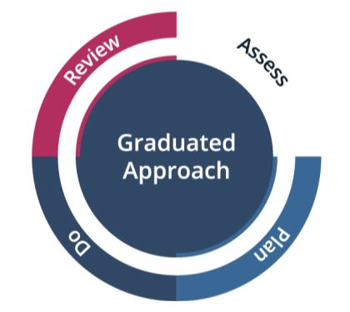

Stage 1: Assess (Spotting the Barriers)
The assessment stage is a mix of formal data and "eyes-on" observation during the first six weeks.
- Initial Assessments: Look beyond the GCSE grades. Check the results of their diagnostic assessments for gaps in "working memory" or "processing speed."
- The "Practical Baseline": Observe them in their first practical task. Does the learner struggle to follow a multi-step instruction? Do they seem overwhelmed by the noise of the workshop?
- Transition Data: Review the "Learner Passport" or EHCP to see what worked in school.

Stage 2: Plan (The UDL Adjustment)
Once a barrier is identified, the lecturer and learner co-produce a plan. This is where the "Buffet" approach comes in.
- Targeted Strategy: Instead of a generic "support," choose a specific UDL tool.
  - Example: If the barrier is "difficulty remembering safety steps," the plan is: "Learner will use a personalised visual checklist for the bench saw."
- Success Criteria: Define what "better" looks like. "Learner can complete the safety check independently within 2 weeks."

Stage 3: Do (Implementing the Strategy)
The lecturer remains responsible for the learner’s progress. Even if a Learning Support Assistant (LSA) is present, the lecturer ensures the environment is inclusive.
- Consistent Application: Ensure the visual checklist is always available.
- Normalising the Tool: Don't make it a fuss. Hand it over as part of the standard tool kit for the session.

Stage 4: Review (The "So What?" Phase)
This is the most critical stage and the one most often skipped in busy colleges.
- The 5-Minute Review: This doesn't need to be a formal meeting. It can be a "Check-in" at the end of a practical block.
- Impact over Effort: Ask: "Did the checklist help you get started faster today?"
  - If Yes: The strategy becomes part of their permanent " UAP Toolbox."
  - If No: Why not? Was it too complicated? Do we need to try a video prompt instead? (Return to Assess).

The Graduated Response in a Vocational Context
Vocational Area | Assess (The Barrier) | Plan (The Strategy) | Do (The Action) | Review (The Outcome)
Catering | Learner misses ingredients in complex recipes. | Use a visual checklist. | Learner ticks off items before cooking begins. | Learner is 20% faster and reduces food waste.
Construction | Learner struggles with the math in "Cut Lists." | Provide a pre-formatted calculator app/template. | Learner uses the app on their phone at the bench. | Accuracy of cuts improved; learner feels less "stuck."
Childcare | Learner is too anxious to lead a group story-time. | Use a "Scripted Prompt" card or a peer-buddy. | Learner leads a 2-minute segment with a peer. | Confidence built; learner moves to 5-minute segments.

Why This Matters for UAP
The Graduated Response ensures that support is evidence-based. We aren't just guessing; we are trialling strategies, measuring their impact, and evolving. This prevents "learned helplessness" or over-reliance, where a learner relies on a person (LSA) rather than a process (a UDL strategy).
Think of the Graduated Response like tuning an engine. You don't just hope it runs better; you check the diagnostics (Assess), make a tweak (Plan), run the engine (Do), and then check the diagnostics again (Review) to see if the timing is right.
5. Staff Training and Awareness
This section addresses the cultural shift required within a college. For UAP to work, staff must move away from the traditional "Behaviour Management" model, which often punishes the symptoms of a disability, toward an inclusive model that supports the underlying need. This also begins with understanding behaviour is communication. What is the learner trying to tell us?
Staff Training and Awareness: From "Managing Behaviour" to "Supporting Needs"
What can be perceived as "challenging behaviour" is often just unmet need or stress communicating itself. A learner walking out of a loud metalwork shop isn't necessarily being defiant; they may be experiencing sensory fry. Staff training focuses on giving lecturers the "detective lenses" to see these triggers.
Understanding Neurodiversity as a Competitive Edge
Training shouldn't just focus on the deficits of ADHD, Autism, or Dyslexia. It should highlight the "Spiky Profile" of neurodivergent learners. A learner may struggle with organisation (Executive Function) but be the most creative problem-solver in the graphic design studio.
- CPD Focus: Move beyond "Awareness" (knowing a diagnosis exists) to "Acceptance" (adjusting the environment to welcome the learner).
- The Spiky Profile: Recognising that a learner can be "Level 3" in practical skills but "Entry Level" in their ability to sit still for a 60-minute theory lecture.

Positive Behaviour Support (PBS) and Inclusive Language
Language shapes our perception. When we change how we talk about learners, we change how we teach them.
Instead of saying... | Try saying... | The UAP Shift
"They are being lazy/unmotivated." | "They are struggling to initiate the task." | Provide a "Starter Checklist" or a 1:1 prompt.
"They are being disruptive/loud." | "They are sensory-seeking or overwhelmed." | Provide a sensory break or a quieter workstation.
"They are refusing to follow instructions." | "They haven't processed the verbal info yet." | Use visual prompts or "Wait Time."

Equipping Staff for Sensory and Communication Needs
Lecturers are subject specialists, not doctors. However, they are the "architects" of the learning environment.
- Communication Training: Teaching the "10-second rule." After giving an instruction, count to ten in your head before repeating it. This allows the learner’s brain to "download" the information.
- Sensory Audits: Training staff to look at their rooms. Is the hum of the fridge in the canteen kitchen distracting? Are the fluorescent lights in the IT suite flickering? Small changes to the environment are UAP in its purest form.
Mental Health First Aid and Emotional Regulation
FE is a high-pressure environment. Staff training must include "Co-regulation" techniques.
- The "Window of Tolerance": Training staff to recognise when a learner is becoming "hyper-aroused" (anxious/angry) or "hypo-aroused" (shut down/withdrawn).
- De-escalation: Instead of a public confrontation, use "Private Praise and Private Correction." Pull the learner aside at the workbench for a quiet word rather than calling them out in front of the peer group.

The A, B, Cs of Behaviour: The Lecturer’s Diagnostic Tool


The A, B, Cs of Behaviour is a vital tool for the "detective lenses". It moves the lecturer from reacting to a "disruption" to analysing the function of that behaviour: looking below the waterline.
In our settings, where learners are often trying to navigate adult expectations for the first time, understanding this cycle is the difference between a successful intervention and a disciplinary referral.
To support a learner’s needs effectively under UAP, we must look at behaviour as a form of communication. The A, B, C model helps us break down what happened before, during, and after a challenge.
A - Antecedent (The Trigger)
This is what happens immediately before the behaviour occurs. In a vocational setting, this is often environmental or task related.
- Environmental: The loud drone of a vacuum in a salon, the smell of solder in an engineering lab, or a crowded corridor during a break.
- Instructional: Being handed a "wall of text" instructions or being asked to stand up and speak in front of the group.
- Social: A perceived slight from a peer or a change in the regular lecturer.
B - Behaviour (The Action)
This is the observable action. Instead of labelling it ("He was being rude"), we describe it ("He pushed his chair back and walked out of the room").
- Physical: Pacing, fidgeting, or leaving the area.
- Verbal: Direct refusal, "talking back," or becoming unusually quiet/withdrawn (shutdown).
C - Consequence (The Outcome)
This is what happens immediately after the behaviour. Crucially, the consequence often reinforces the behaviour, making it more likely to happen again.
- Escape: If a learner is "kicked out" of a difficult theory class for being disruptive, they have successfully escaped the task they found hard. Their brain marks "disruption" as a successful survival strategy.
- Attention: The learner gains the focus of the teacher or their peers.
- Sensory Relief: The learner leaves the loud room, and their anxiety levels drop.
Reframing the ABCs for UAP
As part of UAP, we use the ABC model to change the Antecedent, so the Behaviour doesn't need to happen.
Vocational Scenario | Antecedent | Behaviour | Consequence (Traditional) | UAP Intervention (Changing the 'A')
IT Suite | Asked to write a 500-word evaluation. | Learner starts browsing YouTube/distracting others. | Reprimand for "off task" behaviour. | Provide a Writing Frame or allow Voice-to-Text (Scaffolding).
Sports Pitch | Complex verbal instructions for a new drill. | Learner stands still and looks "lazy" or confused. | Marked down for "lack of effort." | Use a Visual Tactical Board or a physical demo (Representation).
Animal Care | Transitioning from the quiet kennel to a loud classroom. | Learner becomes argumentative and "bolshy." | Sent to the Head of Dept for "attitude." | Allow a 5-minute "reset" or a staggered entry (Sensory Support).

The "Function" of Behaviour
Understanding the ABCs helps us all realise that most behaviour in FE has one of four functions:
- Sensory (Seeking or Avoiding)
- Escape (Getting away from a task or person)
- Attention (Seeking connection, even negative)
- Tangible (Wanting a specific object or activity)
The "S.E.A.T." Acronym: Think of it as finding a "seat" for the learner in your lesson. If you can identify which of these four is driving the ABC cycle, you can adjust your UAP to meet that need before the behaviour occurs.
Case Study: The "Refusal" in the Garage
The Scenario: A Motor Vehicle learner consistently refuses to go into the theory classroom after two hours under the car. He becomes argumentative and eventually walks off-site.
The Training-Led Response:
Instead of a "referral" for attendance, the staff use their ABC training:
- Recognition: They realise the transition from "active" (under the car) to "passive" (sitting in a chair) is causing a spike in his ADHD-related hyperactivity.
- Adaptation: The lecturer allows the learner to use a fidget tool or a standing desk at the back of the theory room.
- Result: The "refusal" disappears because the physical need for movement was met.
Staff don't need to be experts in every disability; they just need to be experts in curiosity. When a learner struggles, ask "Why?" before asking "What is the punishment?"

6. Learner Voice and Co-Production: "Nothing About Me, Without Me"
Co-production is the practice of involving learners as equal partners in the design and delivery of their support. In a UAP context, this means moving away from clinical labels and toward practical, learner-led strategies. If a learner understands how they learn, they can advocate for themselves long after they leave your college.

The "Expert Learner" Mindset
We must treat the learner as the primary consultant on their own neurodiversity or learning style. A lecturer might see "disengagement," but the learner knows it’s actually "sensory overwhelm."
How to find this out and engage them:
- The "User Manual" Activity: At the start of term, have all learners (not just those with SEND) create a one-page "How I Work Best" guide.
  - Prompt questions: "I focus best when...", "I struggle when...", "If I’m stuck, the best way to help me is..."

- The 1:1 "Workbench Check-in": Ditch the formal office meeting. In a vocational setting, the most honest conversations happen over a car engine, a mannequin head, or a computer screen.
  - The Strategy: Use the "One Change" Rule. Ask: "What is one thing I can change about my delivery today to make this task easier for you to access?" This makes the adjustment feel like a professional tweak rather than a "special favour."

Moving from Paperwork to Person-Centred Reviews
Traditional reviews can feel like an autopsy of a learner's failings. Person-centred reviews focus on aspirations and adaptations.
Traditional Review | Person-Centred UAP Review
Focuses on what the learner can't do. | Focuses on how the environment can be adjusted.
Led by the lecturer's data and grades. | Led by the learner's lived experience.
Results in a static, filed document. | Results in a "Live Strategy" used at the workbench.
Uses clinical language ("processing issues"). | Uses functional language ("needs time to think").

UDL Connection: Engagement and Self-Regulation
Co-production is a direct application of the UDL principle of Engagement. By giving learners a voice, you help them develop Self-Regulation; the ability to monitor their own emotions and task-demands.
- Self-Assessment of Tools: After a "Buffet-style" lesson, ask the class: "Which tool helped you most today? The video, the checklist, or the peer-demo?" This encourages learners to reflect on their own learning "diet."
- Co-Designing Assessment: If a learner struggles with written work, sit down and look at the assessment criteria together. Ask: "The goal is to show you understand health and safety. How do YOU want to prove that to me?"
Case Studies
- In Construction: A learner with ASC found the workshop too loud but didn't want to wear ear defenders because he felt "stupid." Through a 5-minute check-in, the lecturer and learner co-produced a solution: the learner would wear discreet noise-filtering earplugs and work at the "quietest" bench near the door.
- In Health and Social Care: A learner with anxiety felt overwhelmed by long lectures. She suggested a "Signal System", a small red magnet she could move on her desk to let the lecturer know she was "at capacity" and needed to process information in silence for a few minutes.
The "Nothing About Me Without Me" Golden Rule: If you are planning an intervention or an adjustment for a learner, if they haven't been part of the conversation, it isn't Co-Production.
7. Transitions: Don’t Stop Moving
The transition into college is one of the biggest changes a young person will go through in their educational and formative years.
This guide transforms the transition process into an actionable, instructional framework. To move away from a "one-off" induction, follow this iterative, developmental approach focused on the transition into college. This process should also be repeated for learners transitioning from one course to another and also into another placement, employment or supported or independent living.

When to Start
Transition is most effective when it is proactive rather than reactive.
- Year 9 (Foundation): Begin conversations about preparing for adulthood and post-16 pathways.
- 12 Months Pre-Entry (Active Phase): Start formal college familiarisation.
- Termly Increments: Autumn/Spring: Two visits per term to build familiarity.
  - Summer (July/August): Intensive structured programs to bridge the 10-week gap before term starts.
- Post-Entry: Continue transition support through the first half-term (minimum) to manage the "shock" of GCSE results and timetable shifts.

Core Components of an Effective Transition
Whilst “Taster Days” should be engaging, avoid turning them into "fun-only" days. Instead, build an honest representation of college life centred on these three pillars:

A. The "Hook"
Spark interest and passion for the subject area early on. If a learner isn't excited about the curriculum, they are less likely to persist during stressful periods.

B. Practical Familiarisation
Include specific activities that reduce "the unknown":
- Staff Introductions: Meeting the people who will provide daily support.
- Person-Centred Planning: The learner is able to identify the form of support and strategies that they feel will work at college for them (see Chapter 6)
- Peer Connections: Early social opportunities with future classmates.
- Travel Training: Mapping out and practicing the physical journey to campus.
- Curriculum Tasters: Realistic "day-in-the-life" experiences, not just highlights.

C. Information Sharing
It is vital to collaborate with the learners Alternative Provision (AP) or previous school. A holistic understanding of the learner prevents support breakdowns and reduces the risk of the learner becoming NEET (Not in Education, Employment, or Training). Arranging “Information Sharing Days” for local SENCos and Wellbeing Leads at your college will ensure that all information regarding learners who have applied can be shared, not only those with EHCPs.
Beyond September
Effective transition support must continue beyond the beginning of term for learners to feel safe and confident in their new setting. Key staff and, in ideal circumstances, staff from their previous setting, will be able to provide reassurance and mentoring through the first term. This scaffold approach can taper off as the learner becomes settled within their new setting.
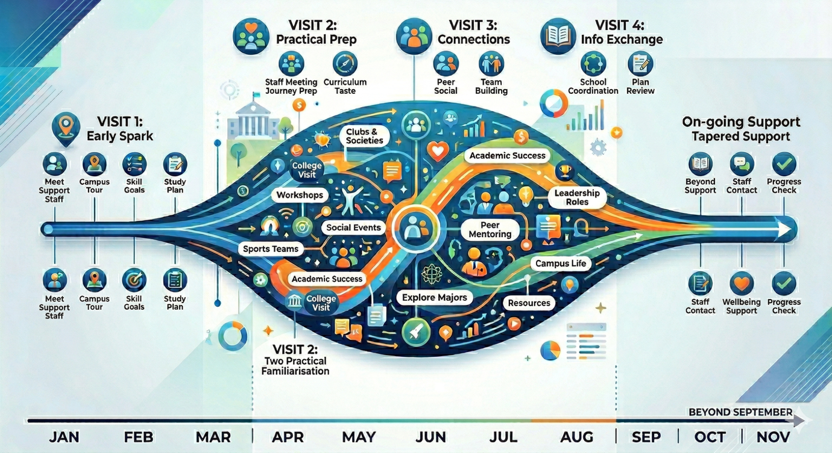

The "Success Recipe" Standards
To ensure the transition sticks, evaluate your programme against these three criteria:
Standard | Description
Person-Centred | The learner’s voice must drive the decision-making. They should co-produce their plan.
Incremental | Exposure should be gradual to avoid overwhelming the learner.
Consistent | Support must be a steady thread throughout the entire pre-entry year.

The Three-Word Mantra
When designing or auditing your transition process, always aim for: Early. Often. Choice.
8. Preparing for Adulthood (PfA): The Ultimate Goal of FE Provision
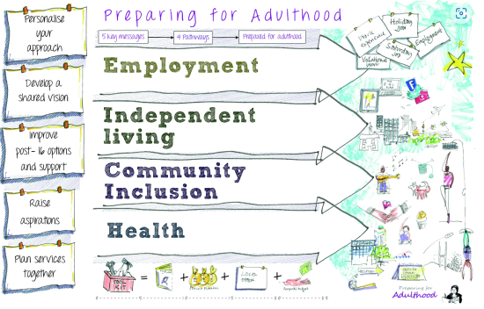
In FE, UAP isn’t just about helping a learner pass a Level 2 Diploma; it is about the transition from a supported child to an independent, empowered adult. While the SEND Code of Practice (2015) mandates a focus on Preparing for Adulthood (PfA) from Year 9 onwards, FE colleges are the "finish line" where these skills are tested in real-world environments.
Embedding PfA within UAP means that every lesson, whether in a motor vehicle workshop, a professional kitchen, or a digital suite, is a rehearsal for adulthood.
We categorise this into four core pathways:
- Employment
- Independent Living
- Better Health
- Community Inclusion
1. Employment: Beyond the Qualification
For an FE lecturer, UAP in employment isn't just about teaching the technical trade; it’s about teaching the "Soft Skills" or "Employability Standards" that allow a person to keep a job.
- UDL Integration (Representation): Instead of just telling learners how to act in an interview, provide "Model Videos" of both good and bad workplace interactions. Create a "Workplace Norms" visual guide for the workshop (“In this industry, we arrive 5 minutes early”).
- UAP in Practice: Use Role-Play Scenarios as a standard part of delivery. In a Hair and Beauty salon, learners shouldn't just cut hair; they should practice the "Client Consultation" to build communication stamina.
- The "Plus-One" Strategy: Add a digital "Professional Portfolio" (like a LinkedIn profile or a Padlet) where learners collect evidence of their work as they go. This reduces the "cliff-edge" of job hunting at the end of the course.
2. Independent Living
Independent living isn't just about moving out of home; it’s about self-advocacy and problem-solving. In an FE setting, we embed this by stepping back and allowing learners to manage their own learning environment.
- UDL Integration (Action and Expression): Allow learners to take the lead in setting up their workstations. Instead of the lecturer laying out all the tools, provide a "Required Tools Checklist" and let the learners self-organise.
- UAP in Practice: Use "Directed Choice." Instead of telling a learner exactly what to do next, ask: "You’ve finished the prep; looking at the board, what are your two options for the next task?" This builds the executive function skills needed to live independently.
- Self-Advocacy: Teach learners how to explain their needs to a supervisor. A learner who uses a coloured overlay shouldn't just have one handed to them; they should be coached to say, "I work best when I use this overlay; can I have this printed on blue paper next time?"
3. Better Health: Managing Wellbeing
Many learners in FE struggle with the transition because of the increased pressure on mental health and the loss of the rigid structures of school. UAP should normalise health management.
- UDL Integration (Engagement): Normalise "Sensory Breaks." In a loud construction environment, don't wait for a learner to have a meltdown. Build in a "10-minute quiet-tool time" for the whole class. The same applies for tasks that require excessive cognitive load.
- UAP in Practice: Integrate "Wellbeing Checks" into 1-to-1 tutorials. Use a simple "Traffic Light" system on desks so learners can signal their stress levels without having to speak.
- Navigating Systems: For learners with physical or sensory needs, adulthood involves managing their own appointments and equipment. Use college transitions to practice this, such as having the learner take the lead in their own Annual Review.
4. Community Inclusion: Belonging and Safety
FE colleges are often a learner’s first taste of a diverse, adult community. UAP should focus on building the social "scripts" and confidence to navigate this.
- UDL Integration (Engagement): Use Collaborative Learning. Pair learners with different strengths (a learner who is great at practical work but struggles with theory with a learner who is the opposite). This mimics a real-world "team" environment.
- UAP in Practice: Use "Campus-Based Challenges." Have learners navigate the college canteen, the library, or the learner union to complete a task. This builds the "spatial and social" confidence to use community facilities outside of college.
- Digital Citizenship: In a world that is increasingly online, UAP must include teaching learners how to stay safe on social media and how to communicate professionally in cyberspace.
The "Adult" Mindset
The shift from "School" to "College" is the shift from Compliance to Competence.
When we apply UDL to Preparing for Adulthood, we are not just helping a learner "get through" the day. We are giving them a toolbox.
- The Set Menu approach says: "I will give you exactly what you need to pass this unit."
- The UAP Buffet approach says: "I will provide a range of tools and strategies. You will learn which ones work for you, so that when you leave this college and enter the world of work or independent living, you know exactly how to support yourself."
The most " Universally Available" provision we can offer is the gift of self-knowledge. A learner who knows they need a visual checklist, a quiet space to decompress and self-regulate, and a digital tool for writing is a learner who is ready for adulthood.

9. Legal and Policy Context
As a lecturer, you aren't just being "nice"; you are fulfilling legal duties:
- Equality Act (2010): You have a duty to make Reasonable Adjustments.
- SEND Code of Practice: You are responsible for the progress of all learners in your class, including those supported by LSAs.
- Ofsted: They now look for "ambition for all," specifically how you adapt your curriculum for learners with SEND.
- Note to Staff: Provision is " Universally Available" when it is part of your standard practice. If a learner requires these adjustments, it is our legal obligation under the Equality Act (2010) to provide them, regardless of whether they have an official diagnosis or EHCP.

Resources

The Inclusive Classroom Checklist
Environment and Prep
- Visual Roadmap: Is today’s lesson breakdown visible on the board? (1. Demo, 2. Practical, 3. Clean-up, 4. Recap).
- Sensory Check: Are there high-traffic areas or loud machines that will overwhelm some? Can I provide ear defenders or a "low-sensory" workstation?
- Digital Accessibility: Are my handouts uploaded to the VLE (Moodle/Teams) in advance so learners can use screen readers or change background colours?
Instruction and Delivery (UDL: Representation)
- The "Rule of Three": Have I given instructions in three ways? (Verbally, written on the board, and demonstrated physically).
- No-Jargon Zone: Have I defined new technical terms? (Defining "torque" in a motor vehicle workshop using a physical analogy).
- Wait Time: Am I giving at least 10 seconds of "thinking time" after asking a question before calling on someone?
Engagement and Assessment (UDL: Action and Expression)
- The "Time Out Card" System: Do learners know the discreet signal to take a 5-minute break if they feel overwhelmed?
- Choice of Output: Can the learner show me they understand the task through a sketch, a video clip, or a verbal explanation instead of just a written paragraph?
- Scaffolded Tasks: Are there "step-by-step" prompt cards at the workstations for complex practical procedures?
The "Graduated Response" Check
- Transition Data: Have I checked the "Support Needs" or "Initial Assessment" data for this group this morning?
Setting: Level 2 Professional Cookery (Professional Kitchen)
The Barrier: A learner with ADHD and Dyslexia struggles to follow a 12-step recipe card while the industrial extractor fans are creating a high-noise environment.
The UAP Response:
- Representation: The lecturer provides a laminated photo-sequence of the recipe steps at the prep station (Visual scaffolds).
- Engagement: The learner is permitted to wear noise-cancelling earbuds during the prep phase to maintain focus.
- Action/Expression: Instead of a written reflection on the "Maillard reaction," the learner records a 30-second voice memo on their phone explaining why the meat browned.

The UDL Audit

Use this to evaluate a specific unit or a recurring weekly session.
1. Engagement (The 'Why')
Do I give learners a reason to care and the safety to try?
Audit Question | Evidence in my Practice | Level (1-5)
Authenticity: Do assignments mimic real-world industry tasks (a "live brief" from a local garage or salon)?
Choice: Can learners choose their own sub-topics or project themes within the curriculum constraints?
Feedback: Do I provide "low-stakes" opportunities to fail and improve before a final summative assessment?
Self-Regulation: Do I use checklists or "burn-down" charts to help learners manage their own progress during long practical sessions?

2. Representation (The 'What')
Am I presenting the 'technical' knowledge in ways that everyone can 'see' and 'hear'?
Audit Question | Evidence in my Practice | Level (1-5)
Perception: Is my text-based content accessible? (sans-serif fonts, 12pt+, accessible digitally for screen readers).
Dual Coding: Do I always provide a visual (diagram/photo) alongside a technical written instruction?
Language/Symbols: Do I have a "Glossary of Industry Terms" visible on the workshop wall or VLE?
Scaffolding: Do I provide "Worked Examples" or "What Good Looks Like" models for learners to refer back to?

3. Action and Expression (The 'How')
Am I letting them show their 'industry competence' in flexible ways?
Audit Question | Evidence in my Practice | Level (1-5)
Physical Action: Can learners use tech (apps, voice-to-text, video) to record evidence instead of hand-writing everything?
Executive Function: Do I provide templates for planning (a "Day Plan" for a catering service or a "Cut List" for carpentry)?
Communication: Can a learner demonstrate knowledge via a professional discussion or a practical demo instead of a standard written test?

From Audit to Action: The "Plus-One" Strategy
The goal of UDL isn't to change everything at once. We recommend the "Plus-One" Approach:
- Identify one barrier that learners consistently face ("They always get stuck on the written reflection").
- Add one alternative way to engage, represent, or express that task ("I will offer a 2-minute video reflection as an alternative to the written one").
Example Case Study: The Construction Workshop
- The Problem: Learners were forgetting the 5-point safety check for the table saw.
- The Audit Finding: The instructions were only in the learner handbook (Representation barrier).
- The Plus-One Solution: The lecturer added a high-contrast visual infographic directly next to the machine and provided a QR code that linked to a 30-second "Safety Recap" video.
- This UDL Audit Tool is designed for the FE context, specifically for practitioners who balance classroom theory with practical workshop or salon delivery. It moves the conversation from "What am I doing for the learners with SEND?" to "How flexible and inclusive is my environment for everyone?"

The "Learner-Led Strategy" Card
The learner fills this in and keeps it in their pocket or on their digital device.
"To help me succeed in this workshop, I need..."
- (Written instructions to take away)
- (A 2-minute warning before we switch tasks)
- (To record your demos on my phone)

The "Trial and Error" Log
Within the interactive guide, we could include a simple digital log where lecturers can jot down:
- What we tried: (Video instructions)
- How it went: (Helped with the 'how-to', but learner still struggled with 'why')
- Next step: (Add a 1:1 verbal check-in after the video)

The PfA " UAP" Audit for Lecturers
Pathway | Ask Yourself... | One Small Change (The Buffet Option)
Employment | Am I teaching the implicit /"unwritten rules" of this industry (punctuality, dress code)? | Post a "Professional Standards" poster in the workshop that mirrors an actual job description.
Independent Living | Do I solve every problem for the learner, or do I give them the tools to solve it themselves? | Stop handing out pens/paper; have a "Self-Service Station" where they must find what they need.
Better Health | Is my classroom a "high-pressure" or "high-support" environment? | Build a "5-minute mindfulness or reset" into the middle of a long 3-hour block.
Community | Does the learner interact with people outside of their immediate "friend group"? | Use "Random Partner" generators for small group discussions to build social flexibility.

Elklan Communication Model
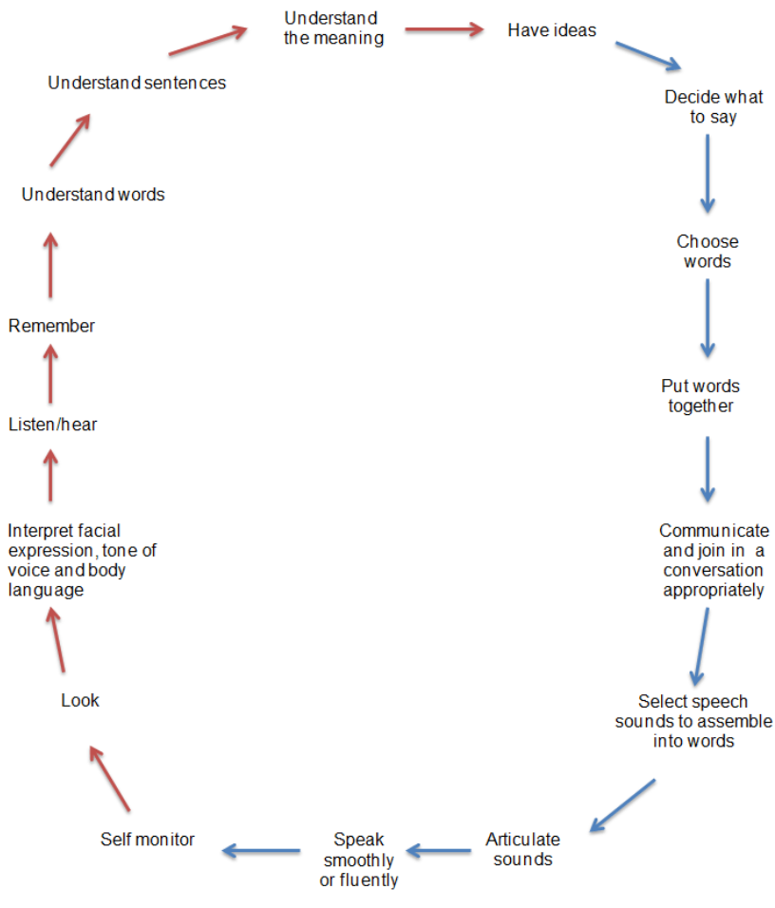

Written by Simon Brown – Chichester College Group on behalf of the SESLIP PfA network.
March 2026

