Minutes and Actions 
South East regional Early Help network

Chair Dr Mac Heath, DCS Milton Keynes, Vice Chair Lucy Peake, Chief Executive Kinship, SESLIP support rebeccaeligon@gmail.com
Attendees: Caroline Smith (Kent), Clark McAuley (Surrey), Jo Denoris (Kinship), Sam Turner (Kinship), Alitha Lee-Townsend (Slough), Gayle Langhorn (Southampton), Zoe Rosenfield (Brighton and Hove), Dave Crewe (Portsmouth), Claire Hunt (Achieving for Children), Rosanna Smith (Hampshire), Maryke Mccarthy (Bucks), Carol Norrington Beard (Surrey), Arek Ksizazek (Milton Keynes), George Layzell (Medway), Chi Chiringa (Medway), Sam Howard (Bracknell Forest), Ananda Bodenstein (West Berkshire), Annita Andreou (Portsmouth), Natalie Bugeja (Achieving for Children), Janine Hernandez (West Sussex), Ashley Schofield (Isle of Wight), Charlotte Davey (Oxfordshire), Victoria Grey (Kinship), Saima Arif (Slough)
LAs without a representative: East Sussex, Reading, Wokingham
Item 1: Introduction: MH welcomed new attendees to the group and reflected that there is lots going on, new Kinship care ambassador report last week, Keen to hear from Medway on kinship pilots that have just been announced, DCSs identified Kinship as a priority area for regional practice focus. Conversations this morning about RCC in the South East are also relevant and give greater prominence to kinship.
Item 2: Policy update and discussion: ST introduced some of the major policy developments relevant to Kinship. He noted all of this is happening in the context of broader FFP reforms and for some LAs LGR.
First of the major policy announcements is the launch of the 7 kinship zones and pilot of financial allowances and an extra family network support packages. In the South East the pilot LA is Medway. Government launches investment in support for kinship carers - GOV.UK Jahnine Davis also published her insights paper last week which reflected a theme we have been discussing in this group for some time - kinship care is not solely a decision about where a child should live, it is a whole-family transition that requires a coordinated, whole-system support. Improving the kinship local offer and approach to kinship care
Second, Fostering reforms were published at beginning of February. The relevant parts to kinship are the removal of requirement for fostering panels. ST noted we’ve been talking with practitioners and carers about the needs of kinship carers. Government also interested in whether changes made in 2024 have had a positive impact. We are expecting further changes in relation to policy relating to kinship carers, following the lead in Wales with a different approach to kinship carers.
The third major policy initiative is the Adoption support that works for all - GOV.UK consultation – This wasn’t well received by kinship given the focus remains on adoption. This is about the future of the ASGSF from 2027/28 onwards.
Fourth, there is a policy development around parental leave of which kinship families are a part. Kinship has been lobbying in relation to this.
The other things in the background are the Law Commission’s review, a date hasn’t yet been agreed. The idea is to simplify the legal architecture around Kinship with an aim to publish recommendations in autumn.
Children’s wellbeing and school coming back, and strengthens duty around the kinship local offer and extending the responsibility of the virtual school to children in kinship care. The schools census is also going to start collecting data on kinship.
CC responded that they are at early stages of project mobilisation relating to the pilot in Medway. CC noted that plans needs to be submitted by March 30 and they are looking to start from April 1. In Medway they are trying to make sure to reach out via a range of means to identify all eligible families. The pilot will be running for 3.5 years, with budget set out by Government.
Kinship colleagues also shared some links related to the policy areas:
Advice guide on financial allowances pilot: https://kinship.org.uk/support-and-advice/advice-and-information/financial-allowances-pilot/
New paper on designing a right to paid leave for kinship carers: https://kinship.org.uk/our-work-and-impact/policy-and-influencing/reports-and-publications/designin…
Response to consultation and proposals on adoption and kinship support: https://kinship.org.uk/our-work-and-impact/news/kinship-responds-to-government-announcement-on-refo…
Financial allowances pilot for kinship carers - Kinship
Information about the financial allowances pilot for kinship carers, including the local authorities chosen and how the pilot will work.
Kinship responds to government announcement on reform of the adoption and special guardianship support fund (ASGSF) - Kinship
ST and LP asked given the scale of policy changes in this space, how it this landing with LAs?
SA responded we are experiencing challenges in Slough around leadership changes but we are making progress. Our sticking point is around the funding we are not able to support kinship carers in the same way.
CM said in Surrey we have a great offer for kinship carers, but the judiciary hasn’t caught up. Judges are speeding things along but they don’t understand that the package of support and the time it takes to put that support in place can be significant. ST this is a point we are making as well in Kinship, that more work is needed with MoJ on the family justice side to understand the need for well thought through support.
GL reflected that she had the benefit of being in a lot of meetings with DfE and Jahnine Davis, she shared that the emphasis in those conversations is particularly on the pre-order, it isn’t on post order work and support. The emphasis is on thinking pre-kinship and preventing children from becoming looked after.
CM said my worry around removing panels is removing that ability to hold council services to account.
Item 3: Achieving for Children practice journey: NB presented the AfC journey. Prior to transformation there were elements of kinship care under 5 different ADs. Connected carers were supported in fostering, SG carers supported in SG team, viability assessments were completed by the child social worker and very limited/non existent practice around FGCs.
In AfC (which covers Richmond, Kingston and Windsor and Maidenhead) they set up a task and finish group which included community members, carers and professionals and started with a focus on FGCs. They collated a lot of feedback from connected carers and special guardians. Because of this they joined up fostering, SG and kinship into a single service along with FGCs and stopped the RAA Adopt Thames Valley delivering post support. To improve practice around FGCs they hired four independent coordinators and offered training to staff to become a trained FGC chairs, there are now 10 coordinators. Now AfC have a whole team who do viability assessments across the three LAs. This is leading to earlier conversations with families. They launched the Kinship local offer and held a whole service event with a focus on kinship. Afc relaunched connected network meetings, instead of family network meetings. They are also now working with families after the order to make sure families feel confident and supported.
Key learning points were around taking the time around staff and kinship carer engagement. Some social workers enjoyed the assessment work moving to the new team, but others didn’t like the team taking away the viability assessments.
MH said he was interested in the work around how AfC are using non-social work qualified staff in aspects of the transformation.
Item 4 Mapping payment rates: Rebecca shared the payment information that had been collated from 16 Las. Action: We will have a further discussion on this at the next meeting. LP shared a document: Guide to supporting Special Guardians - further evidence about good practice, including Brighton & Hove https://kinship.org.uk/wp-content/uploads/2024/09/Kinship-ASGLB-July-2022-Final-for-publication.pdf

Summary of kinship payment themes:
This is based on information submitted by 16 LAs (I have summarised but may have misinterpreted your submissions, so check they are accurate). Information was not received from Isle of wight, Medway, Portsmouth.

Pay in Line with Fostering Minimum Rates (Often Means-Tested)
These LAs broadly align SG/kinship payments with national fostering minimum allowances, often with annual means testing:
- Bracknell Forest – Fostering minimum rates; means tested annually
- Kent – SG carers only; fostering minimum rates; means tested annually
- West Sussex – SG and kinship foster carers paid in line with national minimum rates; SG means tested
- Southampton – Payments start in line with fostering rates; means tested if not foster-approved
- Surrey – In line with fostering rates; SGO means tested after 2 years
- East Sussex – Fostering rate minus professional element; means tested and reviewed yearly

Two-Year “Transitional Protection” (Full Fostering Rate Then Means Test)
These LAs protect carers financially for the first two years post-SGO (especially if child was previously LAC), then apply means testing – this protects income when moving from fostering to SG:
- Buckinghamshire – Protected fostering rate (same as mainstream foster carers) for first 2 years post-SGO, then means tested
- Slough – Former Reg 24 carers receive fostering-equivalent allowance for first 2 years post-SGO; after 2 years a means-tested financial assessment determines SG allowance; no further reviews unless significant change in circumstances
- Reading – 2 years non-means-tested if previously kinship foster carer
- Windsor & Maidenhead – 2 years equivalent to fostering (minus child benefit), then means tested
- West Berkshire – 2 years fostering equivalent (above minimum), then means tested
- Surrey – 2 years SGO; not-detriment rule may extend full allowance
- Wokingham – 2 years minimum fostering allowance (if previously LAC), then means tested

Full Fostering Allowance for Approved Kinship Foster Carers
These LAs treat approved kinship foster carers the same as mainstream foster carers: Where kinship carers are formally foster-approved, parity with mainstream fostering is standard.
- Buckinghamshire – Kinship foster carers paid at same rate as mainstream foster carers
- Milton Keynes – Approved kinship carers receive the same payments as mainstream foster carers; temporarily approved carers receive the fostering allowance but not the professional fee
- Oxfordshire – Approved/temporarily approved kinship carers paid in line with national minimum rates
- Wokingham – Fully approved kinship foster carers receive full fostering allowance regardless of income
- East Sussex – Foster-approved carers receive full fostering rate

Pay SG Carers Only (Limited Wider Kinship Support)
These LAs prioritise Special Guardianship over CAO/RO/private arrangements in terms of payment
- Kent – SG only (not other kinship carers)
- Hampshire – SG in line with fostering; other orders discretionary

Discretionary / Case-by-Case Approach for Other Orders (CAO/RO)
Several authorities consider Child Arrangement Orders (CAO) or Residence Orders individually. There is no automatic entitlement outside SGO/LAC cases; needs-based assessment
- Brighton & Hove – Discretionary payments for CAO/RO
- Hampshire – Discretionary CAO/RO payments
- Milton Keynes – Means-tested allowance available for CAO
- Reading – CAO assessed based on need/prior LA care
- Windsor & Maidenhead – Case-by-case for non-SG kinship
- West Berkshire – Case-by-case depending on child’s needs/LAC status
- Wokingham – CAO subject to financial assessment

Means Testing Models Differ
There are two main financial assessment approaches to means testing:
A. Always Means Tested
- Bracknell Forest
- Kent
- East Sussex
- West Sussex
- Southampton (if not foster approved)
- Milton Keynes (SG and CAO allowances)
B. Means Tested After 2 Years
- Bucks
- Reading
- Windsor & Maidenhead
- West Berkshire
- Surrey
- Wokingham
- Slough

Deduction of Child Benefit / UC
Most SG allowances deduct child benefit; some treat this as part of means test. Common practice:
- Brighton & Hove deduct child benefit
- Windsor & Maidenhead deduct child benefit
- Wokingham deduct child benefit
- West Sussex applies deductions

“No Detriment” / Enhanced Protection Policies
More protective models:
- Brighton and Hove- Explicit no-detriment policy; pays all kinship foster carers and those with a legal order for care experienced children in line with national minimum fostering rates.
- Oxfordshire – Explicit no-detriment policy; pays all kinship carers in line with national minimum fostering rates
- Surrey – Not-detriment guidance may extend full allowance to 18
- West Berkshire – First two years exceeds fostering minimum
- Buckinghamshire – Protected fostering rate for first two years post-SGO
- Slough – Two-year fostering-equivalent protection for former Reg 24 carers

S17 for Informal Kinship Care
Some LAs explicitly restrict financial support where carers are not formally approved or do not hold legal orders:
- Milton Keynes – No allowance for private fostering or informal family arrangements; support may be provided via Section 17 following assessment of need
- Southampton – Private arrangements generally supported only through Section 17 where needs are identified
Informal kinship care often falls outside regular allowance structures and relies on discretionary children’s services support.

Overall Patterns
Across the region:
- Fostering minimum rates are the benchmark almost everywhere
- Most SG allowances become means tested at some stage
- Two-year transitional protection is common across many LAs
- Support beyond SG (CAO/RO/private) is usually discretionary or means tested
- Children previously looked after (LAC/Reg 24/Connected) receive stronger financial protection
- Very few LAs offer universal, non-means-tested long-term SG allowances
- Approved kinship foster carers are usually paid the same as mainstream foster carers
- Informal kinship arrangements generally rely on S17 discretionary support.

Full feedback from LAs on Kinship payment:
LA | info on SG/kinship payments
Bracknell Forest | Bracknell Forest pay kinship carers in line with minimum fostering allowances. This is means tested annually.
Brighton and Hove | ‘BHCC pays Special Guardians of care experienced children the same as national fostering minimum allowances. BHCC deducts child benefit as SGs can claim CB. BHCC does not deduct CB if the SG claims means-tested benefits or their only income is a state pension. There is a no detriment to moving to SGO from Kinship FC, and BHCC does not means test the allowance.  BHCC pays all kinship foster carers the NMA equivalent. On completion of Core Skills Training BHCC pays NMA + Level 1 Foster Carer Fee. On completion of Mandatory training BHCC pays NMA + Level 2 Foster Carer Fees. BHCC pays all Kinship carers (either approved or temp approved as foster carers) in line with national minimum fostering rates.  Payments to carers who hold a CAO for a care experienced child are discretionary and paid as per national fostering minimum allowances. BHCC deducts child benefit, unless the CAO carer is in receipt of a means tested benefit, or their only income is state pension.’
Buckinghamshire | Bucks pay kinship foster carers at the same rate as mainstream foster carers. For SG carers, we pay the protected fostering rate (as for mainstream carers) for the 1st 2 years post order, whereafter it becomes means tested.
East Sussex | We pay kinship carers in line with the fostering rates minus the professional element, the allowance is means-tested and reviewed yearly. Those who have fostering approval are paid the full fostering rate, and this is regularly reviewed via the SSW. Private applications are considered on an individual basis.
Hampshire | Hampshire pay SG carers in line with foster care minimum rates. Similarly to Brighton and Hove we pay some other kinship carers with other legal orders ie CAO or RO in line with foster care minimum rates on a discretionary basis
Isle of Wight
Kent | Kinship (Connected) foster carers receive full fostering payment both maintenance and reward (once they have completed Skills to Foster), to maintain the reward payment they must complete yearly training/support groups etc, this is means tested and reviewed at the carers annual review.
Medway
Milton Keynes | In accordance with our fostering payments policy, all approved kinship carers receive the same payments as mainstream foster carers. Temporarily approved kinship carers are entitled to the fostering allowance, however, they are not eligible for the professional fee. Special Guardians receive a means‑tested SGO allowance, aligned with South East fostering rates. A means‑tested allowance is also provided for Child Arrangement Orders. For other kinship carers, including those in private fostering arrangements or informal family arrangements, no allowance is paid. However, financial support may be provided under Section 17 where an assessed need has been identified.
Oxfordshire | Oxfordshire have a no-detriment policy in place for all children who are CWCF at the time of making an Order. We pay all Kinship carers ( either approved or temp approved as foster carers) in line with national minimum fostering rates.
Portsmouth
Reading | SG carers receive a non means tested allowance for 2 years post the granting of any order if they were previously kinship foster carers. After 2 years, payments are means tested.  Consideration of any payment is in line with national fostering minimum rates.  For other Kinship carers i.e. CAO consideration is given depending on factors such as the children’s needs and/or whether the children were in Local Authority care immediately before the application.
Slough | SCF pay the carers who were Reg 24 carers prior to the order being granted an amount equivalent to the fostering allowances for the first two years protected to support the transition Reg 24 to SG. After the two-year period they would have a financial assessment which is means tested and if the carers meet the criteria they would receive an SG allowance. There are no further reviews unless there has been a significant change in their circumstances and at that point they financial circumstances can be reviewed.  Where a carer has never had a child previously in placement, they would undertake a financial assessment and if they met the criteria, they would receive the SG allowance with no further review unless there has been a significant change.  Other kinship arrangement are considered on a cases-by-cases basis and where payment is made this is paid from the sec 17 payments.
Southampton | Where a carer has never had a child previously in placement, they would undertake a financial assessment and if they met the criteria, they would receive the SG allowance with no further review unless there has been a significant change.
Surrey | Other kinship arrangement are considered on a cases-by-cases basis and where payment is made this is paid from the sec 17 payments.
Windsor and Maidenhead | AfC pays SG carers (where the children were in LA care prior to the order) an amount equivalent to our fostering allowance (minus child benefit) for the first two years, so the carers payments will be unchanged as they move from fostering to SG. After two years, we carry out a means test, and if carers meet the criteria, they receive an SG allowance that may be close to or equivalent to the foster care minimum rates. This is reviewed each year. Other Kinship cases are considered on a case-by-case basis, for example CAO. Other than this we do not have a specific policy around private arrangements other than Sec 17 payments.
West Berks | West Berkshire pays SG carers (where the children were in LA care prior to the order) an amount equivalent to our fostering allowance for the first two years, which exceeds the foster care minimum rates. After two years, we carry out a means test, and if carers meet the criteria, they receive an SG allowance that is close to or equivalent to the foster care minimum rates. Other Kinship cases are considered on a case-by-case basis, depending on factors such as the children’s needs and/or whether the children were in LA care immediately before the CAO/private SG applications.
West Sussex | Our Kinship foster carers and Special Guardians receive the same weekly all-inclusive allowance, set in line with Natational fostering minimum rates, paid partly in arrears and partly in advance. Special Guardianship allowances are means-tested because SGs can claim Child Benefit and some UC elements, and deductions are applied accordingly. SGs may also receive a skills fee or enhanced payments under special agreement.
Wokingham | Kinship foster carers (as fully approved foster carers) receive the full fostering allowance regardless of income and may receive a Skills Fee once trained. If caring for a young person turning 18, they receive the Staying Put rate, with any Skills Fee tapering down annually until age 21.  Connected Carers  Connected carers receive:  Child allowance in line with government guidance  Fostering fees, but only if the child’s permanency plan is connected care  Council tax support  If the child’s plan is likely to move towards a Special Guardianship Order (SGO), then once the carers are fully approved as connected carers:  They do not receive the fostering fee.  They do not receive the council tax contribution.  Special Guardianship (SG) Carers  If the child was looked after (LAC) immediately before the SGO was granted:  The carer automatically receives, for the first two years:  Minimum fostering child allowance  Minus child benefit (which the carer claims themselves).  If the child was not looked after before the SGO:  A financial assessment is completed.  Carers may receive child allowance, depending on a means test.  Means-tested SG allowances:  Are reviewed every two years.  Do not automatically increase over time unless there are significant or exceptional circumstances that justify a change.  Child arrangement orders:  Carers may receive child allowance, depending on a financial assessment and means test.

Item 5: Kinship 5th quarterly data review
JF presented summary slides from the 5th quarterly collection of kinship data. First JF presented the proportion of children ceasing care with an end reason of SG. This continues to be the lowest in the South East for any region in the UK. But JF notes that is likely due to the fact that there are more Unaccompanied and separated children in the region – there is an inverse relationship. JF noted that understanding this contextual information is important as it is one of the only real published indicators nationally.
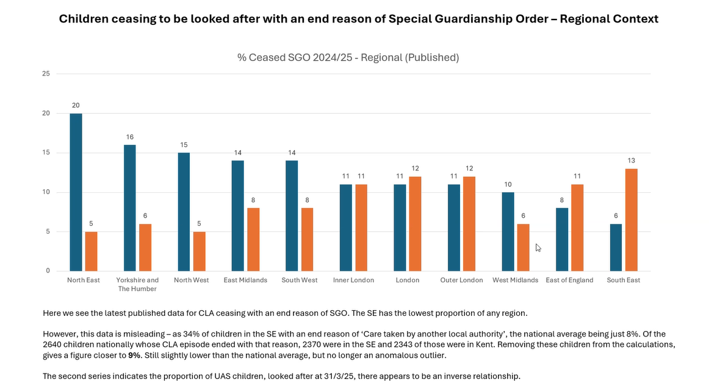
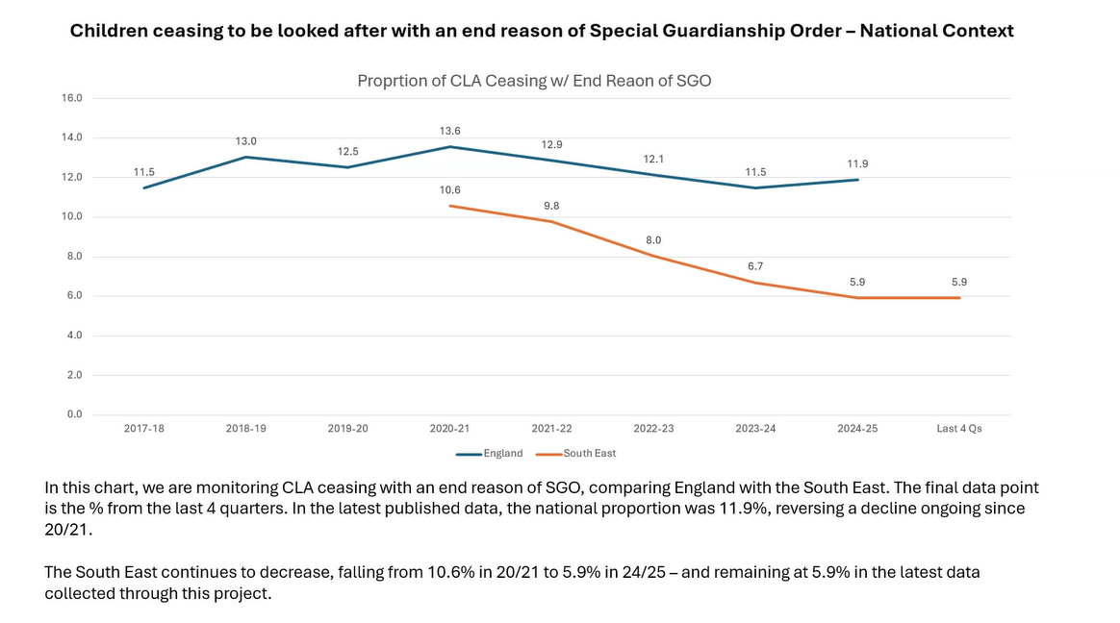
JF noted that there does appear to be an increase in proportion in kinship placements from 12% to 14% which tells us although the proportion is below other regions, the proportion in kinship care is growing.
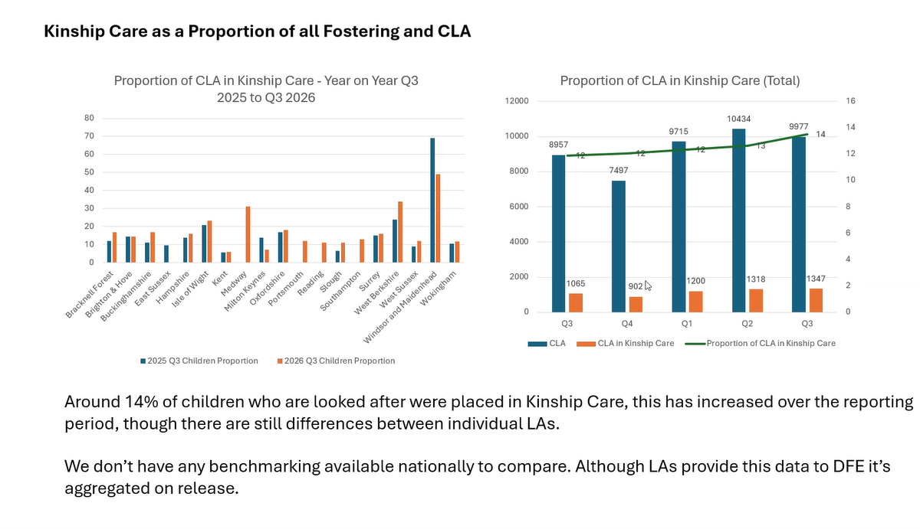
The final data point which JF shared related to unlawful placements. JF noted that the biggest reason for these unlawful places is in relation to DBS checks. JF asked what we might do as a region to address this?
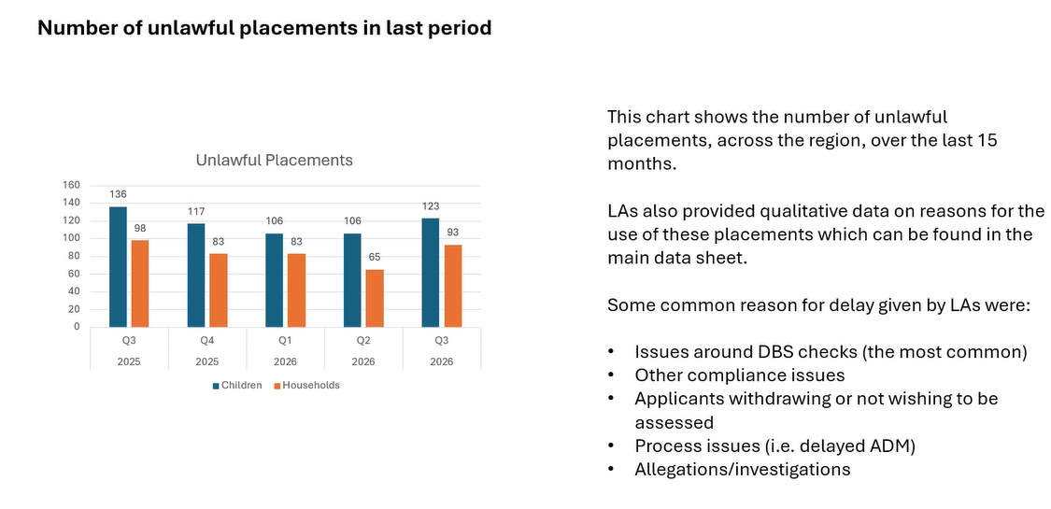
JF noted that the new items in the CiN census from April 26, but won’t be ready until Oct 27 may provide interesting contextual information for this group.
GL said the issues with delays to DBS checks relate to police. CM said we should be escalating regarding to PND/PNCs/police checks as there is inconsistency. RS from Hampshire, said we request police checks prior to reg 24 but they are refusing to do them as police colleagues say it would frustrate the DBS process. This then causes a knock on impact regarding timely panels. If you are in proceedings without a DBS CAFCASS won’t support the order (even if there is a police check). It is unsettling for families and prolonging the process for young people.
Issue to escalate and discuss with DCS colleagues: MH to raise Police prioritising and responding to police checks and DBS checks as it feels like a lottery across the region.

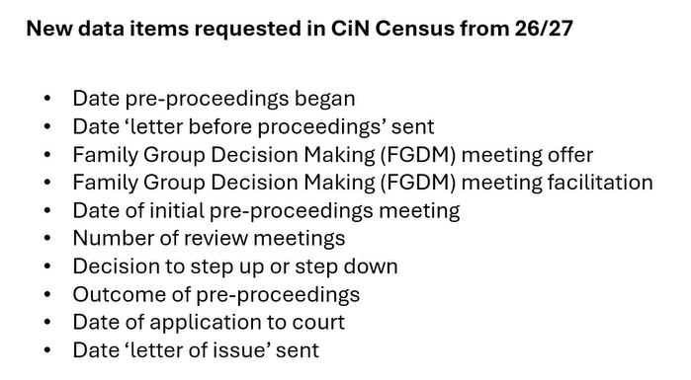
Item 6; Update on Kinship projects funded by the DfE:
Kinship Reach; VG shared that the Kinship Reach programme launched in 18 LAs in November 2025. So far they have received 23 referrals with 20 open cases. Support is well received. Several cases are coming to a close. Quote from one carer “I feel connected, I feel I have had my hand held even at a distance”. VG reported that support groups are being attended by those not yet having an assessment complete and they will continue to be open to carers even when their supported through the programme has finished.
Kinship connected is proposed to be piloted in parts of West Berks, Wokingham, Slough, Windsor and Maidenhead, and Bracknell Forest. A meeting is being set up with these LAs and Kinship to go through more detail.
Upcoming meeting dates;
- 9 June 2-3.30pm: Agenda for next time: policy updates, Framework on the Kinship local offer, Focused discussion on payments and update from Medway on national pilot, 6th wave of quarterly data
- 8 Sept 1-2.30

Action log: This action log was updated on 7 March 2026. Shaded actions are closed or complete
 | Action | Responsible | Date issued | Status
24 | Item on June agenda to focus on Medway payment pilot and payments across the region | RE | Mar 2026 | In progress
23 | MH to raise via DCS colleagues Police prioritising and responding to police checks and DBS checks as it feels like a lottery across the region | MH | Mar 2026 | Open
22 | Quarterly benchmarking to continue | RE | Dec 2025 | complete
21 | RE to collate which LAs are paying the minimum fostering rates and allowances to SG carers/ or have some sort of no detriment policy via email and present back next time | All | December 2025 | Complete
20 | All LAs to email tim.fisher@kinship.org.uk when they have published Kinship local offer so the links can be published on Compass page. | All | December 2025 | complete
19 | All LAs to get back by Sept 26 if they are in or out of Kinship Reach. Rebecca to meet with Kinship directly to develop business case for an in person regional offering to come back to a future meeting. Kinship to develop a costed proposal for £15k to support coproduction of the kinship local offer in LAs. | RE | September 2025 | Complete
18 | All to note deadline for next submission as JF will be presenting annual data returns as well as quarterly trends. 13 November submission date | All | Sept 2025 | Complete
17 | Lucy to consider what other data points for national comparison may be available. The Law Commission review is an opportunity to discuss those issues | LP | September | Complete
16 | RE to put forward DfE bids for coproduction of local offer, and prevention of placement breakdown through Kinship Reach and Kinshio connects | RE | June 2025 | complete
15 | KW to share terms of reference for placement breakdown rapid response meeting | KW | June 2025 | complete
14 | JF include national comparison data where available in benchmarking, and JF and RE to produce an annual narrative with trends once four quarters of data collected | RE | June 2025 | complete
13 | JF to produce different metrics for proportions of kinship households measuring against the different baselines to allow both national comparison and also to have insight into the proportion in kinship arrangements. JF will recalculate metrics against the CLA figure in the RIIA collection. | JF | March 2025 | Complete

