South East Transformation Network
meeting notes and action log January 2026

Date: 27 January 2026 10.30-12
Chair: Steph How (Chair, Hants),
Attendees: Clare Chamberlain (independent facilitator ex-DCS, working with Mutual Ventures), Adam Thomas (Surrey), Anita Stanbury (west berks), Dan Buckle (Southampton), James Carter (Oxfordshire), Anna Clarke (IoW), Deborah Ennes (East Sussex), Teresa Devito (Medway), Ingrid Crisnan (Kent), Kirsty Morris Sellley, Hannah Leat (Hampshire), Marie Foley (West Sussex), Steph Murrey, Natalie Bugeja (Achieving for Children), Nicola McGeown (East Sussex), Priscilla Kurewa (Bracknell Forest), Rebecca Walsh (west Sussex), Richenda Polson (Kent), Michelle Sanders (Portsmouth), Sam Taylor (Hampshire), Tom Stibbs (Brighton and Hove), Luke Varndell (Portsmouth), Victoria Gibbs (Slough), Bosede Lawal (Surrey), Estelle Kelleway (Wokingham), Edwina Gregory-Johnson (Achieving for Children), Anna Clarke (IoW), Selina Rattu (SESLIP support), Rebecca Eligon (SESLIP support)
Apologies: Janet Jones (Surrey), Collette Visagie (West Sussex), Andrea King (Reading), Keith Langley (West Berks), Ananda Bodenstein (West Berks), Laura Travett, Stuart Ashley (Hants), Hayley Rees (Wokingham), Jonny Bradish (Brighter Futures, Reading), Wendy Evans (Milton Keynes), Sarah Moran (Achieving for Children), Alison Munt (Bucks), Dora Gouveia Schofield (West Berks), Jenny Thomas (Milton Keynes), Errol Albert (Bucks), Kirsty Morris-Selley (Milton Keynes), Kay Jones (Isle of Wight), Richenda Polson (Kent),
Introduction: SH opened and explained that she would be taking over as chair as Stuart Ashley the previous chair and DCS for Hants is retiring.
Item 1: MACPT themed discussion
SH reflected on the discussions we have been having in this meeting, and the subsequent changes and elements relating to MACPTs which are on hold, we believe due to some of the feedback from this group. We have been raising our concerns in our individual calls with the DfE and had some helpful calls with Jamie from DfE.
CC said her reflection is that MACPTs have struggled to get going in some places. CC assured that she isn’t here on behalf of DfE, CC reflected on the most important themes from the McAllister review. We do know that CP conferences can be quite overwhelming and it isn’t about saying you are performing badly, but that the safeguarding framework we are all using perhaps isn’t serving families. CC asked is there a kinder and more compassionate way to work with families even where there are worries about risk. Particularly important is the involvement of families and wider families, and when you do that well the state might not need to intervene in the same way.

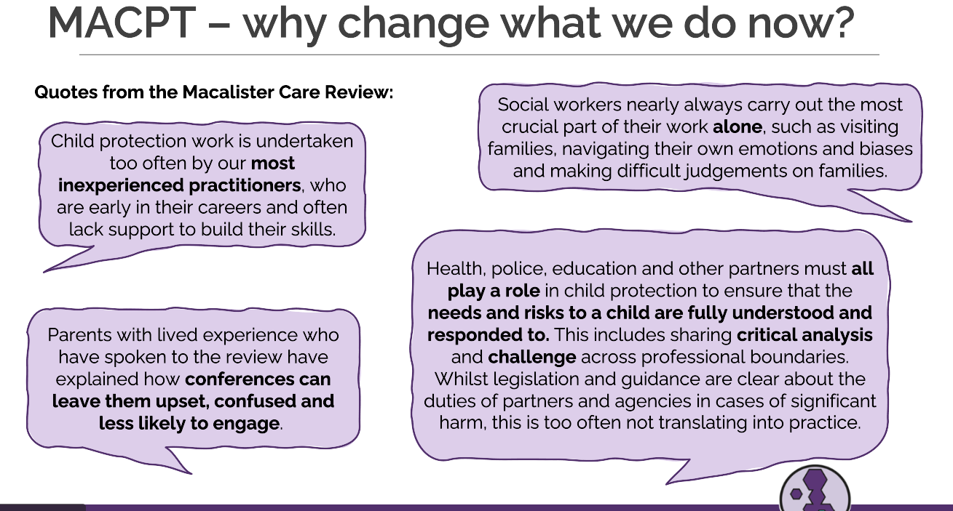
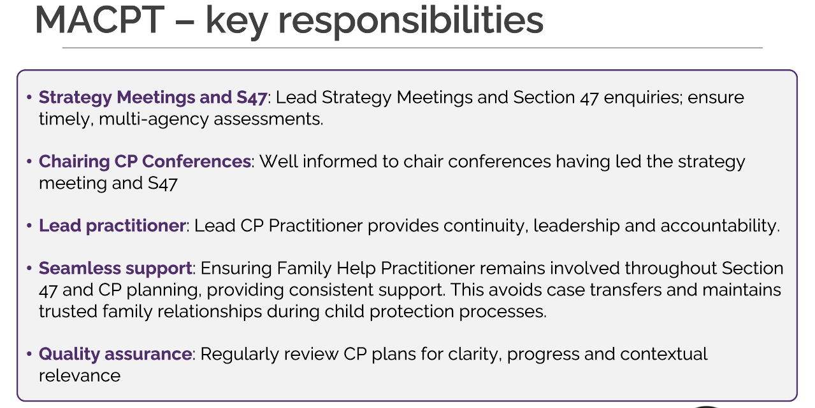
Many MASH’s around the country are different but CC also shared that the MACPT is a different role to a MASH.
CC reflected on some of the challenges and live debates relating to partner funding, worries about dismantling a strong safeguarding system for something unknown, the concerns flagged by Munro and Baroness Barran as well as the lack of an evidence base around this new way of working.
SH said in Hampshire they have a large MASH, they do the strategy discussion in the MASH. There are 36 family help teams in Hampshire. The chairs are now based in localities. SH reflected that partner resourcing in the MASH is difficult already, but then filtering partner capacity into operational teams feels very tricky. CC said I think MASH’s are great, but we do use them to invest an awful lot in sifting information. Often we are duplicating activities which come later. Do we need to be looking at those lower risk/EH families coming to the MASH. Instead of all in the MASH, could half of partner capacity be involved in investigations.
CC reflected from her work nationally that the people finding it most difficult are CP chairs who historically have not been in homes. CC said she has observed that whilst some CP Chairs have enjoyed the transition to LCPP, they have found it a harder transition than for senior practitioners or operational team managers moving into that role. CC said it is important to have a mix of experienced social workers and ex-CP chairs who may feel it is a step backwards.
RW from West Sussex – we’ve got an integrated front door, so all the greens do not touch the multi-agency partners. We have already done that to free up partner agencies. We also chair strategy discussions, but not S47s and CP conferences in the MASH. Feedback from partners is that they can’t give us any more resource.
CC says on reflection it would have been helpful for DfE to get DoH and Police on board early.
AT from Surrey said the local context of LGR happening in next 12 months makes these additional changes very difficult. AT is looking for some ideas and other LAs to connect with. The whole of Surrey will be splitting and the senior capacity focus will be there. CC advised that if there is a lot of focus in the organisation on structural change around LGR then the focus in the FF programme could helpfully focus on practice and family led decision making. On MACPT you could focus on different types of partner conversations.
CC said you could deliver the reforms and focus on practice rather than on structural/HR change or systems and process changes.
JC said we started a 4-month pilot MACPT in Oxfordshire 2 weeks ago (South of county only). Comprises CP Chairs (in LCPP role), Assessment Service, Police, and Adolescent Services. Pursuing health and education involvement but not there yet. Worth noting that our LCPPs are NOT chairing strats or authoring S47s. They DO provide pre-threshold consultation, attend some strats (repeat planning/ CP), QA S47s, offer joint home visiting, chair ICPC, and chair ROTH conference.
Oxfordshire’s Rationale: Incremental implementation, avoids service re-structure/ re-design without having first tested/ understood impact (intended or otherwise), retains some CP chair independence; increases joint decision-making (particularly earlier in S47 process), flexible - can be rolled back or more deeply embedded/ further entrenched depending on learning, national changes, and LGR. This works for us, based on our current set up and local needs - appreciate others will come from different base. Their pilot also includes Early Help holding some CIN (supervised by SW managers) and FNM at assessment stage (but neither of those particularly controversial).
VG said in Slough they have both managerial level and senior prac with the managerial level is leading chairing and independence. The challenge in Slough is more around health partner capacity and funding. We’ve received different messages about the grant conditions to use funding for partner capacity. CC said her understanding of the grant conditions that this is allowed. RE confirmed this as well but only for transformation and not for ongoing posts in the establishment.
AC said the reforms brings in a number of roles and in Isle of Wight they are thinking about how might we make that work in a small LA both from a resource point of view but also in terms of how that feels for families. CC said yes the LCPP will be one more person, but joint visits provide a second pair of eyes. CC said in Redbridge, this is someone else there to help you do this very difficult visit.
TD in Medway said All our CP Chairs visit children in their homes prior to ICPC and a Review and this is included in our performance dashboard.
Priscilla Kurewa from Bracknell Forest asked the role of education lead within MACPTs. CC said it is less clear and developed role. But it would be helpful to have a strategic link and liaison with schools.
HL from Hants said I am comfortable and can see the benefits of MACPTs but what families and partners think about the removal of independent chairs. HL said in some instances there is also value in not having met the family and coming to it independently. Some families see a benefit in having someone challenge the social workers. CC said she didn’t have feedback from families. CC said she expected that families love the independence when the chair says we aren’t putting the child on a plan, but they don’t love it when they go the opposite way.
NM said in ESCC they used the SESLIP formula and it was very expensive to bring in the amount of capacity that might be needed. The evaluation of the enormously significant changes and the pathfinder evaluation was quite qualitative, so I think it is a good thing that things are being paused.
CC said she agrees and there hasn’t been information she has seen about the financial impact of this.
JC said everyone’s starting point is different and so what feels viable is different. In Oxfordshire they moved to family safeguarding got rid of assessment service which didn’t work. Adam Thomas asked, please can you say why it didn't work previously to remove the assessment teams - what was it that didn't work. AT said they got implementation wrong - ploughed on with Family Safeguarding in the middle of Covid, big bang approach, teams under-prepared. SW time got completely swallowed into assessment time and court activity - family engagement got really squeezed. We hadn't, probably, done enough work with our teams to ready them for taking on different aspects of their role.
Michelle Sanders: said they have also used the tool in Portsmouth and the numbers required for LCPPs is very high despite being a small LA
Tom Stibbs: We have used the SESLIP tool too and like Nicola this would very significantly increase the number of LCPPs we would need and this would have a massive impact on finances.
SH said one elephant in the room which hasn’t yet been referenced is Ofsted. We are a very risk averse profession. We met with Josh Macallister early on to talk through plans for family help in Hampshire. We should have family help and a very small amount of Child protection with a view that this capacity is constantly pushing down and asking why CP is needed.
There is an element of the Ofsted inspection which encourages this culture of risk aversion. SH asked for CC reflections on Ofsted coming on this journey. CC said the DfE and government are looking at what inspections could and should be like in the future. They don’t ask how many you have in care, if your CLA per 10,000 is much higher than neighbours Ofsted isn’t interested in why, they are interested in policies and procedures. Warwickshire was downgraded but some other pathfinders were upgraded. I didn’t see anywhere in the report a link between the reforms and the outcome, the marking was about the practice. CC said this is a challenging tightrope to walk.
AOB:
RE flagged that SESLIP has been asked to consider what regional work we might do in relation to contextual safeguarding, risk outside the home. IC said in Kent they had conference and launched tool, role of family hubs around contextual risk. They can contribute learning . Kent, Hampshire and Southampton all had approaches and models to share.
SH asked can we think about a model of best practice?
Action: SR and RE to develop proposal around contextual risk for DfE funding via SESLIP with a focus on a conference/practice sharing in 2026/27

Action log: updated February 26 2o26 Shaded lines, actions are complete
 | Action | Responsible | Date issued | Status
1 | Priorities for the group listed in the Terms of reference to be amended in light of discussion at the end of the meeting. | RE SR | Sept 2025 | Complete
2 | IoW to present at future meeting about their family hubs model. | KJ | Sept 2025 | Complete
3 | Next meeting to hear from Reading/Brighter Futures, Slough Children first, Southampton, Surrey, West Berks, Wokingham, West Sussex and Achieving for Children | Presenting LAs | Sept 2025 | Complete
4 | Next meeting to hear from remaining LAs: West Sussex and Wokingham | Presenting LAs | November 2025 | complete
5 | SR and RE to collate he case management systems that all LAs are working with so you can join up any conversations with providers. | SR RE | November 2025 | Complete
6 | West Sussex and Milton Keynes to share family network meeting guidance | DE JT | November 2025 | Complete
7 | SR and RE to benchmark conversion of PLO to proceedings in LA with established FGC vs those without . 43% PLO don’t go to court proceedings in Milton Keynes where FGCs are well embedded with 80% take up. | SR RE | November 2025 | Complete
8 | SH offered to meet up with EK to share more about Hants journey to move family practitioners. EK to contact | EK | Dec 2025 | Open
9 | SR and RE to set up subgroups of the LAs with the same case management system with a focus on reforms | SR RE | Dec 2025 | complete
10 | Jan meeting to focus on MACPTs with Clare chamberlain, and Hants family worker model | SR RE | Dec 2025 | complete
11 | future item on sharing content from DfE meetings. Consider whether to invite Jamie (DfE) to this meeting in Spring | SR RE | Dec 2025 | Open
12 | All to submit DfE delivery plan part two to SR and RE to present back to the group | All | Dec 2025 | Open
13 | SR and RE to develop proposal around contextual risk for DfE funding via SESLIP with a focus on a conference/practice sharing in 2026/27 | SR RE | Jan 2026 | Open

