Fostering regional group Minutes and action log June 2026
Chair: Sarah Daly DCS Portsmouth
Meeting details: 22 June MS teams: 10-11.30:
Anne-marie Ali (LAFSE fostering hub lead), Alison Miller, Cathy Seiderer (Brighton and hove), Dave Crewe (Portsmouth), Jo Kearney (East Sussex), John Donnely (Brighton and hove), Karl Davis (West berks), Keith Langley (west berks), Kelly Wilkes (west sussex), Kimberley (West Sussex), Matthew Edwards (AfC), Peter hodges (Bracknell forest), Kerry Richards (Portsmouth), Saima Arif (Slough), Sarah Tarrant (Slough), Sharon Godrey (Milton Kenes), Vince Clark (Home and Future), Tessa Doust (Hampshire), Carol Norrington Beard (Surrey), Kimberley Showell (West Sussex), Carly Arnold (Southampton), George Matthew (Slough). Indebir Pannu (LAFSE), Holli Blackburn (Wokingham)
Item 1: Direction of travel regional fostering governance (LAFSE, End to End Fostering, SESLIP, Home+future):
VC updated around direction of travel that Home + Future will take over role for fostering hub for South East taking over from LAFSE. The government direction of travel in December didn’t really have any mention of end to end fostering, was then policy direction set in March but with very tight timelines. Want to take first contact to approval, some regions are taking though to support but there hasn’t been appetite for this in the South East. £1.5m allocated to deliver model in South East.
VC said H+F is funded by councils and is here to follow the direction set by the region. KD asked is H+F having to register as an IFA as that process can take a year or more. VC said there isn’t a clear answer, but it is a probably outcome. KD said we are in the midst of discussions around LGR and there needs to be flex in the end to end model to respond to changes.
SG asked about whether Charms will be CRM approach. VC said this is still to be defined, but there will need to be a single CRM system. Milton Keynes is joining Bucks and Oxfordshire who are proposed to host their subregion, but they are all on a different system. If there is an expectation to shift there will be costs. VC said the development funding has been set aside to deliver this.
CS said Charms has been implemented in Brighton and Hove from pre-approval to support. The licensing is for staff only.
SG asked if we are having 5 separate hubs what is the possibility of doing things quite differently. For example in our sub region we were thinking that staff stay with their local authority and move over more gradually, whereas other hubs might want to move more quickly from day 1. VC said there is opportunity to be nuanced and to have difference between the 5 areas.
ME asked if there will be a move to harmonise fees and support. VC said this is a direction of travel but will take a long time.
SD updated on the direction of travel at the DCS and Director conference in May (attended by 70+) which are relevant to our discussion:
- SESLIP to focus on practice, innovations, and building relationships between LAs whereas Home+Future to focus on data, sufficiency, market management and commissioning.
- Clarify the future roles of SESLIP and Home+Future (especially relating to education/SEND and fostering where there are seen to be overlaps) and strengthen the South East's collective voice.
- Both SESLIP and Home+Future to increase sub-regional collaboration to reflect emerging system footprints (including LGR/ICB etc).
SD asked the group whether it wanted to continue given that Home+Future will be taking some areas of fostering responsibility. CS said: yes definitely think there is great benefit to SESLIP continuing for all the reasons outlined including policy and best practice and relationships and the fact that its a consistent and familiar space to meet which has worked well over the years. It is helpful to have something separate and we don’t have other opportunities to meet as this group in this format.
JD: said I would like to use this group to continue to think about post approval and support, building relationships, sharing best practice. I think it has been a very useful and it doesn’t feel burdensome in terms of frequency. This is a strong group, with good a regular attendance.
GM from Slough said agree to continue in the current form
KW said i agree very happy and keen to continue to be part of this space
KL said they agreed with the sentiment of JD.
Update on regional fostering innovation bids:
The government is investing £12.4 million in the Fostering Innovation Fund across the 2026 to 2027 and 2027 to 2028 financial years. Regional Care Co-operatives (RCCs) and fostering hubs in England can bid for £500,000 to £750,000 per project.
The South East put in three bids via Home+Future. Two updated Mulberry bush – therapeutic
RE updated on the fostering community project. Which is a pilot in 7 LAs and has its genesis in this group. We should know in August.
ME said we will need to show impact and be reversible. RE and SD agreed.
Fostering wellbeing project
Purpose was to share with yo findings from foster carer research and to socialise and get feedback on the idea of a foster carer wellbeing programme
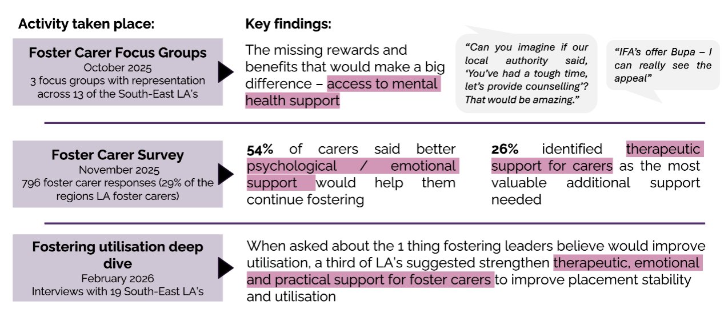
This is more light touch than the therapeutic bid that has gone into DfE. This is a 6 week online and in person group to focus on nervous system regulation.
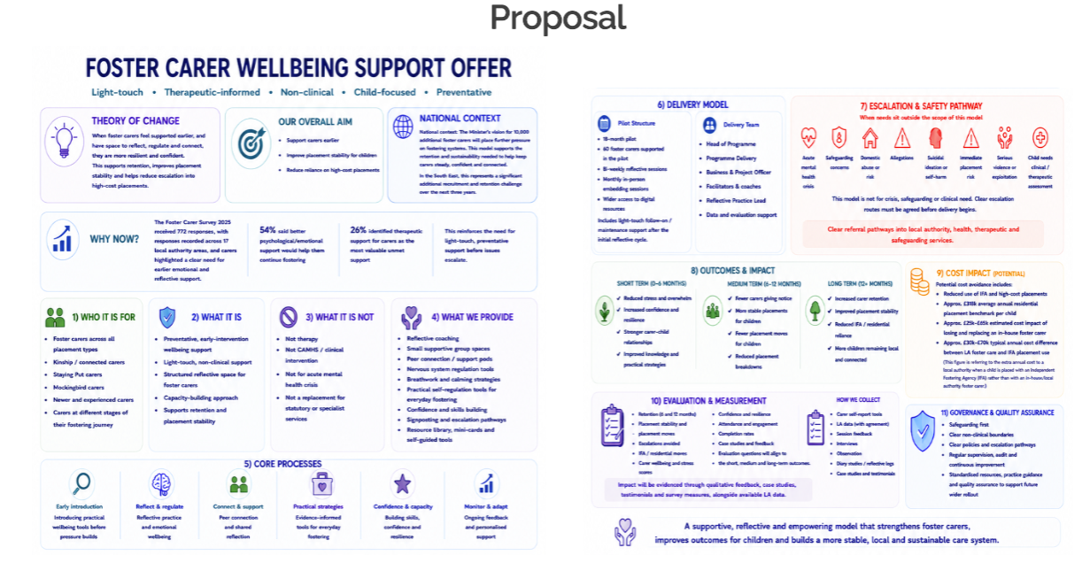
The pilot would focus on particular stages:
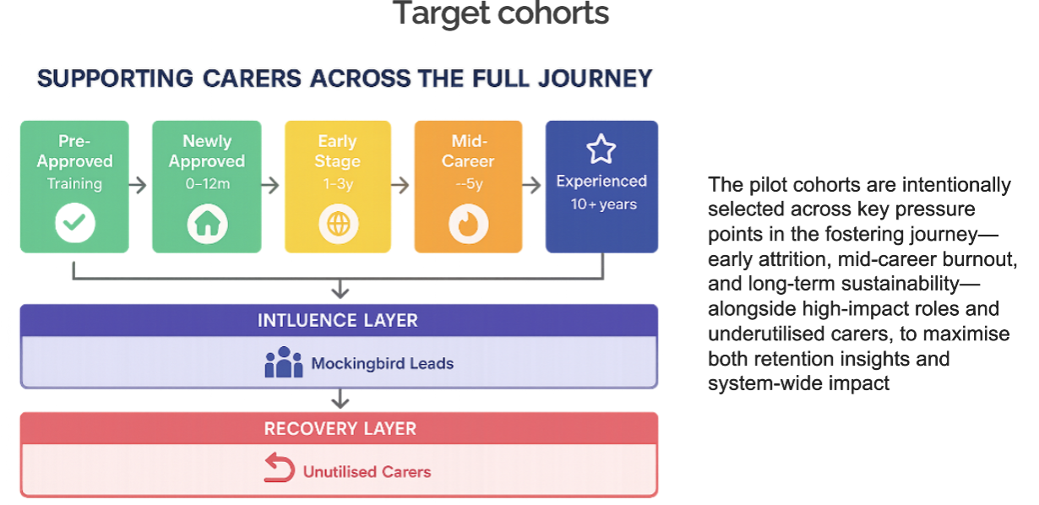
CM from Surrey – looking at placement stability, utilisation and reductions in de-registration. PH from Bracknell Forest – had foster carer conference and a key theme was them overlooking their own wellbeing. Curious if there is a way to access this support on an ongoing basis in addition to a 6 week programme. Bracknell Forest would also be interested. SA said we are definitely interested in Slough. CS said she would need to check with colleagues but would like to be involved, Brighton and Hove have started to develop wellness action plans, wellbeing walks and would be keen to share practice. Sharing out offer of wellbeing offers of support to staff also to foster carers.
HB – in Wokingham we have an older generation of foster carers, they don’t buy in to them being a therapeutic vessel, that language and the nervous system isn’t language that would land with older carers. AMA said language and approach would need to be developed.
RE asked if there had been thinking about funding, hosting given changes. AMA said at early stages so not yet clear on those areas.
JK said the issue in East Sussex is the impact of difficult endings, even if they are positive endings.
AS said IoW would be interested. CA said Southampton would be interested too.
RF said Bucks would be interested.
JF agree with what JK said, he said transitions is the biggest issue – moving to independence, adoption, breakdown. One plus is reaching carers on a break to help them return to fostering.
KW – West Sussex agree – who is doing this/running these groups. AMA is at early stages of development, would want a reflective practitioner, coaches, project lead.
Action: AMA to contact LAs that have expressed interest and develop proposal more fully once funding is secured
ME said my only concern is how much we have going on at the moment and we may need to prioritise according to where we receive DfE grant funding
Standing items/AOB: JK asked for templates for staff and foster carers and when that might come out from Home+Future. VC said these will come out via Diana Griffith in next 10 days.
CAN film is planned not to go ahead this year around fostering recruitment. KW expressed disappointment. CS said B+H would support the film.
Next meeting dates:
Mon December 14 1-3.30pm

 | Action | Responsible | Date issued | Status
61 | AMA to contact LAs that have expressed interest and develop proposal more fully once funding is secured | AMA | June 2026 | underway
60 | All to contact Homes for Good to find out more about the support they can provide | all | Mar 2026 | Complete
59 | other LAs to get back to RE and SS on if any of you have mileage up to a certain amount included in your standard weekly payments | All | Mar 2026 | complete
58 | MC to send step across policy to RE to share. | MC | Mar 2026 | complete
57 | CA, HB and ME to share approach to Council Tax | CA HB ME | Mar 2026 | complete
56 | SD/RE to share feedback to LAFSE re: overlap of meetings which LAs are invited to. | SD/RE | Mar 2026 | complete
55 | March 2026 meeting to hear from Kent (MC) on step across and children with disabilities led project. | MC | Dec 2025 | Complete
54 | The group agreed with a proposal to seek funding to trial a pilot in the 7 LAs which had been part of the steering group. RE to meet with SD and DCS Mac Heath in his role as DCS chair in SESLIP to see what scale of pilot might work/be palatable for DfE to fund. | RE | Dec 2025 | Complete
53 | RE to connect Bracknell Forest with placement modelling tool from Data to insight | RE | Sept 2025 | Complete
52 | Any LAs interested in finding out or for a demo of Tracs or ICompass e can contact Colin on colin@tracsuk.org | All | Sept 2025 | Complete
51 | RE to connect PH with the Data to Insight placement modelling tool which can be used to model placement types and costs using 903 return data. | RE | Sept 2025 | complete
50 | CS asked that “those for whom the time isn’t right” is added to the group who want to foster but cannot in the fostering community project. RE to add this to project plan | RE | Sept 2025 | complete
49 | MC to share out of hours policy | MC | July 2025 | complete
48 | RE to convene a design meeting with those that are interested, and to liaise with DfE about this new idea. This to be the main item at the next regional meeting. | RE | July 2025 | complete
47 | GS and SD to meet with MH to discuss how this group can be used moving forward to help provide a space for LAs to provide feedback/identify key issues to ensure the success of the hub moving forward. NB: The hub is likely moving aligning with direction of travel with RCC | SD | March 2025 | Ongoing/  complete
46 | SD has agreed to escalate and take to the regional DCS group that there are issues around cost and pace/delays regarding foster carer medicals. SD has flagged this. | SD | March 2025 | complete
45 | SD asked the group to find out and report back: What is driving delays is it capacity, payment, or it isn’t part of the commissioned offer, is it costing too much? What is the issue. Have you escalated in place-based partnerships and ICB risk logs? | ALL | Dec 2024 | complete

