June 9 2026 Minutes and Actions 
South East regional Kinship network

Chair Dr Mac Heath, DCS Milton Keynes, Vice Chair Lucy Peake, Chief Executive Kinship, SESLIP support rebeccaeligon@gmail.com
Attendees: Alitha Lee-Townsend (Slough), Ananda Bodenstein (West Berkshire), Annita Andreou (Portsmouth), Arek Ksizazek (Milton Keynes), Mark Vening (Kent), Clark McAuley (Surrey), Sam Turner (Kinship), Chi Chiringa (Medway), Ashley Schofield (Isle of Wight), Victoria Grey (Kinship), Maryke McCarthy (Bucks), Carly Arnold (Southampton), Aimee Dennis (Portsmouth), Hannah Leedham (Achieving for Children), John Foster (Data to insight), Kerry Boltwood (West Sussex), Lisa Apps (East Sussex), Faye Nethercote (Hampshire), Nicola Lord (??), Peter Hodges (Bracknell forest), Wendy Queralt (Oxfordshire), Sam Turner (Kinship), Sharon Godfrey (Milton Keynes), Tim Fisher (Kinship), Eszter Kovacs (Wokingham), Karl Davis , Becky Snook (Hants), Julie McNally (Oxfordshire)
31 attendees in total, LAs without a representative: Reading (also not present last quarter), Brighton and Hove
Item 1: Introduction: MH introduced this as one of the many groups supported by SESLIP. There are number of changes under consideration to review groups ensuring their connection with work in the RCC including end to end fostering.
Actions from March meeting agreed.
Item 2: Policy update and discussion: ST from Kinship updated the national policy agenda, particularly relating to the DfE-led initiatives and set out the timeframes for this. Colleagues reflected this is a very busy space with a number of uncoordinated but aligned initiatives. LP flagged the Kinship policy tracker as a helpful space to keep up to date with all that is going on. Kinship care policy tracker | Kinship
LP noted in the chat:
For more policy and practice updates, tickets are live for our Kinship Knowledge 2026 on 14 July in London. Speakers include DfE, Jahnine Davis Kinship Care Ambassador, Yvette Stanley from Ofsted and Ann-Marie Matson from NE Lincs Kinship Zone. Kinship knowledge exchange 2026
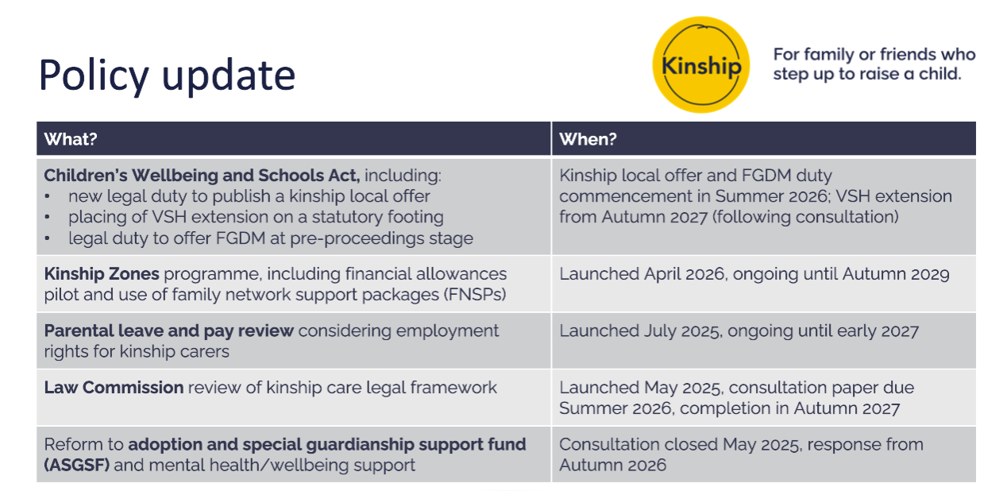
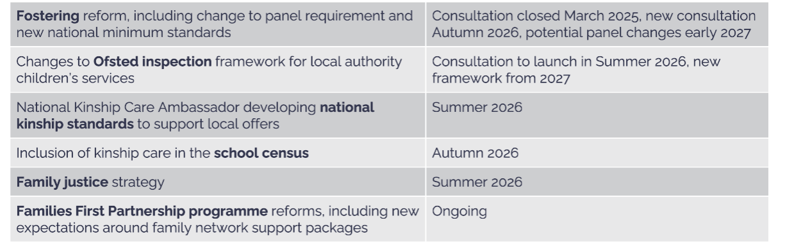
Item 3: Quarterly data update: JF noted that full quarterly analysis could not be shared and confirmed that two quarters data will be presented next time.
Item 4 Kinship local offer research: TF presented the findings from 162 kinship carers with 44% of responses from less heard groups, and 48% from kinship carers on informal orders. TF noted that there are differences in views from less heard vs other carers with a stronger focus on financial stability for the less heard group. Overall the ask from the carers were simple: named contact, support with trauma, sense of belonging and the importance of peer support.
CM from Surrey asked that sometimes some of the elements around post order support are changed in court and that system change is needed to address this as the LA and carer have to deal with the outcomes/fallout. CM asked if this came out in the research. TF said it did in the discussion group.
MH said how much of this is about a lack of understanding in front door and safeguarding social workers in court. CM agreed that it is also a practice issue. CM said it would be helpful to draw out the needs of those in informal arrangements in the analysis.
EK reflected that many of the system change requirements are ones that they recognise in Wokingham and would be good to work as a region on actions to address these key themes.
LP reflected that it is important to coproduce with kinship carers, when probed, and given time to reflect, they might not want the same as foster carers, and they are well placed to identify what would work.
Action: Rebecca and Tim to meet to develop a practical actionable framework, add in more about the perspectives of those in informal arrangements and to create a toolkit/set of stimulus materials for Las to use in coproduction with their own carers.
Item 5: Kinship Reach; VG shared that the Kinship Reach programme launched in 18 LAs in November 2025. During Quarter 2 (January–March 2026), the SESLIP Kinship Reach service received 19 new referrals, bringing the total number of referrals received to date to 35. During quarter 2 support was provided via 102 phone calls. 6 LA’s over the past few months have used the services for out of county carers, this works well and provided that extended arm support that Reach can provide.
During Quarter 2, carers most commonly set goals focused on supporting their own emotional and mental health and wellbeing, reflecting the significant emotional impact of taking on and sustaining a kinship caring role. A further proportion of goals were centred on improving access to services and information, highlighting an ongoing need for clear, timely guidance to help carers navigate education, children’s services and wider support systems. A smaller number of carers identified goals related to building confidence in caring for kinship children, including managing behaviour and responding to children’s emotional needs, underlining the complex and interconnected challenges faced by kinship families.
One carer from Oxford said ‘Honestly I cannot thank you enough for your continued support over the past four months. It’s been an absolute pleasure I have learnt a lot about myself and my situation, I can’t thank you enough.
Another carer said this about the support group; I always learn so much every time I attend the kinship support group. It really helps me to be an even better parent to my kinship child. Thank you for your support.
RE reflected on SESLIP funding and the desire to continue the pilot til until at least the end of the financial year.
Action: Rebecca to put forward bid for DCS consideration to continue Kinship Reach, alongside kinship connected by July 15 deadline.
Item 6: Discussion of kinship payment themes: CC shared progress on pilot in Medway which is at mobilisation phase for quite a long term pilot of 3.5 years. So far Medway has received about 110 applications. It is means-tested, tax exempt and carers in receipt of these payments can apply for child benefit. The intention is that no one should be financial worse off by participating and many should be better off.
Rebecca shared the payment information that had been collated from 16 LAs (below) which led to group discussion of how LAs are responding/adapting their approach to finances.
CM asked what do we know about what works the best in terms of means tested/no detriment/matched to foster carers etc? LP said on the detail there isn’t evidence that one is better than the other, but the what works evaluation does show that adequate financial support is important. CC reflected that this will be tested through the pilot evaluation. CC also said that some of the issues still require resolution, for example if another LA has placed in Medway they wouldn’t be eligible, but Medway families living elsewhere would.
PH from Bracknell Forest was curious about regional agreement around how we manage allowances on a regional basis. Are there opportunities at a regional level (e.g. given the three year rule) to have a clearer and more consistent approach at a subregional or regional level.
MH reflected on CM’s point – do we know the impact, and what works. MH said his view is yes there needs to be more consistency especially as we lean more into subregional and regional arrangements.
Action: further update from Medway in 6-9 months.

Summary of kinship payment themes:
This is based on information submitted by 16 LAs (I have summarised but may have misinterpreted your submissions, so check they are accurate). Information was not received from Isle of wight, Medway, Portsmouth.

Pay in Line with Fostering Minimum Rates (Often Means-Tested)
These LAs broadly align SG/kinship payments with national fostering minimum allowances, often with annual means testing:
- Bracknell Forest – Fostering minimum rates; means tested annually
- Kent – SG carers only; fostering minimum rates; means tested annually
- West Sussex – SG and kinship foster carers paid in line with national minimum rates; SG means tested
- Southampton – Payments start in line with fostering rates; means tested if not foster-approved
- Surrey – In line with fostering rates; SGO means tested after 2 years
- East Sussex – Fostering rate minus professional element; means tested and reviewed yearly

Two-Year “Transitional Protection” (Full Fostering Rate Then Means Test)
These LAs protect carers financially for the first two years post-SGO (especially if child was previously LAC), then apply means testing – this protects income when moving from fostering to SG:
- Buckinghamshire – Protected fostering rate (same as mainstream foster carers) for first 2 years post-SGO, then means tested
- Slough – Former Reg 24 carers receive fostering-equivalent allowance for first 2 years post-SGO; after 2 years a means-tested financial assessment determines SG allowance; no further reviews unless significant change in circumstances
- Reading – 2 years non-means-tested if previously kinship foster carer
- Windsor & Maidenhead – 2 years equivalent to fostering (minus child benefit), then means tested
- West Berkshire – 2 years fostering equivalent (above minimum), then means tested
- Surrey – 2 years SGO; not-detriment rule may extend full allowance
- Wokingham – 2 years minimum fostering allowance (if previously LAC), then means tested

Full Fostering Allowance for Approved Kinship Foster Carers
These LAs treat approved kinship foster carers the same as mainstream foster carers: Where kinship carers are formally foster-approved, parity with mainstream fostering is standard.
- Buckinghamshire – Kinship foster carers paid at same rate as mainstream foster carers
- Milton Keynes – Approved kinship carers receive the same payments as mainstream foster carers; temporarily approved carers receive the fostering allowance but not the professional fee
- Oxfordshire – Approved/temporarily approved kinship carers paid in line with national minimum rates
- Wokingham – Fully approved kinship foster carers receive full fostering allowance regardless of income
- East Sussex – Foster-approved carers receive full fostering rate

Pay SG Carers Only (Limited Wider Kinship Support)
These LAs prioritise Special Guardianship over CAO/RO/private arrangements in terms of payment
- Kent – SG only (not other kinship carers)
- Hampshire – SG in line with fostering; other orders discretionary

Discretionary / Case-by-Case Approach for Other Orders (CAO/RO)
Several authorities consider Child Arrangement Orders (CAO) or Residence Orders individually. There is no automatic entitlement outside SGO/LAC cases; needs-based assessment
- Brighton & Hove – Discretionary payments for CAO/RO
- Hampshire – Discretionary CAO/RO payments
- Milton Keynes – Means-tested allowance available for CAO
- Reading – CAO assessed based on need/prior LA care
- Windsor & Maidenhead – Case-by-case for non-SG kinship
- West Berkshire – Case-by-case depending on child’s needs/LAC status
- Wokingham – CAO subject to financial assessment

Means Testing Models Differ
There are two main financial assessment approaches to means testing:
A. Always Means Tested
- Bracknell Forest
- Kent
- East Sussex
- West Sussex
- Southampton (if not foster approved)
- Milton Keynes (SG and CAO allowances)
B. Means Tested After 2 Years
- Bucks
- Reading
- Windsor & Maidenhead
- West Berkshire
- Surrey
- Wokingham
- Slough

Deduction of Child Benefit / UC
Most SG allowances deduct child benefit; some treat this as part of means test. Common practice:
- Brighton & Hove deduct child benefit
- Windsor & Maidenhead deduct child benefit
- Wokingham deduct child benefit
- West Sussex applies deductions

“No Detriment” / Enhanced Protection Policies
More protective models:
- Brighton and Hove- Explicit no-detriment policy; pays all kinship foster carers and those with a legal order for care experienced children in line with national minimum fostering rates.
- Oxfordshire – Explicit no-detriment policy; pays all kinship carers in line with national minimum fostering rates
- Surrey – Not-detriment guidance may extend full allowance to 18
- West Berkshire – First two years exceeds fostering minimum
- Buckinghamshire – Protected fostering rate for first two years post-SGO
- Slough – Two-year fostering-equivalent protection for former Reg 24 carers

S17 for Informal Kinship Care
Some LAs explicitly restrict financial support where carers are not formally approved or do not hold legal orders:
- Milton Keynes – No allowance for private fostering or informal family arrangements; support may be provided via Section 17 following assessment of need
- Southampton – Private arrangements generally supported only through Section 17 where needs are identified
Informal kinship care often falls outside regular allowance structures and relies on discretionary children’s services support.

Overall Patterns
Across the region:
- Fostering minimum rates are the benchmark almost everywhere
- Most SG allowances become means tested at some stage
- Two-year transitional protection is common across many LAs
- Support beyond SG (CAO/RO/private) is usually discretionary or means tested
- Children previously looked after (LAC/Reg 24/Connected) receive stronger financial protection
- Very few LAs offer universal, non-means-tested long-term SG allowances
- Approved kinship foster carers are usually paid the same as mainstream foster carers
- Informal kinship arrangements generally rely on S17 discretionary support.

Full feedback from LAs on Kinship payment:
LA | info on SG/kinship payments
Bracknell Forest | Bracknell Forest pay kinship carers in line with minimum fostering allowances. This is means tested annually.
Brighton and Hove | ‘BHCC pays Special Guardians of care experienced children the same as national fostering minimum allowances. BHCC deducts child benefit as SGs can claim CB. BHCC does not deduct CB if the SG claims means-tested benefits or their only income is a state pension. There is a no detriment to moving to SGO from Kinship FC, and BHCC does not means test the allowance.  BHCC pays all kinship foster carers the NMA equivalent. On completion of Core Skills Training BHCC pays NMA + Level 1 Foster Carer Fee. On completion of Mandatory training BHCC pays NMA + Level 2 Foster Carer Fees. BHCC pays all Kinship carers (either approved or temp approved as foster carers) in line with national minimum fostering rates.  Payments to carers who hold a CAO for a care experienced child are discretionary and paid as per national fostering minimum allowances. BHCC deducts child benefit, unless the CAO carer is in receipt of a means tested benefit, or their only income is state pension.’
Buckinghamshire | Bucks pay kinship foster carers at the same rate as mainstream foster carers. For SG carers, we pay the protected fostering rate (as for mainstream carers) for the 1st 2 years post order, whereafter it becomes means tested.
East Sussex | We pay kinship carers in line with the fostering rates minus the professional element, the allowance is means-tested and reviewed yearly. Those who have fostering approval are paid the full fostering rate, and this is regularly reviewed via the SSW. Private applications are considered on an individual basis.
Hampshire | Hampshire pay SG carers in line with foster care minimum rates. Similarly to Brighton and Hove we pay some other kinship carers with other legal orders ie CAO or RO in line with foster care minimum rates on a discretionary basis
Isle of Wight
Kent | Kinship (Connected) foster carers receive full fostering payment both maintenance and reward (once they have completed Skills to Foster), to maintain the reward payment they must complete yearly training/support groups etc, this is means tested and reviewed at the carers annual review.
Medway
Milton Keynes | In accordance with our fostering payments policy, all approved kinship carers receive the same payments as mainstream foster carers. Temporarily approved kinship carers are entitled to the fostering allowance, however, they are not eligible for the professional fee. Special Guardians receive a means‑tested SGO allowance, aligned with South East fostering rates. A means‑tested allowance is also provided for Child Arrangement Orders. For other kinship carers, including those in private fostering arrangements or informal family arrangements, no allowance is paid. However, financial support may be provided under Section 17 where an assessed need has been identified.
Oxfordshire | Oxfordshire have a no-detriment policy in place for all children who are CWCF at the time of making an Order. We pay all Kinship carers ( either approved or temp approved as foster carers) in line with national minimum fostering rates.
Portsmouth
Reading | SG carers receive a non means tested allowance for 2 years post the granting of any order if they were previously kinship foster carers. After 2 years, payments are means tested.  Consideration of any payment is in line with national fostering minimum rates.  For other Kinship carers i.e. CAO consideration is given depending on factors such as the children’s needs and/or whether the children were in Local Authority care immediately before the application.
Slough | SCF pay the carers who were Reg 24 carers prior to the order being granted an amount equivalent to the fostering allowances for the first two years protected to support the transition Reg 24 to SG. After the two-year period they would have a financial assessment which is means tested and if the carers meet the criteria they would receive an SG allowance. There are no further reviews unless there has been a significant change in their circumstances and at that point they financial circumstances can be reviewed.  Where a carer has never had a child previously in placement, they would undertake a financial assessment and if they met the criteria, they would receive the SG allowance with no further review unless there has been a significant change.  Other kinship arrangement are considered on a cases-by-cases basis and where payment is made this is paid from the sec 17 payments.
Southampton | Where a carer has never had a child previously in placement, they would undertake a financial assessment and if they met the criteria, they would receive the SG allowance with no further review unless there has been a significant change.
Surrey | Other kinship arrangement are considered on a cases-by-cases basis and where payment is made this is paid from the sec 17 payments.
Windsor and Maidenhead | AfC pays SG carers (where the children were in LA care prior to the order) an amount equivalent to our fostering allowance (minus child benefit) for the first two years, so the carers payments will be unchanged as they move from fostering to SG. After two years, we carry out a means test, and if carers meet the criteria, they receive an SG allowance that may be close to or equivalent to the foster care minimum rates. This is reviewed each year. Other Kinship cases are considered on a case-by-case basis, for example CAO. Other than this we do not have a specific policy around private arrangements other than Sec 17 payments.
West Berks | West Berkshire pays SG carers (where the children were in LA care prior to the order) an amount equivalent to our fostering allowance for the first two years, which exceeds the foster care minimum rates. After two years, we carry out a means test, and if carers meet the criteria, they receive an SG allowance that is close to or equivalent to the foster care minimum rates. Other Kinship cases are considered on a case-by-case basis, depending on factors such as the children’s needs and/or whether the children were in LA care immediately before the CAO/private SG applications.
West Sussex | Our Kinship foster carers and Special Guardians receive the same weekly all-inclusive allowance, set in line with Natational fostering minimum rates, paid partly in arrears and partly in advance. Special Guardianship allowances are means-tested because SGs can claim Child Benefit and some UC elements, and deductions are applied accordingly. SGs may also receive a skills fee or enhanced payments under special agreement.
Wokingham | Kinship foster carers (as fully approved foster carers) receive the full fostering allowance regardless of income and may receive a Skills Fee once trained. If caring for a young person turning 18, they receive the Staying Put rate, with any Skills Fee tapering down annually until age 21.  Connected Carers  Connected carers receive:  Child allowance in line with government guidance  Fostering fees, but only if the child’s permanency plan is connected care  Council tax support  If the child’s plan is likely to move towards a Special Guardianship Order (SGO), then once the carers are fully approved as connected carers:  They do not receive the fostering fee.  They do not receive the council tax contribution.  Special Guardianship (SG) Carers  If the child was looked after (LAC) immediately before the SGO was granted:  The carer automatically receives, for the first two years:  Minimum fostering child allowance  Minus child benefit (which the carer claims themselves).  If the child was not looked after before the SGO:  A financial assessment is completed.  Carers may receive child allowance, depending on a means test.  Means-tested SG allowances:  Are reviewed every two years.  Do not automatically increase over time unless there are significant or exceptional circumstances that justify a change.  Child arrangement orders:  Carers may receive child allowance, depending on a financial assessment and means test.

Item 6: Standing item: agenda for next meeting and items for escalation 8 Sept 1-2.30
Policy update, data for last 2 quarters, update on connection of kinship work with end to end fostering/RCC
Action log: This action log was updated on 6 September. Shaded actions are closed or complete
 | Action | Responsible | Date issued | Status
26 | further update from Medway in 6-9 months. (c. Dec 2026 or March 2027) | CC | June 2026 | open
25 | Rebecca and Tim to meet to develop a practical actionable framework, add in more about the perspectives of those in informal arrangements and to create a toolkit/set of stimulus materials for Las to use in coproduction with their own carers. | RE TF | June 2026 | complete
24 | Item on June agenda to focus on Medway payment pilot and payments across the region | RE | Mar 2026 | complete
23 | MH to raise via DCS colleagues Police prioritising and responding to police checks and DBS checks as it feels like a lottery across the region | MH | Mar 2026 | complete
22 | Quarterly benchmarking to continue | RE | Dec 2025 | complete
21 | RE to collate which LAs are paying the minimum fostering rates and allowances to SG carers/ or have some sort of no detriment policy via email and present back next time | All | December 2025 | Complete
20 | All LAs to email tim.fisher@kinship.org.uk when they have published Kinship local offer so the links can be published on Compass page. | All | December 2025 | complete
19 | All LAs to get back by Sept 26 if they are in or out of Kinship Reach. Rebecca to meet with Kinship directly to develop business case for an in person regional offering to come back to a future meeting. Kinship to develop a costed proposal for £15k to support coproduction of the kinship local offer in LAs. | RE | September 2025 | Complete
18 | All to note deadline for next submission as JF will be presenting annual data returns as well as quarterly trends. 13 November submission date | All | Sept 2025 | Complete
17 | Lucy to consider what other data points for national comparison may be available. The Law Commission review is an opportunity to discuss those issues | LP | September | Complete
16 | RE to put forward DfE bids for coproduction of local offer, and prevention of placement breakdown through Kinship Reach and Kinshio connects | RE | June 2025 | complete
15 | KW to share terms of reference for placement breakdown rapid response meeting | KW | June 2025 | complete
14 | JF include national comparison data where available in benchmarking, and JF and RE to produce an annual narrative with trends once four quarters of data collected | RE | June 2025 | complete

